Joseph Silva Jr.

11/20/2021

SNHU

CS 499 – Milestone 2: Enhancement One: Software Design/Engineering

**A. Briefly describe the artifact. What is it? When was it created?**

The artifacts are folders that were linked to the project through visual studios in order to have the project automatically retrieve these files during the operation. These files were header files, vs and fs files, jpg, and png files. The include folder I linked to the project contained many header files, which included mathematics from GLM, camera.h file, a 3D cylinder design file, etc. Along with the include folder, I also created an image folder, which contained the jpg and png files, and a shaderfile folder, which contained the vs and fs files. The two folders were placed in the main folder of the project and the files are automatically retrieved by the project instead of the project having to go through the computer to find these files. These folders were created at the beginning of this term in order for me to keep the entire project organized and to also have all the required files together with the project just in case it needed to be sent as a zip folder either by email or uploaded onto the internet.

Properties – VC++ Include – Include Directories – Library Include:

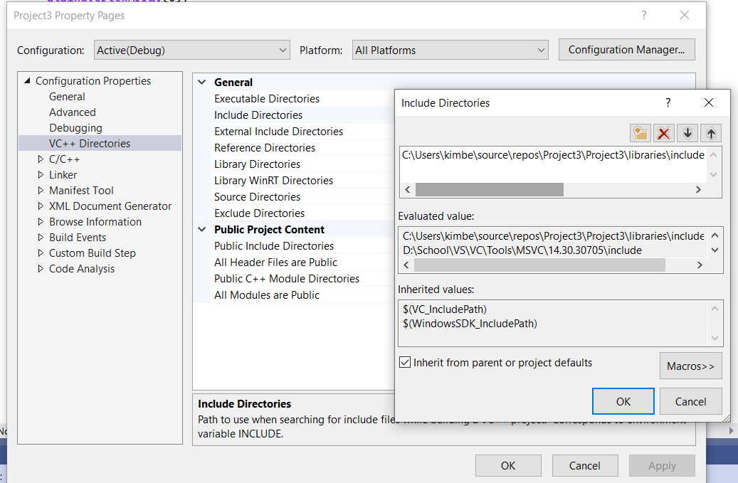

Include Folder:

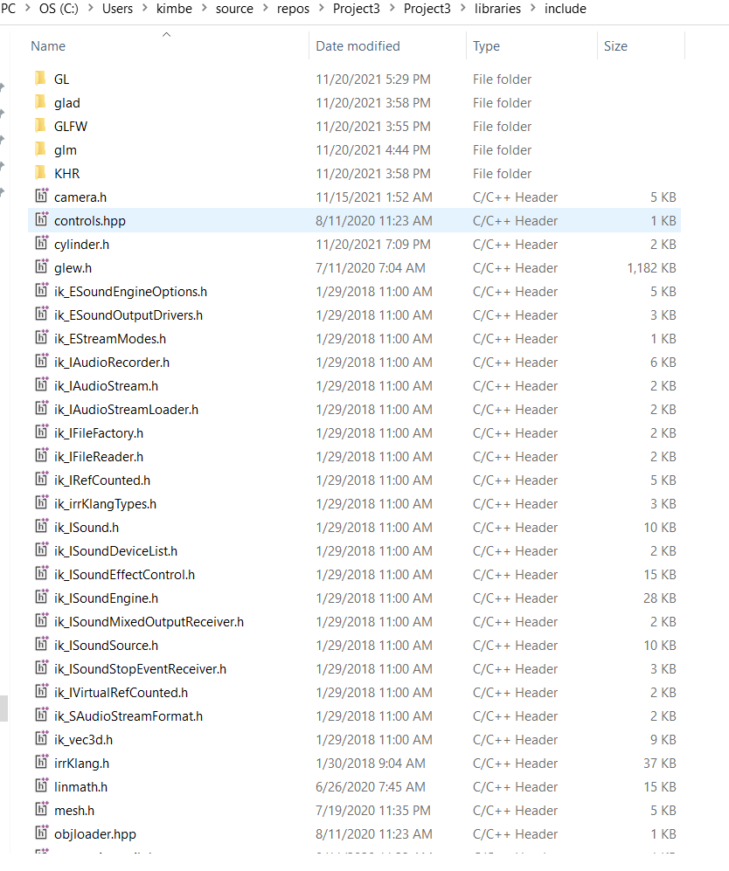

**B. Justify the inclusion of the artifact in your ePortfolio. Why did you select this item? What specific components of the artifact showcase your skills and abilities in software development? How was the artifact improved?**

I selected these items because these are the external files / folders that my project used in order to run properly. I had run into issues with having my files spread out on my computer when it came to running my program and also delivering my program to my professor. For example, if any of the files or folders were modified, the pathway to retrieve the data would malfunction and cause an error / failure in my project. Also, once I had sent the project over to my professor for a review, a lot of the files were missing, or the professor had to relink the pathways together in order for my project to work.

These types of errors are not a large issue when it comes to working on a project by yourself, but when it comes to working with a team, these errors can cause a halt in production because the files are not attached with the main branch. I believe this showed my ability to be able to implement many different files whether created by myself, a team member, or an external party into my project very easily by just dropping the files into one directory instead of including multiple directories like we did in CS 330. Being able to make projects simple is a standard practice for new programmers and experienced ones. In the area below, I placed examples on how easy it was for my project to find certain files already included in the file by comparing a linker error. Please see arrows for the differences in photos.

Linker errors without proper pathway: (Shaderfiles example)

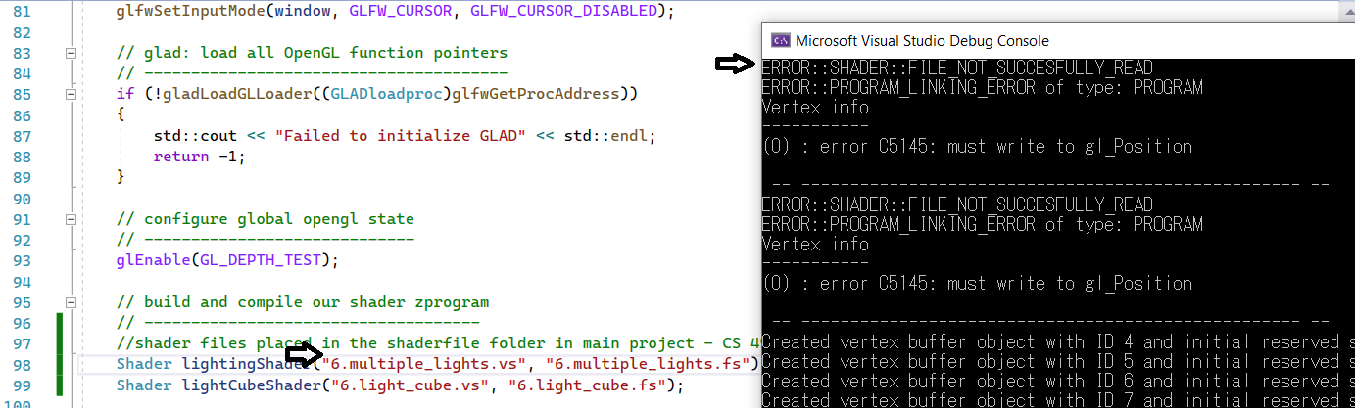

No errors with proper pathway:

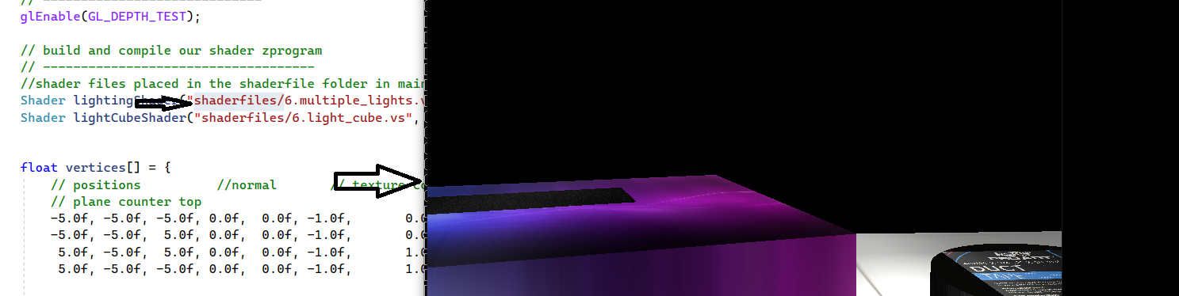

**C. Did you meet the course objectives you planned to meet with this enhancement in Module One? Do you have any updates to your outcome-coverage plans?**

The enhancement did meet my plans for my enhancement because I can now easily implement many different files such as vertexbuffer and staticmesh3D header files into my project by just dropping it into the include folder without having to implement it into my project. For my updates, I have found the header files needed to add music to my project from irrklang. I was able to easily place the header files into the project. The header files for irrklang are not being implemented yet, but they are also not taking space in the header files area of visual studios in the project.

**D. Reflect on the process of enhancing and/or modifying the artifact. What did you learn as you were creating it and improving it? What challenges did you face?**

When modifying my artifact, I learned it was a lot easier to implement new files into my project by adding the header files into the include folder because the include folder was already linked to my project. I did not have to add the header files into the actual project in visual studios because the project automatically retrieved the files since they were in the main project. One issue I had when I re-started my project was, I ran into libraries and files that were corrupted or malfunctioning since my original project used x32 and visual studios 2019 during my CS 330 class. For my CS 499, I had to use my own personal device instead of using Apporto virtual lab and I had to download visual studios 2022 with windows x64. This caused an issue with my linkers, directories, and libraries because I was using a different windows architecture than what was previously used.