Joseph Silva Jr.

11/20/2021

SNHU

CS 499 – Milestone 3: Enhancement Two: Algorithms and Data Structure

**A. Briefly describe the artifact. What is it? When was it created?**

The artifacts that I added and modified to my project were header files and cpp files. The cpp and header files staticMesh3D and vertexBufferObject were implemented with the main.cpp and cylinder files in order to make the 3D designs inside my 3D world have better quality. These files were created approximately in 2014, but I found these files prior to my CS 499 class because I wanted to add to my project. The other file I modified was my main.cpp file and my camera.h file. The camera.h file was found on learnopengl site, during my CS 330 class. I modified these files in order to add new commands to my project. In my previous version of my project, the camera was only able to go left, right, forward, and backwards with the use of the keyboards and GLFW library. In the newer version, I added the camera to be able to move up and down as well.

**B. Justify the inclusion of the artifact in your ePortfolio. Why did you select this item? What specific components of the artifact showcase your skills and abilities in software development? How was the artifact improved?**

I selected these items because the 3D designs’ textures in the older version of my project were grainy, watery, and not correctly aligned. I was also having an issue with implementing images with higher pixels into my 3D designs and I had to go with lower quality imagery to complete the project. I also added new commands to the camera movement because I did not like how I had to use the scroll along with combining keyboard commands to make the camera view go up and down. These combinations of commands sometimes made my view of the 3D world at an unacceptable angle. The following are two photos comparing the 3D designs’ textures from the older and newer version of my project:

The next is the code I implemented into my camera.h and main.cpp files in order to create the new commands. Please see arrows in photos for the modifications:

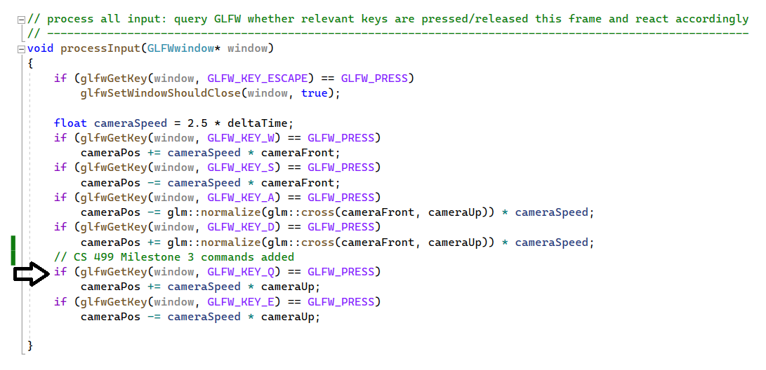

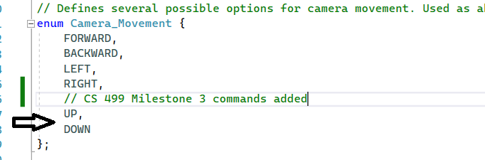

I believe these showed my abilities to locate open-source code and implementing the open-source code to my already created project by modifying it to fit with my original written code. The implemented code allowed me to update and upgrade my project to show and create better 3D design textures for any future project. The implementation of these additional codes and commands allows me or anyone using my open-source original code to have higher quality 3D texture designs with only making simple modifications within my original code to create a new 3D world by only having to worry about changing the vertices, indices, and image files.

**C. Did you meet the course objectives you planned to meet with this enhancement in Module One? Do you have any updates to your outcome-coverage plans?**

The enhancement to my project by implementing additional header files and cpp files worked great. These files caused the 3D world and objects to looker higher in quality than my previous version of the project. I will be using header files from the learnopengl website 2D design to add sound affects and music to my 3D design to make my project seem more like a video game level than just an 3D art piece. The header files and cpp files have already been downloaded from irrklang opensource and I will be implementing them into my project.

**D. Reflect on the process of enhancing and/or modifying the artifact. What did you learn as you were creating it and improving it? What challenges did you face?**

I learned I could enhance the design of my project by adding these open-source header files and cpp files. An issue I ran into when implementing these files were running into errors such as linker 2019 Microsoft errors. I placed the header files into the include folder and the cpp files into the main project, I also went into the header files and the cpp files to modify the codes on their pathway and their implementation into the main project. After modifying these areas, the project exe file worked like a charm.