
EVENT MANAGEMENT REPORT
HoA DRIVE Project
Solar Fridge Handover Ceremonies
“Delivering Cold-Chain Livelihoods”
SUBMITTED TO
Abdulkadir Hussein Hassan
Focal Point, HoA DRIVE Project
Project Implementation Unit (PIU), Ministry of Finance, Federal Government of Somalia

Client | Project Implementation Unit (PIU), DRIVE Project, Ministry of Finance, Federal Government of Somalia
Project | De-risking, Inclusion and Value Enhancement of Pastoral Economies in the Horn of Africa (HoA DRIVE)
Contract reference | [Contract No.] dated [date]
Event period | 18 August 2026 to 30 September 2026
Locations | 9 districts across Galmudug, Banadir, South West, Hirshabelle and Jubaland
Beneficiaries | 540 families (60 per district)
Project focal point | Abdulkadir Hussein Hassan
Submitted by | Rasmi Logistic Service, Waabari Mall, Mogadishu
Date of report | 14 October 2026

1. Background
The HoA DRIVE Project is implemented by the Project Implementation Unit (PIU) of the Ministry of Finance, Federal Government of Somalia, with financing from the World Bank. Under the project, solar-powered fridges are provided to women milk vendors so they can keep milk fresh, reduce spoilage and increase income from milk sales.
Public handover ceremonies were organised in each target district to formally hand over the fridges to beneficiary families and to create a visible record of the support provided.
Rasmi Logistic Service was contracted by the PIU under Contract No. [Contract No.] dated [date] to provide logistics support for these handover ceremonies. This report summarises the services delivered under the contract.

2. Executive Summary
Between 18 August and 30 September 2026, Rasmi Logistic Service supported fridge handover ceremonies in nine districts across four Federal Member States and Banadir. A total of 540 families received their fridges (60 per district).
Districts | Families | FMS + Banadir | Period
9 | 540 | 4 + 1 | 18 Aug 2026 to 30 Sep 2026

Services delivered, in line with the contract:
- Carrying and handling of fridge equipment in all nine districts.
- Catering in Afgoye and Balcad only.
- Vehicle rent and transportation, within city or intercity, in all nine districts.
- Media coverage of the ceremonies in all nine districts.

Reach by Federal Member State:
FMS / Area | Districts | Date(s) | Families
Galmudug | Dhusamareeb, Cadaado, Galkacyo | 18 Aug 2026 | 180
Banadir | Mogadishu | 6 Sep 2026 | 60
South West | Afgoye | [date] | 60
Hirshabelle | Jowhar, Beledweyne, Balcad | 14 Sep 2026 | 180
Jubaland | Kismayo | 30 Sep 2026 | 60
Total | 9 districts |  | 540

3. Scope of Services
The table below sets out the services under the contract and where each was provided. The fridges were supplied by the project; Rasmi's role was logistics support for the handover.
Service | Description | Coverage
Fridge carrying and handling | Loading, moving and carrying the fridge equipment to the venue and helping each family carry their fridge after handover. | All 9 districts
Catering | Refreshments for participants and guests at the ceremony. | Afgoye and Balcad only
Vehicle rent / transportation | Vehicle rent for movement within the city, and intercity transport between locations where required, for the team, materials and fridges. | All 9 districts
Media coverage | Photography and video coverage of each ceremony. All media is available through the link in Section 6. | All 9 districts

4. Delivery by District
# | District | FMS / Area | Date | Families | Fridge carrying | Catering | Transport | Media
1 | Dhusamareeb | Galmudug | 18 Aug 2026 | 60 | Yes | No | Yes | Yes
2 | Cadaado | Galmudug | 18 Aug 2026 | 60 | Yes | No | Yes | Yes
3 | Galkacyo | Galmudug | 18 Aug 2026 | 60 | Yes | No | Yes | Yes
4 | Mogadishu | Banadir | 6 Sep 2026 | 60 | Yes | No | Yes | Yes
5 | Afgoye | South West | [date] | 60 | Yes | Yes | Yes | Yes
6 | Jowhar | Hirshabelle | 14 Sep 2026 | 60 | Yes | No | Yes | Yes
7 | Beledweyne | Hirshabelle | 14 Sep 2026 | 60 | Yes | No | Yes | Yes
8 | Balcad | Hirshabelle | 14 Sep 2026 | 60 | Yes | Yes | Yes | Yes
9 | Kismayo | Jubaland | 30 Sep 2026 | 60 | Yes | No | Yes | Yes
 | Total |  |  | 540 | 9 | 2 | 9 | 9

5. Logistics and Coordination
Each district was planned and run as a separate deployment, with the same service standard applied at every site.

5.1 Transportation
- Within city: vehicle rent to move the team, materials and fridges between storage and the ceremony venue.
- Intercity: transport between districts where the ceremony site required travel from another city [Rasmi to list the districts served by intercity transport].

5.2 Catering
Catering was provided in Afgoye and Balcad only, as set out in the contract. No catering was provided in the other seven districts.

5.3 Ceremony steps
- Prepare: confirm the district plan, date, venue and transport with the PIU focal point.
- Mobilise: move the team and fridge equipment to the district and set up the venue.
- Hand over: fridges handed over to the 60 beneficiary families; handover list signed.
- Carry: team helps each family carry their fridge from the venue.
- Record: photo and video coverage of the ceremony.
- Close: wrap up on site and confirm the outcome with the PIU focal point.

5.4 Coordination with the PIU
Rasmi kept regular contact with the project focal point, Abdulkadir Hussein Hassan, before and during each ceremony to confirm dates, venues and arrangements.

6. Media Coverage
Photo and video coverage was provided at all nine ceremonies. The full media files are available at:
District | Media link / folder
Dhusamareeb | [link]
Cadaado | https://www.facebook.com/reel/3743534559129368
Galkacyo | https://www.facebook.com/reel/2053184808633587
Mogadishu | https://www.facebook.com/reel/916665714471740
Afgoye | [link]
Jowhar | https://www.facebook.com/reel/1881138039767781
Beledweyne | [link]
Balcad | https://www.facebook.com/reel/4439016306360579
Kismayo | [link]

7. Challenges and How They Were Managed
Challenge | How it was managed
Distance between districts | Planned transport per district (within city or intercity) and scheduled travel so the team arrived in time to set up.
Security and access | Coordinated movements with the project team and local authorities, and kept travel and set-up within safe working hours.
Carrying fridges | Team helped each family carry their fridge so the equipment reached them safely.
Consistent quality across 9 sites | Used the same service checklist in every district.

8. Lessons Learned and Recommendations

What worked well
- A standard service checklist for every district.
- Planning each ceremony as its own deployment.
- Helping families carry their fridges on the day.

For future handovers
- Agree the district schedule with the PIU early.
- Confirm venue, transport type and any catering per district in advance.
- Share media coverage with the PIU within a set number of days after each ceremony.

9. Conclusion
Rasmi Logistic Service supported nine handover ceremonies in which 540 families received solar fridges. Each ceremony is a practical step towards safer milk storage, less spoilage and stronger incomes for families who depend on milk sales.
We thank the Project Implementation Unit, Ministry of Finance, and the project focal point, Abdulkadir Hussein Hassan, for their support throughout.

Prepared by | Verified by
Mohamed Jama Osman  Operation Manager, Rasmi Logistic Service | Abdulkadir Hussein Hassan  Project Focal Point, HoA DRIVE Project
Signature:  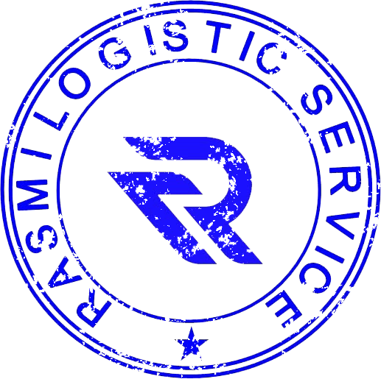 | Signature:  ____________________
Date: 14 October 2026 | Date: ____________________

Annexes
- Annex A: Signed handover / acknowledgement lists per district
- Annex B: Selected photos per district
- Annex C: Media coverage link(s)

