
EVENT MANAGEMENT REPORT
HoA DRIVE Project
Solar Fridge Handover Ceremonies
Jubaland — State Report
“Delivering Cold-Chain Livelihoods”
SUBMITTED TO
Abdulkadir Hussein Hassan
Focal Point, HoA DRIVE Project
Project Implementation Unit (PIU), Ministry of Finance, Federal Government of Somalia

Client | Project Implementation Unit (PIU), DRIVE Project, Ministry of Finance, Federal Government of Somalia
Project | De-risking, Inclusion and Value Enhancement of Pastoral Economies in the Horn of Africa (HoA DRIVE)
Contract reference | [Contract No.] dated [date]
Area covered | Jubaland: 1 district (Kismayo)
Ceremony date | 30 September 2026
Beneficiaries | 200 families
Project focal point | Abdulkadir Hussein Hassan
Submitted by | Rasmi Logistic Service, Waabari Mall, Mogadishu
Date of report | 14 October 2026

1. Background
The HoA DRIVE Project is implemented by the Project Implementation Unit (PIU) of the Ministry of Finance, Federal Government of Somalia, with financing from the World Bank. Under the project, solar-powered fridges are provided to women milk vendors so they can keep milk fresh, reduce spoilage and increase income from milk sales.
Public handover ceremonies were organised in each target district. This report covers the ceremonies in Jubaland: Kismayo. Rasmi Logistic Service was contracted by the PIU to provide logistics support for these ceremonies, and the fridges were supplied by the project.

2. Summary
In Jubaland, Rasmi Logistic Service supported fridge handover ceremonies in 1 district on 30 September 2026. A total of 200 families received their fridges.
Districts | Families | Region | Date
1 | 200 | Jubaland | 30 Sep 2026

Services delivered in Jubaland:
- Carrying and handling of fridge equipment in the district.
- Vehicle rent and transportation, within the city, in the district.
- Media coverage of the ceremony in the district.

3. Scope of Services
The table sets out the services under the contract and where each was provided in this area. The fridges were supplied by the project; Rasmi’s role was logistics support for the handover.
Service | Description | Coverage
Fridge carrying and handling | Loading, moving and carrying the fridge equipment to the venue and helping each family carry their fridge after handover. | Kismayo
Vehicle rent / transportation | Vehicle rent for movement within the city, for the team, materials and fridges. | Kismayo
Media coverage | Photography and video coverage of the ceremony. Links and details are in Annex A. | Kismayo

4. Delivery by District
# | District | Date | Families | Fridge carrying | Transport | Media
1 | Kismayo | 30 Sep 2026 | 200 | Yes | Yes | Yes
 | Total |  | 200 | 1 | 1 | 1

5. Logistics and Coordination
Each district in Jubaland was planned and run as a separate deployment, with the same service standard applied at every site.

5.1 Transportation
- Within city: vehicle rent to move the team, materials and fridges between storage and the ceremony venue.

5.2 Ceremony steps
- Prepare: confirm the district plan, date, venue and transport with the PIU focal point.
- Mobilise: move the team and fridge equipment to the district and set up the venue.
- Hand over: fridges handed over to the 200 beneficiary families in Jubaland; handover list signed.
- Carry: team helps each family carry their fridge from the venue.
- Record: photo and video coverage of the ceremony.
- Close: wrap up on site and confirm the outcome with the PIU focal point.

5.3 Coordination with the PIU
Rasmi kept regular contact with the project focal point, Abdulkadir Hussein Hassan, before and during each ceremony to confirm dates, venues and arrangements.

6. Media Coverage
Photo and video coverage was provided at the ceremony in Jubaland. Links and details for each district are in Annex A.

7. Challenges and How They Were Managed
Challenge | How it was managed
Distance and travel | Planned transport per district and scheduled travel so the team arrived in time to set up.
Security and access | Coordinated movements with the project team and local authorities, and kept travel and set-up within safe working hours.
Carrying fridges | Team helped each family carry their fridge so the equipment reached them safely.
Consistent quality | Used the same service checklist in every district.

8. Conclusion
Rasmi Logistic Service supported the handover ceremonies in Jubaland, in which 200 families received solar fridges. Each ceremony is a practical step towards safer milk storage, less spoilage and stronger incomes for families who depend on milk sales.
We thank the Project Implementation Unit, Ministry of Finance, and the project focal point, Abdulkadir Hussein Hassan, for their support throughout.

Submitted by | Verified by
Mohamed Jama Osman  Operation Manager, Rasmi Logistic Service | Abdulkadir Hussein Hassan  Project Focal Point, HoA DRIVE Project
Signature:  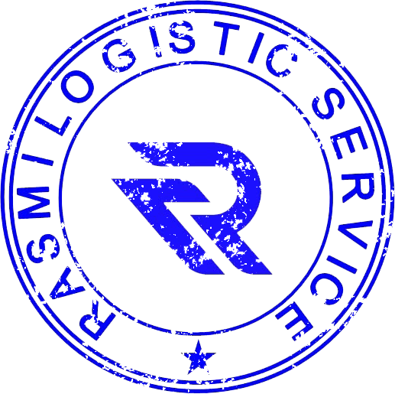 | Signature:  ____________________
Date: 14 October 2026 | Date: ____________________

Annex A: Media Coverage — Links and Details
Photo and video coverage was provided at the ceremony in Jubaland. The details and links for each district are below.

A.1 Kismayo
District | Kismayo
Region | Jubaland
Ceremony date | 30 September 2026
Families | 200
Media provided | Photography and video coverage of the ceremony
Photos and videos | [link]

