
EVENT MANAGEMENT REPORT
HoA DRIVE Project
Solar Fridge Handover Ceremonies
Galmudug — State Report
“Delivering Cold-Chain Livelihoods”
SUBMITTED TO
Abdulkadir Hussein Hassan
Focal Point, HoA DRIVE Project
Project Implementation Unit (PIU), Ministry of Finance, Federal Government of Somalia

Client | Project Implementation Unit (PIU), DRIVE Project, Ministry of Finance, Federal Government of Somalia
Project | De-risking, Inclusion and Value Enhancement of Pastoral Economies in the Horn of Africa (HoA DRIVE)
Contract reference | [Contract No.] dated [date]
Area covered | Galmudug: 3 districts (Dhusamareeb, Cadaado and Galkacyo)
Ceremony dates | Dhusamareeb: 23 Aug 2026; Cadaado: 23 Aug 2026; Galkacyo: 17 Aug 2026
Beneficiaries | 200 families
Project focal point | Abdulkadir Hussein Hassan
Submitted by | Rasmi Logistic Service, Waabari Mall, Mogadishu
Date of report | 14 October 2026

1. Background
The HoA DRIVE Project is implemented by the Project Implementation Unit (PIU) of the Ministry of Finance, Federal Government of Somalia, with financing from the World Bank. Under the project, solar-powered fridges are provided to women milk vendors so they can keep milk fresh, reduce spoilage and increase income from milk sales.
Public handover ceremonies were organised in each target district. This report covers the ceremonies in Galmudug: Dhusamareeb, Cadaado and Galkacyo. Rasmi Logistic Service was contracted by the PIU to provide logistics support for these ceremonies, and the fridges were supplied by the project.

2. Summary
In Galmudug, Rasmi Logistic Service supported fridge handover ceremonies in 3 districts (ceremony dates: Dhusamareeb: 23 Aug 2026; Cadaado: 23 Aug 2026; Galkacyo: 17 Aug 2026). A total of 200 families received their fridges.
Districts | Families | Region | Dates
3 | 200 | Galmudug | 17 – 23 Aug 2026

Services delivered in Galmudug:
- Carrying and handling of fridge equipment in all 3 districts.
- Vehicle rent and transportation, within the city and intercity, in all 3 districts.
- Media coverage of the ceremony in all 3 districts.

3. Scope of Services
The table sets out the services under the contract and where each was provided in this area. The fridges were supplied by the project; Rasmi’s role was logistics support for the handover.
Service | Description | Coverage
Fridge carrying and handling | Loading, moving and carrying the fridge equipment to the venue and helping each family carry their fridge after handover. | All 3 districts
Vehicle rent / transportation | Vehicle rent for movement within the city, and intercity transport where required, for the team, materials and fridges. | All 3 districts
Media coverage | Photography and video coverage of the ceremony. Links and details are in Annex A. | All 3 districts

4. Delivery by District
# | District | Date | Families | Fridge carrying | Transport | Media
1 | Dhusamareeb | 23 Aug 2026 | 80 | Yes | Yes | Yes
2 | Cadaado | 23 Aug 2026 | 60 | Yes | Yes | Yes
3 | Galkacyo | 17 Aug 2026 | 60 | Yes | Yes | Yes
 | Total |  | 200 | 3 | 3 | 3

5. Logistics and Coordination
Each district in Galmudug was planned and run as a separate deployment, with the same service standard applied at every site.

5.1 Transportation
- Within city: vehicle rent to move the team, materials and fridges between storage and the ceremony venue.
- Intercity: transport between locations where the ceremony site required travel from another city:
- Galkacyo – Cadaado
- Cadaado – Dhusamareeb
- Dhusamareeb – Guriel Airport (flight from Mogadishu unavailable)

5.2 Ceremony steps
- Prepare: confirm the district plan, date, venue and transport with the PIU focal point.
- Mobilise: move the team and fridge equipment to the district and set up the venue.
- Hand over: fridges handed over to the 200 beneficiary families in Galmudug; handover list signed.
- Carry: team helps each family carry their fridge from the venue.
- Record: photo and video coverage of the ceremony.
- Close: wrap up on site and confirm the outcome with the PIU focal point.

5.3 Coordination with the PIU
Rasmi kept regular contact with the project focal point, Abdulkadir Hussein Hassan, before and during each ceremony to confirm dates, venues and arrangements.

6. Media Coverage
Photo and video coverage was provided at all 3 ceremonies in Galmudug. Links and details for each district are in Annex A.

7. Challenges and How They Were Managed
Challenge | How it was managed
Distance and travel | Planned transport per district and scheduled travel so the team arrived in time to set up.
Security and access | Coordinated movements with the project team and local authorities, and kept travel and set-up within safe working hours.
Carrying fridges | Team helped each family carry their fridge so the equipment reached them safely.
Consistent quality | Used the same service checklist in every district.

8. Conclusion
Rasmi Logistic Service supported the handover ceremonies in Galmudug, in which 200 families received solar fridges. Each ceremony is a practical step towards safer milk storage, less spoilage and stronger incomes for families who depend on milk sales.
We thank the Project Implementation Unit, Ministry of Finance, and the project focal point, Abdulkadir Hussein Hassan, for their support throughout.

Submitted by | Verified by
Mohamed Jama Osman  Operation Manager, Rasmi Logistic Service | Abdulkadir Hussein Hassan  Project Focal Point, HoA DRIVE Project
Signature:   | Signature:  ____________________
Date: 14 October 2026 | Date: ____________________

Annex A: Media Coverage — Galmudug
Photo and video coverage of the ceremonies in Galmudug, by media house, with the city, the channel, the views and the link to each post. Views were checked on 14 October 2026 and will change.
# | City | Media house / outlet | Channel | Views | Link
1 | Dhusamareeb | Telefishinka Qaranka Soomaaliyeed (SNTV) | Facebook | 18K | facebook.com/share/v/1JpAYpvdNS/
2 | Dhusamareeb | Abdulahi Warsame Roble (personal profile) | Facebook | — | facebook.com/share/v/1D4YYo3kHt/
3 | Cadaado | Telefishinka Qaranka Soomaaliyeed (SNTV) | Facebook | 6K | facebook.com/reel/3743534559129368
4 | Galkacyo | Telefishinka Qaranka Soomaaliyeed (SNTV) | Facebook | 14K | facebook.com/reel/2053184808633587

Photos: Galkacyo
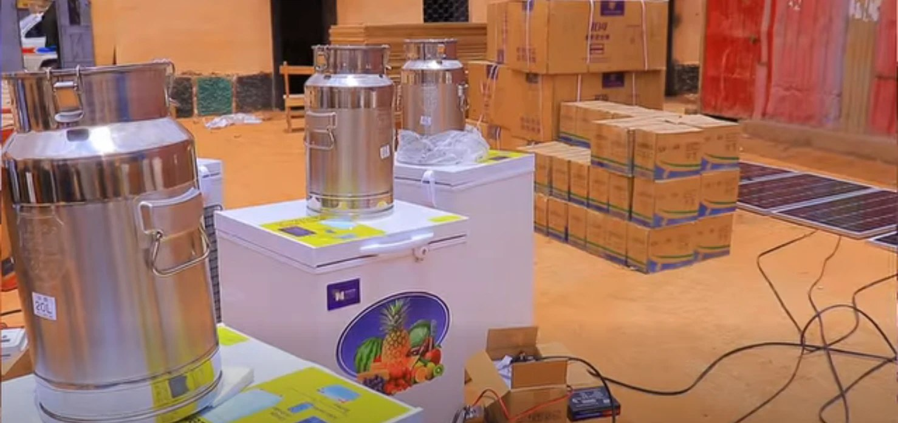  Stainless steel 20-litre milk cans on solar freezers, with boxed equipment stacked behind. | 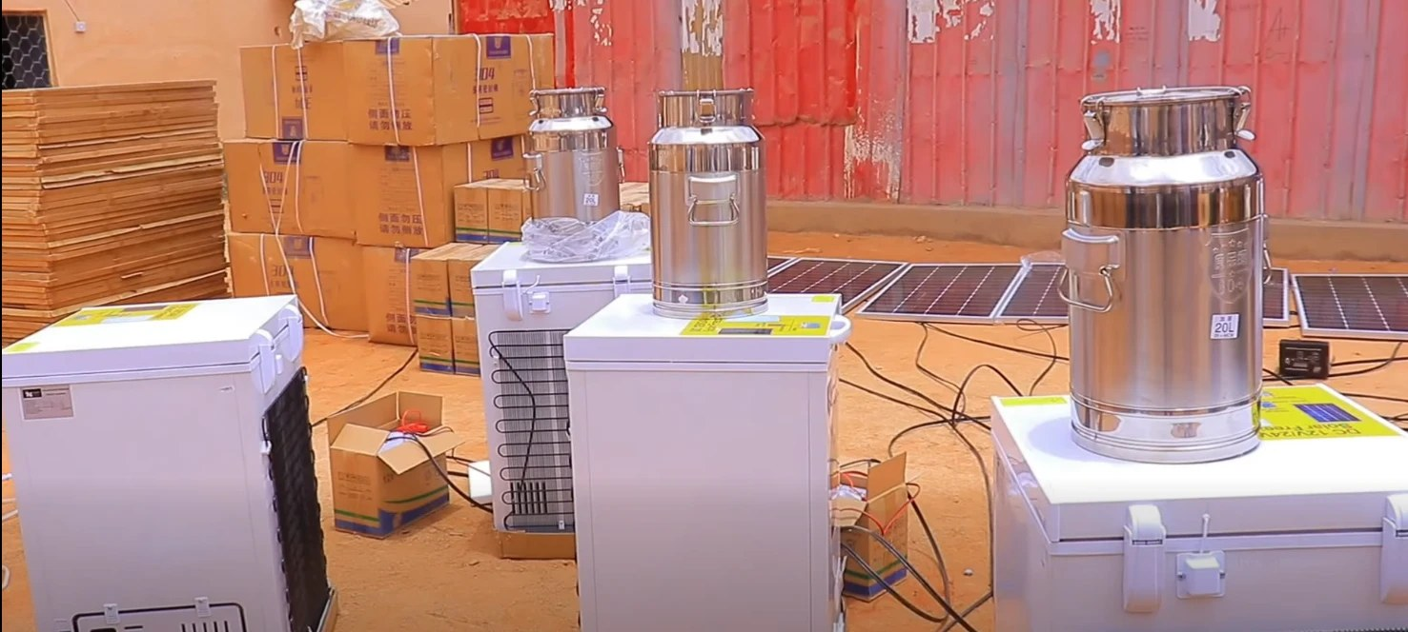  Solar freezers topped with milk cans, with boxes and solar panels laid out behind.
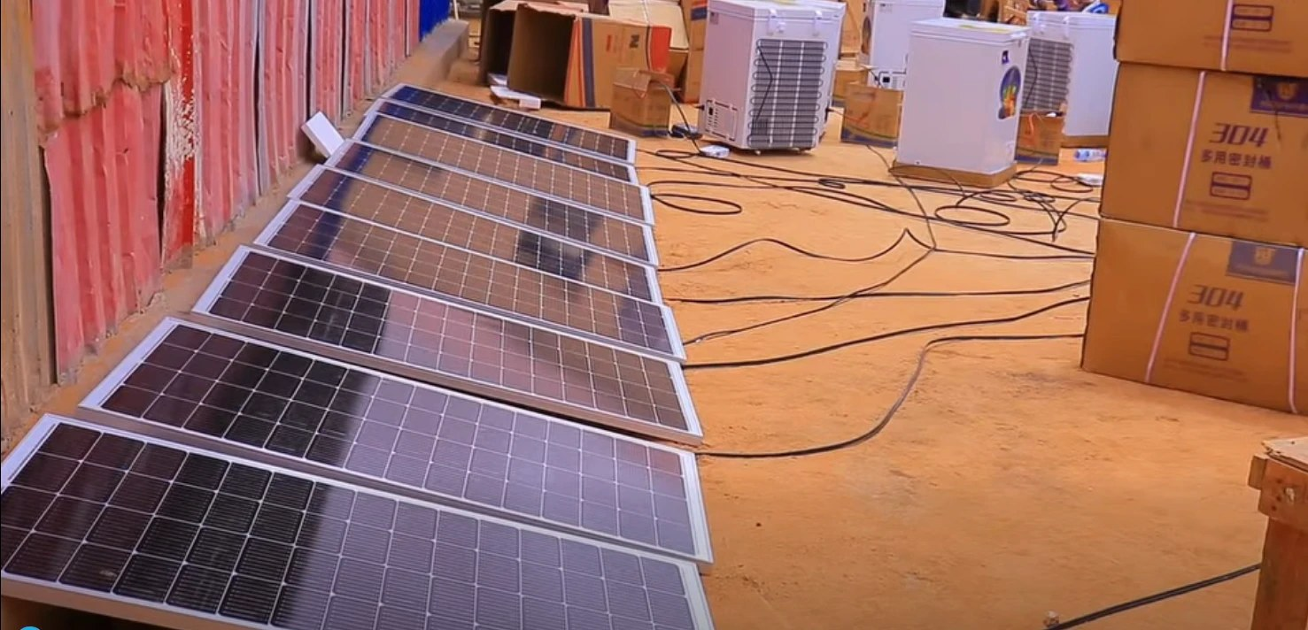  Solar panels laid out in a row along a wall, with solar freezers and boxed milk cans beyond. | 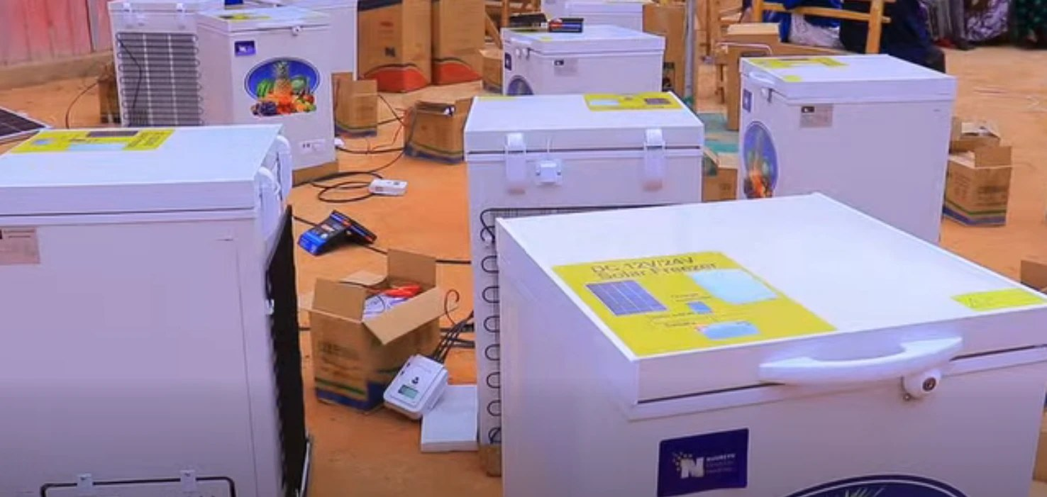  Rows of solar freezers (labelled DC 12V/24V Solar Freezer) with cables and control units on the ground.

Photos: Dhusamareeb
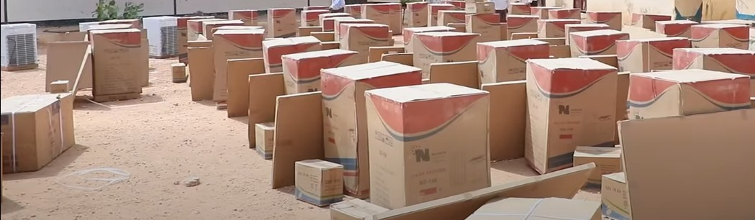
Boxed units set out in rows on open ground.

