ASSIGNMENT 1

1. What is software? What is software engineering?

Software is a set of instructions, data or programs used to operate computers and execute specific tasks.

Software Engineering is branch of computer science that deals with design, development, testing and maintenance of software applications.

1. Explain types of software

There are two types of software

* System software
* Application software
* System software is software which is directly connect with the computer hardware it is provide basic functionality to users so as well as other software to perform smoothly. Ex:- operating system like Microsoft windows, Mac OS, Linux etc.
* Application Software is designed to perform a specific task for end-users. Ex:- Ms word, Ms excel, Power Point etc.

1. What is SDLC? Explain each phase of SDLC

The software development life cycle is used by software development originations to design, develop, test, deploy, and maintain software applications.

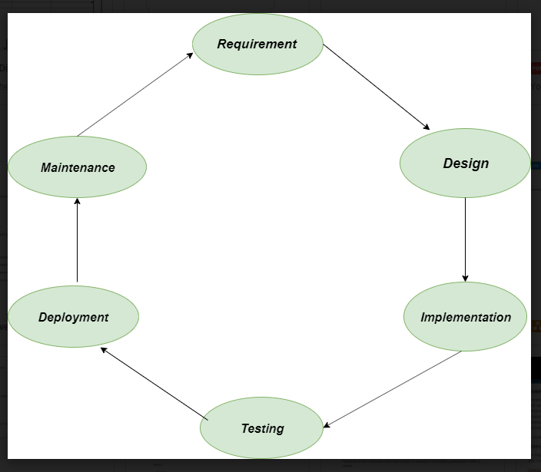

**1. Requirements gathering and analysis:** This phase involves gathering information about the software requirements from stakeholders, such as customers, end-users, and business analysts.

**2. Design:** In this phase, the software design is created, which includes the overall architecture of the software, data structures, and interfaces. It has two steps:

* **High-level design (HLD):** It gives the architecture of software products.
* **Low-level design (LLD):** It describes how each and every feature in the product should work and every component.

**3. Implementation or coding:** The design is then implemented in code, usually in several iterations, and this phase is also called as Development.

things you need to know about this phase:

* This is the longest phase in SDLC model.
* This phase consists of Front end + Middleware + Back-end.
* **In front-end:**Development of coding is done even SEO settings are done.
* **In Middleware:** They connect both the front end and back end.
* **In the back-end:** A database is created.

**4. Testing:**The software is thoroughly tested to ensure that it meets the requirements and works correctly.

**5. Deployment:** After successful testing, The software is deployed to a production environment and made available to end-users.

**6. Maintenance:**This phase includes ongoing support, bug fixes, and updates to the software.

1. What is DFD? Create DFD diagram of filpcart

Data Flow Diagram is data flow of information of any process or system.

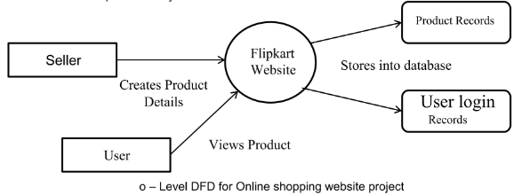

1. What is Flow chart? Create a flowchart to make addition of two numbers

Flowchart is a graphical representation of steps. It shows the flow of algorithm in sequential order.

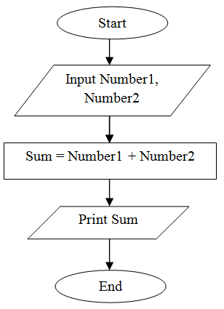

1. What is Use case Diagram? Create a use-case on bill payment on paytm.

Use case diagram is graphical depiction of user’s possible interaction with the system.

