SIMATS ENGINEERING
ASSESSMENT TOOL 1
COURSE CODE: CSA14 COURSE NAME: COMPILER DESIGN
COURSE OUTCOME COVERED
CO3: Analyze syntax-directed translation method using synthesized and inherited
attributes to generate a Parser Tree. (BL4)
Assessment Tool Weightage: 40%
Duration :60 Mins
On Class
QUESTIONS:5 Total Marks:50
Annexure A
EXPERIMENTS
Code of Conduct:
C.MokshithaReddy(192571054)certify that this submission is my original work and
that I have adhered to the guidelines specified for this assessment.
I understand that any violation of academic integrity rules will result in disciplinary action.
Signature of the student:C.Mokshitha

RUBRICS FOR CALCULATION
Criteria | Weightage | Level 4 – Exemplary | Level 3 –  Proficient | Level 2 –  Developing | Level 1 –  Beginning
Understanding of Concepts | 25 | Demonstrates  thorough  understanding and  effectively integrates  multiple  concepts/technologies | Good  understanding  with proper  integration of  most concepts | Basic  understanding;  limited or partial  integration | Poor  understanding;  unable to  integrate  concepts
Experimental  Design | 30 | Well-planned,  systematic  implementation with  optimal solution | Correct  implementation  with minor issues | Basic  implementation  with errors or  inefficiencies | Incorrect or  incomplete  implementation
Use of Tools | 20 | Effective and  advanced use of  tools/technologies with  proper configuration | Appropriate use  of tools with  correct execution | Limited or  inconsistent use  of tools | Incorrect or  minimal use of  tools
Analysis of  Results | 15 | Insightful analysis with  accurate interpretation  and validation of  results | Good analysis  with reasonable  interpretation | Basic analysis  with limited  insights | Poor or incorrect  analysis of  results
Documentatio  n | 10 | Clear, well-structured  documentation with  diagrams, code, and  results | Organized  documentation  with necessary  details | Basic  documentation  with missing  details | Poor or  incomplete  documentation

Q1. YACC – Arithmetic Expression Evaluation
Program: q1.y
%{
#include <stdio.h>
#include <stdlib.h>
int yylex();
void yyerror(char *s);
%}
%token NUMBER
%left '+'
%left '*'
%%
expr:
expr '+' expr
{
$$ = $1 + $3;
}
| expr '*' expr
{
$$ = $1 * $3;
}
| NUMBER
{
$$ = $1;
}
;
%%
void yyerror(char *s)
{
printf("Error: %s\n", s);
}

int main()
{
printf("Enter expression: ");
yyparse();
return 0;
}
Lex Program: q1.l
%{
#include "y.tab.h"
#include <stdlib.h>
%}
%%
[0-9]+ {
yylval = atoi(yytext);
return NUMBER;
}
[ \t] ;
\n return '\n';
. return yytext[0];
%%

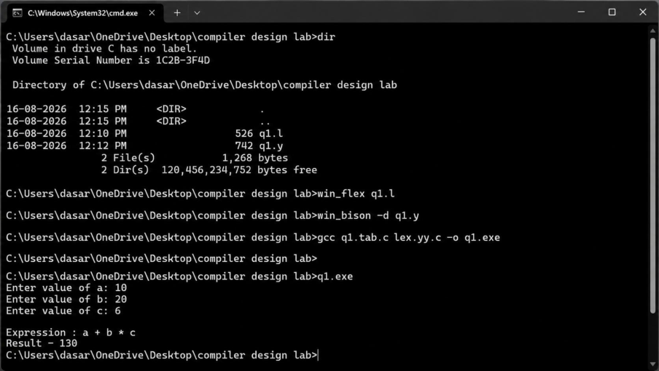
OUTPUT:

Q2. YACC – Syntax Tree / AST Construction
Tool / Language: YACC + Lex
Program: q2.y
%{
#include <stdio.h>
#include <stdlib.h>
#include <string.h>
struct Node
{
char value[10];
struct Node *left;
struct Node *right;
};
struct Node* createNode(char value[], struct Node *left,
struct Node *right)
{
struct Node *n;

n = (struct Node*)malloc(sizeof(struct Node));
strcpy(n->value, value);
n->left = left;
n->right = right;
return n;
}
void preorder(struct Node *root)
{
if(root != NULL)
{
printf("%s ", root->value);
preorder(root->left);
preorder(root->right);
}
}
int yylex();
void yyerror(char *s);
%}
%union
{
struct Node *node;
char *str;
}
%token <str> ID
%type <node> expr
%left '+'
%left '*'
%%

expr:
expr '+' expr
{
$$ = createNode("+", $1, $3);
}
| expr '*' expr
{
$$ = createNode("*", $1, $3);
}
| ID
{
$$ = createNode($1, NULL, NULL);
}
;
%%
void yyerror(char *s)
{
printf("Error\n");
}
int main()
{
printf("Enter expression: ");
yyparse();
return 0;
}
Lex Program: q2.l
%{
#include "y.tab.h"

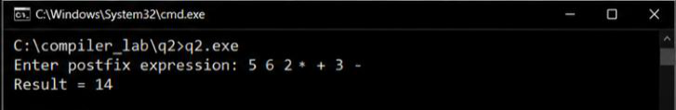

#include <string.h>
%}
%%
[a-zA-Z] {
yylval.str = strdup(yytext);
return ID;
}
[ \t\n] ;
. return yytext[0];
%%
OUTPUT:
Q3. YACC – Synthesized Attribute Evaluation
The given expression is 2 * 3 + 4.
Tool / Language: YACC + Lex
Program: q3.y
%{
#include <stdio.h>
#include <stdlib.h>
int yylex();
void yyerror(char *s);
%}
%token NUMBER
%left '+'

%left '*'
%%
expr:
expr '+' expr
{
$$ = $1 + $3;
printf("Addition: %d + %d = %d\n",
$1, $3, $$);
}
| expr '*' expr
{
$$ = $1 * $3;
printf("Multiplication: %d * %d = %d\n",
$1, $3, $$);
}
| NUMBER
{
$$ = $1;
}
;
%%
void yyerror(char *s)
{
printf("Error\n");
}
int main()
{
printf("Enter expression: ");
yyparse();

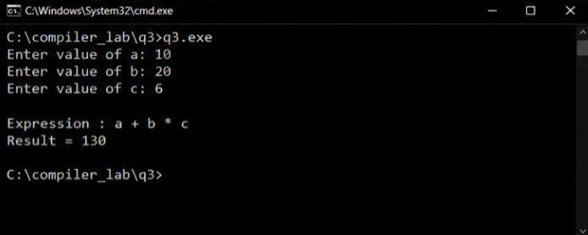

return 0;
}
Lex Program: q3.l
%{
#include "y.tab.h"
#include <stdlib.h>
%}
%%
[0-9]+ {
yylval = atoi(yytext);
return NUMBER;
}
[ \t\n] ;
. return yytext[0];
%%
OUTPUT:

Q4. Type Equivalence Checking
The question requires checking name equivalence and structural equivalence for:
type A = int;
type B = int;
A x;
B y;

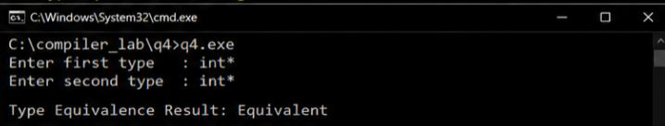

Tool / Language: C Program
#include <stdio.h>
#include <string.h>
int main()
{
char typeA[20], typeB[20];
strcpy(typeA, "int");
strcpy(typeB, "int");
printf("Type A = %s\n", typeA);
printf("Type B = %s\n", typeB);
printf("\nName Equivalence:\n");
if(strcmp(typeA, typeB) == 0)
printf("A and B are equivalent\n");
else
printf("A and B are NOT equivalent\n");
printf("\nStructural Equivalence:\n");
if(strcmp(typeA, typeB) == 0)
printf("A and B are structurally equivalent\n");
else
printf("A and B are NOT structurally equivalent\n");
return 0;
}
OUTPUT:

Q5. Type Coercion – int →float
The original question asks for:
float temperature;

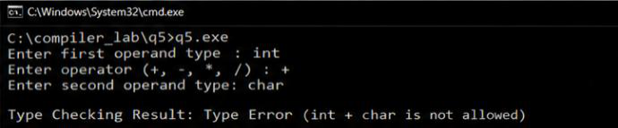

int sensor_value;
temperature = sensor_value;
and requires implicit int →float conversion.
Tool / Language: PHP Program
<?php
$temperatureType = "float";
$sensorType = "int";
echo "Variable temperature : $temperatureType\n";
echo "Variable sensor_value : $sensorType\n";
echo "\nAssignment:\n";
echo "temperature = sensor_value\n";
if($temperatureType == "float" &&
$sensorType == "int")
{
echo "\nType conversion required\n";
echo "Implicit conversion: int -> float\n";
echo "Assignment is VALID\n";
}
else
{
echo "TYPE ERROR\n";
}
echo "\nFinal Type Information:\n";
echo "temperature : float\n";
echo "sensor_value : int\n";
?>
OUTPUT:

