Flutter Roadmap

Stage09 - Validation& Forms

Prepared by:
Momen Mohammed Kraizem
Computer Engineering Graduate
20 July 2026

Login Form
Updated the Login UI from Stage 7 by adding form validation, email validation, password validation, and show/hide password functionality.
validator: (value) {  if (value == null || value.isEmpty) {  return "Can't be Empty";  } else if (value.length < 6) {  return "Password long can't be less than 6";  }  return null;  }, | validator: (value) {  if (value == null || value.isEmpty) {  return "Can't be empty";  } else if (!value.contains("@") || !value.contains(".com")) {  return "Enter a valid Email";  }  return null;  }

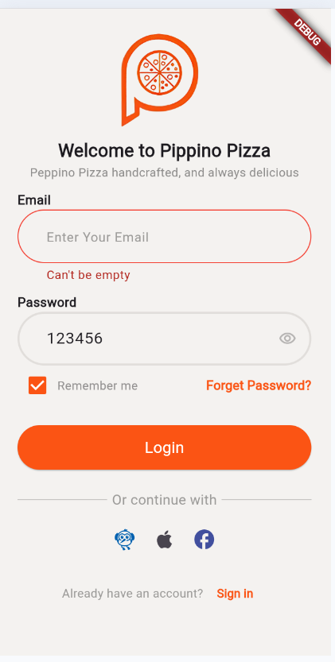 | 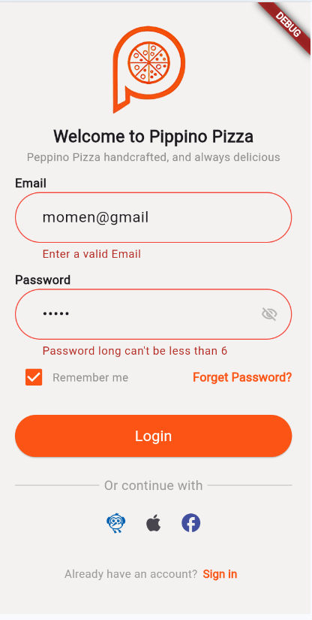

Register Form
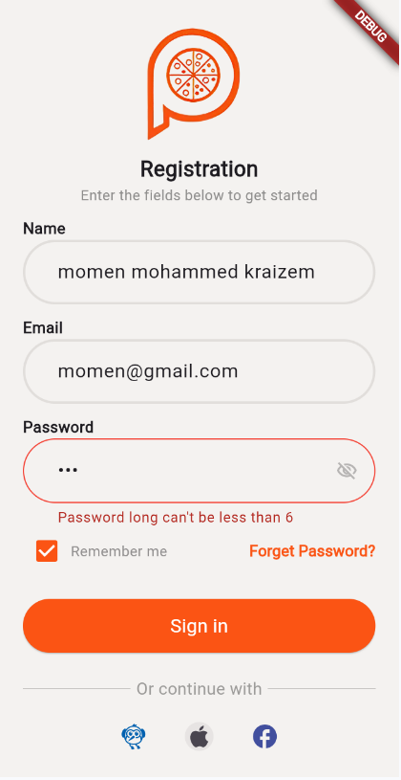 | 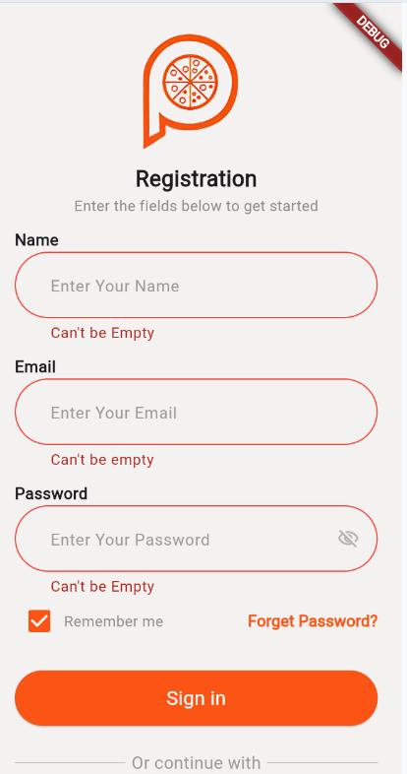

Contact US Form
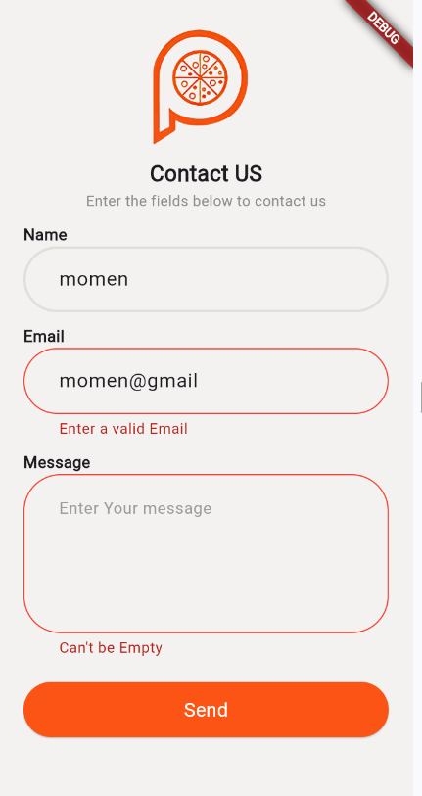

Password Show/Hide
Password Show/Hide functionality was already implemented in the previous exercises.

