Flutter Roadmap

Stage10 – State Managment

Prepared by:
Momen Mohammed Kraizem
Computer Engineering Graduate
16 sep 2026

Counter App
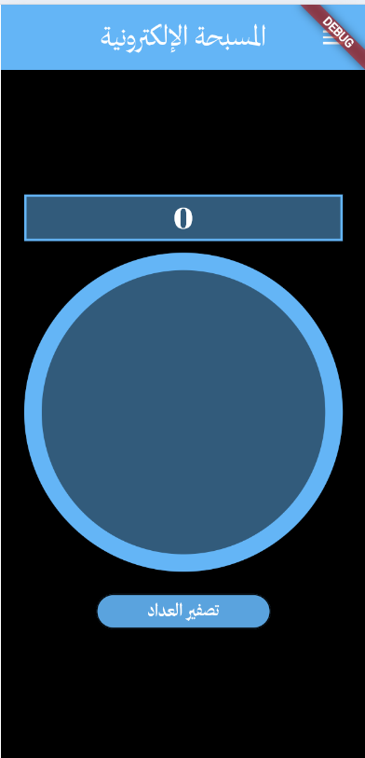

Show/Hide Password
Already done in the previous stages

Adding Item to the List
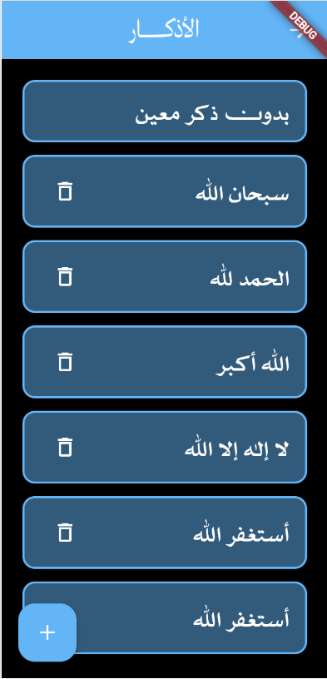 | 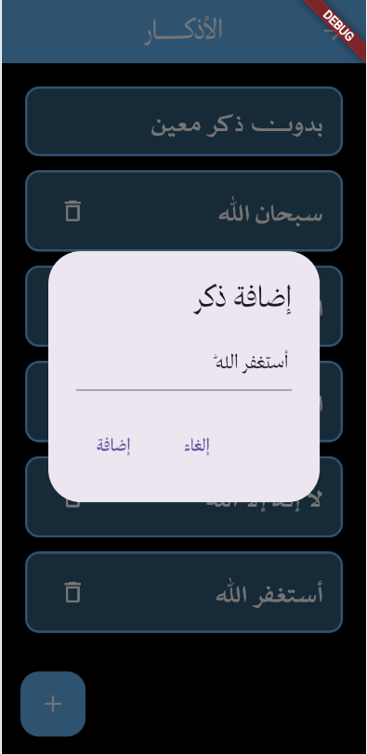 | 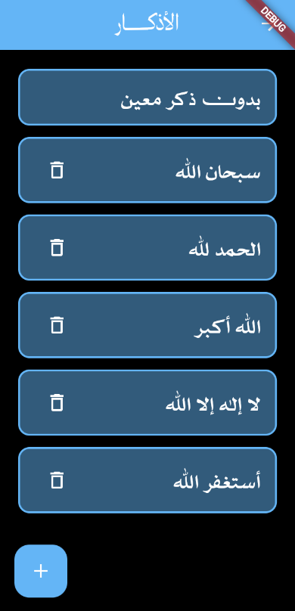
Changing items Color
Just for practice:
 | 

