Flutter Roadmap

Stage 04 – Git & GitHub

Prepared by:
Momen Mohammed Kraizem
Computer Engineering Graduate
20 July 2026

Practical Exercise 1
Create a New Repository
I created a new repository on GitHub called flutter-roadmap.
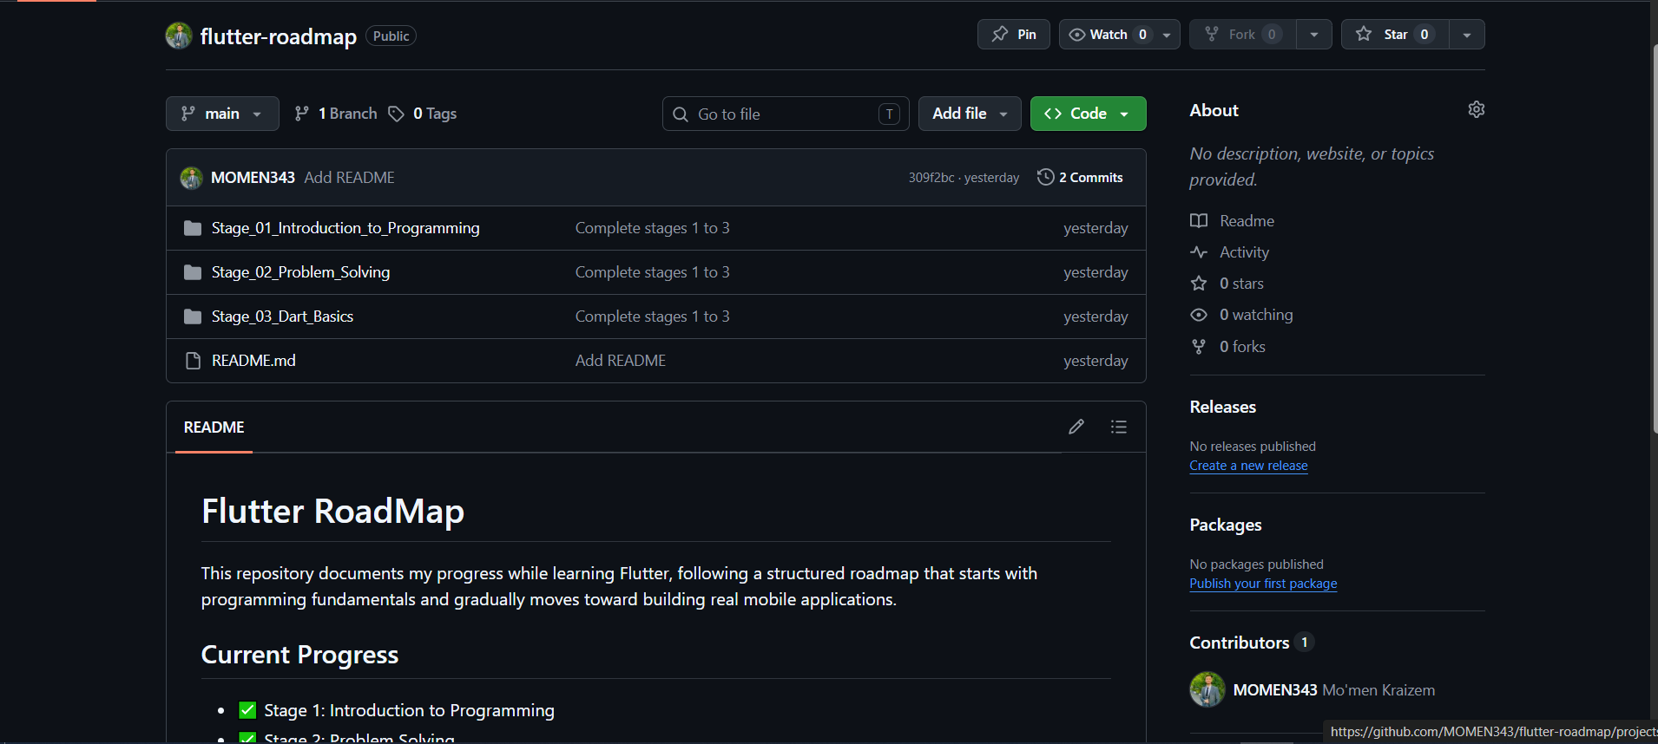
https://github.com/MOMEN343/flutter-roadmap

Practical Exercise 2
Push a Dart Project
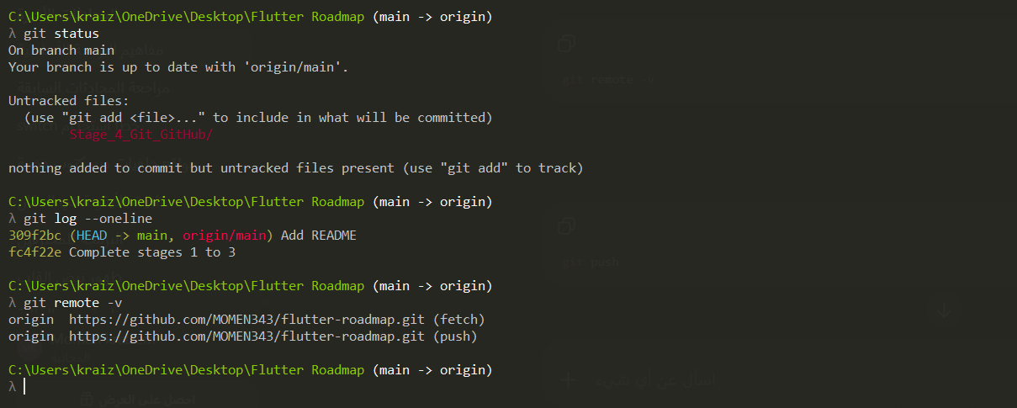

Updating repo with the new stage
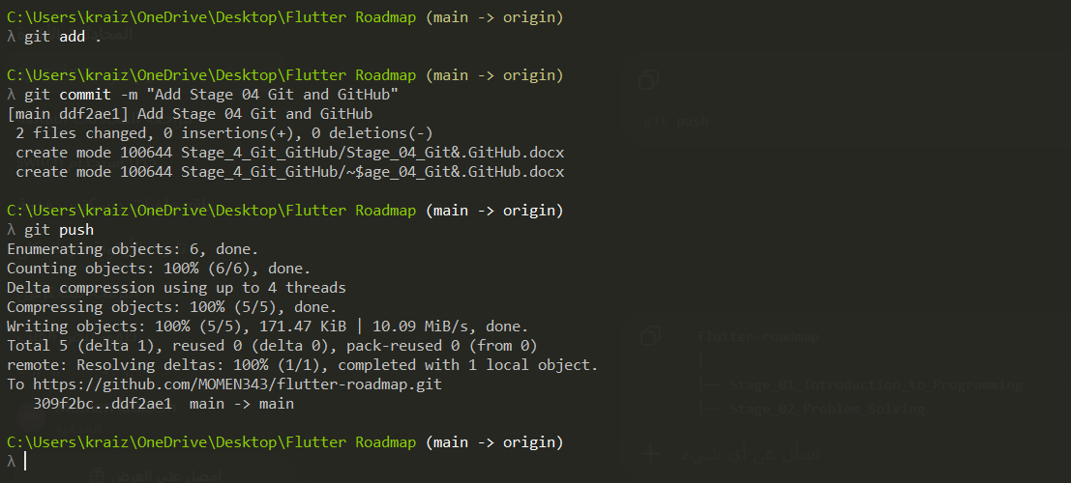

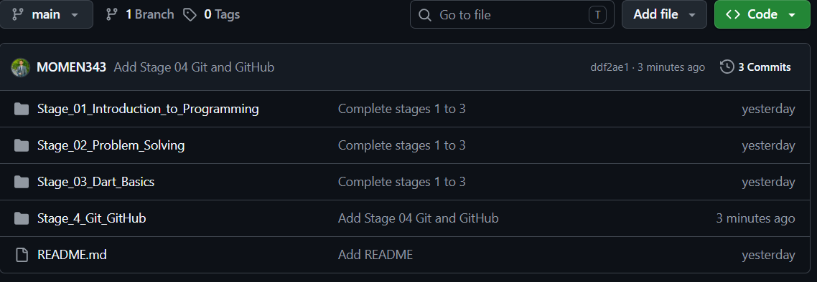

Practical Exercise 3
Adding Readme file
