Flutter Roadmap

Stage 05 – Introduction to Flutter

Prepared by:
Momen Mohammed Kraizem
Computer Engineering Graduate
27 July 2026

Practical Exercise 01
Running Hello Flutter
import 'package:flutter/material.dart';

void main() {
runApp(MyApp());
}

class MyApp extends StatelessWidget {
const MyApp({super.key});

@override
Widget build(BuildContext context) {
return MaterialApp(
home: Scaffold(body: Center(child: Text("Hello Flutter"))),
);
}
}

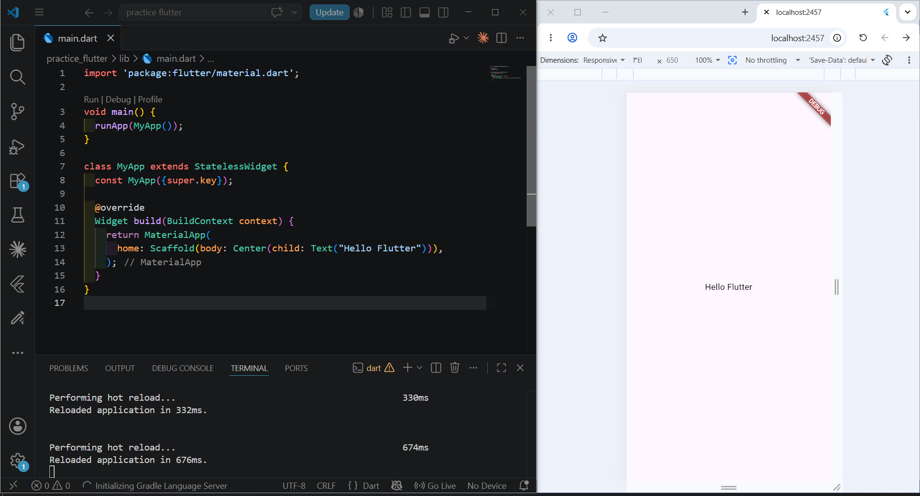

Practical Exercise 02
Editing the Text & Color
I made some more changes – here is the code:
import 'package:flutter/material.dart';

void main() {
runApp(MyApp());
}

class MyApp extends StatelessWidget {
const MyApp({super.key});

@override
Widget build(BuildContext context) {
return MaterialApp(
home: Scaffold(
appBar: AppBar(
title: Text("Hello Flutter", style: TextStyle(color: Colors.white)),
backgroundColor: Colors.deepPurple,
),
body: Center(
child: Text(
"Momen Kraizem",
style: TextStyle(
color: Colors.deepPurple,
fontSize: 25,
fontWeight: FontWeight.w600,
),
),
),
),
);
}
}

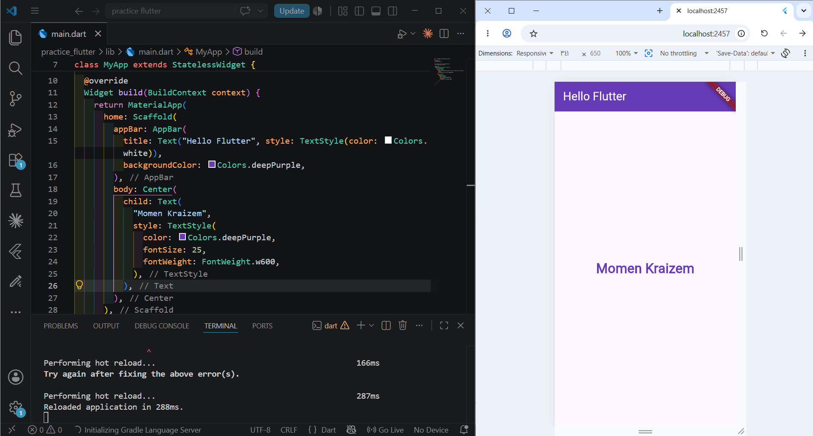

Practical Exercise 03
Trying Hot Reload
Hot Reload was already tested in the previous exercise.
