Flutter Roadmap

Stage 06 – Flutter Widgets Fundamentals

Prepared by:
Momen Mohammed Kraizem
Computer Engineering Graduate
20 July 2026

Profile Screen
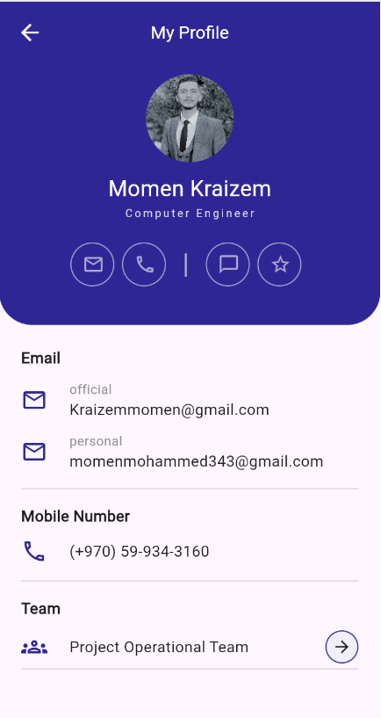

User Card
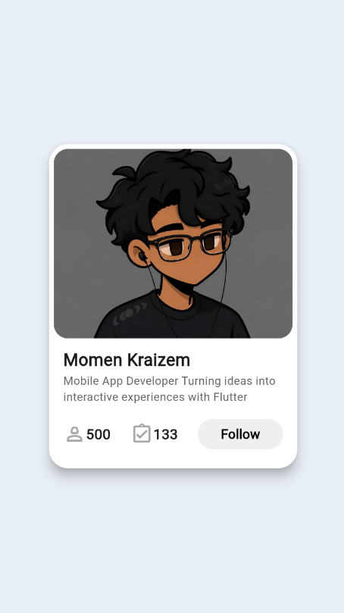

Settings Screen
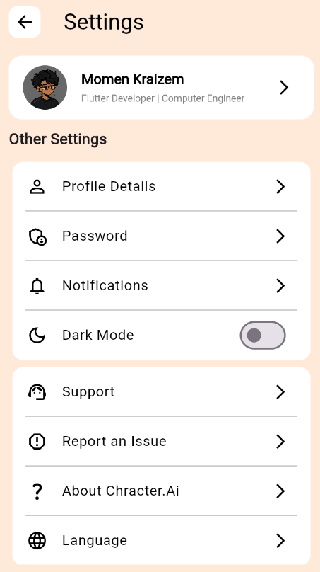

Setting Screen with dark mode
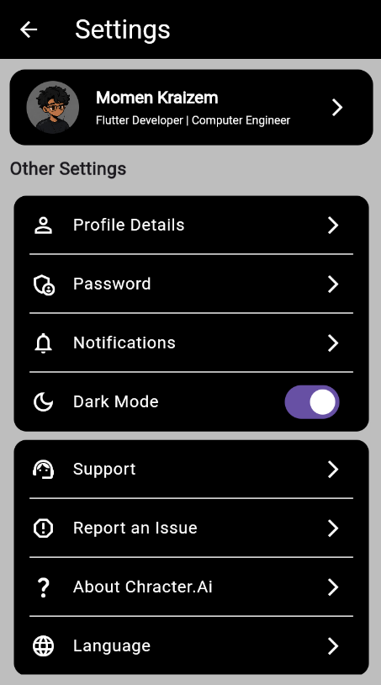

Image, Text & Button Screen
