Flutter Roadmap

Stage08_Navigation

Prepared by:
Momen Mohammed Kraizem
Computer Engineering Graduate
20 July 2026

Login Home Page
Now, the Login button, with simple validation using a constant email and password for now, navigates the user to the Home Page.
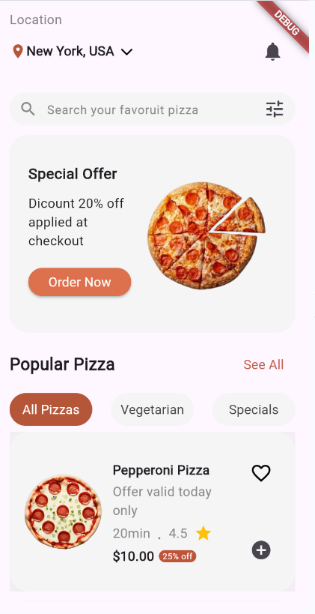 | 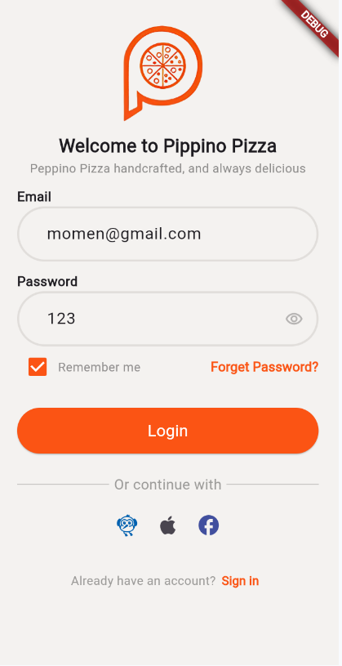

Product List Product Details
Now tapping the card navigates the user to product details screen
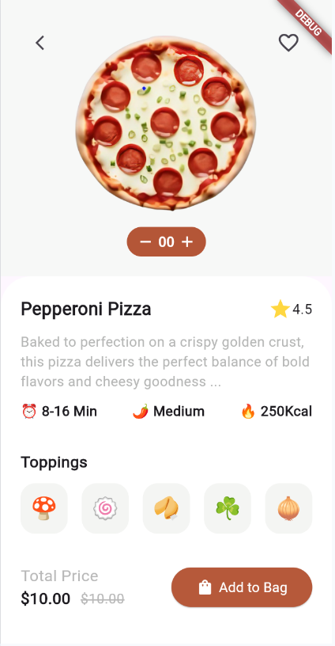

Three Tabs App
