Flutter Roadmap

Stage 04 – Git & GitHub

Prepared by:
Momen Mohammed Kraizem
Computer Engineering Graduate
20 July 2026

Practical Exercise 1
Create a New Repository
I created a new repository on GitHub called flutter-roadmap.
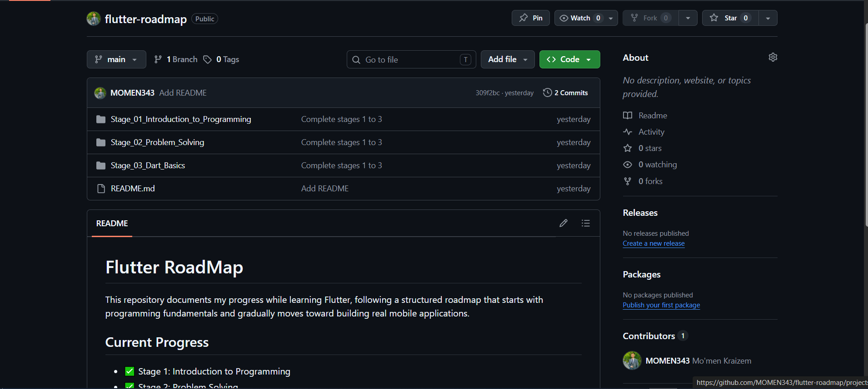
https://github.com/MOMEN343/flutter-roadmap

Practical Exercise 2
Push a Dart Project
The project locally:
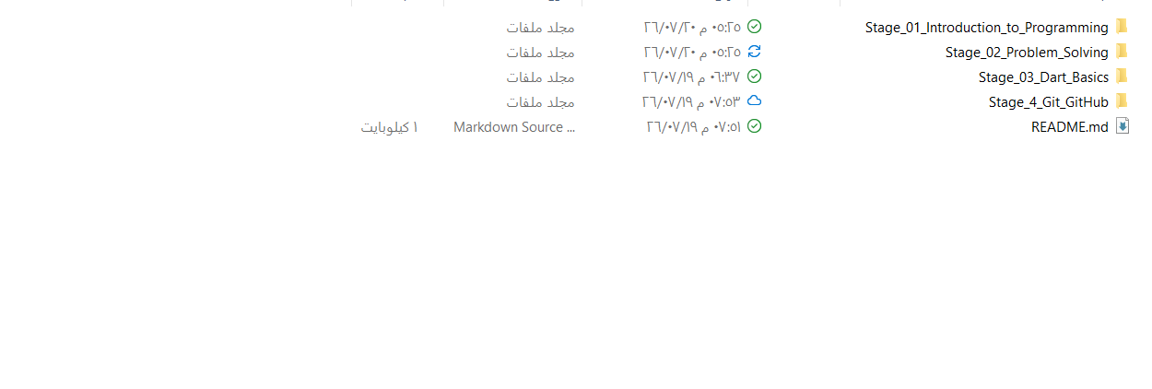
Pseudocode
BEGIN

INPUT length
INPUT width

area = length * width

OUTPUT area

END

Practical Exercise 3
Student Average
Problem:
Calculate the average of three student grades.
Input | process | Output
Grade 1, Grade 2, Grade 3 | Add the three grades and divide the result by 3 | Student average
Algorithm:
- Start.
- Read the first grade.
- Read the second grade.
- Read the third grade.
- Calculate the average.
- Display the average.
- End.
Pseudocode
BEGIN

INPUT grade1
INPUT grade2
INPUT grade3

average = (grade1 + grade2 + grade3) / 3

OUTPUT average

END

Practical Exercise 4
Largest of Two Numbers
Problem:
Determine the larger of two numbers.
Input | process | Output
First number, Second number | Compare the two numbers. | Largest number
Algorithm:
- Start.
- Read the first number.
- Read the second number.
- Compare the two numbers.
- Display the larger number.
- End.
Pseudocode
BEGIN

INPUT number1
INPUT number2

IF number1 > number2 THEN
OUTPUT number1
ELSE
OUTPUT number2
END IF

END

Practical Exercise 5
Celsius to Fahrenheit
Problem:
Convert a temperature from Celsius to Fahrenheit.
Input | process | Output
Temperature in Celsius | Convert Celsius to Fahrenheit using the conversion formula. | Temperature in Fahrenheit
Algorithm:
- Start.
- Read the temperature in Celsius.
- Convert the temperature to Fahrenheit.
- Display the Fahrenheit temperature.
- End.
Pseudocode
BEGIN

INPUT Celsius

Fahrenheit = (Celsius * 9 / 5) + 32

OUTPUT Fahrenheit

END

