Data Analytics Assignment-3

Super store Sales Dashboard:

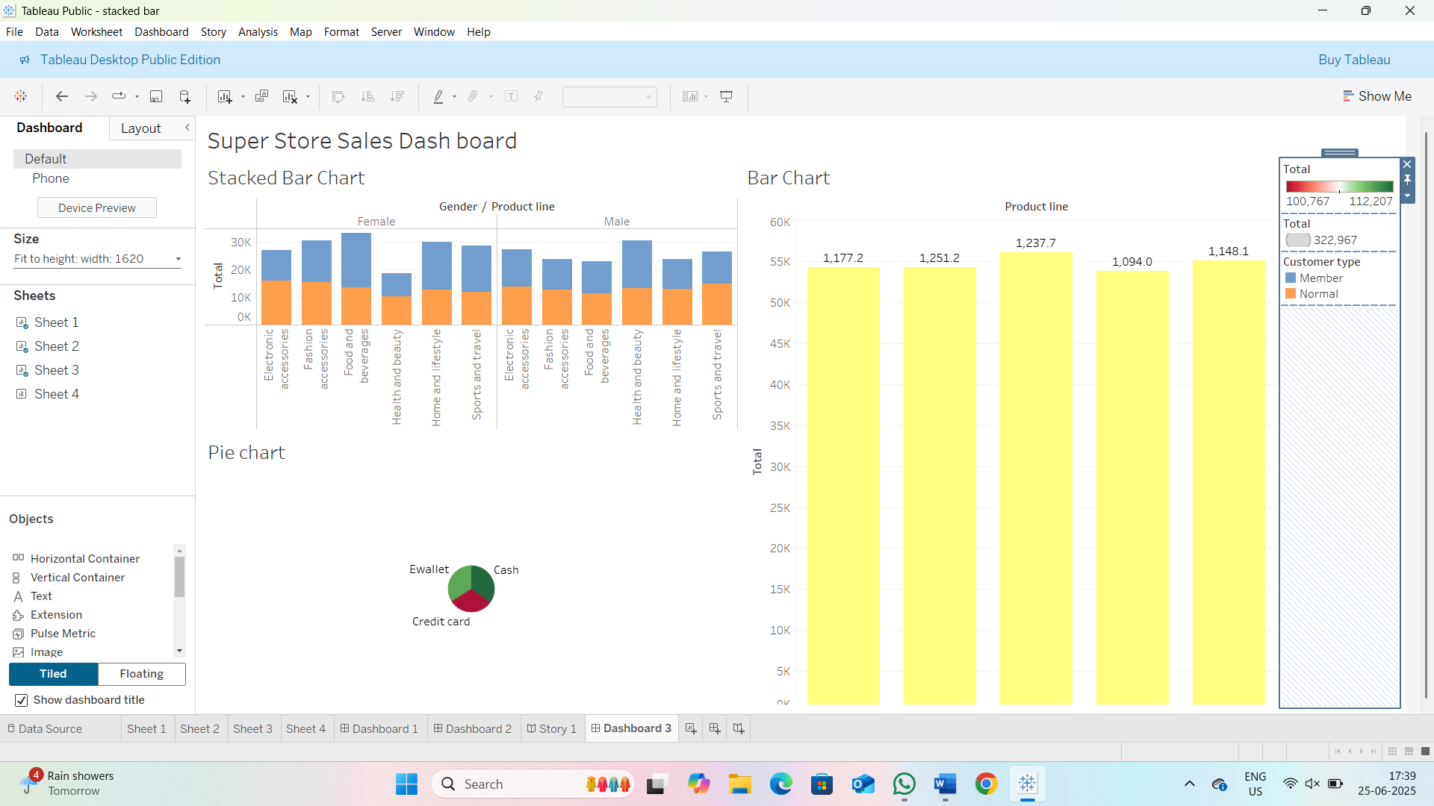

Super sales Profit Dash board:

