Data Analytics Assignment-1

Bar chart:

Pie Chart:

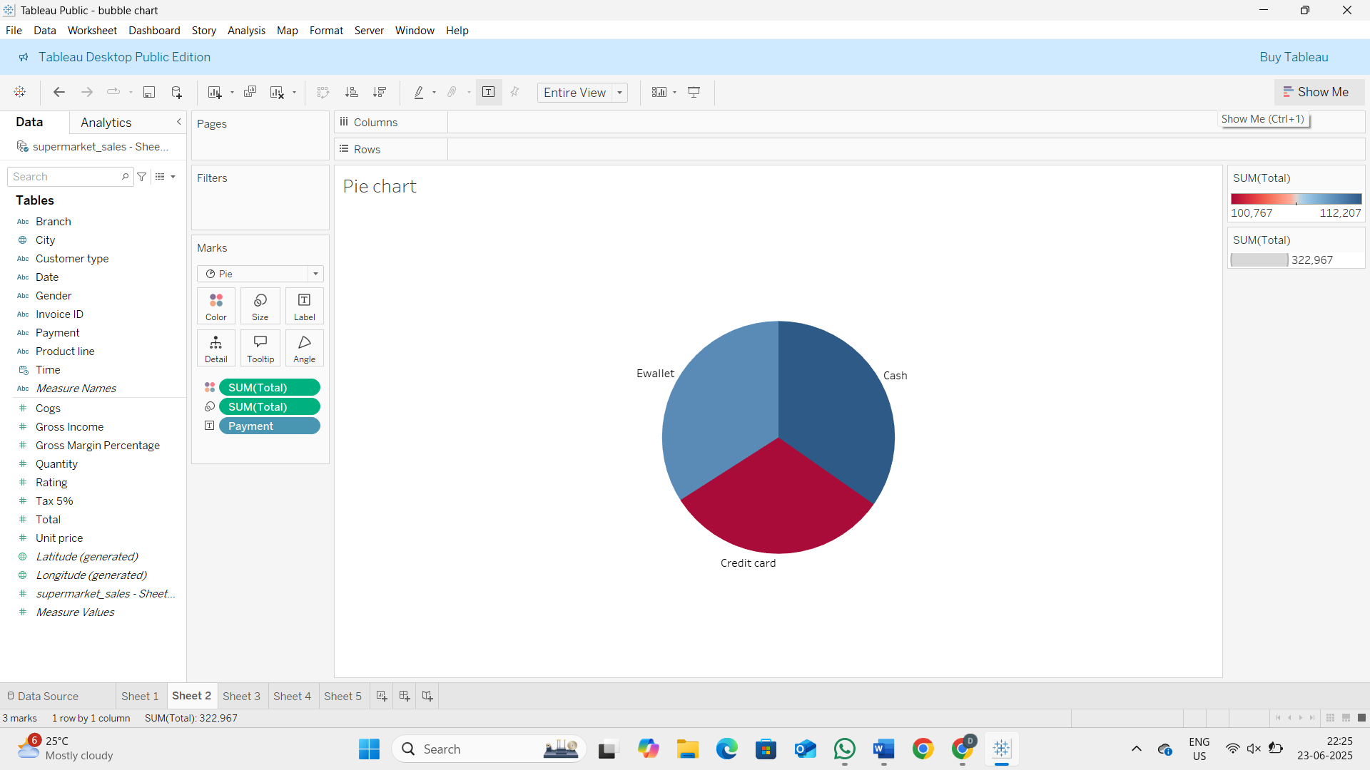

Stacked bar chart:

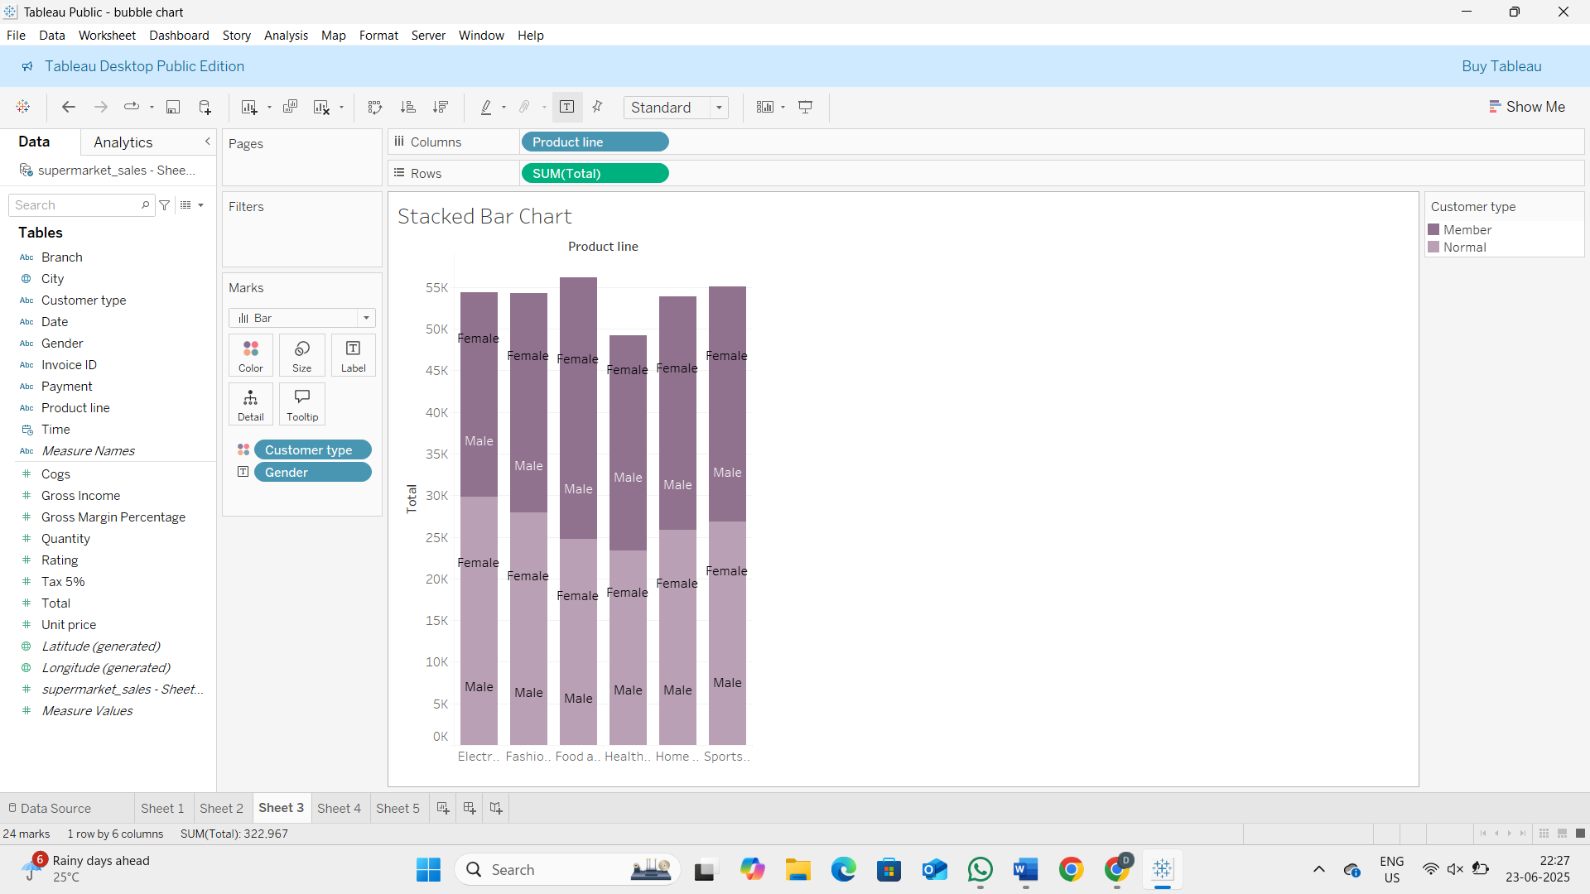

Line chart:

Bubble Chart:

