**Moneeb Toor 221048**

**Muhammad Kamran 221034**

**Devops**

**Assignment 2**

**Submitted to: Miss Warda Aslam**

**Web application site:**

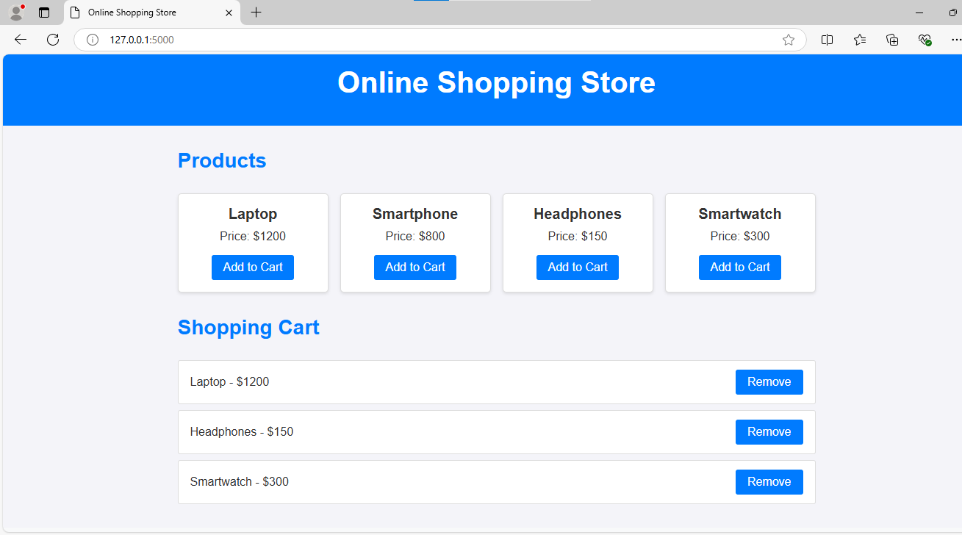

**Building Image:**

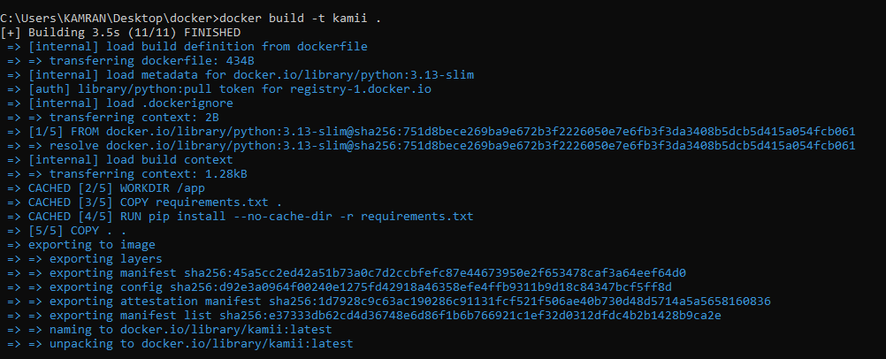

**Running container to access web application:**

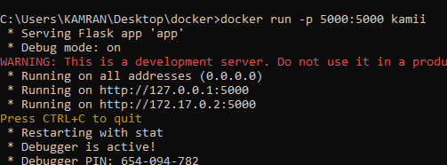

**Building compose:**

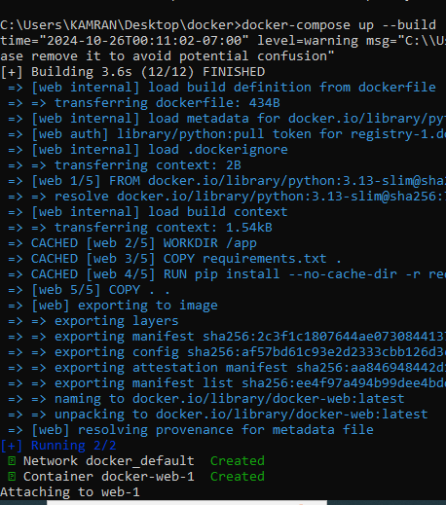

**Readme file:**

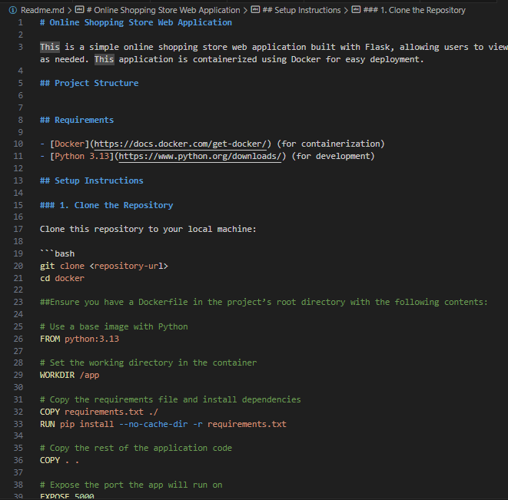

**Acessing through localhost:**

**Setting Dockerfile:**

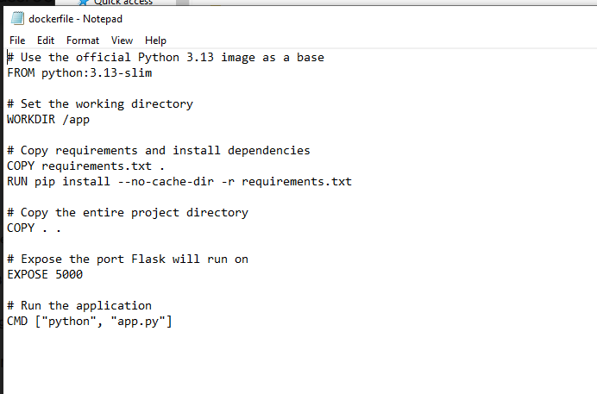

**Compose.yaml file:**

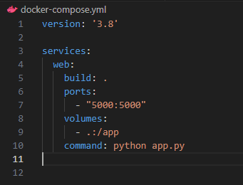

**Index.html:**

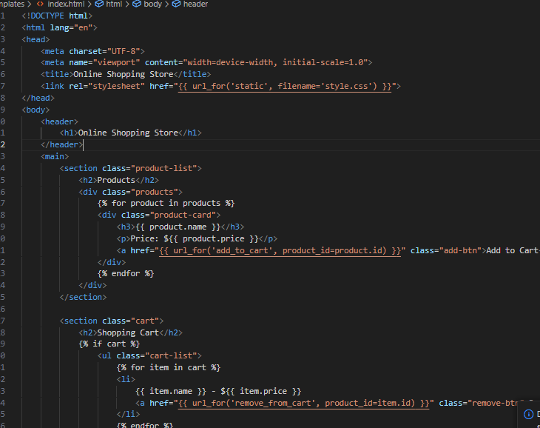

**Style.css:**

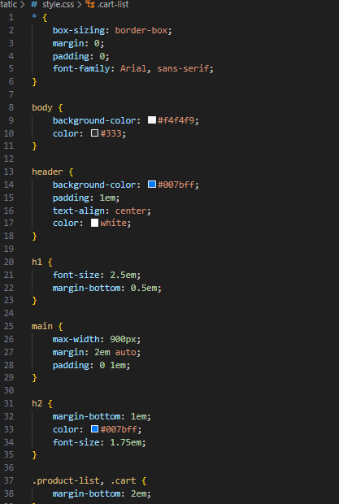

**Script.js:**

**App.py:**

