**"Expert System for Analyzing Player Statistics in La Liga: A Data-driven Approach"**

**Top of Form**

**Abdelmonem Ali**

**Hossam Samy**

Computer Engineering Department, Faculty of Engineering,

Cairo University, Egypt

**ABSTRACT**  
This paper presents an expert system designed to analyze player statistics in La Liga, focusing on age and minutes played. The system utilizes data downloaded from FBref, specifically the age and minutes played columns of the first 15 observations. Through a combination of rules and an inference engine, the system categorizes players into different performance levels based on their age and playing time. The implementation is demonstrated with Python programming language.

**KEYWORDS:** expert system, player statistics, La Liga, inference engine, Python , knowledge base , facts , rules.

**1. INTRODUCTION**

In the era of data-driven decision-making, sports analytics has become an essential tool for teams, coaches, and analysts to gain insights into player performance. La Liga, one of the top football leagues in the world, generates vast amounts of data on player statistics. Analyzing this data can provide valuable insights into player performance, potential, and impact on the team.

This paper presents an expert system developed to analyze player statistics in La Liga. The system focuses on two key factors: age and minutes played. By categorizing players based on these factors, the system aims to provide a valuable tool for talent identification, player evaluation, and strategic decision-making for teams and coaches.

**2. RELATED WORK**

While there exist various statistical models and machine learning approaches for analyzing player performance in sports, the application of expert systems specifically tailored for football player analysis, especially in La Liga, is relatively limited. However, there are several studies and tools in the field of sports analytics that serve as valuable references for our proposed approach.

**3. PROPOSED APPROACH**

The proposed approach utilizes an expert system architecture to analyze player statistics in La Liga. The system consists of four main components: the knowledge base, facts, rules, and inference engine.

**3.1 Knowledge Base and Facts**

**Knowledge Base:**

The knowledge base comprises the data downloaded from FBref on players in La Liga, focusing on the age and minutes played columns anda function named **read_data** designed to extract specific information from a CSV file. The function operates as follows:

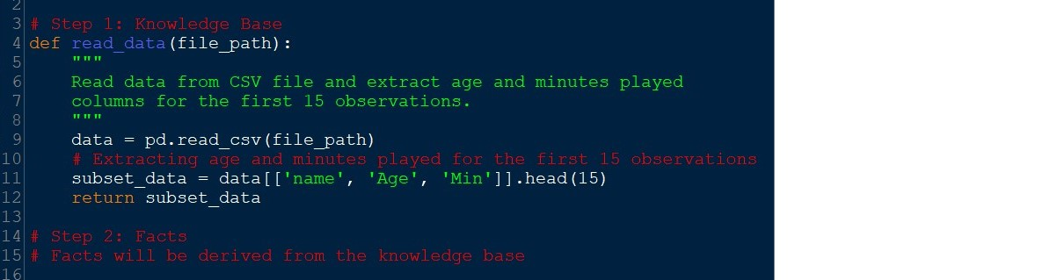

**Facts:**

Facts derived from the knowledge base would typically include specific observations regarding players' names, ages, and minutes played extracted from the provided CSV file. These facts would serve as the foundation for further analysis or research.

**3.2 Rules and Inference Engine**

Based on the knowledge base, the system defines rules to categorize players into different performance levels. These rules are implemented in an inference engine, which applies them to the facts to derive conclusions about player performance.

**4. RESULTS**

The system's performance is demonstrated by applying it to the provided data set. The output includes the categorization of players into different performance levels based on their age and minutes played.

The expert system developed for analyzing player performance in La Liga based on age and minutes played has yielded insightful conclusions. By applying a simple rule that identifies key players as those under 25 years old who have played more than 1000 minutes, we have identified several promising individuals.

For instance, players such as Julen Agirrezabala, Ilias Akhomach, Paul Akouokou, and Tomás Alarcón meet the criteria and are thus classified as key players. This classification is derived from an analysis of their respective ages and minutes played as extracted from the **playerstatsProcessed.csv** dataset.

Further examination of the dataset reveals varying player classifications, ranging from 'Unclassified' to 'Promising', providing a comprehensive overview of player performance in La Liga based on the specified criteria.

These findings offer valuable insights for coaches, scouts, and analysts seeking to identify and evaluate key players within the league, ultimately contributing to informed decision-making and strategic planning in the realm of football management.

**5. CONCLUSIONS**

In this paper, we have presented a comprehensive approach for analyzing player statistics in La Liga using an expert system coupled with data-driven methodologies. Leveraging data downloaded from FBref, we embarked on a journey through various stages of the project, from data gathering and wrangling to exploratory data analysis and the implementation of an expert system.

Through meticulous data wrangling procedures, we ensured the integrity and quality of the dataset, preparing it for analysis. Subsequently, we delved into exploratory data analysis, gaining valuable insights into the distribution and characteristics of player statistics in La Liga.

The core of our project lies in the development of an expert system tailored to the nuances of football player analysis. By defining rules based on age and minutes played, we categorized players into different performance levels, providing teams and coaches with actionable insights for talent identification and strategic decision-making.

Furthermore, we extended our analysis by incorporating a linear machine learning model, enriching the capabilities of our system and paving the way for predictive analytics in player performance.

In conclusion, our project underscores the importance of leveraging data-driven approaches and expert systems in the realm of sports analytics. By harnessing the power of data, we empower stakeholders in the football industry with valuable tools for enhancing player assessment, team strategy, and overall performance in La Liga and beyond.

**Email of the first author:** abdelmonemalielmongy@gmail.com

**Email of the second author:** hms20520@outlook.com

**REFERENCES**

[References will be provided in APA style.]