**Steps :**

1. **Payload Detection ( Steganalysis)**
2. **Payload Extraction**
3. **Payload Classification**
4. **Payload Detection ( Steganalysis)**

**Spam:**

**Code:**

function F = spam686(IMG)

F = spam_extract_2(double(imread('output1.png')),3);

function F = spam_extract_2(X,T)

% horizontal left-right

D = X(:,1:end-1) - X(:,2:end);

L = D(:,3:end); C = D(:,2:end-1); R = D(:,1:end-2);

Mh1 = GetM3(L,C,R,T);

% horizontal right-left

D = -D;

L = D(:,1:end-2); C = D(:,2:end-1); R = D(:,3:end);

Mh2 = GetM3(L,C,R,T);

% vertical bottom top

D = X(1:end-1,:) - X(2:end,:);

L = D(3:end,:); C = D(2:end-1,:); R = D(1:end-2,:);

Mv1 = GetM3(L,C,R,T);

% vertical top bottom

D = -D;

L = D(1:end-2,:); C = D(2:end-1,:); R = D(3:end,:);

Mv2 = GetM3(L,C,R,T);

% diagonal left-right

D = X(1:end-1,1:end-1) - X(2:end,2:end);

L = D(3:end,3:end); C = D(2:end-1,2:end-1); R = D(1:end-2,1:end-2);

Md1 = GetM3(L,C,R,T);

% diagonal right-left

D = -D;

L = D(1:end-2,1:end-2); C = D(2:end-1,2:end-1); R = D(3:end,3:end);

Md2 = GetM3(L,C,R,T);

% minor diagonal left-right

D = X(2:end,1:end-1) - X(1:end-1,2:end);

L = D(1:end-2,3:end); C = D(2:end-1,2:end-1); R = D(3:end,1:end-2);

Mm1 = GetM3(L,C,R,T);

% minor diagonal right-left

D = -D;

L = D(3:end,1:end-2); C = D(2:end-1,2:end-1); R = D(1:end-2,3:end);

Mm2 = GetM3(L,C,R,T);

F1 = (Mh1+Mh2+Mv1+Mv2)/4;

F2 = (Md1+Md2+Mm1+Mm2)/4;

F = [F1;F2];

function M = GetM3(L,C,R,T)

% marginalization into borders

L = L(:); L(L<-T) = -T; L(L>T) = T;

C = C(:); C(C<-T) = -T; C(C>T) = T;

R = R(:); R(R<-T) = -T; R(R>T) = T;

% get cooccurences [-T...T]

M = zeros(2*T+1,2*T+1,2*T+1);

for i=-T:T

C2 = C(L==i);

R2 = R(L==i);

for j=-T:T

R3 = R2(C2==j);

for k=-T:T

M(i+T+1,j+T+1,k+T+1) = sum(R3==k);

end

end

end

% normalization

M = M(:)/sum(M(:));

A = imread('output1.png');

imshow(A);

Code snap: //matlab

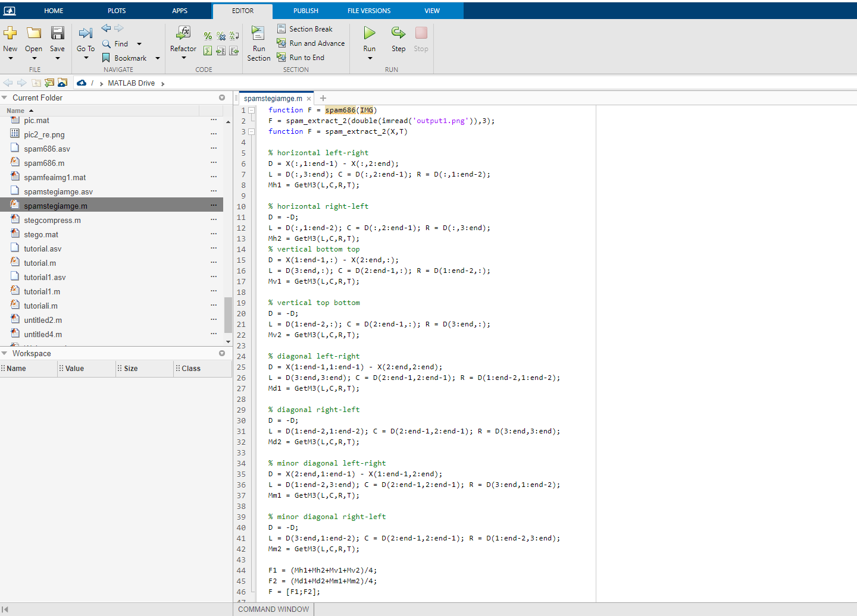

**Output snap:**

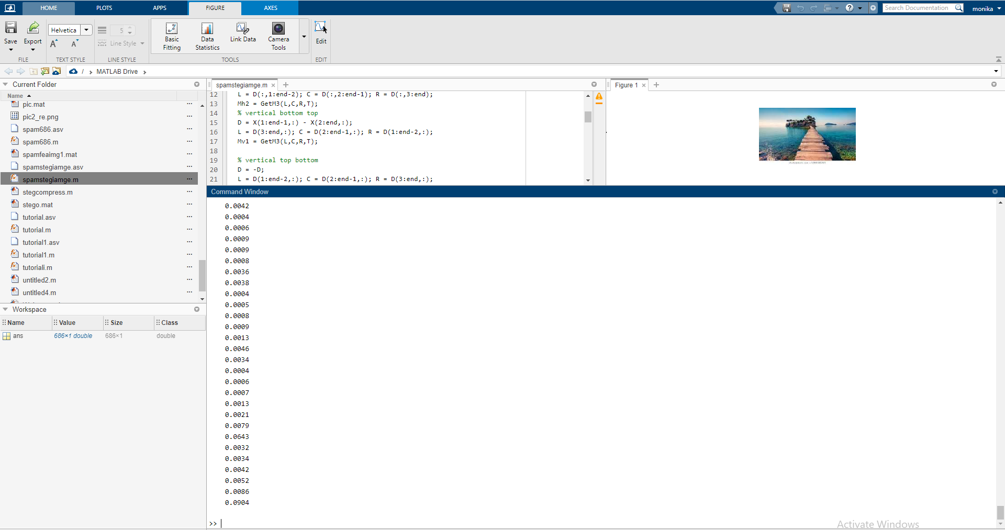

**Ant Colony:**

mport pandas as pd

import numpy as np

from numpy import inf

 import matplotlib.pyplot as plt

from sklearn.ensemble import ExtraTreesClassifier

#given values for the problems

# Loading the data

df = pd.read_csv('stegotest.csv')

iteration = 100

n_ants = 5

n_citys = 5

# intialization part

m = n_ants

n = n_citys

e = .5         #evaporation rate

alpha = 1     #pheromone factor

beta = 2       #visibility factor

#calculating the visibility of the next city visibility(i,j)=1/d(i,j)

visibility = 1/d

visibility[visibility == inf ] = 0

#intializing pheromne present at the paths to the cities

pheromne = .1*np.ones((m,n))

#intializing the rute of the ants with size rute(n_ants,n_citys+1)

#note adding 1 because we want to come back to the source city

rute = np.ones((m,n+1))

for ite in range(iteration):

    rute[:,0] = 1          #initial starting and ending positon of every ants '1' i.e city '1'

    for i in range(m):

        temp_visibility = np.array(visibility)         #creating a copy of visibility

        for j in range(n-1):

            #print(rute)

            combine_feature = np.zeros(5)     #intializing combine_feature array to zero

            cum_prob = np.zeros(5)            #intializing cummulative probability array to zeros

            cur_loc = int(rute[i,j]-1)        #current city of the ant

            temp_visibility[:,cur_loc] = 0     #making visibility of the current city as zero

            p_feature = np.power(pheromne[cur_loc,:],beta)         #calculating pheromne feature

            v_feature = np.power(temp_visibility[cur_loc,:],alpha)  #calculating visibility feature

            p_feature = p_feature[:,np.newaxis]                     #adding axis to make a size[5,1]

            v_feature = v_feature[:,np.newaxis]                     #adding axis to make a size[5,1]

                         combine_feature = np.multiply(p_feature,v_feature)     #calculating the combine feature

            total = np.sum(combine_feature)                        #sum of all the feature

                         probs = combine_feature/total   #finding probability of element probs(i) = comine_feature(i)/total

                         cum_prob = np.cumsum(probs)     #calculating cummulative sum

            #print(cum_prob)

            r = np.random.random_sample()   #randon no in [0,1)

            #print(r)

            city = np.nonzero(cum_prob>r)[0][0]+1       #finding the next city having probability higher then random(r)

            #print(city)

                         rute[i,j+1] = city              #adding city to route

        left = list(set([i for i in range(1,n+1)])-set(rute[i,:-2]))[0]     #finding the last untraversed city to route

                 rute[i,-2] = left                   #adding untraversed city to route

            rute_opt = np.array(rute)               #intializing optimal route

         dist_cost = np.zeros((m,1))             #intializing total_distance_of_tour with zero

         for i in range(m):

                 s = 0

        for j in range(n-1):

                         s = s + d[int(rute_opt[i,j])-1,int(rute_opt[i,j+1])-1]   #calcualting total tour distance

                 dist_cost[i]=s                      #storing distance of tour for 'i'th ant at location 'i'

            dist_min_loc = np.argmin(dist_cost)             #finding location of minimum of dist_cost

    dist_min_cost = dist_cost[dist_min_loc]         #finging min of dist_cost

    best_route = rute[dist_min_loc,:]               #intializing current traversed as best route

    pheromne = (1-e)*pheromne                       #evaporation of pheromne with (1-e)

    for i in range(m):

        for j in range(n-1):

            dt = 1/dist_cost[i]

            pheromne[int(rute_opt[i,j])-1,int(rute_opt[i,j+1])-1] = pheromne[int(rute_opt[i,j])-1,int(rute_opt[i,j+1])-1] + dt

            #updating the pheromne with delta_distance

            #delta_distance will be more with min_dist i.e adding more weight to that route  peromne

  print('route of all the ants at the end :')

# Loading the data

df = pd.read_csv('malware.csv')

  # Seperating the dependent and independent variables

y = df['Class']

X = df.drop('Class', axis = 1)

  X.head()

# Building the model

extra_tree_forest = ExtraTreesClassifier(n_estimators = 5,criterion ='entropy', max_features = 2)

  # Training the model

extra_tree_forest.fit(X, y)

  # Computing the importance of each feature

feature_importance = extra_tree_forest.feature_importances_

  # Normalizing the individual importances

feature_importance_normalized = np.std([tree.feature_importances_ for tree in extra_tree_forest.estimators_],axis = 0)

# Plotting a Bar Graph to compare the models

plt.bar(X.columns, feature_importance_normalized)

plt.xlabel('Feature Labels')

plt.ylabel('Feature Importances')

plt.title('Comparison of different Feature Importances')

plt.show()

**Output snaps:**

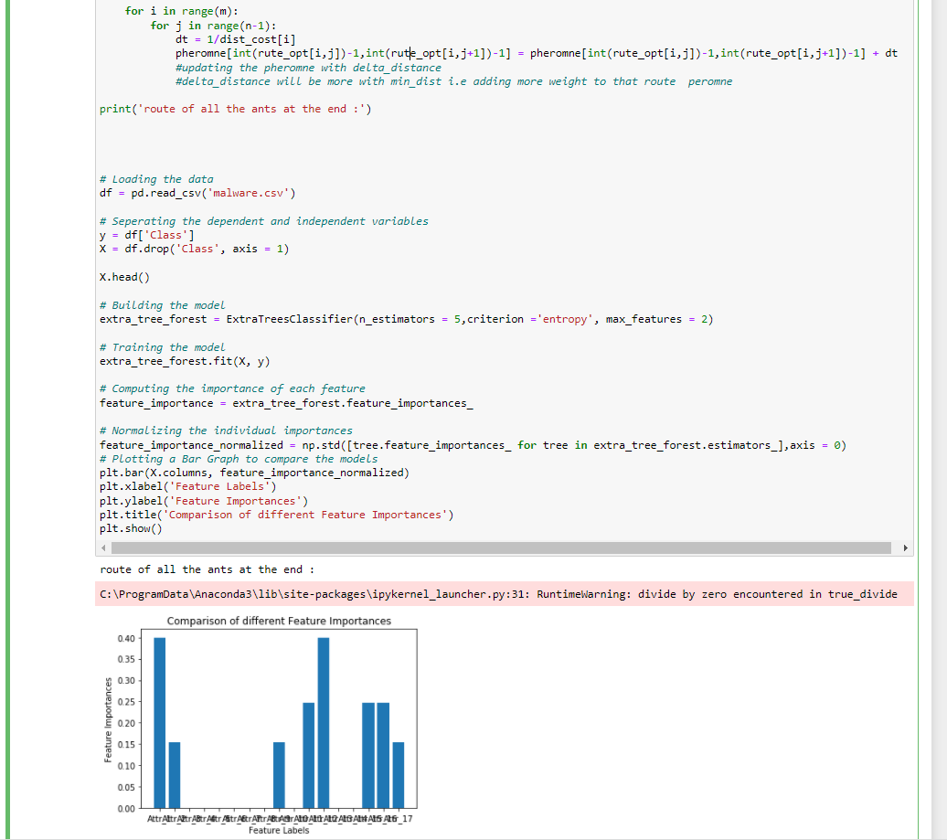

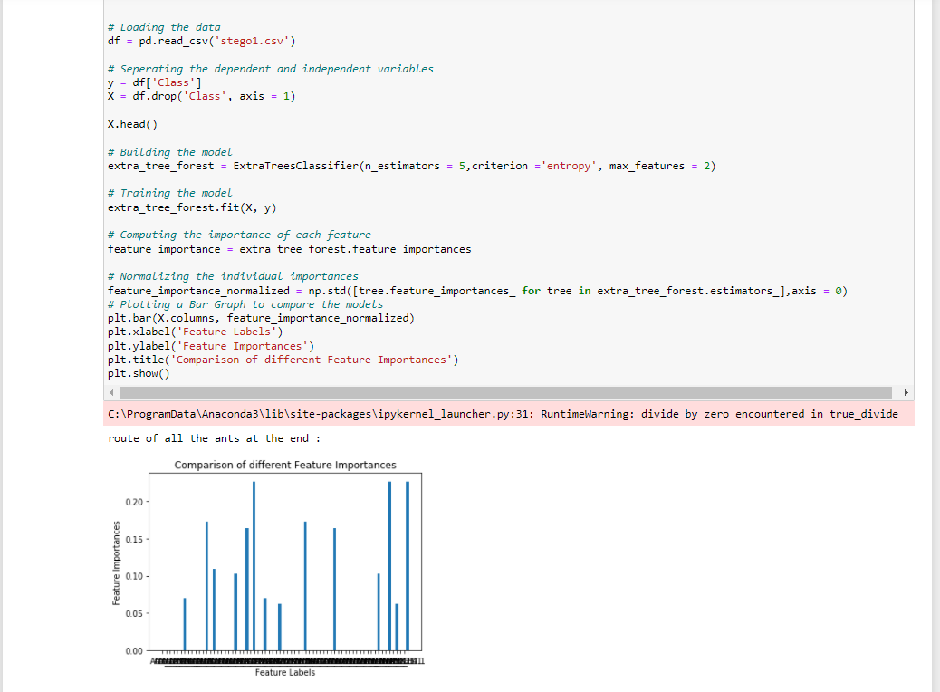



**Decision Tree:**

**Code:**

import pandas as pd

from sklearn.tree import DecisionTreeClassifier

from sklearn.tree import DecisionTreeRegressor

#loading my train dataset into python

 train = pd.read_csv('stegotraingod.csv')

test = pd.read_csv('stego1.csv')

 #factors that will predict the price

desired_factors = ['Attr_1','Attr_2','Attr_3','Attr_4','Attr_5','Attr_6','Attr_7','Attr_8','Attr_9','Attr_10','Attr_11','Attr_12','Attr_13','Attr_14','Attr_15','Attr_16','Attr_17','Attr_18','Attr_19','Attr_20','Attr_21','Attr_22','Attr_23','Attr_24','Attr_25','Attr_26','Attr_27','Attr_28','Attr_29','Attr_30','Attr_31','Attr_32','Attr_33','Attr_34','Attr_35','Attr_36','Attr_37','Attr_38','Attr_39','Attr_40','Attr_41','Attr_42','Attr_43','Attr_44','Attr_45','Attr_46','Attr_47','Attr_48','Attr_49','Attr_50','Attr_51','Attr_52','Attr_53','Attr_54','Attr_55', 'Attr_56','Attr_57','Attr_58','Attr_59','Attr_60','Attr_61','Attr_62','Attr_63','Attr_64', 'Attr_65','Attr_66','Attr67,'Attr_68','Attr_69',''Class']

  #set my model to DecisionTree

model = DecisionTreeRegressor()

 #set prediction data to factors that will predict, and set target to SalePrice

train_data = train[desired_factors]

test_data = test[desired_factors]

target = train.Class

  #fitting model with prediction data and telling it my target

model.fit(train_data, target)

  model.predict(test_data.head())

**Output snaps:**

**Training:**

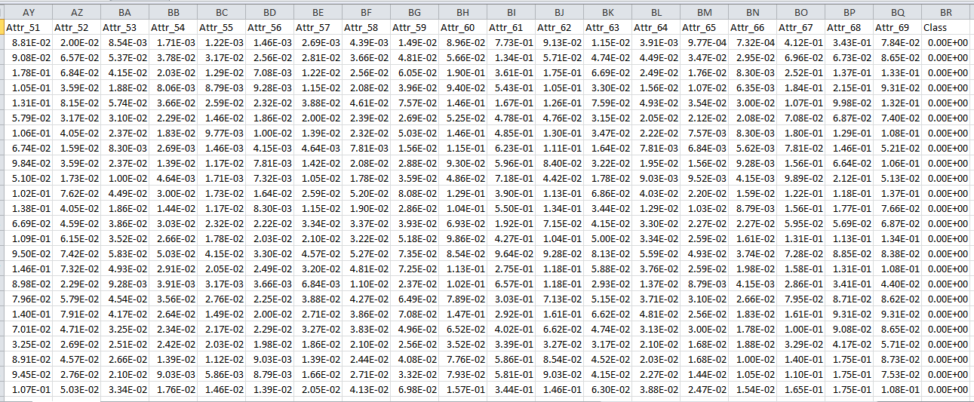

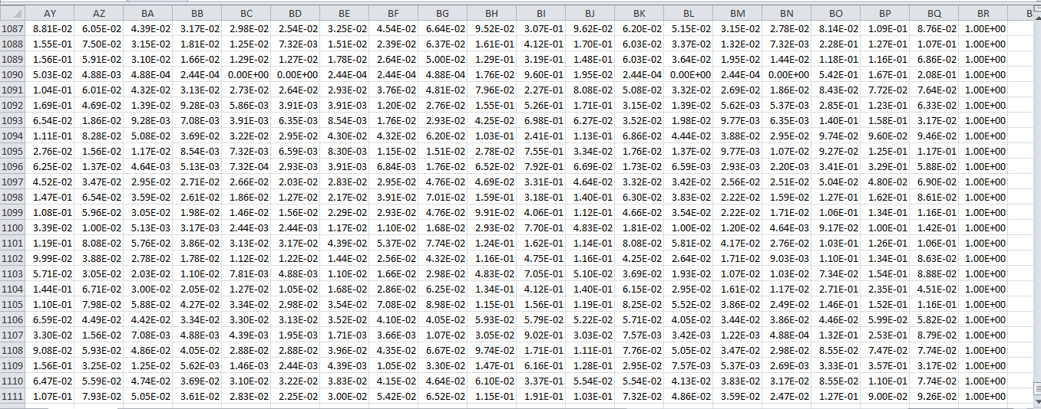

**Testing**

**Input snap**

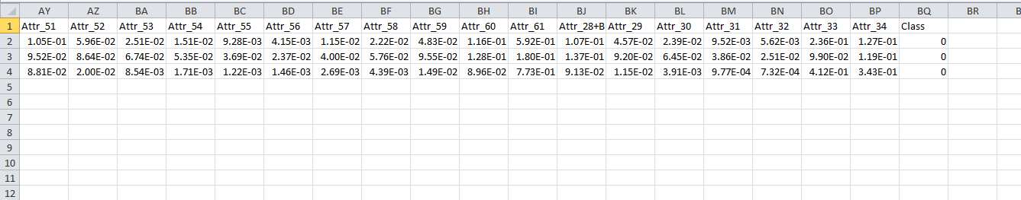

**Output snap**

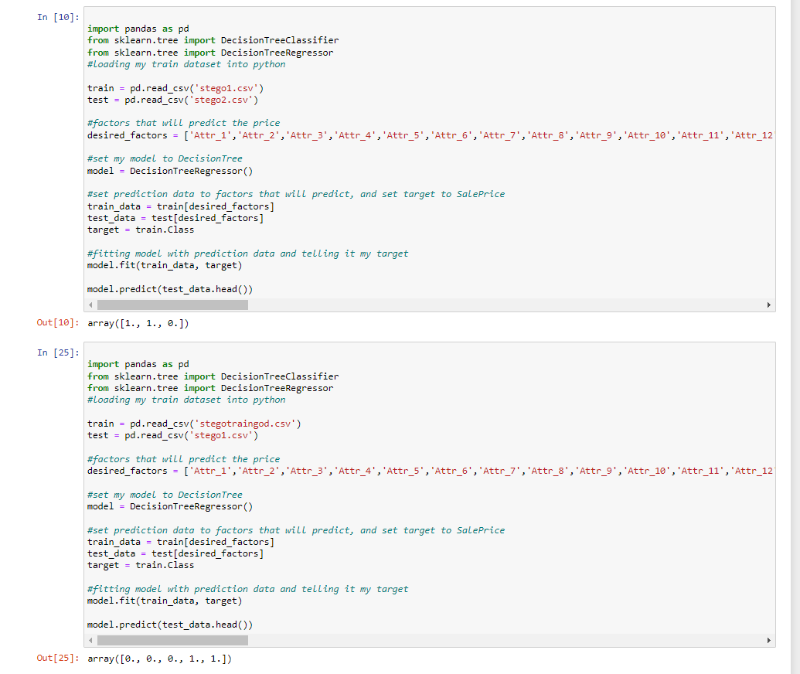

1. **Payload Extraction**

**Model 1:**

# Python program implementing Image Steganography

# PIL module is used to extract

# pixels of image and modify it

from PIL import Image

# Convert encoding data into 8-bit binary

# form using ASCII value of characters

def genData(data):

# list of binary codes

# of given data

newd = []

for i in data:

newd.append(format(ord(i), '08b'))

return newd

# Pixels are modified according to the

# 8-bit binary data and finally returned

def modPix(pix, data):

datalist = genData(data)

lendata = len(datalist)

imdata = iter(pix)

for i in range(lendata):

# Extracting 3 pixels at a time

pix = [value for value in imdata.__next__()[:3] +

imdata.__next__()[:3] +

imdata.__next__()[:3]]

# Pixel value should be made

# odd for 1 and even for 0

for j in range(0, 8):

if (datalist[i][j]=='0') and (pix[j]% 2 != 0):

if (pix[j]% 2 != 0):

pix[j] -= 1

elif (datalist[i][j] == '1') and (pix[j] % 2 == 0):

pix[j] -= 1

# Eigh^th pixel of every set tells

# whether to stop ot read further.

# 0 means keep reading; 1 means the

# message is over.

if (i == lendata - 1):

if (pix[-1] % 2 == 0):

pix[-1] -= 1

else:

if (pix[-1] % 2 != 0):

pix[-1] -= 1

pix = tuple(pix)

yield pix[0:3]

yield pix[3:6]

yield pix[6:9]

def encode_enc(newimg, data):

w = newimg.size[0]

(x, y) = (0, 0)

for pixel in modPix(newimg.getdata(), data):

# Putting modified pixels in the new image

newimg.putpixel((x, y), pixel)

if (x == w - 1):

x = 0

y += 1

else:

x += 1

# Encode data into image

def encode():

img = input("Enter image name(with extension): ")

image = Image.open(img, 'r')

print("\n\nIMAGE IS READ SUCESSFULLY !!!!!!!!!!PIXEL VALUE OF GIVEN IMAGE IS DISPLAYED AS FOLLOWSS!!!!!")

print(image.histogram())

data = input("Enter data to be encoded : ")

if (len(data) == 0):

raise ValueError('Data is empty')

newimg = image.copy()

encode_enc(newimg, data)

new_img_name = input("Enter the name of new image(with extension): ")

newimg.save(new_img_name, str(new_img_name.split(".")[1].upper()))

print("\n\nGIVEN MESSAGE IS SUCCESSFULLY HIDED INSIDE THE IMAGE !!!!!!!!!!!IMAGE PIXELS AFTER ENCRYPTION IS DISPALYED BELOW!!!!!!NOTIFY CHANGES")

print(newimg.histogram())

**# Decode the data in the image**

**def decode():**

**img = input("Enter image name(with extension) :")**

**image = Image.open(img, 'r')**

**data = ''**

**imgdata = iter(image.getdata())**

**while (True):**

**pixels = [value for value in imgdata.__next__()[:3] +**

**imgdata.__next__()[:3] +**

**imgdata.__next__()[:3]]**

**# string of binary data**

**binstr = ''**

**for i in pixels[:8]:**

**if (i % 2 == 0):**

**binstr += '0'**

**else:**

**binstr += '1'**

**data += chr(int(binstr, 2))**

**if (pixels[-1] % 2 != 0):**

**return data**

# Main Function

def main():

a = int(input(":: Welcome to Steganography ::\n" "1. Encode\n 2. Decode\n"))

if (a == 1):

encode()

elif (a == 2):

print("Decoded word- " + decode())

else:

raise Exception("Enter correct input")

# Driver Code

if __name__ == '__main__' :

# Calling main function

main()

**Model 2:**

**## ENCODING FILES**

out = open("C:/Users/MONIKA/Desktop/wrok 1 imp/malimage.png", "wb")

out.write(open("C:/Users/MONIKA/Desktop/wrok 1 imp/in.png", "rb").read())

out.write(open("C:/Users/MONIKA/Desktop/wrok 1 imp/mcpatcher.exe.zip", "rb").read())

out.close()

**###DECODING FILES**

## KALI LINUX

## i - input

## o - output

cd Desktop

foremost -t rar -i imagename.extention -o foldername for output

1. **Payload Classification**

**Binary Classifier BC Code:**

**Model 1:**

{

"cells": [

{

"cell_type": "code",

"execution_count": 8,

"id": "spectacular-jacob",

"metadata": {},

"outputs": [],

"source": [

"import torch\n",

"from utils import set_seed\n",

"import os\n",

"import pickle\n",

"from sklearn.model_selection import train_test_split\n",

"from torch.utils.data import DataLoader, Dataset, Subset\n",

"from torch import nn\n",

"from torch.nn import functional as F\n",

"import random\n",

"import matplotlib.pyplot as plt\n",

"import numpy as np\n",

"import pandas as pd\n",

"import seaborn as sns\n",

"from sklearn.metrics import auc, confusion_matrix, roc_curve\n",

"from torch import optim\n",

"from torch.nn.functional import sigmoid\n",

"from tqdm.auto import tqdm\n",

"from sklearn import metrics\n",

"\n",

"plt.rcParams.update(plt.rcParamsDefault)\n",

"set_seed(42)\n",

"device = torch.device(\"cpu\")\n",

"\n",

"import warnings\n",

"warnings.filterwarnings('ignore')"

]

},

{

"cell_type": "markdown",

"id": "premier-snowboard",

"metadata": {},

"source": [

"## Dataset"

]

},

{

"cell_type": "code",

"execution_count": 9,

"id": "mental-failure",

"metadata": {},

"outputs": [],

"source": [

"class MalwareDataset(Dataset):\n",

" def __init__(self, benign_dir=\"data/benign\", malware_dir=\"data/malware\"):\n",

" self.benign_dir = benign_dir\n",

" self.malware_dir = malware_dir\n",

" self.benign_files = sorted(os.listdir(benign_dir))\n",

" self.malware_files = sorted(os.listdir(malware_dir))\n",

"\n",

" def __getitem__(self, index):\n",

" try:\n",

" file_dir = os.path.join(self.benign_dir, self.benign_files[index])\n",

" label = 0.0\n",

" except IndexError:\n",

" file_dir = os.path.join(\n",

" self.malware_dir, self.malware_files[index - len(self.benign_files)],\n",

" )\n",

" label = 1.0\n",

"\n",

" with open(file_dir, \"rb\") as f:\n",

" file_ = torch.tensor(pickle.load(f))\n",

" return file_, label\n",

"\n",

" def __len__(self):\n",

" return len(self.benign_files) + len(self.malware_files)\n",

"\n",

"class UniLabelDataset(Dataset):\n",

" def __init__(self, data_dir, is_malware):\n",

" self.data_dir = data_dir\n",

" self.is_malware = is_malware\n",

" self.files = sorted(os.listdir(data_dir))\n",

"\n",

" def __getitem__(self, index):\n",

" file_dir = os.path.join(self.data_dir, self.files[index])\n",

" with open(file_dir, \"rb\") as f:\n",

" file_ = torch.tensor(pickle.load(f))\n",

" return file_, float(self.is_malware)\n",

"\n",

" def __len__(self):\n",

" return len(self.files)\n",

"\n",

"\n",

"def collate_fn(batch):\n",

" xs = pad_sequence([x[0] for x in batch], max_len=4096, padding_value=256)\n",

" ys = torch.tensor([x[1] for x in batch])\n",

" return xs, ys\n",

"\n",

"\n",

"def pad_sequence(sequences, max_len=None, padding_value=0):\n",

" batch_size = len(sequences)\n",

" if max_len is None:\n",

" max_len = max([s.size(0) for s in sequences])\n",

" out_tensor = sequences[0].new_full((batch_size, max_len), padding_value)\n",

" for i, tensor in enumerate(sequences):\n",

" length = tensor.size(0)\n",

" if max_len > length:\n",

" out_tensor[i, :length] = tensor\n",

" else:\n",

" out_tensor[i, :max_len] = tensor[:max_len]\n",

" return out_tensor\n",

"\n",

"\n",

"def train_val_test_split(idx, val_size, test_size):\n",

" tv_idx, test_idx = train_test_split(idx, test_size=test_size, shuffle=True)\n",

" train_idx, val_idx = train_test_split(tv_idx, test_size=val_size, shuffle=True)\n",

" return train_idx, val_idx, test_idx\n",

"\n",

"\n",

"def make_idx(dataset, val_size, test_size):\n",

" num_benign = len(dataset.benign_files)\n",

" num_malware = len(dataset.malware_files)\n",

" benign_idx = range(num_benign)\n",

" malware_idx = range(num_benign, num_benign + num_malware)\n",

" benign_train_idx, benign_val_idx, benign_test_idx = train_val_test_split(\n",

" benign_idx, val_size, test_size\n",

" )\n",

" malware_train_idx, malware_val_idx, malware_test_idx = train_val_test_split(\n",

" malware_idx, val_size, test_size\n",

" )\n",

" train_idx = benign_train_idx + malware_train_idx\n",

" val_idx = benign_val_idx + malware_val_idx\n",

" test_idx = benign_test_idx + malware_test_idx\n",

" return train_idx, val_idx, test_idx\n",

"\n",

"\n",

"def make_loaders(batch_size, val_size, test_size):\n",

" dataset = MalwareDataset()\n",

" train_idx, val_idx, test_idx = make_idx(dataset, val_size, test_size)\n",

" train_dataset = Subset(dataset, indices=train_idx)\n",

" val_dataset = Subset(dataset, indices=val_idx)\n",

" test_dataset = Subset(dataset, indices=test_idx)\n",

" train_loader = make_loader(train_dataset, batch_size)\n",

" val_loader = make_loader(val_dataset, batch_size)\n",

" test_loader = make_loader(test_dataset, batch_size)\n",

" return train_loader, val_loader, test_loader\n",

"\n",

"\n",

"def make_loader(dataset, batch_size):\n",

" return DataLoader(\n",

" dataset, batch_size=batch_size, collate_fn=collate_fn, shuffle=True\n",

" )"

]

},

{

"cell_type": "markdown",

"id": "german-holiday",

"metadata": {},

"source": [

"## Models"

]

},

{

"cell_type": "code",

"execution_count": 10,

"id": "secure-scout",

"metadata": {},

"outputs": [],

"source": [

"class MalConv(nn.Module):\n",

" def __init__(self, embed_dim, max_len, out_channels, window_size, dropout=0.5):\n",

" super(MalConv, self).__init__()\n",

" self.embed = nn.Embedding(257, embed_dim)\n",

" self.dropout = nn.Dropout(dropout)\n",

" self.conv = nn.Conv1d(\n",

" in_channels=embed_dim,\n",

" out_channels=out_channels * 2,\n",

" kernel_size=window_size,\n",

" stride=window_size,\n",

" )\n",

" self.fc = nn.Linear(out_channels, 1)\n",

"\n",

" def forward(self, x):\n",

" embedding = self.dropout(self.embed(x))\n",

" conv_in = embedding.permute(0, 2, 1)\n",

" conv_out = self.conv(conv_in)\n",

" glu_out = F.glu(conv_out, dim=1)\n",

" values, _ = glu_out.max(dim=-1)\n",

" output = self.fc(values).squeeze(1)\n",

" return output\n",

" \n",

"class Conv_RNN_Custom(nn.Module):\n",

" def __init__(\n",

" self,\n",

" embed_dim,\n",

" out_channels,\n",

" window_size,\n",

" module,\n",

" hidden_size,\n",

" num_layers,\n",

" bidirectional,\n",

" residual,\n",

" dropout=0.5,\n",

" ):\n",

" super(Conv_RNN_Custom, self).__init__()\n",

" assert module.__name__ in {\n",

" \"RNN\",\n",

" \"GRU\",\n",

" \"LSTM\",\n",

" }, \"`module` must be a `torch.nn` recurrent layer\"\n",

" self.residual = residual\n",

" self.embed = nn.Embedding(257, embed_dim)\n",

" self.conv = nn.Conv1d(\n",

" in_channels=embed_dim,\n",

" out_channels=out_channels,\n",

" kernel_size=window_size,\n",

" stride=window_size,\n",

" )\n",

" self.rnn = module(\n",

" input_size=out_channels,\n",

" hidden_size=hidden_size,\n",

" num_layers=num_layers,\n",

" bidirectional=bidirectional,\n",

" )\n",

" self.dropout = nn.Dropout(dropout)\n",

" rnn_out_size = (int(bidirectional) + 1) * hidden_size\n",

" if residual:\n",

" self.fc = nn.Linear(out_channels + rnn_out_size, 1)\n",

" else:\n",

" self.fc = nn.Linear(rnn_out_size, 1)\n",

"\n",

" def forward(self, x):\n",

" embedding = self.dropout(self.embed(x))\n",

" conv_in = embedding.permute(0, 2, 1)\n",

" conv_out = self.conv(conv_in)\n",

" if self.residual:\n",

" values, _ = conv_out.max(dim=-1)\n",

" conv_out = conv_out.permute(2, 0, 1)\n",

" rnn_out, _ = self.rnn(conv_out)\n",

" fc_in = rnn_out[-1]\n",

" if self.residual:\n",

" fc_in = torch.cat((fc_in, values), dim=-1)\n",

" output = self.fc(fc_in).squeeze(1)\n",

" return output"

]

},

{

"cell_type": "markdown",

"id": "straight-theorem",

"metadata": {},

"source": [

"## Utility Functions"

]

},

{

"cell_type": "code",

"execution_count": 11,

"id": "comparative-funds",

"metadata": {},

"outputs": [],

"source": [

"def set_seed(seed):\n",

" random.seed(seed)\n",

" os.environ[\"PYTHONHASHSEED\"] = str(seed)\n",

" np.random.seed(seed)\n",

" torch.manual_seed(seed)\n",

" torch.backends.cudnn.deterministic = True\n",

" torch.backends.cudnn.benchmark = True\n",

"\n",

" \n",

"def count_params(model, trainable_only=True):\n",

" if trainable_only:\n",

" return sum(p.numel() for p in model.parameters() if p.requires_grad)\n",

" return sum(p.numel() for p in model.parameters())\n",

"\n",

"\n",

"def plot_confusion_matrix(model, test_loader, save_title, device, normalize=\"all\"):\n",

" y_true, y_pred = predict(model, test_loader, device)\n",

" conf_mat = confusion_matrix(y_true, y_pred, normalize=normalize)\n",

" axis_labels = (\"Benign\", \"Malware\")\n",

" df = pd.DataFrame(conf_mat, index=axis_labels, columns=axis_labels)\n",

" plot = sns.heatmap(df, annot=True, cmap=\"Blues\")\n",

" plot.figure.savefig(os.path.join(\"imgs\", f\"{save_title}_conf_mat.png\"), dpi=300)\n",

" plt.close(plot.figure)\n",

"\n",

"\n",

"def plot_roc_curve(models, test_loader, save_title, device):\n",

" fig, ax = plt.subplots()\n",

" ax.grid(linestyle=\"--\")\n",

" ax.set_xlabel(\"False Positive Rate\")\n",

" ax.set_ylabel(\"True Positive Rate\")\n",

" if isinstance(models, dict):\n",

" for label, model in models.items():\n",

" fpr, tpr, auc_score = _rates_auc(model, test_loader, device)\n",

" ax.plot(fpr, tpr, label=f\"{label} ({auc_score:.2f})\")\n",

" else:\n",

" fpr, tpr, auc_score = _rates_auc(models, test_loader, device)\n",

" ax.plot(fpr, tpr, label=f\"{save_title} ({auc_score:.2f})\")\n",

" ax.plot([0, 1], [0, 1], linestyle=\"--\", label=\"Chance (0.5)\")\n",

" ax.legend(loc=\"best\")\n",

" fig.savefig(os.path.join(\"imgs\", f\"{save_title}_roc.png\"), dpi=300)\n",

" plt.close(fig)\n",

"\n",

"\n",

"def _rates_auc(model, test_loader, device):\n",

" y_true, y_pred = predict(model, test_loader, device, apply_sigmoid=True)\n",

" fpr, tpr, _ = metrics.roc_curve(y_true, y_pred)\n",

" auc_score = auc(fpr, tpr)\n",

" return fpr, tpr, auc_score\n",

"\n",

"\n",

"@torch.no_grad()\n",

"def predict(model, data_loader, device, apply_sigmoid=False, to_numpy=True):\n",

" model.eval()\n",

" y_true = []\n",

" y_pred = []\n",

" for inputs, labels in tqdm(data_loader, leave=False):\n",

" inputs = inputs.to(device)\n",

" outputs = model(inputs)\n",

" y_true.append(labels)\n",

" y_pred.append(outputs)\n",

" y_true = torch.cat(y_true).to(int)\n",

" if apply_sigmoid:\n",

" y_pred = sigmoid(torch.cat(y_pred))\n",

" else:\n",

" y_pred = (torch.cat(y_pred) > 0).to(int)\n",

" if to_numpy:\n",

" y_true = y_true.cpu().numpy()\n",

" y_pred = y_pred.cpu().numpy()\n",

" assert y_true.shape == y_pred.shape\n",

" model.train()\n",

" return y_true, y_pred\n",

"\n",

"\n",

"def get_accuracy(model, data_loader, device):\n",

" y_true, y_pred = predict(model, data_loader, device, to_numpy=False)\n",

" return 100 * (y_true == y_pred).to(float).mean().item()\n",

"\n",

"\n",

"def plot_train_history(train_loss_history, val_loss_history, save_title):\n",

" fig, ax = plt.subplots()\n",

" time_ = range(len(train_loss_history))\n",

" ax.set_xlabel(\"Epochs\")\n",

" ax.set_ylabel(\"BCE Loss\")\n",

" ax.grid(linestyle=\"--\")\n",

" ax.plot(time_, train_loss_history, color=\"blue\", label=\"train loss\")\n",

" ax.plot(time_, val_loss_history, color=\"red\", label=\"val loss\")\n",

" ax.legend(loc=\"best\")\n",

" fig.savefig(os.path.join(\"figures\", f\"{save_title}_train_history.png\"), dpi=300)\n",

" plt.close(fig)\n",

"\n",

"\n",

"def train(\n",

" model,\n",

" train_loader,\n",

" val_loader,\n",

" device,\n",

" save_title,\n",

" lr=0.001,\n",

" patience=3,\n",

" num_epochs=5,\n",

" verbose=True,\n",

"):\n",

" train_loss_history = []\n",

" val_loss_history = []\n",

" criterion = torch.nn.BCEWithLogitsLoss()\n",

" optimizer = optim.Adam(model.parameters(), lr=lr)\n",

" monitor = EarlyStopMonitor(patience)\n",

" scheduler = optim.lr_scheduler.ReduceLROnPlateau(\n",

" optimizer, factor=0.5, patience=patience\n",

" )\n",

" for epoch in range(1, num_epochs + 1):\n",

" model.train()\n",

" train_loss = run_epoch(model, train_loader, device, criterion, optimizer)\n",

" train_loss_history.append(train_loss)\n",

" model.eval()\n",

" with torch.no_grad():\n",

" val_loss = run_epoch(model, val_loader, device, criterion)\n",

" val_loss_history.append(val_loss)\n",

" if verbose:\n",

" tqdm.write(\n",

" f\"Epoch [{epoch}/{num_epochs}], \"\n",

" f\"Train Loss: {train_loss:.4f}, \"\n",

" f\"Val Loss: {val_loss:.4f}\"\n",

" )\n",

" scheduler.step(val_loss)\n",

" if monitor.step(val_loss):\n",

" break\n",

" if len(val_loss_history) == 1 or val_loss < val_loss_history[-2]:\n",

" torch.save(\n",

" model.state_dict(), os.path.join(\"checkpoints\", f\"{save_title}.pt\"),\n",

" )\n",

" plot_train_history(train_loss_history, val_loss_history, save_title)\n",

"\n",

"\n",

"def run_epoch(model, data_loader, device, criterion, optimizer=None):\n",

" total_loss = 0\n",

" for inputs, labels in tqdm(data_loader, leave=False):\n",

" inputs = inputs.to(device)\n",

" labels = labels.to(device)\n",

" outputs = model(inputs)\n",

" loss = criterion(outputs, labels)\n",

" if optimizer:\n",

" optimizer.zero_grad()\n",

" loss.backward()\n",

" optimizer.step()\n",

" total_loss += loss.item()\n",

" return total_loss / len(data_loader)\n",

"\n",

"\n",

"class EarlyStopMonitor:\n",

" def __init__(self, patience, mode=\"min\"):\n",

" assert mode in {\"min\", \"max\"}, \"`mode` must be one of 'min' or 'max'\"\n",

" self.log = []\n",

" self.mode = mode\n",

" self.count = 0\n",

" self.patience = patience\n",

"\n",

" def step(self, metric):\n",

" if not self.log:\n",

" self.log.append(metric)\n",

" return False\n",

" flag = metric > self.log[-1]\n",

" if flag == (self.mode == \"min\"):\n",

" self.count += 1\n",

" else:\n",

" self.count = 0\n",

" self.log.append(metric)\n",

" return self.count > self.patience"

]

},

{

"cell_type": "markdown",

"id": "novel-couple",

"metadata": {},

"source": [

"## Training"

]

},

{

"cell_type": "code",

"execution_count": 12,

"id": "theoretical-marine",

"metadata": {},

"outputs": [],

"source": [

"batch_size = 64\n",

"test_size = val_size = 0.2\n",

"\n",

"train_loader, val_loader, test_loader = make_loaders(batch_size, val_size, test_size)"

]

},

{

"cell_type": "code",

"execution_count": null,

"id": "handmade-ancient",

"metadata": {},

"outputs": [],

"source": [

"malconv = MalConv(8, 4096, 128, 32).to(device)\n",

"train(malconv, train_loader, val_loader, device, \"malconv\")\n",

"torch.save(malconv.state_dict(), os.path.join(\"weights\", \"malconv.pt\"))"

]

},

{

"cell_type": "code",

"execution_count": null,

"id": "conscious-sample",

"metadata": {},

"outputs": [],

"source": [

"gru_bi = Conv_RNN_Custom(8, 128, 32, torch.nn.GRU, 256, 1, True, False).to(device)\n",

"train(gru_bi, train_loader, val_loader, device, \"gru_bi\")\n",

"torch.save(gru_bi.state_dict(), os.path.join(\"weights\", \"gru_bi.pt\"))"

]

},

{

"cell_type": "markdown",

"id": "trained-killing",

"metadata": {},

"source": [

"## Testing"

]

},

{

"cell_type": "code",

"execution_count": 6,

"id": "solid-midwest",

"metadata": {},

"outputs": [

{

"data": {

"application/vnd.jupyter.widget-view+json": {

"model_id": "91517400e7c54f8fab2debdcc41f9162",

"version_major": 2,

"version_minor": 0

},

"text/plain": [

" 0%| | 0/114 [00:00<?, ?it/s]"

]

},

"metadata": {},

"output_type": "display_data"

},

{

"data": {

"application/vnd.jupyter.widget-view+json": {

"model_id": "4729be2165494da681a478cb74f6dcec",

"version_major": 2,

"version_minor": 0

},

"text/plain": [

" 0%| | 0/114 [00:00<?, ?it/s]"

]

},

"metadata": {},

"output_type": "display_data"

},

{

"data": {

"application/vnd.jupyter.widget-view+json": {

"model_id": "66f5281124d54e778d7f557bfb5b8167",

"version_major": 2,

"version_minor": 0

},

"text/plain": [

" 0%| | 0/365 [00:00<?, ?it/s]"

]

},

"metadata": {},

"output_type": "display_data"

},

{

"name": "stdout",

"output_type": "stream",

"text": [

"Training accuracy : 98.00051488886982\n"

]

},

{

"data": {

"application/vnd.jupyter.widget-view+json": {

"model_id": "79d0a7e41a5e4da4ac7fd19791861975",

"version_major": 2,

"version_minor": 0

},

"text/plain": [

" 0%| | 0/92 [00:00<?, ?it/s]"

]

},

"metadata": {},

"output_type": "display_data"

},

{

"name": "stdout",

"output_type": "stream",

"text": [

"Validation accuracy : 97.99210571477605\n"

]

},

{

"data": {

"application/vnd.jupyter.widget-view+json": {

"model_id": "8a2f189574504be0b3d01db08f41b3ae",

"version_major": 2,

"version_minor": 0

},

"text/plain": [

" 0%| | 0/114 [00:00<?, ?it/s]"

]

},

"metadata": {},

"output_type": "display_data"

},

{

"name": "stdout",

"output_type": "stream",

"text": [

"Testing accuracy : 97.8448867536033\n"

]

}

],

"source": [

"malconv = MalConv(8, 4096, 128, 32).to(device)\n",

"PATH = os.path.join(\"weights\", \"malconv.pt\")\n",

"malconv.load_state_dict(torch.load(PATH, map_location=torch.device('cpu')))\n",

"malconv.eval()\n",

"plot_confusion_matrix(malconv, test_loader, \"malconv\", device)\n",

"plot_roc_curve(malconv, test_loader, \"malconv\", device)\n",

"print(f\"Training accuracy : {get_accuracy(malconv, train_loader, device)}\")\n",

"print(f\"Validation accuracy : {get_accuracy(malconv, val_loader, device)}\")\n",

"print(f\"Testing accuracy : {get_accuracy(malconv, test_loader, device)}\")"

]

},

{

"cell_type": "code",

"execution_count": 7,

"id": "raised-identity",

"metadata": {},

"outputs": [

{

"data": {

"application/vnd.jupyter.widget-view+json": {

"model_id": "ccd662d23dad4db484e9868265cde127",

"version_major": 2,

"version_minor": 0

},

"text/plain": [

" 0%| | 0/114 [00:00<?, ?it/s]"

]

},

"metadata": {},

"output_type": "display_data"

},

{

"data": {

"application/vnd.jupyter.widget-view+json": {

"model_id": "f8a097c5b40b4f4aa3e28a968ea62beb",

"version_major": 2,

"version_minor": 0

},

"text/plain": [

" 0%| | 0/114 [00:00<?, ?it/s]"

]

},

"metadata": {},

"output_type": "display_data"

},

{

"data": {

"application/vnd.jupyter.widget-view+json": {

"model_id": "8ed7a70623024234b474a63b036f0095",

"version_major": 2,

"version_minor": 0

},

"text/plain": [

" 0%| | 0/365 [00:00<?, ?it/s]"

]

},

"metadata": {},

"output_type": "display_data"

},

{

"name": "stdout",

"output_type": "stream",

"text": [

"Training accuracy : 98.30515747017935\n"

]

},

{

"data": {

"application/vnd.jupyter.widget-view+json": {

"model_id": "001029819972451da8a40705601817ca",

"version_major": 2,

"version_minor": 0

},

"text/plain": [

" 0%| | 0/92 [00:00<?, ?it/s]"

]

},

"metadata": {},

"output_type": "display_data"

},

{

"name": "stdout",

"output_type": "stream",

"text": [

"Validation accuracy : 98.16372061094903\n"

]

},

{

"data": {

"application/vnd.jupyter.widget-view+json": {

"model_id": "e5577cdebcbe4cccad958fab92b3d712",

"version_major": 2,

"version_minor": 0

},

"text/plain": [

" 0%| | 0/114 [00:00<?, ?it/s]"

]

},

"metadata": {},

"output_type": "display_data"

},

{

"name": "stdout",

"output_type": "stream",

"text": [

"Testing accuracy : 98.38023335621139\n"

]

}

],

"source": [

"gru_bi = Conv_RNN_Custom(8, 128, 32, torch.nn.GRU, 256, 1, True, False).to(device)\n",

"PATH = os.path.join(\"weights\", \"gru_bi.pt\")\n",

"gru_bi.load_state_dict(torch.load(PATH, map_location=torch.device('cpu')))\n",

"gru_bi.eval()\n",

"plot_confusion_matrix(gru_bi, test_loader, \"gru_bi\", device)\n",

"plot_roc_curve(gru_bi, test_loader, \"gru_bi\", device)\n",

"print(f\"Training accuracy : {get_accuracy(gru_bi, train_loader, device)}\")\n",

"print(f\"Validation accuracy : {get_accuracy(gru_bi, val_loader, device)}\")\n",

"print(f\"Testing accuracy : {get_accuracy(gru_bi, test_loader, device)}\")"

]

}

],

"metadata": {

"kernelspec": {

"display_name": "Python 3",

"language": "python",

"name": "python3"

},

"language_info": {

"codemirror_mode": {

"name": "ipython",

"version": 3

},

"file_extension": ".py",

"mimetype": "text/x-python",

"name": "python",

"nbconvert_exporter": "python",

"pygments_lexer": "ipython3",

"version": "3.8.7"

}

},

"nbformat": 4,

"nbformat_minor": 5

}

**Model 2:**

# first neural network with keras make predictions

from numpy import loadtxt

from keras.models import Sequential

from keras.layers import Dense

# load the dataset

dataset = loadtxt('malware1.csv', delimiter=',')

# split into input (X) and output (y) variables

X = dataset[:,4:8]

y = dataset[:,4]

# define the keras model

model = Sequential()

model.add(Dense(4, input_dim=4, activation='relu'))

#model.add(Dense(8, activation='relu'))

model.add(Dense(1, activation='relu'))

# compile the keras model

model.compile(loss='binary_crossentropy', optimizer='adam', metrics=['accuracy'])

# fit the keras model on the dataset

model.fit(X, y, epochs=150, batch_size=10, verbose=0)

# make class predictions with the model

predictions = model.predict_classes(X)

# summarize the first 5 cases

for i in range(5):

  print('%s => %d (expected %d)' % (X[i].tolist(), predictions[i], y[i]))

**Code snap**

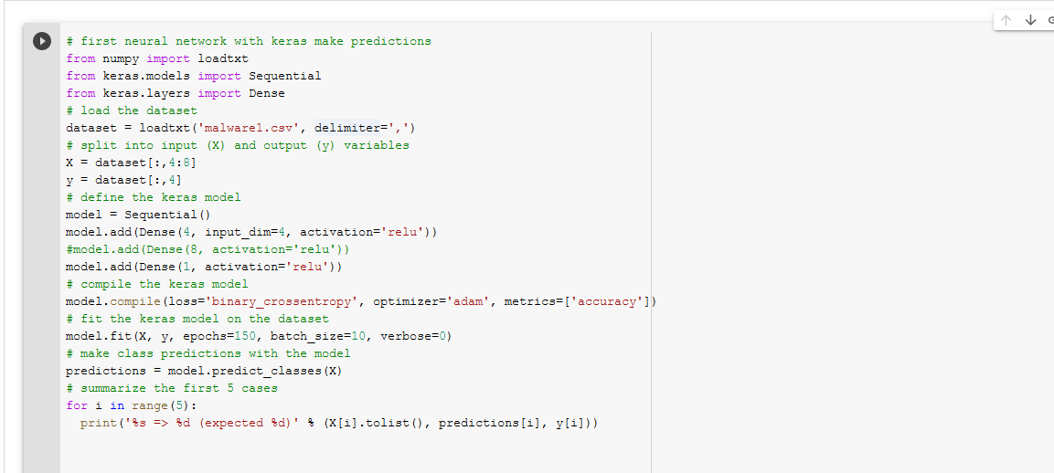

**Input sample snap:**

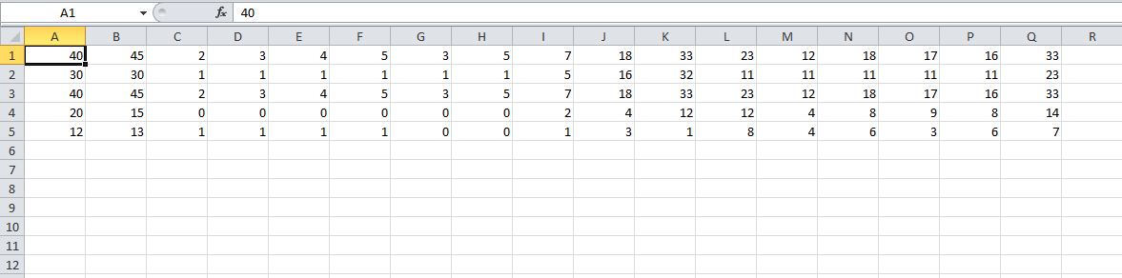

**Output Sample**

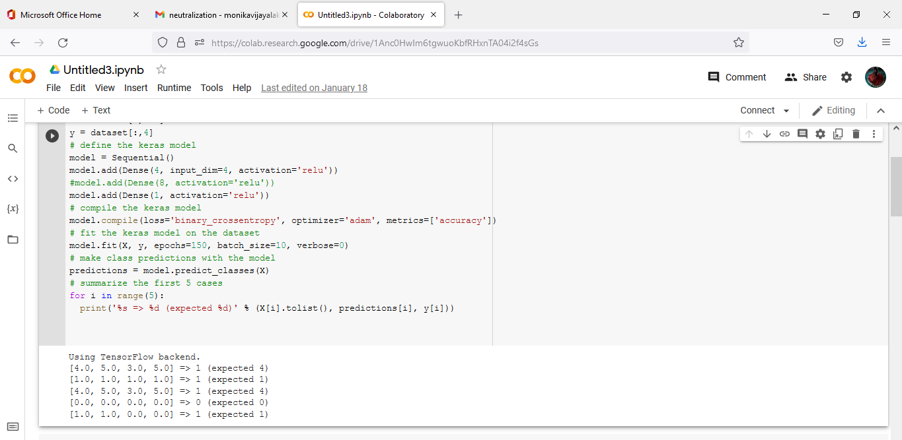

**FCM Code:**

import pandas as pd

import numpy as np

import random

import operator

import math

df_full = pd.read_csv("malware.csv")

columns = list(df_full.columns)

features = columns[:len(columns)-1]

class_labels = list(df_full[columns[-1]])

df = df_full[features]

# Number of Attributes

num_attr = len(df.columns) - 1

# Number of Clusters

k = 2

# Maximum number of iterations

MAX_ITER = 100

# Number of data points

n = len(df)

# Fuzzy parameter

m = 2.00

def accuracy(cluster_labels, class_labels):

county = [0,0]

countn = [0,0]

tp = [0, 0]

tn = [0, 0]

fp = [0, 0]

fn = [0, 0]

#INITIALIZE FUZZY PARTITION OR FUZZY MEMBERSHIP MATRIC

for i in range(len(df)):

# Yes = 1, No = 0

if cluster_labels[i] == 1 and class_labels[i] == 'Yes':

tp[0] = tp[0] + 1

if cluster_labels[i] == 0 and class_labels[i] == 'No':

tn[0] = tn[0] + 1

if cluster_labels[i] == 1 and class_labels[i] == 'No':

fp[0] = fp[0] + 1

if cluster_labels[i] == 0 and class_labels[i] == 'Yes':

fn[0] = fn[0] + 1

for i in range(len(df)):

# Yes = 0, No = 1

if cluster_labels[i] == 0 and class_labels[i] == 'Yes':

tp[1] = tp[1] + 1

if cluster_labels[i] == 1 and class_labels[i] == 'No':

tn[1] = tn[1] + 1

if cluster_labels[i] == 0 and class_labels[i] == 'No':

fp[1] = fp[1] + 1

if cluster_labels[i] == 1 and class_labels[i] == 'Yes':

fn[1] = fn[1] + 1

a0 = float((tp[0] + tn[0]))/(tp[0] + tn[0] + fn[0] + fp[0])

a1 = float((tp[1] + tn[1]))/(tp[1] + tn[1] + fn[1] + fp[1])

p0 = float(tp[0])/(tp[0] + fp[0])

p1 = float(tp[1])/(tp[1] + fp[1])

r0 = float(tp[0])/(tp[0] + fn[0])

r1 = float(tp[1])/(tp[1] + fn[1])

accuracy = [a0*100,a1*100]

precision = [p0*100,p1*100]

recall = [r0*100,r1*100]

return accuracy, precision, recall

#STEP1: INITILAIZE MEMBERSHIP MATRIX

def initializeMembershipMatrix():

membership_mat = list()

for i in range(n):

random_num_list = [random.random() for i in range(k)]

summation = sum(random_num_list)

temp_list = [x/summation for x in random_num_list]

membership_mat.append(temp_list)

return membership_mat

#STEP2: CALCULATE CLUSTER CENTER or CENTRIOD

def calculateClusterCenter(membership_mat):

cluster_mem_val = list(zip(*membership_mat))

cluster_centers = list()

for j in range(k):

x = list(cluster_mem_val[j])

xraised = [e ** m for e in x]

denominator = sum(xraised)

temp_num = list()

for i in range(n):

data_point = list(df.iloc[i])

prod = [xraised[i] * val for val in data_point]

temp_num.append(prod)

numerator = list(map(sum,list(zip(*temp_num))))

center = [z/denominator for z in numerator]

cluster_centers.append(center)

return cluster_centers

#STEP3:UPDATE MEMBERSHIP MEMBERSHIP MATRIX

def updateMembershipValue(membership_mat, cluster_centers):

p = float(2/(m-1))

for i in range(n):

x = list(df.iloc[i])

distances = [np.linalg.norm(list(map(operator.sub, x, cluster_centers[j]))) for j in range(k)]

for j in range(k):

den = sum([math.pow(float(distances[j]/distances[c]), p) for c in range(k)])

membership_mat[i][j] = float(1/den)

return membership_mat

def getClusters(membership_mat):

cluster_labels = list()

for i in range(n):

max_val, idx = max((val, idx) for (idx, val) in enumerate(membership_mat[i]))

cluster_labels.append(idx)

return cluster_labels

#STEP4: OBTAIN FUZZY MEMBERSHIP VALUE FOR EACH FUNCTION

def fuzzyCMeansClustering():

# Membership Matrix

membership_mat = initializeMembershipMatrix()

curr = 0

while curr <= MAX_ITER:

cluster_centers = calculateClusterCenter(membership_mat)

membership_mat = updateMembershipValue(membership_mat, cluster_centers)

cluster_labels = getClusters(membership_mat)

curr += 1

print(membership_mat)

return cluster_labels, cluster_centers

labels, centers = fuzzyCMeansClustering()

a,p,r = accuracy(labels, class_labels)

**Code snap:**

