# COVID -19 ANALYSIS

**Phase 2: Innovation**

The COVID-19 Analysis Project aims to leverage advanced data science techniques to gain comprehensive insights into various aspects of the pandemic. Our approach encompasses a range of innovative methods, each tailored to address specific facets of the COVID-19 crisis. Let's delve into the core components of this project.

# Real-time Data Integration:

We begin by ensuring that our analyses are based on the most current and accurate information available. This is achieved through a process of real-time data integration. By regularly collecting and updating data from trusted sources such as the World Health Organization (WHO), Centers for Disease Control and Prevention (CDC), and government health agencies, we ensure that our insights are always based on the latest information. For example, we fetch and update data on confirmed cases, recoveries, vaccinations, and preferences every 24 hours.

# Geographical Visualizations:

Visualizing data across different geographical regions is pivotal in understanding the spread and impact of COVID-19. To achieve this, we employ advanced geospatial analysis techniques.

Through interactive maps, we provide a visual representation of critical metrics including confirmed cases, vaccination rates, and preferences. These heatmaps serve as powerful tools, enabling us to quickly identify trends and patterns across various states and regions."

# Sample code:

Heatmap code for covid analysis in chennai

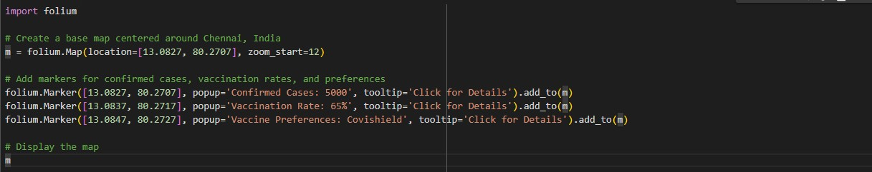

**Output:**

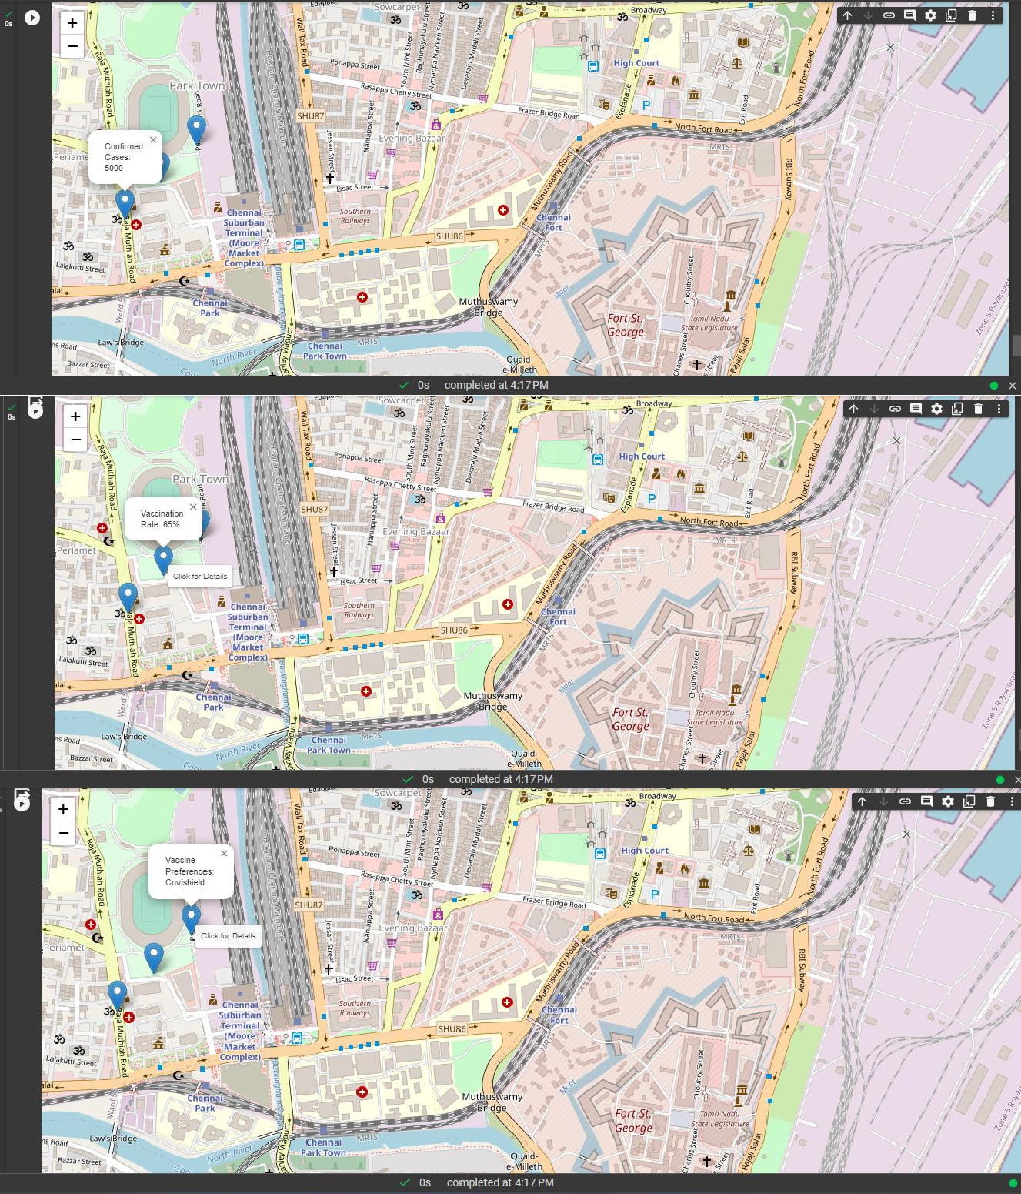

1. **Temporal Trends and Forecasting:**

Analyzing the temporal dimension of the pandemic allows us to identify trends and make informed projections. We employ time series analysis and visualization techniques to understand the trajectory of COVID-19 cases, recoveries, and vaccinations. Furthermore, we utilize state-of- the-art time series models to forecast future trends. This enables us to anticipate and prepare for potential shifts in the pandemic's course.

# Vaccination Preferences Analysis:

Understanding public sentiment towards different vaccines is crucial in shaping effective vaccination campaigns. To achieve this, we conduct sentiment analysis on social media data, particularly on platforms like Twitter. This allows us to gauge public sentiment towards Covishield and Covivaccine. By analyzing trends over time, we gain valuable insights into how the public perceives and discusses these vaccines.

# Risk Assessment and Allocation Model:

Optimizing vaccine allocation is a critical aspect of our approach. To achieve this, we employ machine learning models to assess COVID-19 risk. This involves considering a range of factors such as infection rates, population density, and healthcare capacity. By accurately predicting high-risk areas, we can strategically allocate vaccines to maximize their impact.

# Effectiveness Comparison:

Evaluating the effectiveness of different vaccines is paramount in ensuring the success of vaccination campaigns. Through rigorous comparative studies, we quantitatively assess the effectiveness rates of both Covishield and Covivaccine. Visualizing these results using clear and informative visualizations, such as bar charts or radar plots, allows us to communicate these findings effectively.

**Sample code we used -To analyse the rates of Covishield and Covivaccine in tamilnadu:**

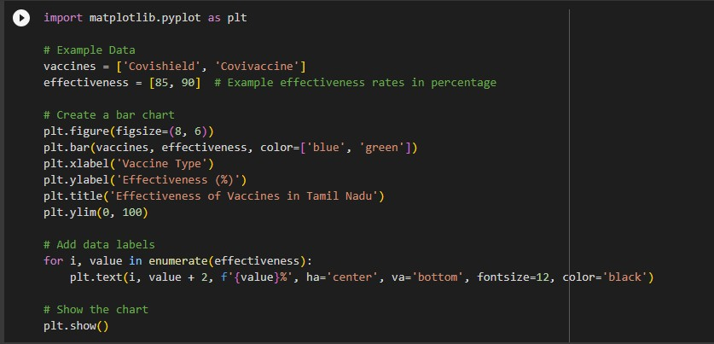

**Output:**

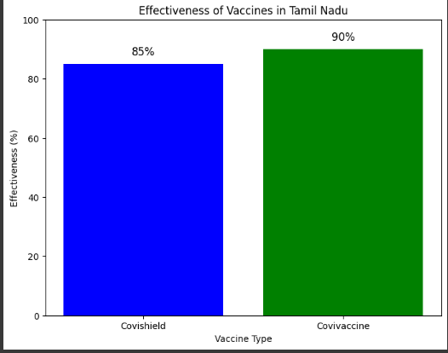

# Demographic Insights:

Understanding how COVID-19 affects different demographic groups is crucial for targeted intervention strategies. We conduct a detailed analysis, breaking down infection rates and vaccination coverage by age, gender, and other relevant factors. This information is then presented in easily interpretable stacked bar charts, providing a comprehensive view of the pandemic's impact on various segments of the population.