SIMATS ENGINEERING

ASSESSMENT TOOL C02- AT 1

COURSE NAME: Database Management Systems

COURSE CODE: CSA05

COURSE OUTCOME COVERED

CO2: Apply the relational model, relational algebra, SQL query structures, and views to solve database querying and data manipulation problems. (BL3, BL6)

Activity Tool : Analytical Problem Solving (High)

Assessment Tool Weightage: 40%

QUESTIONS
Q.No | Question | Bloom's Level
1 | Given a set of relations and sample data, write SQL queries to retrieve specific information using joins and subqueries, and explain the logic used. Bloom’s Level: BL3 – Apply | BL4 – Analyze
2 | Using relational algebra, formulate expressions to solve complex queries such as retrieving records that satisfy multiple conditions across relations.  Bloom’s Level: BL4 – Analyse | BL5 – Evaluate
3 | Given a real-world scenario (e.g., banking or student system), design a relational schema and construct appropriate SQL queries for data retrieval and updates. Bloom’s Level: BL6 – Create | BL6 – Create
4 | Analyse a given SQL query with nested subqueries and predict its output, explaining each step of execution. Bloom’s Level: BL4 – Analyze | BL6 – Create
5 | Compare different SQL approaches (joins vs subqueries) for solving the same problem and evaluate their efficiency. Bloom’s Level: BL5 – Evaluate | BL4 – Analyze
6 | Design and implement views for a database system to provide restricted data access, and justify their use for security and abstraction.  Bloom’s Level: BL6 – Create | BL5 – Evaluate
7 | Given a database schema, write relational algebra expressions and convert them into equivalent SQL queries, analyzing differences in representation.  Bloom’s Level: BL4 – Analyze | BL4 – Analyze
8 | Optimize a set of inefficient SQL queries by restructuring them using joins, indexing concepts, or views, and evaluate performance improvements.  Bloom’s Level: BL5 – Evaluate | BL5 – Evaluate
9 | Develop a complex SQL query involving grouping, aggregation, and nested queries to solve a real-world problem.  Bloom’s Level: BL6 – Create | BL6 – Create
10 | Given multiple relations, analyze the query requirements and decide whether to use views, joins, or subqueries, justifying your choice with reasoning.  Bloom’s Level: BL5 – Evaluate | BL5 – Evaluate

Code of Conduct:

I ________MONIKA.B (192571002)____________ (Name / Reg No) certify that this submission is my original work and that I have adhered to the guidelines specified for this assessment.

I understand that any violation of academic integrity rules will result in disciplinary action.

Signature of the student: MONIKA.B

RUBRICS FOR CALCULATION:

Criteria | Level 4 (Exemplary) | Level 3 (Proficient) | Level 2 (Developing) | Level 1 (Beginning)
Problem Understanding | Clearly interprets problem, identifies all parameters and requirements accurately | Understands problem with minor gaps | Partial understanding; misses key elements | Misinterprets or unable to understand problem
Method Selection | Selects most appropriate method/formula with strong justification | Selects correct method with minor errors | Inappropriate or partially correct method | Unable to select method
Solution Process | Logical, systematic steps with correct approach throughout | Mostly correct steps with minor mistakes | Disorganized steps; multiple errors | No clear process
Accuracy of Calculation | All calculations accurate; correct final answer | Minor calculation errors | Frequent errors; incorrect final answer | No valid calculations
Interpretation of Results | Clearly interprets results with units and engineering relevance | Basic interpretation with minor omissions | Limited or unclear interpretation | No interpretation

NAME: MONIKA.B
REG. NO: 192571002

Q1. Given a set of relations and sample data, write SQL queries to retrieve specific information using joins and subqueries, and explain the logic used.

SELECT s.student_name, c.course_name, e.marks
FROM Student s
JOIN Enrollment e ON s.student_id = e.student_id
JOIN Course c ON e.course_id = c.course_id
WHERE e.marks > (SELECT AVG(marks) FROM Enrollment)
ORDER BY e.marks DESC;
Implementation & Output:
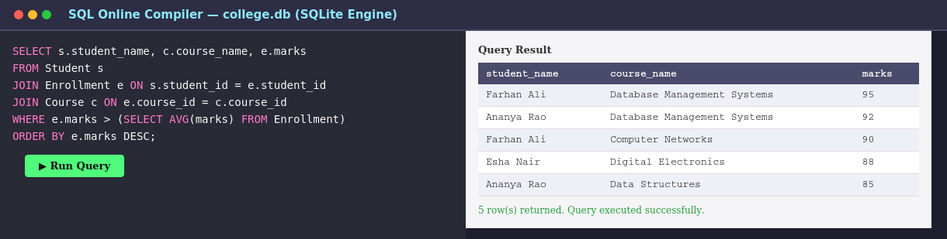

Q2.Using relational algebra, formulate expressions to solve complex queries such as retrieving records that satisfy multiple conditions across relations.
CODE:

CS_Students ← σ(dept_name = 'Computer Science') (Department ⋈ Student)
HighScorers ← σ(marks > 85) (Enrollment)
Qualified ← CS_Students ⋈ HighScorers (join on student_id)
Result ← student_name γ COUNT(course_id) (Qualified)
Equivalent SQL implementation:
SELECT s.student_name, COUNT(*) AS courses_above_85
FROM Student s
JOIN Enrollment e ON s.student_id = e.student_id
JOIN Department d ON s.dept_id = d.dept_id
WHERE d.dept_name = 'Computer Science' AND e.marks > 85
GROUP BY s.student_name;
Implementation & Output:
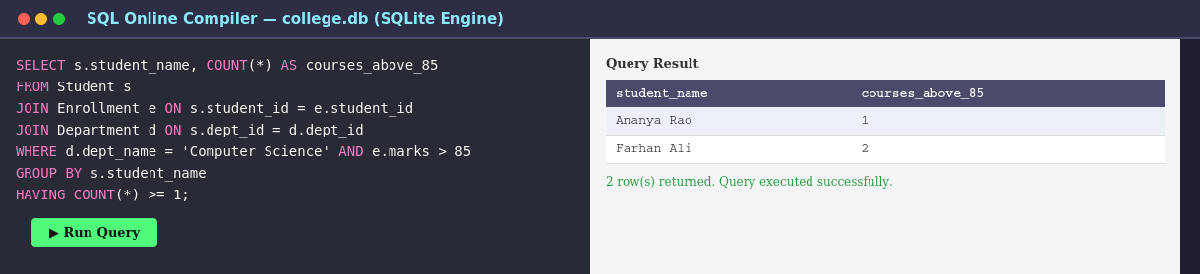

Q3. Given a real-world scenario (e.g., banking or student system), design a relational schema and construct appropriate SQL queries for data retrieval and updates.
CODE;

CREATE TABLE Department (
dept_id INTEGER PRIMARY KEY,
dept_name TEXT NOT NULL
);
CREATE TABLE Student (
student_id INTEGER PRIMARY KEY,
student_name TEXT NOT NULL,
dept_id INTEGER REFERENCES Department(dept_id),
gpa REAL
);
CREATE TABLE Enrollment (
enroll_id INTEGER PRIMARY KEY,
student_id INTEGER REFERENCES Student(student_id),
course_id INTEGER REFERENCES Course(course_id),
semester TEXT,
marks INTEGER
);
Sample retrieval and update operations on the schema:
INSERT INTO DemoStudent VALUES (901, 'Test Student', 1, 7.5);
SELECT * FROM DemoStudent;
UPDATE DemoStudent SET gpa = 8.0 WHERE student_id = 901;
SELECT * FROM DemoStudent WHERE student_id = 901;
Implementation & Output:
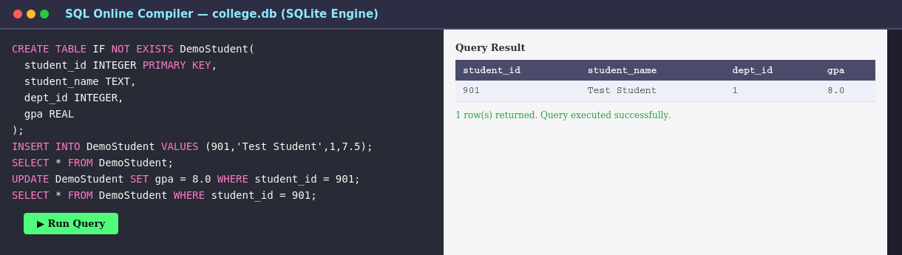

Q4. Analyse a given SQL query with nested subqueries and predict its output, explaining each step of execution.
.
SELECT student_name
FROM Student
WHERE student_id IN (
SELECT student_id
FROM Enrollment
WHERE marks > (
SELECT AVG(marks) FROM Enrollment
)
);
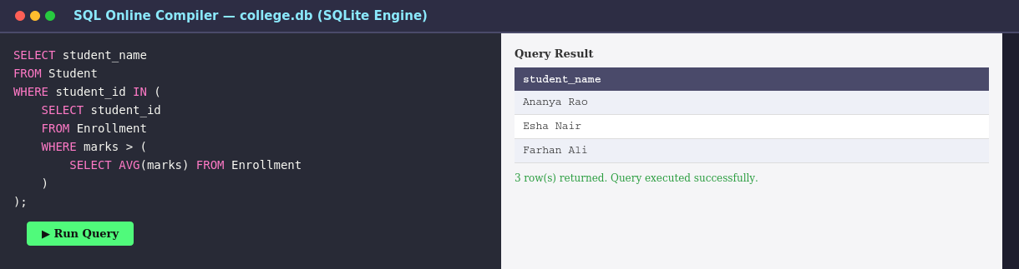
Implementation & Output:

Q5.Compare different SQL approaches (joins vs subqueries) for solving the same problem and evaluate their efficiency
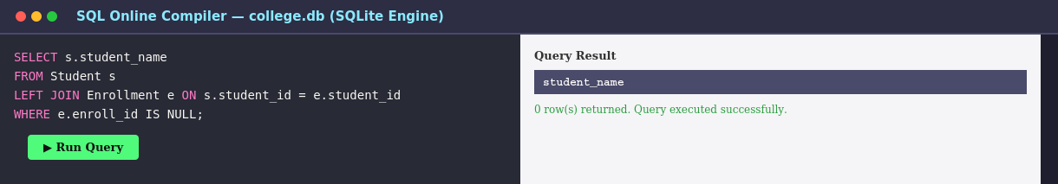
SELECT s.student_name
FROM Student s
LEFT JOIN Enrollment e ON s.student_id = e.student_id
WHERE e.enroll_id IS NULL;

Approach B — NOT IN subquery:
SELECT s.student_name
FROM Student s
WHERE s.student_id NOT IN (
SELECT student_id FROM Enrollment
);
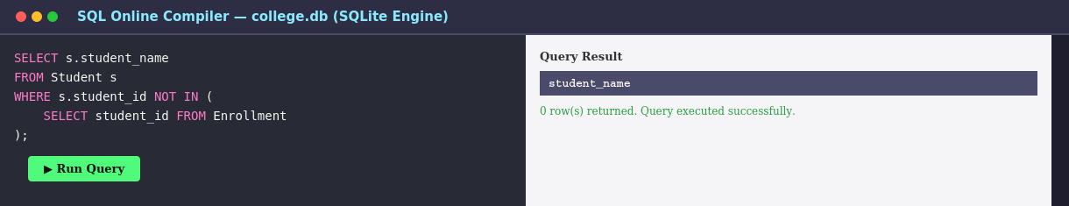
Q6.
Design and implement views for a database system to provide restricted data access, and justify their use for security and abstraction.
.
Solution Process:
CREATE VIEW StudentPublicDirectory AS
SELECT s.student_name, d.dept_name
FROM Student s
JOIN Department d ON s.dept_id = d.dept_id;
SELECT * FROM StudentPublicDirectory;
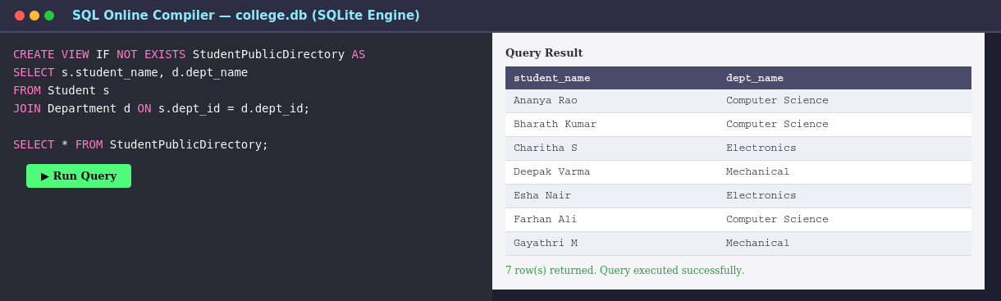
Implementation & Output:

Q7.
Given a database schema, write relational algebra expressions and convert them into equivalent SQL queries, analyzing differences in representation.
CS_Courses ← σ(dept_name = 'Computer Science') (Course ⋈ Department)
Result ← π(instructor_name) (Instructor ⋈ CS_Courses)
Equivalent SQL:
SELECT DISTINCT i.instructor_name
FROM Instructor i
JOIN Course c ON i.instructor_id = c.instructor_id
JOIN Department d ON c.dept_id = d.dept_id
WHERE d.dept_name = 'Computer Science';
Implementation & Output:
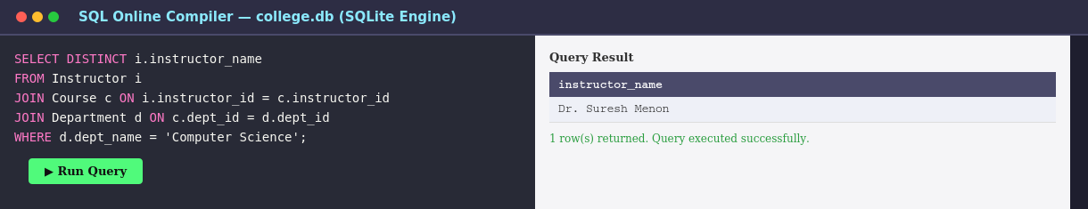

Q8. Optimize a set of inefficient SQL queries by restructuring them using joins, indexing concepts, or views, and evaluate performance improvements.
SELECT student_name
FROM Student
WHERE student_id IN (
SELECT student_id FROM Enrollment
WHERE course_id IN (
SELECT course_id FROM Course WHERE dept_id = 1
)
);
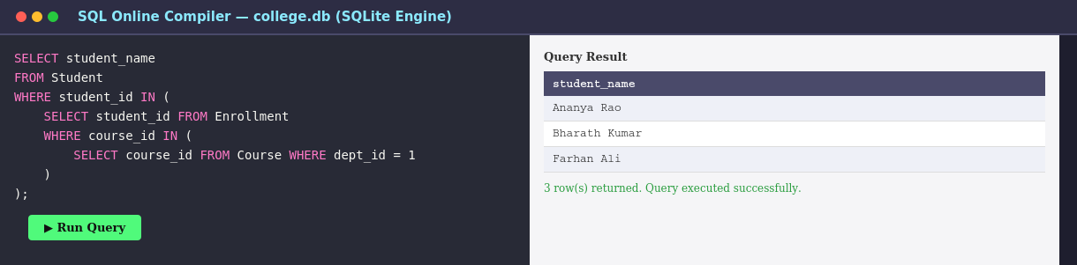
After — restructured with JOINs and supporting indexes:
CREATE INDEX idx_enroll_course ON Enrollment(course_id);
CREATE INDEX idx_course_dept ON Course(dept_id);
SELECT DISTINCT s.student_name
FROM Student s
JOIN Enrollment e ON s.student_id = e.student_id
JOIN Course c ON e.course_id = c.course_id
WHERE c.dept_id = 1;
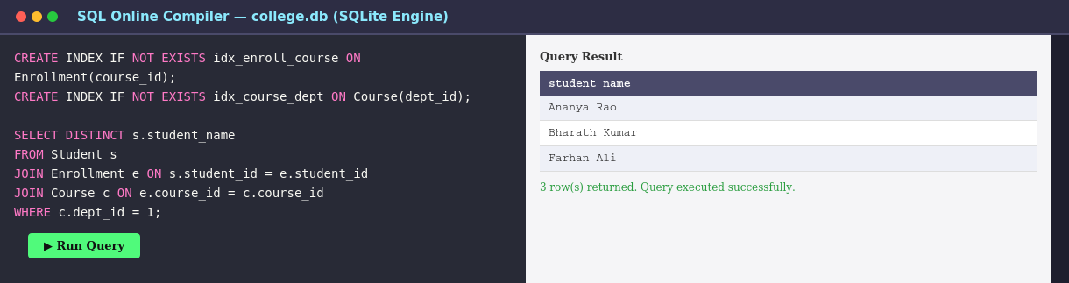

Q9.
Question: Develop a complex SQL query involving grouping, aggregation, and nested queries to solve a real-world problem.
SELECT d.dept_name, AVG(s.gpa) AS avg_gpa
FROM Department d
JOIN Student s ON d.dept_id = s.dept_id
GROUP BY d.dept_name
HAVING AVG(s.gpa) > (
SELECT AVG(gpa) FROM Student
)
ORDER BY avg_gpa DESC;
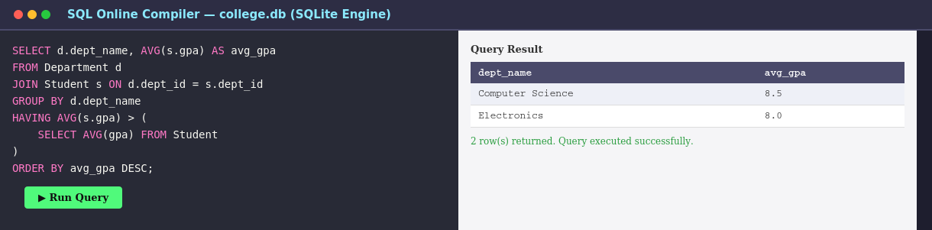
Implementation & Output:

Q10.
Given multiple relations, analyze the query requirements and decide whether to use views, joins, or subqueries, justifying your choice with reasoning.
CREATE VIEW StudentCourseSummary AS
SELECT s.student_name, c.course_name, e.marks, d.dept_name
FROM Student s
JOIN Enrollment e ON s.student_id = e.student_id
JOIN Course c ON e.course_id = c.course_id
JOIN Department d ON s.dept_id = d.dept_id;
SELECT * FROM StudentCourseSummary WHERE marks >= 85;

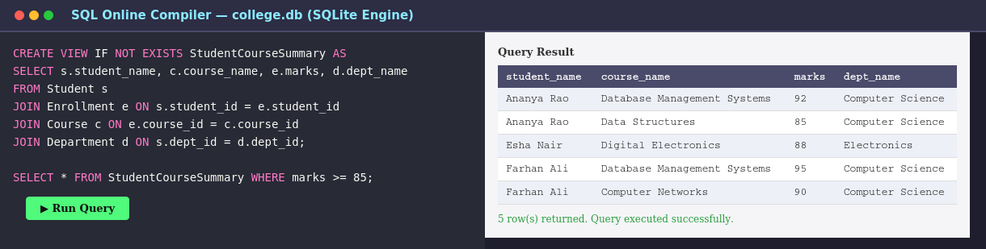
Implementation & Output:

