**DESIGN THINKING AND INNOVATION**

**Week 3**

**Team 23:** ZENOURA

**Team Members:**

1. **Monic Auditya A. - 230701194**
2. Monish D.Y. - 230701195
3. Kamalesh P. - 230701137

**Progress of Week 3:**

**Empathy Map**

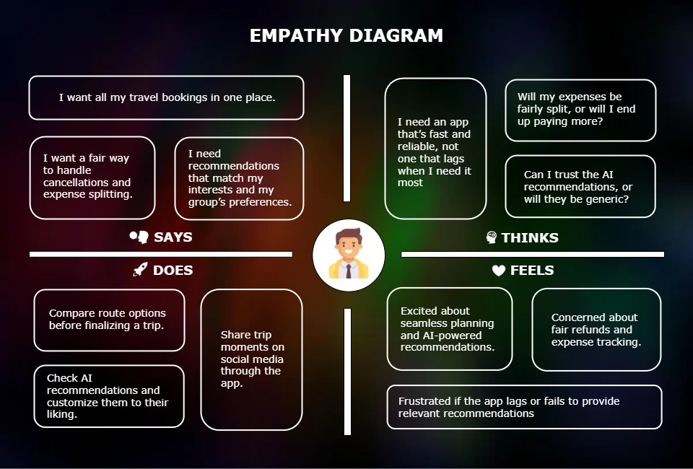

**Persona**

Persona 1:

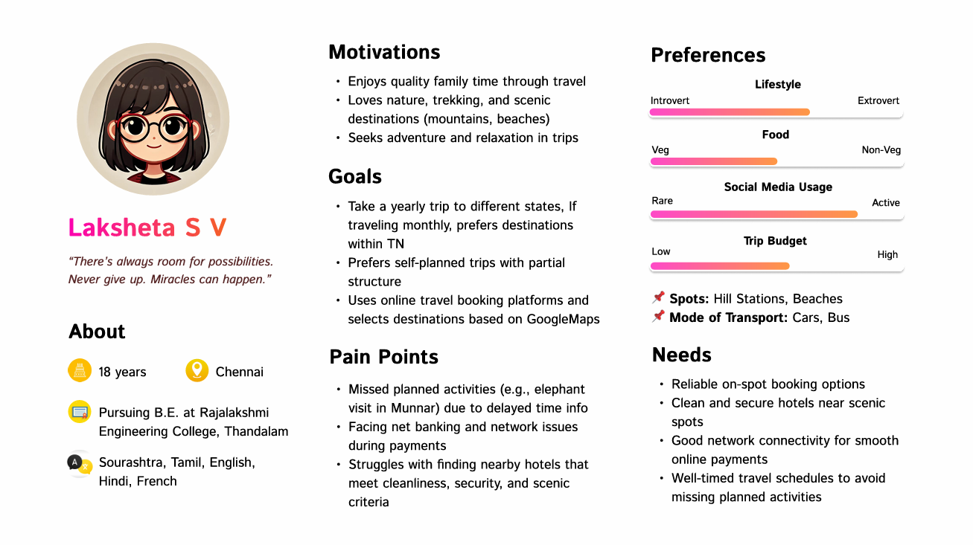

Persona 2:

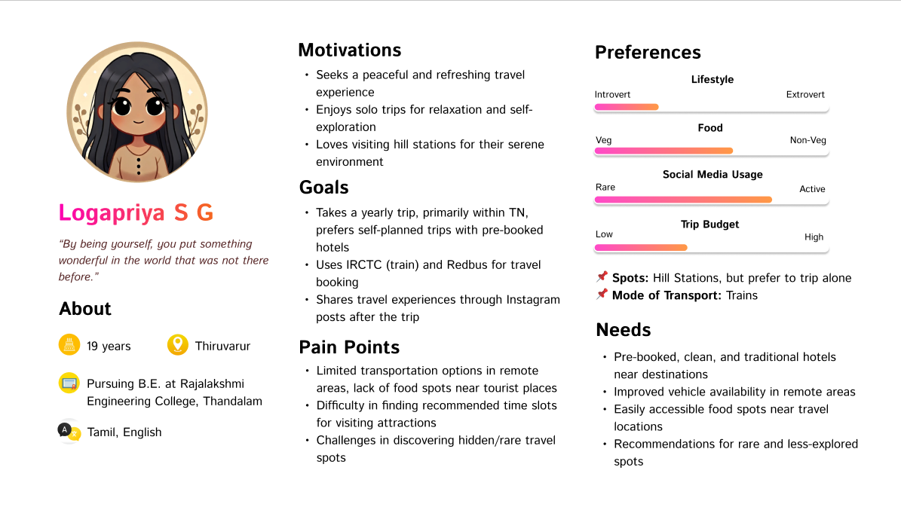

Persona 3:

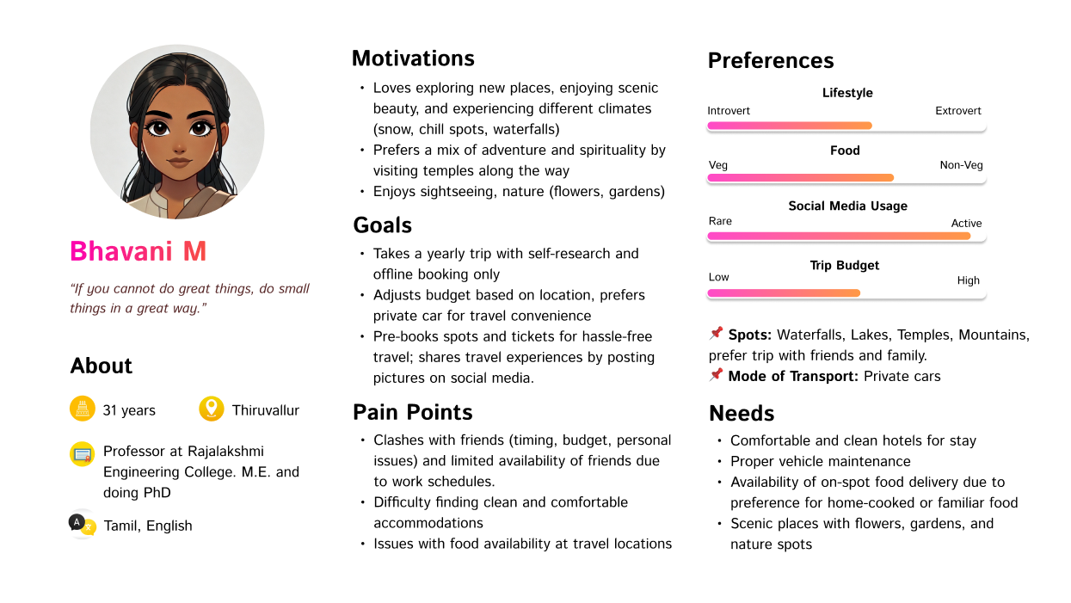

Persona 4:

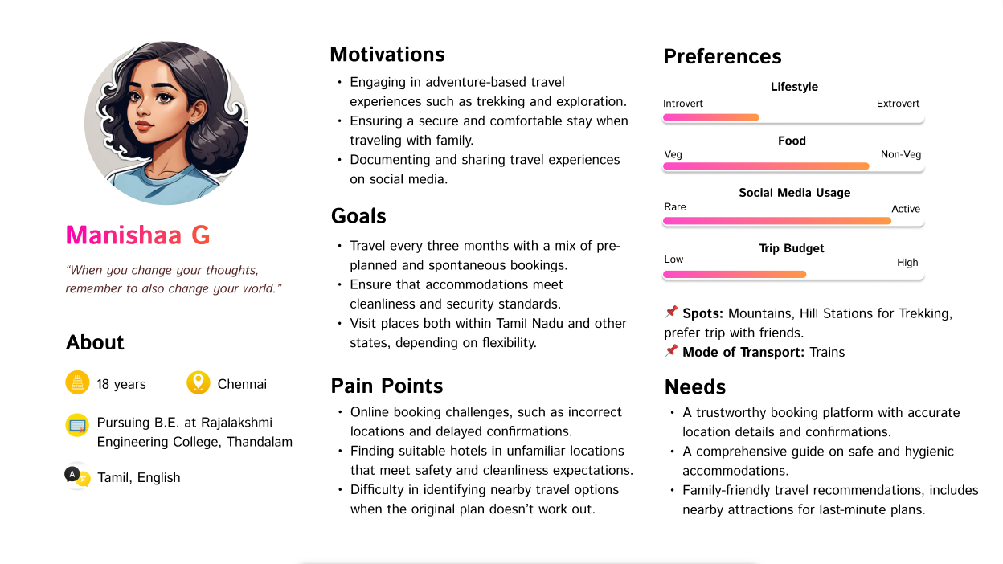

Persona 5:

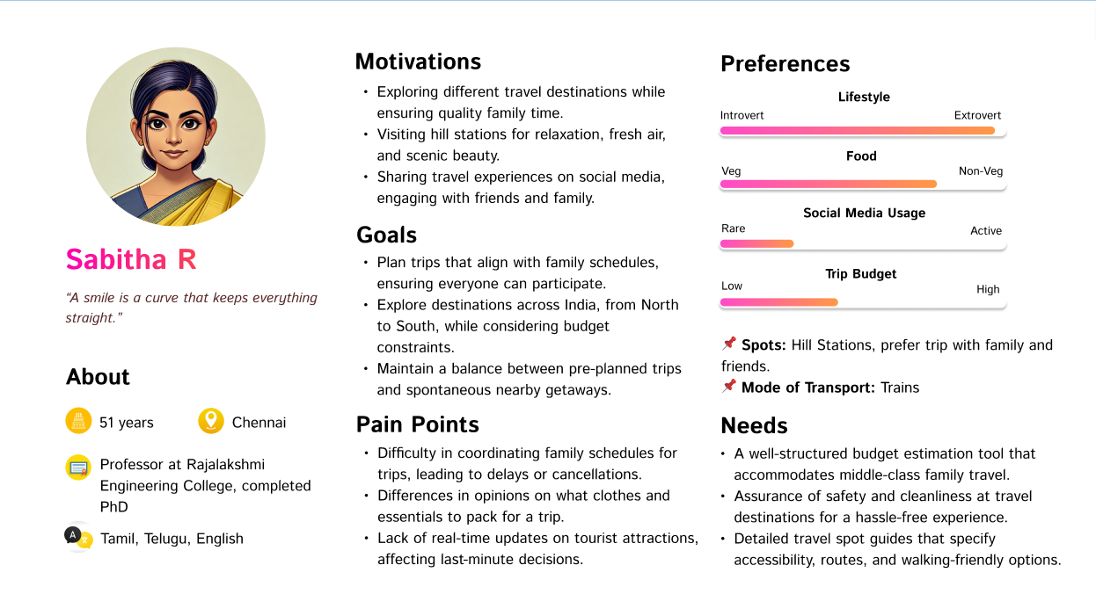

Persona 6:

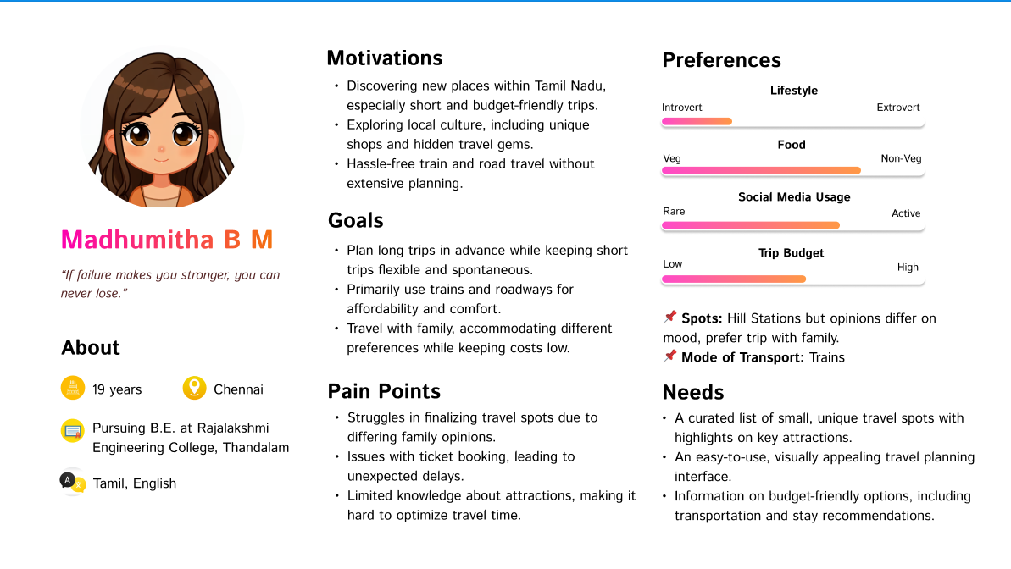

**Journey Map**

