Week_02

230701195

2025-02-01

f <- function(x) { x^2 }  
result <- integrate(f, lower = 0, upper = 1)  
print(result$value)

## [1] 0.3333333

library(pracma)  
f <- function(x) { sin(x) }  
result <- integral(f, xmin = 0, xmax = pi)  
print(result)

## [1] 2

library(ggplot2)  
f <- function(x) {sin(x)}  
x_values <- seq(0, pi, by = 0.01)  
y_values <- f(x_values)  
  
data <- data.frame(x = x_values, y = y_values)  
  
ggplot(data, aes(x = x, y = y)) +  
geom_area(fill = "gold") +  
ggtitle("Area under the curve of sin(x) from 0 to π")

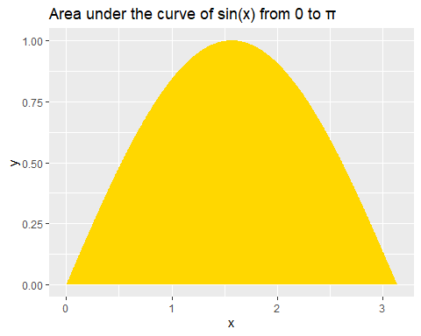

library(pracma)  
f <- function(x, y) x + y  
result <- dblquad(f, 0, 1, 0, 1)  
print(result)

## [1] 1

f <- function(x, y) { x * y }  
double_integral <- function(x) {  
sapply(x, function(x) integrate(f, lower = 0, upper = 1, y = x)$value)}  
result <- integrate(double_integral, lower = 0, upper = 1)  
print(result$value)

## [1] 0.25

# Example dataset  
time <- seq(0, 10, by = 0.1)  
velocity <- 3 * time^2 - 2 * time + 1   
data <- data.frame(time = time, velocity = velocity)  
distance_function <- function(t) { 3 * t^2 - 2 * t + 1 }  
result <- integrate(distance_function, lower = 0, upper = 10)  
print(result$value)

## [1] 910

# Cumulative distance  
cumulative_distance <- cumsum(velocity) * 0.1  
# Visualization  
data$cumulative_distance <- cumulative_distance  
ggplot(data, aes(x = time)) +  
geom_line(aes(y = velocity), color = "blue") +  
geom_line(aes(y = cumulative_distance), color = "red") +  
ggtitle("Velocity (blue) and Cumulative Distance (red) over Time")

