Week_04

230701195

2025-02-22

# Binomial Distribution - PDF  
n <- 25  
p <- 0.5  
x <- 0:n  
pdf <- dbinom(x, size = n, prob = p)  
barplot(pdf, names.arg = x, main = "Binomial PDF", xlab = "x", ylab = "Probability", col = "green")

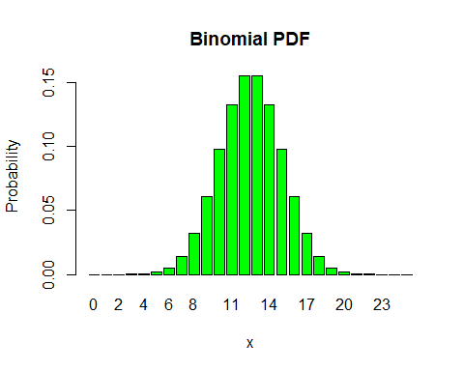

# Binomial Distribution - CDF  
cdf <- pbinom(x, size = n, prob = p)  
plot(x, cdf, type = "b", main = "Binomial CDF", xlab = "x", ylab = "Cumulative Probability")

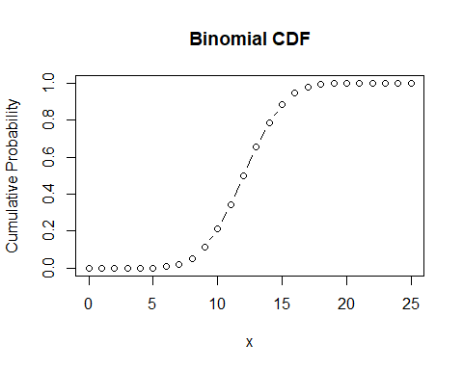

# Poisson Distribution - PDF  
lambda <- 5  
x <- 0:25  
pdf <- dpois(x, lambda)  
barplot(pdf, names.arg = x, main = "Poisson PDF", xlab = "x", ylab = "Probability", col = "lightblue")

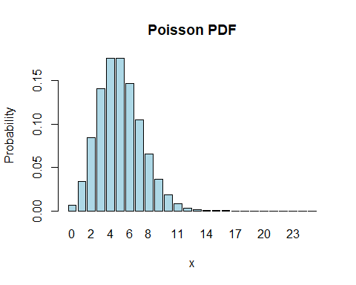

# Poisson Distribution - CDF  
cdf <- ppois(x, lambda)  
plot(x, cdf, type = "s", main = "Poisson CDF", xlab = "x", ylab = "Cumulative Probability")

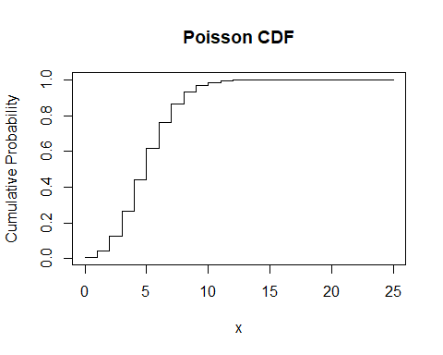

# Exponential Distribution - PDF  
rate <- 1.5  
x <- seq(0, 5, by = 0.1)  
pdf <- dexp(x, rate)  
plot(x, pdf, type = "l", main = "Exponential PDF", xlab = "x", ylab = "Density")

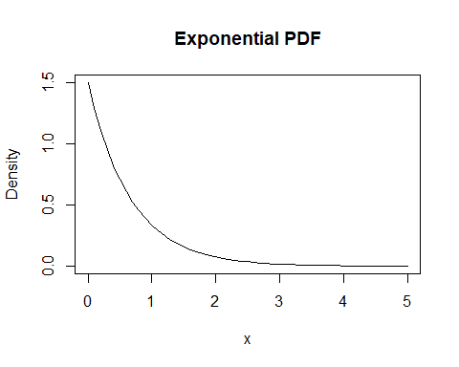

# Exponential Distribution - CDF  
cdf <- pexp(x, rate)  
plot(x, cdf, type = "l", main = "Exponential CDF", xlab = "x", ylab = "Cumulative Probability")

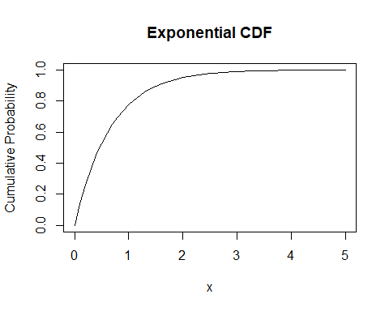

# Uniform Distribution - PDF  
a <- 0  
b <- 1  
x <- seq(a, b, by = 0.01)  
pdf <- dunif(x, min = a, max = b)  
plot(x, pdf, type = "l", main = "Uniform PDF", xlab = "x", ylab = "Density")

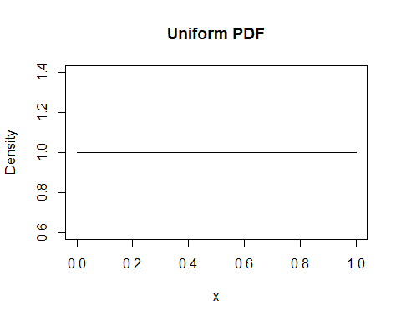

# Uniform Distribution - CDF  
cdf <- punif(x, min = a, max = b)  
plot(x, cdf, type = "l", main = "Uniform CDF", xlab = "x", ylab = "Cumulative Probability")

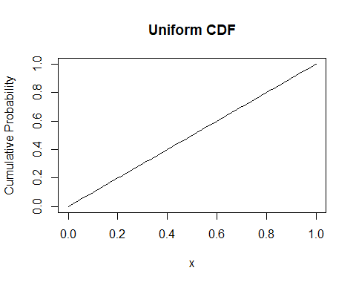

# Normal Distribution - PDF  
mean <- 0  
sd <- 1  
x <- seq(-4, 4, by = 0.1)  
pdf <- dnorm(x, mean = mean, sd = sd)  
plot(x, pdf, type = "s", main = "Normal PDF", xlab = "x", ylab = "Density")

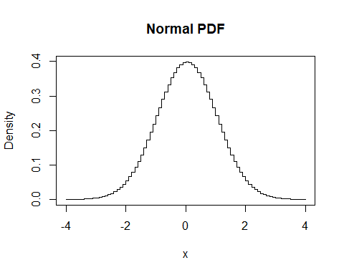

# Normal Distribution - CDF  
cdf <- pnorm(x, mean = mean, sd = sd)  
plot(x, cdf, type = "l", main = "Normal CDF", xlab = "x", ylab = "Cumulative Probability")

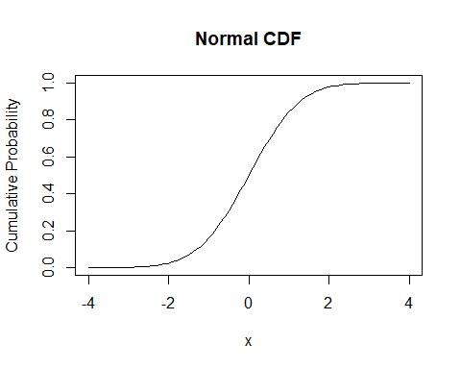

# Compute the probability that a random variable from N(0,1) lies between -1 and 1.  
prob <- pnorm(1, mean = 0, sd = 1) - pnorm(-1, mean = 0, sd = 1)  
prob

## [1] 0.6826895

# Calculate the mean of an Exponential distribution using numerical integration.  
rate <- 1.5  
mean_value <- integrate(function(x) x * dexp(x, rate), lower = 0, upper = Inf)$value  
mean_value

## [1] 0.6666667

# Calculate the probability of getting exactly 3 successes in a Binomial distribution with n = 8 and p = 0.6.  
n <- 8  
p <- 0.6  
prob <- dbinom(3, size = n, prob = p)  
prob

## [1] 0.123863

# Find the probability of observing at most 5 events in a Poisson distribution with λ = 2.  
lambda <- 2  
prob <- ppois(5, lambda)  
prob

## [1] 0.9834364

# Generate 1000 random numbers from a Uniform distribution between 5 and 10, and plot a histogram.  
set.seed(123)  
data <- runif(1000, min = 5, max = 10)  
hist(data, main = "Histogram of Uniform Distribution", xlab = "Value", ylab = "Frequency", col = "blue")

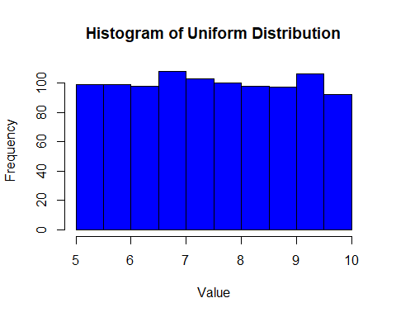

# Simulate and visualize 1000 random numbers from a Normal distribution with mean = 50 and sd = 10.  
set.seed(123)  
data <- rnorm(1000, mean = 50, sd = 10)  
hist(data, main = "Histogram of Normal Distribution", xlab = "Value", ylab = "Frequency", col = "green", breaks = 30)

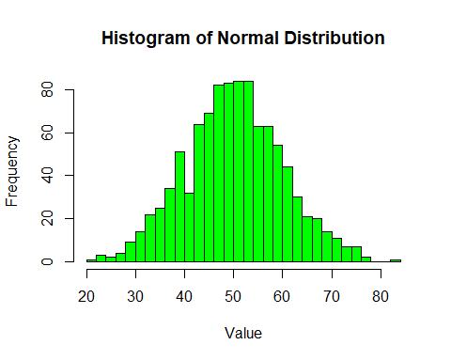

# Verify the mean and variance of a Poisson distribution with λ = 3 using simulation.  
set.seed(123)  
data <- rpois(1000, lambda = 3)  
mean(data)

## [1] 2.967

var(data)

## [1] 2.916828

# Calculate the median of an Exponential distribution with rate = 2.  
rate <- 2  
median <- qexp(0.5, rate)  
median

## [1] 0.3465736

# Generate and plot the CDF of a Uniform distribution on [-2, 2].  
a <- -2  
b <- 2  
x <- seq(a, b, by = 0.01)  
cdf <- punif(x, min = a, max = b)  
plot(x, cdf, type = "l", main = "Uniform CDF on [-2, 2]", xlab = "x", ylab = "Cumulative Probability")

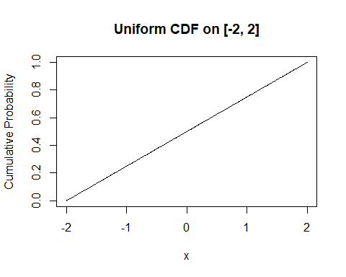

# Simulate 1000 values from a Binomial distribution and compute the empirical mean and variance.  
set.seed(123)  
n <- 10  
p <- 0.5  
data <- rbinom(1000, size = n, prob = p)  
mean(data)

## [1] 4.975

var(data)

## [1] 2.556932