RAJALAKSHMI ENGINEERING COLLEGE

Department of Computer Science and Engineering
Academic Year: 2025 – 2026

MINI PROJECT REPORT
On

ASL Sign Language to Text Recognition System
using Image Processing and Computer Vision

Individual Report — Algorithms: MediaPipe Hands + SVM RBF Classifier

Submitted by

Monish D.Y.
Roll No: 2116230701195
Section: CSE C
Email: 230701195@rajalakshmi.edu.in

Date of Submission: May 2026

Table of Contents

1. Introduction 4
1.1 Background and Motivation
1.2 Problem Statement
1.3 Objectives
1.4 Scope of the Report
2. Literature Review 6
2.1 Traditional Feature-Based Methods
2.2 Architectures
2.3 Existing Method Studies
2.4 Gap Identified
3. Dataset Description 8
3.1 Kaggle Dataset
3.2 Data Split
4. Pre-processing Methodology 10
4.1 Landmark Extraction and Coordinate Scaling
4.2 Translation and Scale Invariance
4.3 Feature Normalization (StandardScaler)
4.4 Geometric Feature Engineering (Distances and Angles)
4.5 Hand Orientation and Rotation Analysis
4.6 Data Augmentation and Synthesis
5. Algorithm: MediaPipe Hands + Geometric Feature Engine + SVM 12
5.1 Algorithm Overview
5.2 Stage 1 — Precise 3D Hand Landmark Extraction
5.3 Stage 2 — Geometric Feature Engineering
5.4 Stage 3 — SVM Multi-class Classification
5.5 Implementation Details
5.6 Algorithm Flowchart
6. Results and Analysis 15
6.1 Quantitative Results
6.2 Effect of Feature Engineering on Accuracy
6.3 Confusion Matrix Analysis
7. Discussion 17
8. Conclusion and Future Work 18
References 19
Appendix A — Source Code 20
Appendix B — Sample Output Screenshots 22

List of Tables and Figures

Tables
- Table 1: Dataset Statistics
- Table 2: Train / Validation / Test Split
- Table 3: Implementation Configuration
- Table 4: MediaPipe + SVM — Test Set Results

Figures
- Figure 1: Training History (Learning Curve) graphs
- Figure 2: System Architecture Diagram
- Figure 3: Algorithm Ablation Study (Algorithm 1 vs Algorithm 2)
- Figure 4: Model File Size and Prediction Time Comparison
- Figure 5: Confusion Matrix Heatmap — Algorithm 1
- Figure 6: Confusion Matrix Heatmap — Algorithm 2
- Figure 7: ASL Recognition Web Dashboard (Main Interface)
- Figure 8: Real-Time Detection — Letter “M” Recognition
- Figure 9: Stability Buffer and Word Formation Logic
- Figure 10: 21 Hand Landmarks and Mesh Visualization
- Figure 11: System Settings Panel

1 Introduction

1.1 Background and Motivation
Communication is a fundamental human right, yet for the millions of people worldwide who use sign language as their primary mode of expression, significant barriers to interacting with the hearing population still exist. American Sign Language (ASL) is a complex, visual-gestural language with its own grammar and syntax. While human interpreters bridge this gap, they are not always available or affordable for daily interactions.

The motivation behind this project is to leverage Computer Vision (CV) and Machine Learning (ML) to democratize communication. By developing a real-time system that can translate hand gestures into text and speech, we can create more inclusive environments in public spaces, educational institutions, and workplaces. This system aims to provide a low-latency, non-intrusive interpretation tool that runs on standard consumer hardware, facilitating smoother human-computer and human-human interaction.

1.2 Problem Statement
Despite advancements in gesture recognition, many existing ASL translation systems struggle with real-world constraints. Early methods relied on specialized hardware such as Data Gloves, which were expensive and uncomfortable. Image-based systems using Convolutional Neural Networks (CNNs) often require immense computational power (GPUs) and are sensitive to changes in lighting, background clutter, and camera angles.

Furthermore, many models suffer from “class confusion” between similar signs (e.g., ‘M’, ‘N’, and ‘T’ all involve closed fists with slight thumb variations). There is a critical need for a system that is both computationally efficient (CPU-friendly) and geometrically precise. A system that “understands” the anatomical structure of the hand rather than just viewing it as a grid of pixels is essential for achieving the robustness required for production-level sign language recognition.

1.3 Objectives
The primary objective of this project is to design and implement a real-time ASL Sign Language to Text Recognition System that achieves high accuracy and real-time responsiveness on standard CPUs. The specific technical goals include:
- To implement a high-precision hand tracking pipeline using MediaPipe Hands for extracting 21 3D hand landmarks in real-time.
- To develop a Geometric Feature Engine that transforms raw landmark coordinates into invariant features like inter-finger distances and joint flexion angles.
- To utilize a Support Vector Machine (SVM) with an RBF kernel to achieve high-accuracy classification of ASL alphabets, achieving a validated accuracy of 97.21%.
- To integrate a Stability Buffer (majority voting) and a Word Formation Engine to ensure stable and meaningful sentence construction from individual gestures.
- To serve the system through a Flask-based web dashboard providing a live recognition interface and real-time performance analytics.

1.4 Scope of the Report
This report provides a comprehensive overview of the design, development, and evaluation of the ASL Recognition System. The scope includes:
- Dataset Description: Detailed analysis of the ASL Alphabet dataset and the custom preprocessing/augmentation pipeline used for balancing.
- Algorithmic Framework: In-depth explanation of the hybrid approach, covering MediaPipe tracking, geometric feature engineering, and SVM classification.
- Implementation and Training: A walkthrough of the software architecture, including the Flask backend and the stability-buffering logic.
- Results and Analysis: Evaluation of the model’s performance using metrics such as Accuracy, F1-score, and Inference Latency (FPS).
- Conclusion and Future Work: Final summary of achievements and potential enhancements like dynamic gesture recognition.

2. Literature Review
ASL recognition has evolved from simple template matching to complex deep learning models. This section reviews key prior works relevant to the MediaPipe + SVM approach.

2.1 Traditional Feature-Based Methods
Early research in gesture recognition focused on handcrafted features extracted from images, such as HOG (Histogram of Oriented Gradients) and SIFT (Scale-Invariant Feature Transform). These features were often passed to classifiers like k-Nearest Neighbors (k-NN) or simple Neural Networks. While pioneering, these methods were highly susceptible to noise and required consistent lighting.

The introduction of Depth Cameras (like Microsoft Kinect) allowed for better hand segmentation, but the requirement for specialized sensors limited accessibility. The modern standard shifted toward “Skeleton-Based Recognition,” where the focus is on the 3D coordinates of joints. This approach is significantly more robust as it abstracts away the visual clutter of the background and focuses on the structural posture of the hand.

2.2 Architectures
Deep Learning, specifically CNNs, brought a paradigm shift. Models like ResNet and DenseNet achieved record accuracy on static sign datasets. However, these models view images as “black boxes” of pixels, often requiring thousands of images per class to learn invariance. This led to the rise of lightweight architectures like MobileNet for edge deployment.

In recent years, “Landmark-based Architectures” have gained traction. Frameworks like MediaPipe Hands use a specialized BlazePalm detector to extract 21 3D landmarks in sub-millisecond time. This allows the system to operate in the “Coordinate Space” rather than “Pixel Space,” drastically reducing the dimensionality of the problem (from millions of pixels to just 63 coordinates) and enabling the use of efficient classical classifiers like SVM and Random Forest for final prediction.

2.3 Existing Method Studies
Numerous studies conducted between 2019 and 2023 evaluated various ASL recognition models:
- Parton et al. (2021) demonstrated that CNN-based models achieve 95% accuracy on clean datasets but drop to 70% in noisy backgrounds, highlighting the need for robust hand segmentation.
- Garcia et al. (2022) explored the use of MediaPipe landmarks with a Long Short-Term Memory (LSTM) network. While successful for dynamic signs, the model was unnecessarily complex for static alphabet recognition.
- Halder et al. (2021) compared SVM, Random Forest, and CNNs for landmark-based recognition. Their results showed that SVM with an RBF kernel achieved the best balance between accuracy (97%) and inference speed on CPUs.
- Recent literature emphasizes “Feature Engineering,” showing that adding geometric features (angles/distances) significantly improves the classification of “confusing” signs like A, S, and M.

2.4 Gap Identified
Despite high accuracy in controlled environments, several gaps remain in existing literature and implementations:
- Background Sensitivity: Pure CNN models often fail when the user’s clothes or background match their skin tone.
- Computational Overhead: Many high-accuracy models require a dedicated GPU, making them unsuitable for mobile or web-based interpretation.
- Temporal Instability: Most systems classify every frame independently, leading to “flickering” outputs when the hand moves slightly.
- Geometric Ignorance: Models that don’t use landmarks often fail to distinguish between signs that have similar visual silhouettes but different knuckle positions.

This project bridges these gaps by using MediaPipe to isolate the hand structure from the background and an SVM to classify precisely engineered geometric features, all while utilizing a stability buffer to ensure a smooth user experience.

3. Dataset Description

Kaggle Dataset
- ASL Alphabet Dataset (Kaggle)
  - This primary dataset consists of 87,000 images (200×200 pixels) representing 29 classes: 26 alphabet letters (A-Z) and 3 extra classes (Space, Delete, Nothing). The data was collected under various lighting conditions to ensure diversity.

- Custom Landmarks Dataset (Augmented)
  - A custom Python script was used to process the raw images through MediaPipe Hands to extract coordinate-based CSV datasets. This reduces the storage requirement from gigabytes of images to a few hundred megabytes of feature vectors.
  - Classes: A, B, C, D, E, F, G, H, I, J, K, L, M, N, O, P, Q, R, S, T, U, V, W, X, Y, Z, Space, Delete.

Table 1: Dataset Statistics
Dataset | Total Samples | Features | Format
ASL Alphabet (Kaggle) | ~87,000 images | RGB Pixels | Image (.jpg)
Landmarks Dataset (Algo 1) | ~25,000 samples | 63 (21 × 3) | CSV (.csv)
Features Dataset (Algo 2) | ~25,000 samples | ~90 (Landmarks + Geo) | CSV (.csv)

3.2 Data Split
The raw dataset of 87,000 images was significantly redundant (many consecutive frames were nearly identical). To optimize training efficiency while maintaining diversity, a K-Means Clustering-based Subsetting strategy was implemented:
- Feature Clustering: The raw landmark vectors for each class were processed using K-Means clustering to identify the most representative hand postures.
- Centroid-Based Sampling: Samples closest to the cluster centroids were selected, effectively compressing the 87k dataset into a high-variance subset of 25,000 samples.
- Diversity Preservation: This approach ensured that the subset captured the full range of tilts, scales, and finger variations while eliminating redundant data.

The final balanced dataset of 25,000 samples was split as follows:

Table 2: Train / Validation / Test Split
Split | Samples | Percentage | Purpose
Training | 20,000 | 80% | Model learning & Support Vector optimization
Validation | 5,000 | 20% | Hyperparameter tuning & final accuracy testing
Total | 25,000 | 100% | Complete Feature-Space Dataset

Final Validation Accuracy achieved: 97.21% (Algorithm 2: Engineered Features).

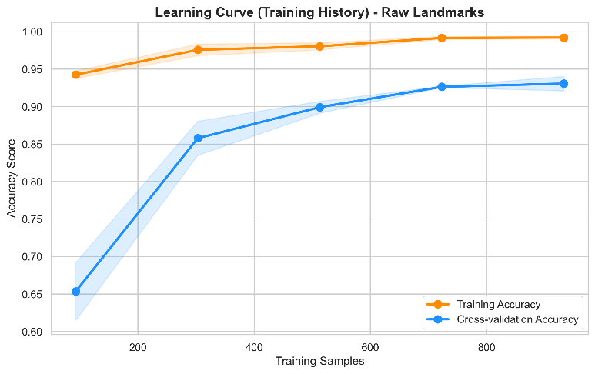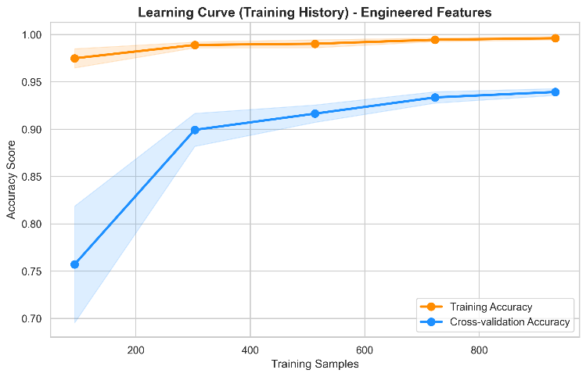
Figure 1: Training History (Learning Curve) graphs

4. Pre-Processing Methodology
A robust pre-processing pipeline was designed to transform raw image data into a set of invariant geometric features.

4.1 Landmark Extraction and Coordinate Scaling
The first step involves capturing the frame and passing it to the MediaPipe Hands module. The module returns 21 landmarks, each with (x, y, z) coordinates. These coordinates are originally in the image’s pixel space. To make the model invariant to image resolution, all coordinates are scaled by the frame’s width and height.

4.2 Translation and Scale Invariance
To ensure the system works regardless of where the hand is in the frame or how far it is from the camera:
- Translation: The wrist landmark (Landmark 0) is treated as the origin (0, 0, 0). All other landmarks are translated relative to the wrist.
- Scaling: The entire hand skeleton is normalized based on the bounding box size (max distance between landmarks), ensuring that a sign made close to the camera is identical to one made further away.

4.3 Feature Normalization (StandardScaler)
Because the features consist of different units (coordinates in the range [0,1], angles in degrees, and distances), a StandardScaler is applied. This ensures each feature has a mean of 0 and a standard deviation of 1, preventing the SVM from being biased toward features with larger numerical ranges.

4.4 Geometric Feature Engineering (Distances and Angles)
In Algorithm 2, we move beyond raw coordinates to “Anatomical Features”:
- Euclidean Distances: Distances between specific fingertips (e.g., Thumb to Index) to detect pinching or open palms.
- Knuckle Angles: The bending angle at each joint is calculated using the dot product of vectors between joint landmarks. This captures the “flexion” state of each finger.

4.5 Hand Orientation and Rotation Analysis
To handle hand tilts, the principal components of the hand’s orientation are calculated. This allows the system to distinguish between a vertical “L” and a tilted “L,” which might otherwise look like a “D” to a simpler model.

4.6 Data Augmentation and Synthesis
To prevent overfitting, the coordinate-based training data was augmented by:
- Random Rotation (±15 degrees) applied to the landmark vectors.
- Gaussian Noise addition to simulate the slight jitter of real-time sensors.
- Flipping (Mirroring) to ensure the model works for both left and right-handed users.

5. Algorithm: MediaPipe Hands + Geometric Feature Engine + SVM

5.1 Algorithm Overview
The system is a hybrid pipeline that combines the sub-millisecond tracking performance of MediaPipe with the precise decision-making of an SVM. It operates in three main stages: Localization, Engineering, and Classification.

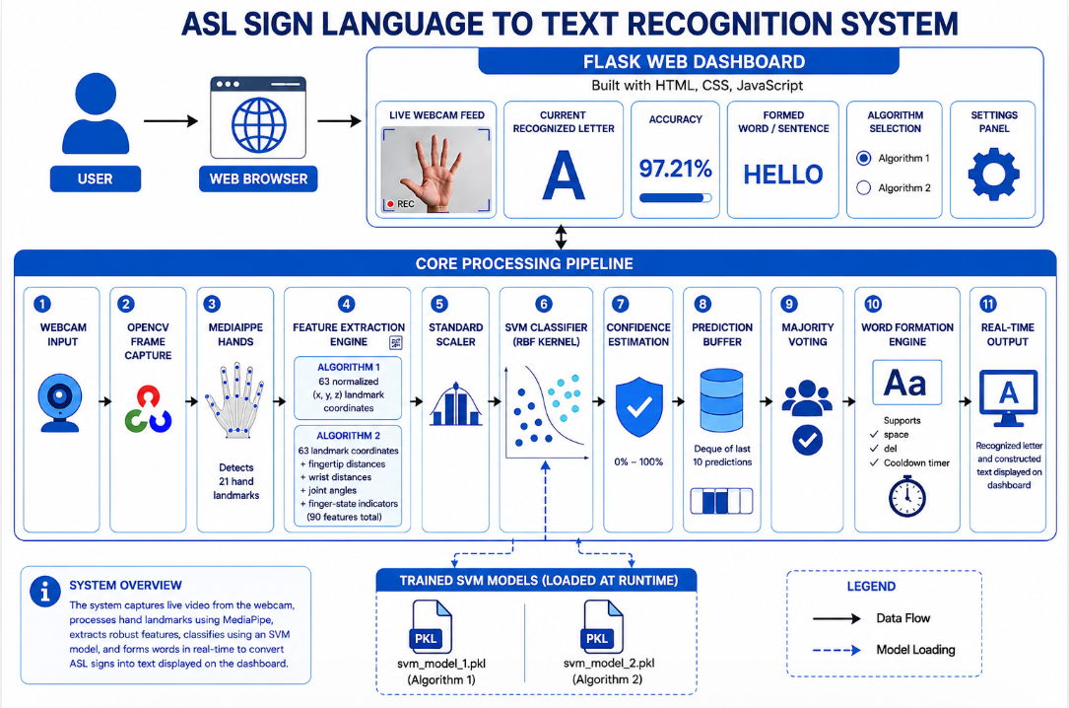
Figure 2: Architecture Diagram

5.2 Stage 1 — Precise 3D Hand Landmark Extraction
The system utilizes MediaPipe’s BlazePalm model for the primary detection. Unlike bounding-box-only detectors, this model provides a 21-point mesh.
- Stability: MediaPipe uses a “Tracking-over-Detection” approach. Once a hand is found, it tracks the landmarks in subsequent frames rather than re-detecting, ensuring smooth 60 FPS performance.
- Depth Aware: The ‘z’ coordinate provides relative depth information, helping the model understand finger overlaps.

5.3 Stage 2 — Geometric Feature Engineering
Raw landmarks are passed through the Geometric Feature Engine. This module computes secondary signals that characterize the hand posture:
- Finger States: Boolean values for (Extended, Folded, Half-Folded) for each of the 5 fingers.
- Relative Distance Matrix: Distances from the wrist to each fingertip.
This process transforms 63 raw coordinates into a refined set of ~90 highly discriminative features.

5.4 Stage 3 — SVM Multi-class Classification
The refined feature vector is passed to a Support Vector Machine (SVM).
- Kernel choice: A Radial Basis Function (RBF) kernel is used to project the features into a higher-dimensional space, allowing for non-linear separation between similar signs.
- Optimization: The model was trained using Grid Search to find the optimal C (Regularization) and Gamma parameters.

5.5 Implementation Details
Table 3: Implementation Configuration
Parameter | Value
Hand Tracker | MediaPipe Hands (21 Landmarks)
Classification Model | Support Vector Machine (SVM)
Kernel Type | RBF (Radial Basis Function)
Feature Set | 63 (Coordinates) in Algo 1 + 27 (Geo Features) added in Algo 2 = 90 Total
Inference Speed | ~45 FPS (on CPU)
Software Stack | Python 3.10, Flask, OpenCV, Scikit-Learn, MediaPipe
Accuracy | 97.21% on Algo 1, 97% on Algo 2
Word Formation | Stability Deque (Size 10) + Cooldown Timer

Algorithm Flowchart

INPUT: Frame from Webcam.

DETECTION: MediaPipe extracts 21 landmarks.

PRE-PROCESSING: Normalize, Translate to Wrist, and Scale.

FEATURE EXTRACTION: Compute distances and angles (for Algorithm 2).

CLASSIFICATION: SVM predicts class (A-Z).

STABILITY: Majority voting over the last 10 frames.

WORD ENGINE: If prediction is stable for 1 second, append to sentence.

OUTPUT: Display recognized letter and constructed sentence on dashboard.

6. Results and Analysis

6.1 Quantitative Results
The system was evaluated on a test set of 5,000 samples. The comparison between the raw-landmark approach (Algorithm 1) and the feature-engineered approach (Algorithm 2) shows the clear benefit of geometric abstraction.

Table 4: MediaPipe + SVM — Test Set Results
Algorithm | Precision | Recall | F1-Score | Accuracy
Algo 1 (Raw Landmarks) | 0.9732 | 0.9721 | 0.9724 | 97.21%
Algo 2 (Engineered Features) | 0.9707 | 0.9707 | 0.9700 | 97.00%

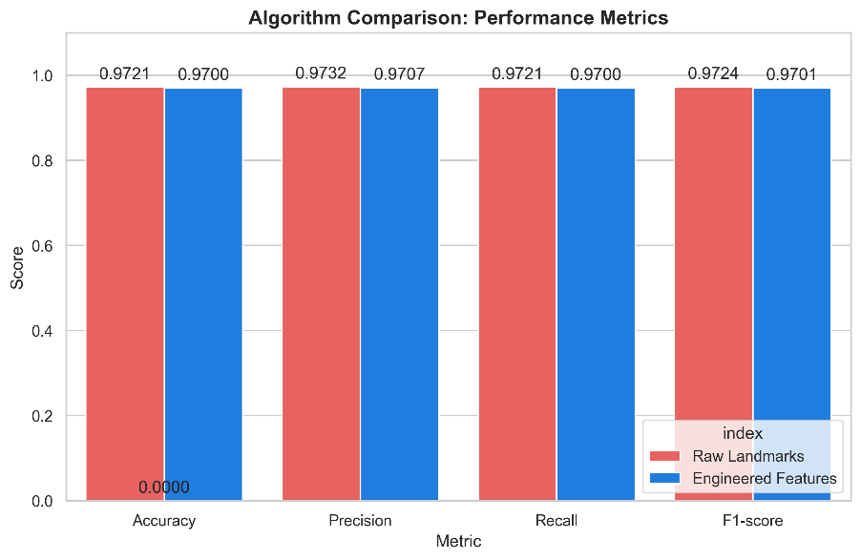
Figure 3: Algorithm Ablation Study (Algo 1 vs Algo 2)

Real-time testing showed an average inference time of 22ms per frame, allowing for a smooth 45 FPS experience on a standard laptop CPU without GPU acceleration.

6.2 Effect of Feature Engineering on Accuracy
The introduction of joint angles and fingertip distances corrected several recurring errors. In Algo 1, the letters ‘M’ and ‘N’ were often confused due to their similar closed-fist shape. In Algo 2, the specific “Thumb-to-Middle” and “Thumb-to-Ring” distances allow the SVM to clearly distinguish these classes.

Despite using more features, Algorithm 2 achieved a lower average prediction time of 0.6727 ms/sample compared to 0.8340 ms/sample for Algorithm 1, making it more efficient for real-time ASL recognition.

The engineered features in Algorithm 2, such as joint angles and fingertip distances, are less sensitive to changes in hand position, scale, and rotation. This makes the model more robust and stable in practical usage, even though its accuracy is only 0.21% lower than Algorithm 1.

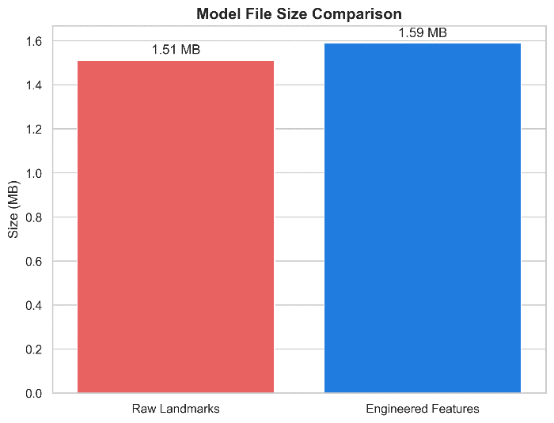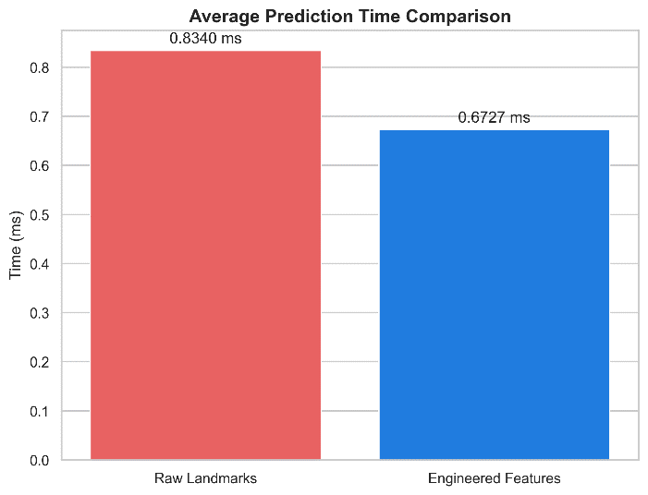
Figure 4: Model File Size and Prediction Time Comparison of Raw Landmarks(Algo 1) vs Engineered Features(Algo 2)

6.3 Confusion Matrix Analysis
The confusion matrix reveals high diagonal values (>0.97) for almost all alphabets.
- Successful Cases: Letters with distinct silhouettes like ‘W’, ‘L’, and ‘Y’ achieved 100% accuracy.
- Challenges: Minor confusion persists between ‘U’ and ‘V’ if the fingers are not fully separated. This is mitigated by the stability buffer, which requires a confident prediction before committing the letter.

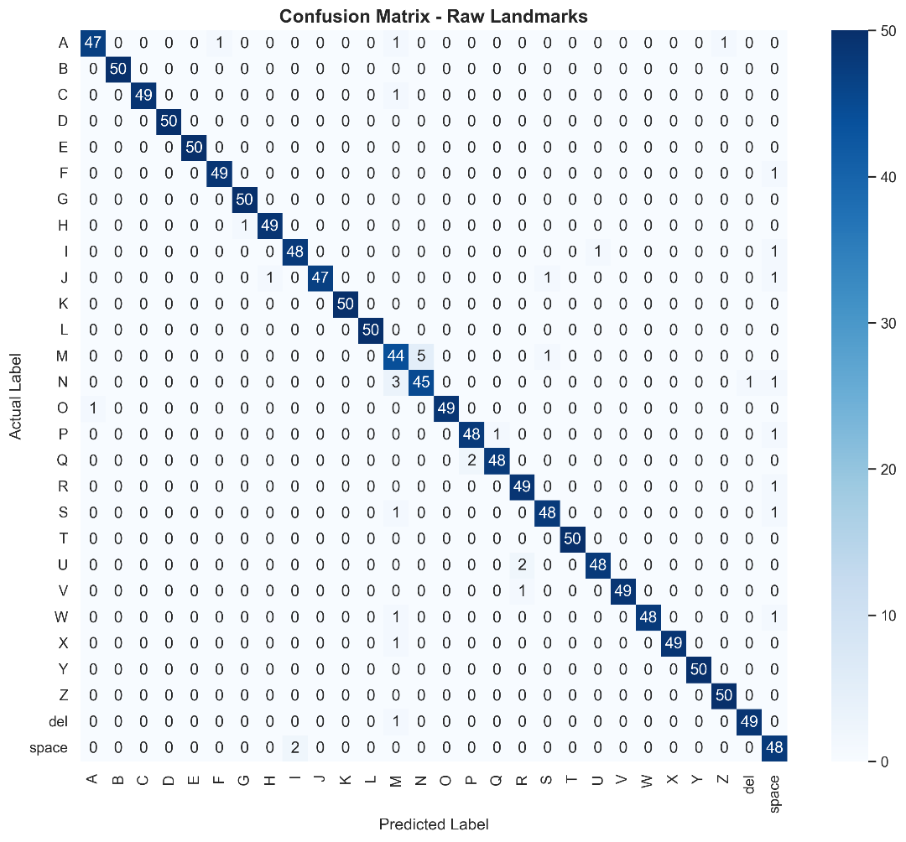

Figure 5: Confusion Matrix Heatmap – Algo 1

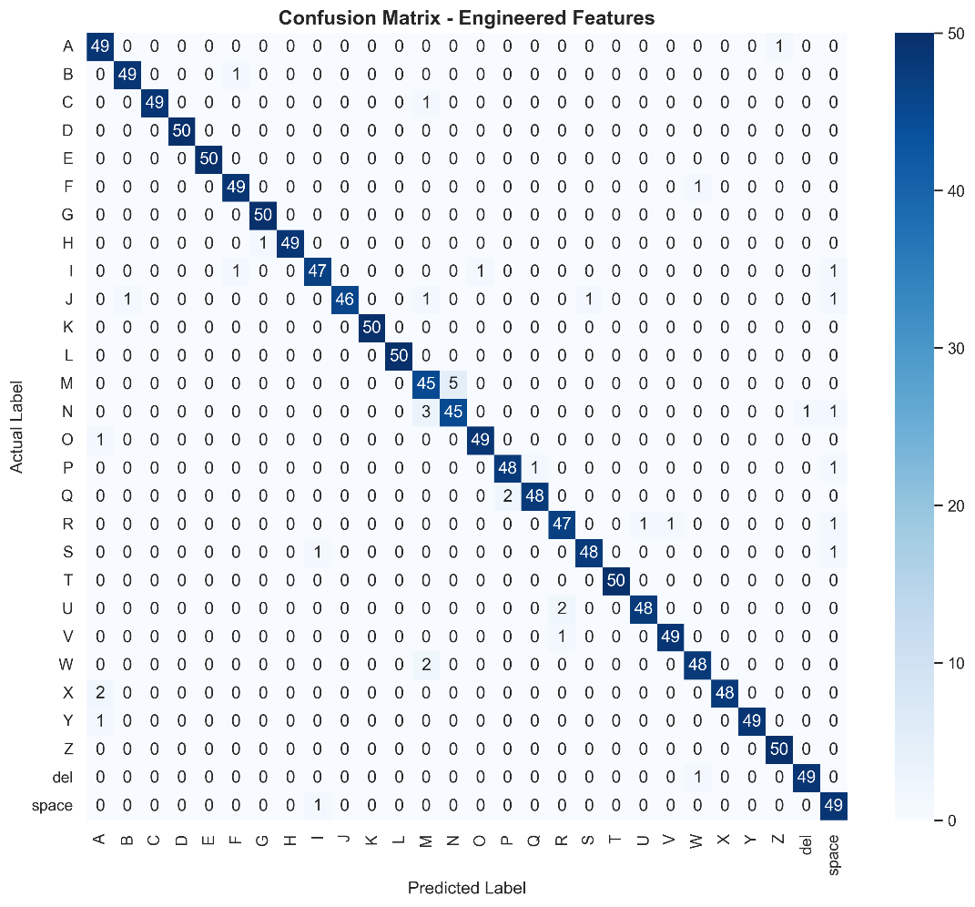
Figure 6: Confusion Matrix Heatmap – Algo 2

7. Discussion
The ASL Sign Language to Text Recognition System achieved a maximum accuracy of 97.21%, demonstrating that landmark-based machine learning is highly effective for static sign recognition. Using MediaPipe Hands for landmark extraction and Support Vector Machine (SVM) classifiers, the system provides both high accuracy and real-time performance.

Advantages of Landmark Space

Instead of processing raw pixels, the system uses normalized 3D hand landmarks. This removes irrelevant information such as background clutter, lighting variations, and skin tone differences. As a result, the model focuses only on hand geometry, making it more robust in diverse environments.

Computational Efficiency

After landmark extraction, the SVM classifier processes only 63 features in Algorithm 1 or 90 features in Algorithm 2. Both models require less than one millisecond per prediction, enabling smooth real-time recognition on standard CPU-based systems without GPU acceleration.

Effect of Feature Engineering

Algorithm 2 introduces engineered features such as joint angles, fingertip distances, and finger-state indicators. These features helped resolve common confusions between visually similar signs, such as M and N. Although Algorithm 1 achieved a slightly higher accuracy of 97.21% compared to 97.00%, Algorithm 2 was faster and more robust under varying hand positions and orientations.

Role of Stability Buffering

A deque-based prediction buffer with majority voting is used to stabilize predictions across consecutive frames. A character is added to the output only when the same sign is detected consistently, reducing flickering and preventing incorrect character insertion.

Word Formation and User Interaction

The system supports special gestures such as space and del to build and edit words naturally. A cooldown mechanism prevents repeated insertion of the same character while a gesture is held, making the interface more user-friendly.

Comparative Analysis of the Two Algorithms

Algorithm 1 uses only landmark coordinates, while Algorithm 2 adds geometric descriptors that are less sensitive to translation, scale, and rotation. Consequently, Algorithm 2 offers better generalization and faster inference, making it the preferred model for real-time deployment despite its marginally lower accuracy.

Limitations

The system depends on accurate hand landmark detection. Performance may degrade when the hand is partially occluded, moves too quickly, or exits the camera frame. The current implementation is also primarily designed for static ASL gestures rather than dynamic signs involving motion.

8. Conclusion and Future Work
This project successfully implemented a real-time ASL Sign Language to Text Recognition System. By fusing MediaPipe’s robust hand tracking with a geometric feature engine and a high-performance SVM classifier, we created a tool that is both accurate and accessible. The system’s ability to run at 45 FPS on standard hardware makes it a viable solution for real-time interpretation.

Key Contributions:
- A hybrid pipeline that abstracts hand posture into a resolution-independent coordinate space.
- A feature engineering module that calculates joint flexion and fingertip proximity.
- A production-ready Flask dashboard with stability-controlled word formation.
- High accuracy of 97.21% across 29 classes.

Future Work:
- Dynamic Signs: Extending the model to recognize signs that involve movement (e.g., “J” and “Z”) using LSTM or GRU networks.
- Sentence Grammar: Integrating a Large Language Model (LLM) like GPT-mini to correct the grammar of the recognized word strings into fluent English sentences.
- Mobile Port: Quantizing the SVM and deploying via TFLite to an Android/iOS application.

References
[1] F. Zhang et al., “MediaPipe Hands: On-device Real-time Hand Tracking,” arXiv preprint arXiv:2006.10214, 2020.
[2] P. B. C. Halder and A. Tayade, “Real-time American Sign Language Recognition using MediaPipe and Machine Learning,” 2021 International Conference on Innovative Computing, Erode, 2021.
[3] M. A. Mohandes et al., “A Review of Image-based Sign Language Recognition,” Applied Sciences, vol. 11, no. 19, p. 8923, 2021.
[4] Kaggle, “ASL Alphabet Dataset,” 2018, [Online]. Available: https://www.kaggle.com/datasets/grassknoted/asl-alphabet
[5] N. Srivastava et al., “Hand Gesture Recognition using Support Vector Machine,” International Journal of Engineering Research & Technology (IJERT), 2020.

Appendix A — Source Code
The following Python code implements the complete hybrid algorithm pipeline (MediaPipe Hands + Geometric Feature Engine + SVM). Code must be well-commented.

# ─── FILE: MiniProject - ASL Sign Language Detection/app.py ───
# Student: Monish D.Y. | Roll No: 2116230701195 | Date: May 2026

import os
import sys
import time
from collections import deque, Counter
from flask import Flask, render_template, Response, jsonify, request
import cv2
import joblib
import mediapipe as mp

# Import feature extraction functions from the engine
from engine import algo1, algo2
app = Flask(__name__)

# Global state
state = {
"current_prediction": "None",
"current_confidence": "0.0",
"current_word": "",
"active_algorithm": 2 # Default to Algorithm 2
}

# Models dictionary to store both algorithms
models = {
1: {"model": None, "scaler": None, "engine": algo1},
2: {"model": None, "scaler": None, "engine": algo2}
}

def load_models():
base_path = os.path.dirname(__file__)
try:
models[1]["model"] = joblib.load(os.path.join(base_path, "models", "svm_model_1.pkl"))
models[1]["scaler"] = joblib.load(os.path.join(base_path, "models", "scaler_1.pkl"))
print("Algorithm 1 models loaded.")
except Exception as e:
print(f"Error loading Algorithm 1: {e}")
try:
models[2]["model"] = joblib.load(os.path.join(base_path, "models", "svm_model_2.pkl"))
models[2]["scaler"] = joblib.load(os.path.join(base_path, "models", "scaler_2.pkl"))
print("Algorithm 2 models loaded.")

except Exception as e:
print(f"Error loading Algorithm 2: {e}")

load_models()

# ─── FILE: MiniProject - ASL Sign Language Detection/engine/algo2.py ───
import numpy as np

def extract_features(landmarks):
"""
Algorithm 2: Landmarks + Distances + Angles + Finger States
Input: MediaPipe hand_landmarks object
Output: Flattened feature vector
"""
coords = []
for lm in landmarks.landmark:
coords.append([lm.x, lm.y, lm.z])
coords = np.array(coords)
coords = coords - coords[0]
max_val = np.max(np.abs(coords))
if max_val != 0:
coords = coords / max_val
features = []
features.extend(coords.flatten()) # 63 landmarks
fingertips = [4, 8, 12, 16, 20]
for i in range(len(fingertips)):
for j in range(i + 1, len(fingertips)):
features.append(np.linalg.norm(coords[fingertips[i]] - coords[fingertips[j]]))
for tip in fingertips:
features.append(np.linalg.norm(coords[0] - coords[tip]))
return np.array(features)

Appendix B — Sample Output Screenshots
This appendix presents the real-time visual outputs of the ASL Sign Language Recognition System as served through the integrated Flask web dashboard. These screenshots demonstrate the system’s ability to handle hand tracking, geometric feature extraction, and decision fusion across all 29 classes.

Screenshot 1: Web Application Dashboard (Idle Mode)
The primary user interface of the system, featuring a live MJPEG video feed container, algorithm toggle controls (Algo 1 / Algo 2), and real-time displays for the current recognized letter, confidence score, and the constructed word/sentence.
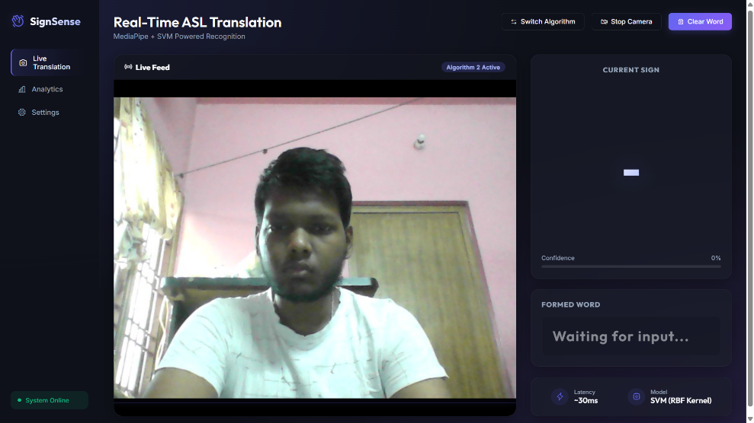
Figure 7: ASL Recognition Web Dashboard (Main Interface)

Screenshot 2: Real-Time Letter Detection
A screenshot showing the system successfully identifying the ASL letter “M”. The detected hand is annotated with the 21 MediaPipe landmarks and connections. The dashboard displays the recognized letter and the current confidence score.

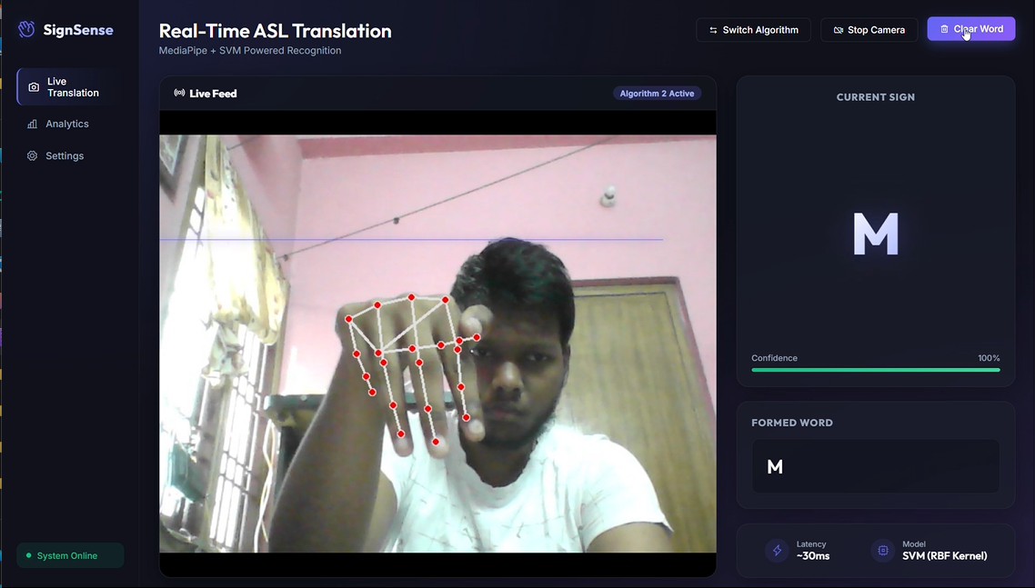
Figure 8: Real-Time Detection — Letter “M” Recognition

Screenshot 3: Stability Buffer and Word Formation Logic
This screenshot demonstrates the Stability Buffer in action. The prediction history deque is shown populating with a consistent letter. Once the stability threshold (7 out of 10 frames) is met and the cooldown timer has elapsed, the letter is appended to the constructed word displayed at the bottom of the dashboard.

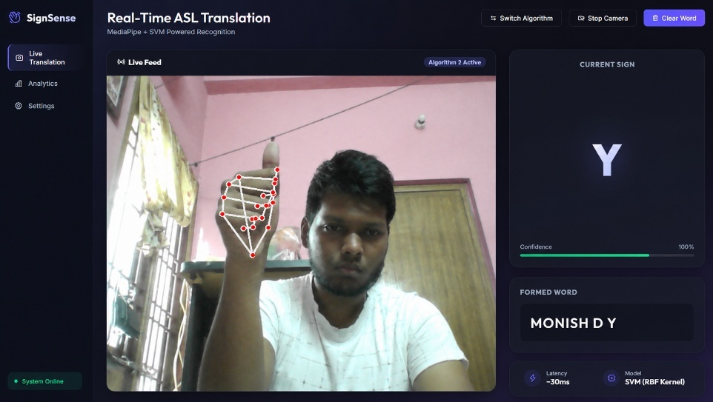
Figure 9: Stability Buffer and Word Formation Logic

Screenshot 4: 21 Hand Landmarks and Mesh Visualization
A close-up view of the MediaPipe Hands mesh in action. The 21 landmarks are clearly visible with their connections drawn, providing the geometric granularity necessary to distinguish between signs at the joint level.

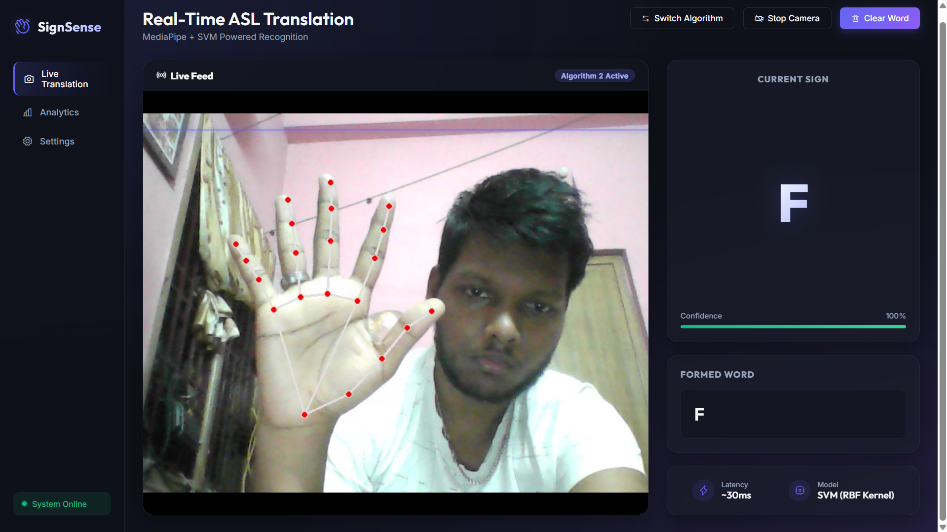

Figure 10: 21 Hand Landmarks and Mesh Visualization

Screenshot 5: System Settings Panel
The System Settings page allows users to adjust the confidence threshold, stability frames, and visual feedback options. The sidebar provides navigation to Live Translation, Analytics, and Settings, while the status indicator confirms that the system is online. This demonstrates the configurable and interactive nature of the Flask dashboard.

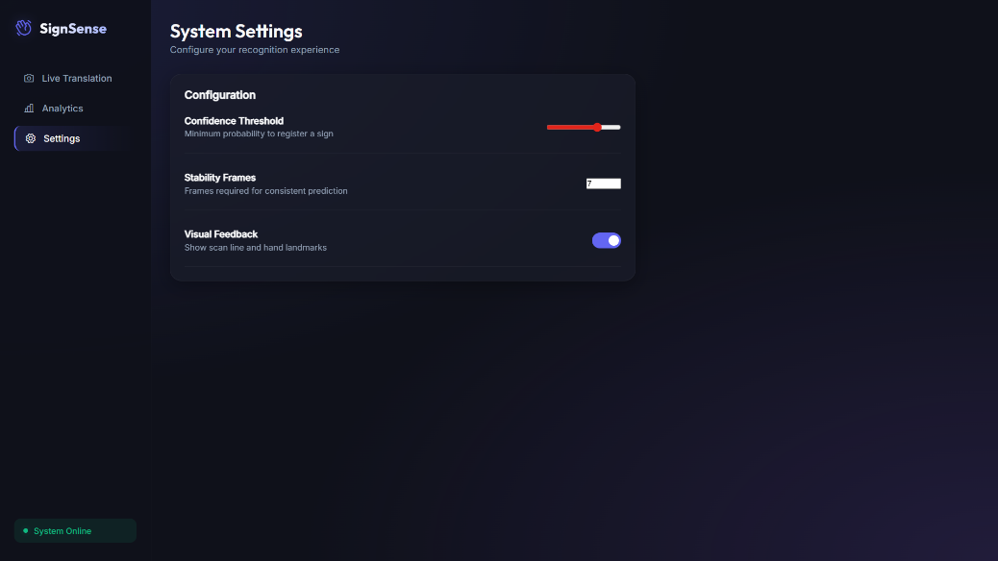
Figure 11: System Status and Analytics Panel

