HABITPULSE - INTELLIGENT GAMIFIED HABIT TRACKER

A PROJECT REPORT
Submitted by,

MONISH D Y 2116230701195
MATHAN KUMAR M 2116230701181

in partial fulfilment of the award of the degree
of

BACHELOR OF ENGINEERING
IN
COMPUTER SCIENCE AND ENGINEERING



RAJALAKSHMI ENGINEERING COLLEGE
ANNA UNIVERSITY, CHENNAI

MAY 2026
RAJALAKSHMI ENGINEERING COLLEGE (AUTONOMOUS)
RAJALAKSHMI NAGAR, THANDALAM – 602 105

BONAFIDE CERTIFICATE
Certified that this project titled "HabitPulse - Intelligent Gamified Habit Tracker" is the bonafide work of MONISH D Y (2116230701195), MATHAN KUMAR M (2116230701181), who carried out the project work under my supervision.

SIGNATURE OF THE FACULTY,
Dr. V. KARTHICK, M.E. (Ph.D.)
Associate Professor and Supervisor,
Department of Computer Science and Engineering,
Rajalakshmi Engineering College,
Thandalam, Chennai – 602 105.

Submitted to the Project Viva-Voce Examination held on _______________.

INTERNAL EXAMINER EXTERNAL EXAMINER

ABSTRACT

In today’s fast-paced world, maintaining positive habits and staying consistent with personal goals has become increasingly challenging. While many habit tracking applications are available, most of them offer only basic progress monitoring and fail to keep users motivated over long periods. HabitPulse is an Android-based mobile application developed using Kotlin in Android Studio to provide an engaging and rewarding approach to habit building. The application is designed to work entirely offline and uses modern Android components such as Room Database, DataStore, and WorkManager to store user data securely and manage reminder notifications efficiently. The application integrates a variety of features, including habit creation and tracking, streak monitoring, experience points (XP), level progression, achievements, daily quests, boss battles, analytics dashboards, calendar-based history, and a floating focus timer. These gamification elements transform routine habit tracking into an interactive experience that motivates users to remain disciplined and consistent. The user interface is developed using Jetpack Compose and follows the MVVM architectural pattern, ensuring a clean, responsive, and maintainable design. This project demonstrates how gamification principles and modern mobile development practices can be combined to create an effective productivity tool. The Intelligent Gamified Habit Tracker serves as a digital companion for users seeking to build better habits, improve self-discipline, and achieve long-term personal growth through a single intuitive mobile application.

ACKNOWLEDGEMENT

Initially, we thank the Almighty for being with us through every walk of our lives and showering his blessings through the endeavour to put forth this report. Our sincere thanks to our chairman, Mr. S. MEGANATHAN, B.E, F.I.E., our respected Chairperson, Dr. (Mrs.) THANGAM MEGANATHAN, Ph.D., our Vice Chairman, Mr. ABHAY SHANKAR MEGANATHAN, B.E, M.S., for providing us with the requisite infrastructure and sincere endeavour in educating us in their premier institution.
Our sincere thanks to Dr. S.N. MURUGESAN, M.E., Ph.D., our beloved principal for his kind support and facilities provided to complete our work in time. We express our sincere thanks to Dr. E. M. MALATHY, M.E., Ph.D., Professor and Head of the Department of Computer Science and Engineering, and our mentor, Dr. V. Karthick, M.E., Ph.D., Assistant Professor, Department of Computer Science and Engineering, for his useful tips during our review to build our project.

TABLE OF CONTENTS

CHAPTER | TITLE | PAGE NO.
A | ABSTRACT
B | ACKNOWLEDGEMENT
1 | INTRODUCTION | 1
 | GENERAL | 1
 | SCOPE OF THE PROJECT | 1
 | AIM AND OBJECTIVE OF THE PROJECT | 2
2 | LITERATURE SURVEY | 3
3 | SYSTEM DESIGN | 5
 | ARCHITECTURE DIAGRAM | 5
 | USE CASE DIAGRAM | 5
 | HARDWARE SPECIFICATIONS | 6
 | SOFTWARE SPECIFICATIONS | 7
4 | PROPOSED SYSTEM | 9
5 | MODULE DESCRIPTION | 11
6 | OUTPUT | 13
7 | CONCLUSION AND FUTURE ENHANCEMENTS | 14
8 | REFERENCES | 15

CHAPTER 1
INTRODUCTION

  - GENERAL
Habit formation plays a crucial role in achieving personal and professional success. However, maintaining consistency is often difficult because users lose motivation after the initial excitement fades. Traditional habit tracking applications provide simple checklists but lack features that make the process engaging. The Intelligent Gamified Habit Tracker – HabitPulse, was designed to solve this problem by integrating gaming concepts into daily habit management. In this application, users earn experience points (XP) whenever they complete habits. As they accumulate points, they level up, unlock achievements, and gain access to special challenges such as boss battles and daily quests. The application also includes reminder notifications, analytics dashboards, calendar-based progress visualization, and a productivity timer. These features work together to help users stay focused and committed to their goals.

1.2 SCOPE OF THE WORK
The scope of HabitPulse is to design and develop an Android-based mobile application that helps users build and maintain productive habits. The application is intended for students, professionals, and individuals who want to improve consistency, discipline, and overall productivity.
The project includes:
- Habit creation, editing, and deletion
- Daily progress tracking and streak monitoring
- Analytics with charts and completion statistics
- Gamification using points, badges, and achievements
- Reminder notifications for scheduled habits
- Offline data storage using local storage
HabitPulse provides a simple and user-friendly interface that works entirely offline, allowing users to manage their habits anytime without an internet connection. Advanced features such as cloud synchronization and social sharing are not included in the current version and can be considered for future enhancements.

1.3 AIM AND OBJECTIVES OF THE PROJECT
HabitPulse aims to empower users to build lasting positive habits and eliminate unproductive routines by providing a smart, engaging, and gamified mobile application that promotes consistency, productivity, and personal growth. The objectives of HabitPulse are to provide a user-friendly platform for efficiently creating, organizing, and tracking daily habits. The application monitors habit completion and streaks, motivates users through a reward-based system using XP, levels, badges, and achievements, and sends reminder notifications to encourage consistency. It also offers visual analytics and progress insights to help users evaluate their performance over time. HabitPulse is designed to operate entirely offline, using local storage to ensure reliable access to data without an internet connection.
CHAPTER 2
LITERATURE SURVEY

Habit tracking and productivity applications have been extensively studied as effective tools for promoting self-discipline and long-term behavioral change. Lally et al. showed that habits are formed through repeated actions performed consistently in stable contexts, highlighting the importance of daily tracking and streak maintenance [1]. Fogg’s Behavior Model states that behavior occurs when motivation, ability, and triggers are present simultaneously, supporting the inclusion of reminder notifications and simple user interfaces [2]. Deci and Ryan’s Self-Determination Theory explains that users remain engaged when they experience autonomy, competence, and achievement, which justifies the use of rewards and progress indicators [3].
Gamification has proven to be a powerful strategy for increasing motivation and sustaining user engagement. Deterding et al. defined gamification as the use of game design elements such as points, badges, levels, and challenges in non-game contexts [4]. Hamari et al. concluded that gamification positively influences engagement and commitment across various domains [5]. Werbach and Hunter emphasized that meaningful reward structures and continuous feedback loops are essential for maintaining user interest [6].
Additional research has expanded on the design of habit-forming products. Eyal’s Hook Model describes how triggers, actions, rewards, and investments work together to build long-term user habits [7]. Zichermann and Cunningham demonstrated that achievements and progression systems significantly enhance participation [8]. Chou’s Octalysis Framework identified motivational drivers such as accomplishment, ownership, and curiosity, which are highly effective in productivity applications [9]. Nir and Eyal further highlighted the role of progress tracking and variable rewards in sustaining attention and consistency [10].
Existing applications provide practical implementations of these concepts. Habitica transforms tasks into a role-playing game where users earn experience points, unlock rewards, and complete quests, inspiring the XP system, achievements, daily quests, and boss battles in HabitPulse. Loop Habit Tracker focuses on simplicity and offers streak tracking, habit strength calculations, and visual graphs, which inspired the analytics dashboard and progress monitoring features.
Based on these studies and applications, HabitPulse integrates habit creation, streak tracking, reminder notifications, visual analytics, XP-based leveling, achievements, daily quests, boss battles, and mastery galleries into a single offline Android application. By combining psychological principles of habit formation with advanced gamification techniques, HabitPulse provides a more immersive, motivating, and effective experience than conventional habit tracking applications.

CHAPTER 3
SYSTEM DESIGN

3.1 ARCHITECTURE DIAGRAM
HabitPulse follows the Model-View-ViewModel (MVVM) architecture. The user interface is developed using Jetpack Compose, which communicates with ViewModels. The ViewModels contain the business logic and interact with repositories that manage data flow between the application and the Room Database. WorkManager is used to execute background tasks such as notifications, while DataStore stores user preferences. This layered architecture ensures maintainability, scalability, and separation of concerns.

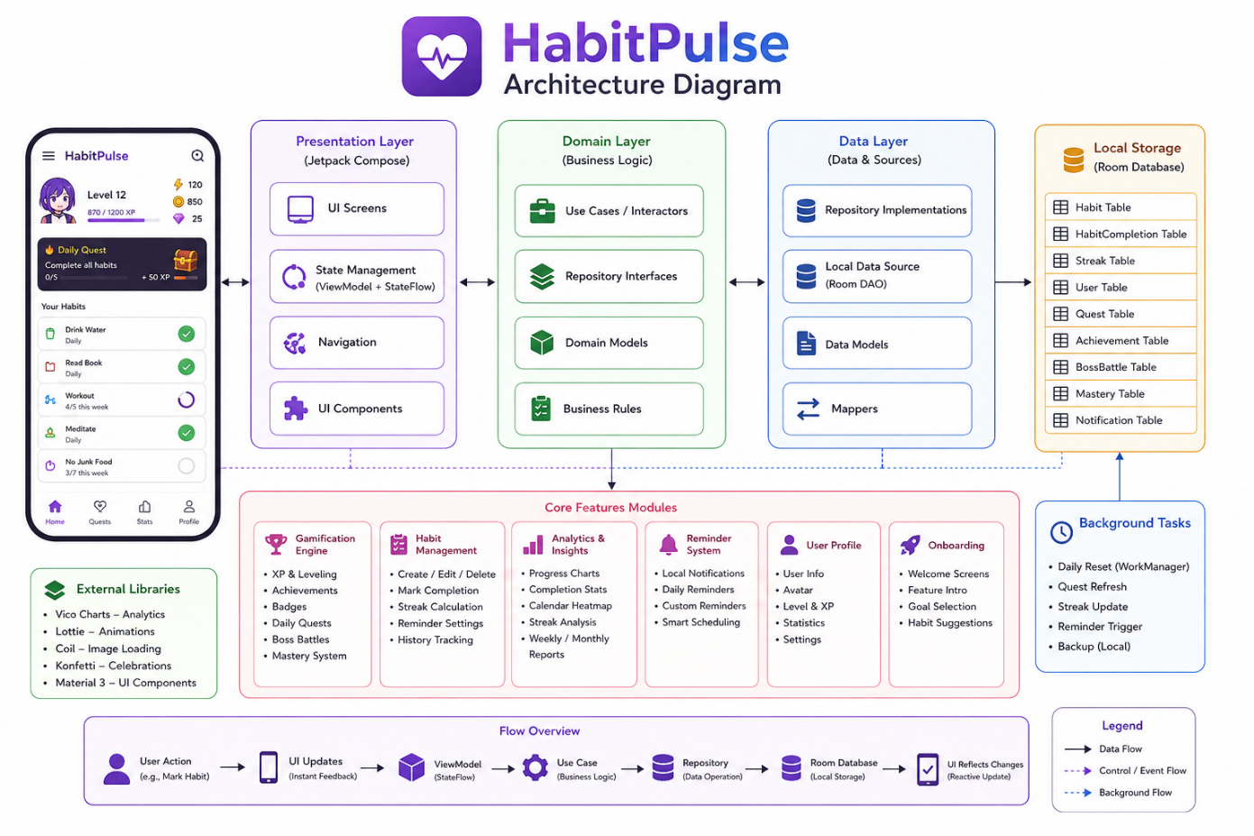

Fig 3.1.1 Architecture Diagram

3.2 USE CASE DIAGRAM
The primary actor in the system is the user. The user can register and log in, create and manage habits, mark habits as completed, view dashboards, earn rewards, unlock achievements, analyze progress, receive reminders, complete quests, participate in boss battles, and view profile statistics. The use case diagram illustrates the interaction between the user and these system functionalities.
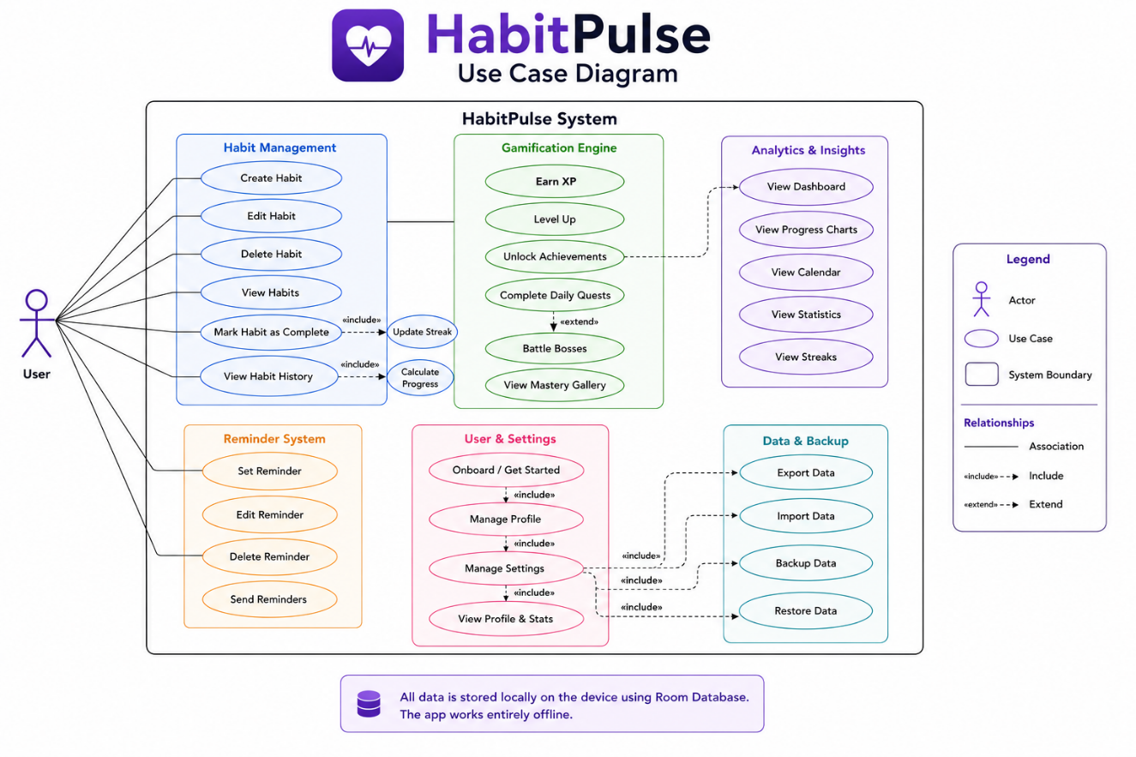
Fig 3.2.1 Use Case Diagram

3.3 HARDWARE SPECIFICATIONS
The successful development and execution of HabitPulse require suitable hardware resources for the development environment and the target Android devices. Since the application is designed to operate entirely offline, no dedicated server infrastructure is required for the current version.
DEVELOPMENT SYSTEM REQUIREMENTS
The development environment for HabitPulse requires a computer with the following minimum specifications:
- Processor: Intel Core i5 (8th Generation or higher) or AMD Ryzen 5 equivalent
- RAM: 8 GB minimum (16 GB recommended)
- Storage: At least 20 GB of free disk space
- Operating System: Windows 10/11, macOS, or Linux
- Display: Full HD (1920 × 1080) resolution recommended
- Internet Connection: Required for downloading dependencies and updates
MOBILE DEVICE REQUIREMENTS
HabitPulse is designed to run on Android smartphones with the following specifications:
- Operating System: Android 8.0 (API Level 26) or higher
- RAM: Minimum 3 GB
- Storage: Approximately 100 MB of free space
- Processor: Quad-core or higher
- Notification Support: Required for reminder alerts
SERVER REQUIREMENTS
HabitPulse does not require a dedicated server for its core functionality. All user data is stored locally on the device using Room Database, enabling the application to function completely offline. Optional cloud infrastructure may be added in future versions for backup and synchronization features.
The successful development and deployment of HabitPulse require appropriate hardware resources for both the development environment and the target Android devices to ensure smooth performance, efficient data processing, and reliable offline operation.

3.4 SOFTWARE SPECIFICATIONS
The development of HabitPulse requires a collection of software tools, frameworks, and libraries to design the user interface, implement application logic, manage local data, and support testing and deployment.

FRONTEND TECHNOLOGIES
The frontend is developed using Kotlin with Jetpack Compose and Material 3 to create a modern, responsive, and user-friendly interface.

BACKEND TECHNOLOGIES
The application logic is built using MVVM and Clean Architecture, with Kotlin Coroutines and Flow for handling asynchronous operations and real-time data updates.

DATABASE TECHNOLOGIES
Room Database is used to store habits, progress, and achievements locally, while DataStore is used to store application settings and user preferences.

THIRD-PARTY LIBRARIES AND SERVICES
Hilt is used for dependency injection, WorkManager for scheduling reminder notifications and background tasks, Vico Charts for visual analytics, and Lottie and Konfetti for animations and celebration effects.

VERSION CONTROL
Git and GitHub are used to manage source code and track project changes.

OTHER SUPPORTING TOOLS
Android Studio is used as the integrated development environment, with Gradle for build automation and Java 17 for language compatibility.

ANDROID SDK REQUIREMENTS
The application supports Android 8.0 (API Level 26) and above, with API Level 34 used as the target and compile SDK version.
These software requirements provide the complete development environment needed to build, test, and deploy HabitPulse as a fully functional offline Android application.

CHAPTER 4
PROPOSED SYSTEM

HabitPulse is a gamified Android application designed to make habit building more engaging, motivating, and effective. Unlike traditional habit trackers that simply record whether a task was completed, HabitPulse transforms the process into an interactive experience by rewarding users with experience points (XP), levels, badges, and achievements. This approach encourages users to remain consistent and view personal development as a rewarding journey rather than a routine task.
The application allows users to create and manage custom habits by specifying habit names, categories, frequencies, and reminder times. Users can mark habits as completed each day, and the system automatically updates streak counts, completion history, and progress statistics. Every completed habit contributes to the user’s XP, which helps them level up and unlock new milestones.
To increase engagement, HabitPulse includes advanced gamification features such as dynamic daily quests, achievement badges, mastery progression, and boss battles. Daily quests provide additional challenges based on user behavior, while boss battles are milestone-based events where consistent habit completion helps the user “defeat” a virtual boss. The mastery system tracks progress within specific habit categories such as fitness, learning, and health.
The application also provides a comprehensive analytics dashboard that displays completion rates, streak trends, XP growth, and category-wise performance using interactive charts. A calendar view allows users to review their habit history on specific dates, and a floating focus timer supports productivity techniques such as Pomodoro sessions.
HabitPulse is designed as an offline-first application. All user data, including habits, progress, achievements, and settings, is stored locally using Room Database and DataStore. Reminder notifications are scheduled using WorkManager, ensuring reliable operation even when the device is offline.
Overall, the proposed system combines habit tracking, productivity tools, and game mechanics into a single mobile application that helps users build positive habits, stay motivated, and achieve long-term personal growth.

CHAPTER 5
MODULE DESCRIPTION
HabitPulse is organized into several functional modules, each responsible for handling a specific aspect of the application. This modular design improves maintainability, scalability, and code organization while ensuring that all core features work together seamlessly.

5.1 AUTHENTICATION MODULE
The Authentication Module manages user registration and login using locally stored credentials. It ensures secure access to the application and maintains the user’s profile information and personalized progress data.

5.2 ONBOARDING MODULE
The Onboarding Module introduces first-time users to the features of HabitPulse and collects initial preferences such as username, avatar, and habit interests. This helps personalize the application experience from the beginning.

5.3 HABIT MANAGEMENT MODULE
The Habit Management Module allows users to create, edit, and delete habits. Users can define habit categories, target frequencies, and reminder times, while the system stores completion history and maintains streak information.

5.4 DASHBOARD MODULE
The Dashboard Module serves as the main screen of the application. It displays daily habits, current streaks, XP, level, and a summary of overall progress.

5.5 GAMIFICATION ENGINE
The Gamification Engine calculates experience points, levels, and rewards based on habit completion. It provides a sense of progression and motivates users to remain consistent.

5.6 DAILY QUEST AND BOSS BATTLE MODULE
The Daily Quest Module generates dynamic challenges based on the user’s active habits. Completing these quests grants bonus XP and additional rewards. The Boss Battle Module introduces milestone-based challenges where users must complete habits consistently to defeat virtual bosses and unlock achievements.

5.7 ACHIEVEMENT MODULE
The Achievement Module tracks milestones and awards badges for accomplishments such as maintaining streaks, completing quests, and reaching higher levels.

5.8 ANALYTICS MODULE
The Analytics Module presents performance insights through charts and statistics, including completion rates, streak trends, and category-wise progress. The Calendar provides a date-wise view of habit completion history, allowing users to review their consistency over time.

5.9 REMINDER MODULE
The Reminder Module uses WorkManager to schedule and deliver local notifications that remind users to complete their habits.

5.10 TIMER MODULE
The Timer Module provides a floating focus timer that supports productivity techniques such as the Pomodoro method.
Together, these modules form the complete HabitPulse system, integrating habit tracking, gamification, analytics, and productivity tools into a unified application that helps users build lasting habits and achieve their personal goals.

CHAPTER 6
OUTPUT
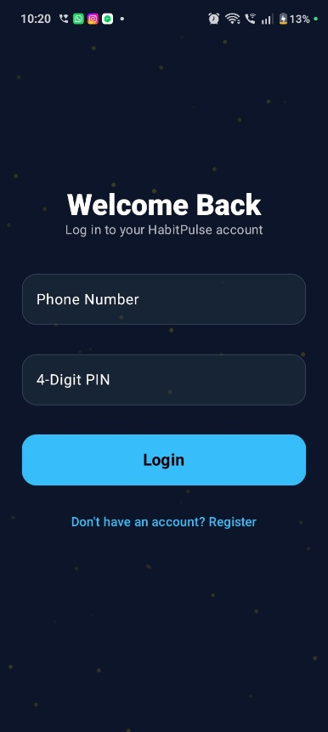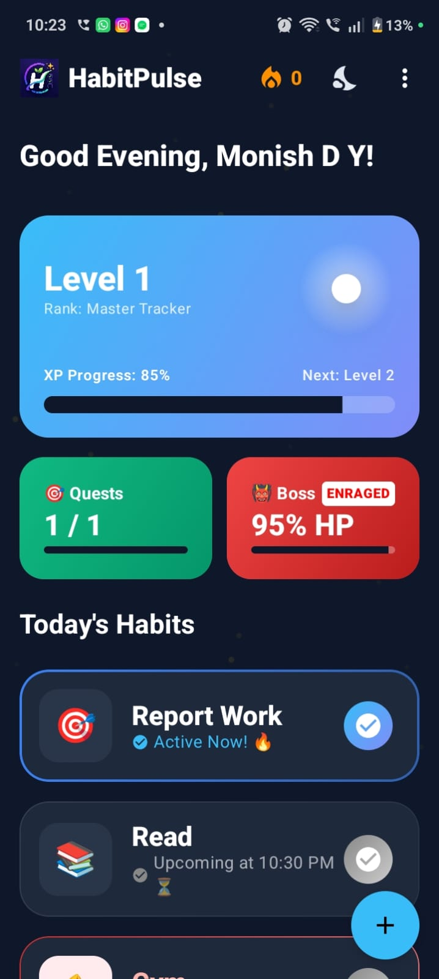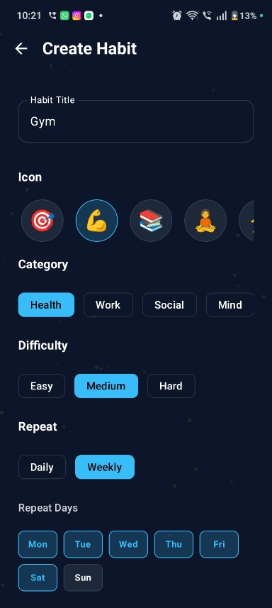
(a) (b) (c)
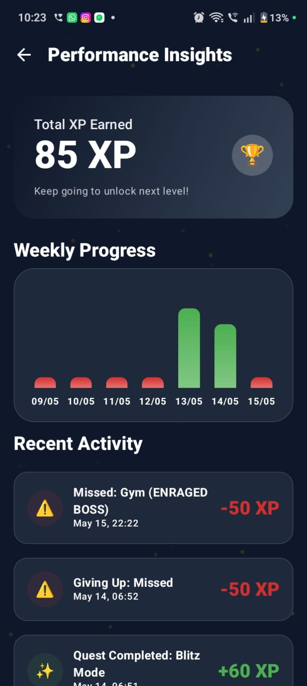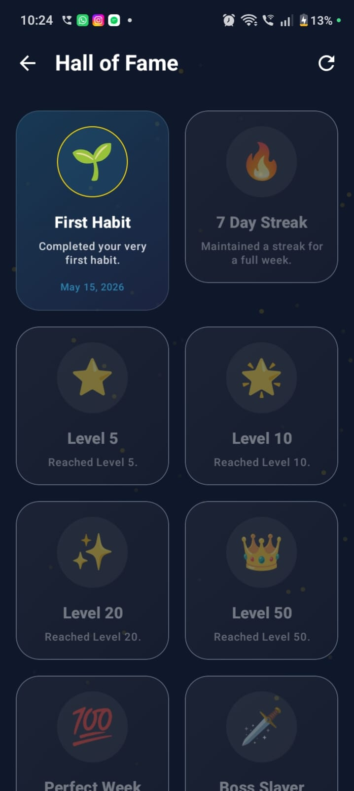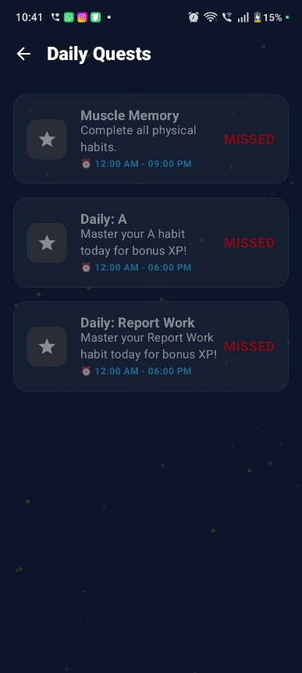
(d) (e) (f)
Fig 6.1 Output Screenshots of HabitPulse App
CHAPTER 7
CONCLUSION AND FUTURE ENHANCEMENTS

CONCLUSION
HabitPulse successfully demonstrates how gamification can transform habit tracking into a more engaging and motivating experience. By combining productivity principles with game mechanics such as XP, levels, achievements, daily quests, and boss battles, the application encourages users to maintain consistency and develop positive habits over time.
The project is implemented using modern Android technologies including Kotlin, Jetpack Compose, Room Database, Hilt, WorkManager, and DataStore. These technologies provide a scalable, maintainable, and efficient architecture. The application also includes analytics, calendar history, reminder notifications, and a focus timer, making it a comprehensive productivity tool. Its offline-first design ensures that all features remain fully functional without an internet connection, improving reliability and accessibility. Overall, HabitPulse achieves its objective of helping users improve productivity, discipline, and personal growth through an interactive and user-friendly mobile application.
FUTURE ENHANCEMENTS
Future versions of HabitPulse can include cloud synchronization using Firebase or Supabase, allowing users to back up and restore data across multiple devices. Social features such as friend leaderboards, team challenges, and habit-sharing can be added to increase engagement and accountability. Artificial intelligence can be integrated to provide personalized habit recommendations, adaptive reminders, and predictive analytics based on user behavior. Additional enhancements may include smartwatch integration, PDF report generation, advanced theme customization, widget support, and cross-platform deployment using Kotlin Multiplatform or Flutter.
These improvements would further enhance the functionality, accessibility, and overall impact of HabitPulse as a next-generation habit tracking and productivity platform.

CHAPTER 8
REFERENCES

[1] Lally, P., van Jaarsveld, C. H. M., Potts, H. W. W., & Wardle, J. (2010). How are Habits Formed: Modelling Habit Formation in the Real World. European Journal of Social Psychology, 40(6), 998–1009.
[2] Fogg, B. J. (2009). A Behavior Model for Persuasive Design. Proceedings of the 4th International Conference on Persuasive Technology.
[3] Deci, E. L., & Ryan, R. M. (2000). The “What” and “Why” of Goal Pursuits: Human Needs and the Self-Determination of Behavior. Psychological Inquiry, 11(4), 227–268.
[4] Deterding, S., Dixon, D., Khaled, R., & Nacke, L. (2011). From Game Design Elements to Gamefulness: Defining Gamification. Proceedings of the 15th International Academic MindTrek Conference.
[5] Hamari, J., Koivisto, J., & Sarsa, H. (2014). Does Gamification Work? A Literature Review of Empirical Studies on Gamification. Proceedings of the 47th Hawaii International Conference on System Sciences.
[6] Werbach, K., & Hunter, D. (2012). For the Win: How Game Thinking Can Revolutionize Your Business. Wharton Digital Press.
[7] Eyal, N. (2014). Hooked: How to Build Habit-Forming Products. Portfolio.
[8] Zichermann, G., & Cunningham, C. (2011). Gamification by Design. O’Reilly Media.
[9] Chou, Y. K. (2015). Actionable Gamification: Beyond Points, Badges, and Leaderboards. Octalysis Media.
[10] Nir, E., & Eyal, N. (2019). Indistractable: How to Control Your Attention and Choose Your Life. BenBella Books.

