DOCUMENT MANAGEMENT SYSYTEM
U23CS492-  FULL STACK DEVELOPMENT PROJECT  APRIL/MAY 2025 |  | U23CS492-FULLSTACK DEVELOPMENT PROJECT REPORT  SUBMITTED IN PARTIAL FULFILLMENT OF THE REQUIREMENTS FOR THE AWARD OF THE  DEGREE OF BACHELOR OF ENGINEERING  IN CSE (ARTIFICIAL INTELLIGENCE AND MACHINE LEARNING)  OF THE ANNA UNIVERSITY
 |  | 
PROJECT  WORK  BATCH  2023 – 2027 |  | SUBMITTED BY  MONISH KANNA M 722823148035
UNDER THE GUIDANCE OF
DR.S.SUMATHI,
ASSOCIATE PROFESSOR AND HEAD
DEPARTMENT OF CSE(ARTIFICIAL INTELLIGENCE AND MACHINE LEARNING)
 | Sri Eshwar College of Engineering  (An Autonomous Institution)  Kinathukadavu (Tk), Coimbatore - 641 202, Tamil Nadu  Approved by AICTE, New Delhi and Affiliated to Anna University, Chennai |  | 



BONAFIDE CERTIFICATE

Certified that this Report titled “Document Management System” is the bonafide work of
MONISH KANNA M | 722823148035

who carried out the project work under my supervision.

----------------------------------------- | -----------------------------------------
SIGNATURE | SIGNATURE
Dr. S.Sumathi, M.E, Ph.D.  HEAD OF THE DEPARTMENT,  Associate Professor & Head,  CSE (Artificial Intelligence and Machine Learning),  Sri Eshwar College of Engineering,  Coimbatore – 641 202. | Ms.P.Preethi, M.E.,(Ph.D),  SUPERVISOR  Assistant Professor,  CSE (Artificial Intelligence and Machine Learning),  Sri Eshwar College of Engineering,  Coimbatore – 641 202.

Submitted for the Autonomous Semester End Full Stack Development Project Viva-Voce held on………………….

_________________________  INTERNAL EXAMINER | _________________________  EXTERNAL EXAMINER


QUALITY POLICY
To establish a system of Quality Enhancement, which would on a continuous basis evaluate and enhance the quality of teaching – learning, research and extension activities of the institution, leading to improvements in all processes, enabling the institution to attain excellence.

INSTITUTION VISION
To be recognized as a premier institution, grooming students into globally acknowledged engineering professionals.

INSTITUTION MISSION
- Providing outcome and value-based engineering education
- Nurturing research and entrepreneurial culture
- Enabling students to be industry ready and fulfil their career aspirations
- Grooming students through behavioural and leadership training programs
- Making students socially responsible

DEPARTMENT OF CSE (ARTIFICIAL INTELLIGENCE AND MACHINE LEARNING)

DEPARTMENT VISION
To become a model hub for Computer Science and Engineering-Artificial Intelligence and Machine Learning education and research by acquiring, disseminating, and generating knowledge in order to meet societal demands.

DEPARTMENT MISSION
- Evolve curriculum and delivery approaches to provide broad and wide exposure to the learner to gain adequate knowledge in their field of study.
- Provide opportunities for faculties to enhance their domain knowledge and skills required for the programs offered.
- Establish connections with local, national and global experts to share, utilize and exchange domain expertise.
- Conduct Outreach activities for the society that involve the use of artificial intelligence and machine learning solutions to deal with societal issues.
- Create and provide a conducive ecosystem and facilities for offering education related to artificial intelligence and machine learning.PROGRAM

EDUCATIONAL OBJECTIVES
PEO1: Graduates will have successful careers in AI and ML-related fields, including positions such as data scientists, machine learning engineers, AI researchers, and consultants.
PEO2: Graduates will recognize the dynamic nature of AI and ML technologies and engage in continuous learning to stay abreast of the latest advancements, tools, and techniques in the field.
PEO3: Graduates will have the knowledge and skills to identify opportunities for applying AI and ML in various domains, potentially founding startups, or contributing to the growth and competitiveness of existing organizations.

PROGRAM OUTCOMES
PO1: Engineering Knowledge: Apply knowledge of mathematics, natural science, computing, engineering fundamentals and an engineering specialization as specified in WK1 to WK4 respectively to develop to the solution of complex engineering problems.
PO2: Problem Analysis: Identify, formulate, review research literature and analyze complex engineering problems reaching substantiated conclusions with consideration for sustainable development. (WK1 to WK4)
PO3: Design/Development of Solutions: Design creative solutions for complex engineering problems and design/develop systems/components/processes to meet identified needs with consideration for the public health and safety, whole-life cost, net zero carbon, culture, society and environment as required. (WK5)
PO4: Conduct Investigations of Complex Problems: Conduct investigations of complex engineering problems using research-based knowledge including design of experiments, modelling, analysis & interpretation of data to provide valid conclusions. (WK8).
PO5: Engineering Tool Usage: Create, select and apply appropriate techniques, resources and modern engineering & IT tools, including prediction and modelling recognizing their limitations to solve complex engineering problems. (WK2 and WK6)
PO6: The Engineer and The World:Analyze and evaluate societal and environmental aspects while solving complex engineering problems for its impact on sustainability with reference to economy, health, safety, legal framework, culture and environment. (WK1, WK5, and WK7).
PO7: Ethics: Apply ethical principles and commit to professional ethics, human values, diversity and inclusion; adhere to national & international laws. (WK9)
PO8: Individual and Collaborative Team work: Function effectively as an individual, and as a member or leader in diverse/multi-disciplinary teams.
PO9: Communication: Communicate effectively and inclusively within the engineering community and society at large, such as being able to comprehend and write effective reports and design documentation, make effective presentations considering cultural, language, and learning differences
PO10: Project Management and Finance: Apply knowledge and understanding of engineering management principles and economic decision-making and apply these to one’s own work, as a member and leader in a team, and to manage projects and in multidisciplinary environments.
PO11: Life-Long Learning: Recognize the need for, and have the preparation and ability for i) independent and life-long learning ii) adaptability to new and emerging technologies and iii) critical thinking in the broadest context of technological change. (WK8)

PROGRAM SPECIFIC OUTCOMES
PSO1: Apply the knowledge of mathematical concepts, programming fundamentals and algorithms for solving complex problems in AI and ML domains.
PSO2: Design, implement, and evaluate end-to-end AI solutions, including data acquisition, preprocessing, model development, deployment, and monitoring, adhering to best practices in software engineering and system design.

ACKNOWLEDGEMENT

We thank God for his grace and blessing that have been showered upon us to bring success for this project. The success we have accomplished in our project would not have been possible without the timely help and guidance rendered to us by many people. We take this opportunity to thank them all.
We wish to express our deep gratitude Mr. R. Mohanram, Chairman, Sri Eshwar College of Engineering, Kondampatti for being kindly permitted us to carry on the project. He has an abiding interest in our wellbeing.
We are grateful to Dr. Sudha Mohanram M.E., Ph.D Principal, Sri Eshwar College of Engineering, Kondampatti for having made all provision available to us.
We are thankful to Mr. R. Rajaram, Director, Sri Eshwar College of Engineering, Kondampatti for all his support to complete the project effectively.
We would like to express our heartfelt gratitude and humble thanks to Head of the Department Dr. S.Sumathi M.E., Ph.D for having facilitated us to complete the project successfully.
With the deep sense of gratitude, we extend our earnest and sincere thanks to our project guide Ms.P.Preethi M.E,(Ph.D), Assistant Professor, Department of CSE (Artificial Intelligence and Machine Learning) , for his kind suggestion and co-operation for doing the project. Finally, we would like to extend our thanks to our teaching and non-teaching staffs those who helped us in bringing out project successfully.

CHAPTER NO. | TITLE |  | PAGE NO.
 | ABSTRACT |  | i
1 | LIST OF FIGURES  INTRODUCTION |  | ii
 | 1.1 | OBJECTIVES | 1
 | 1.2 | SCOPE OF THE PROJECT | 1
2 | SYSTEM ANALYSIS AND SPECIFICATION |  | 2
 | 2.1 | PROBLEM DESCRIPTION | 2
 | 2.2 | FUNCTIONAL REQUIREMENT - HARDWARE & SOFTWARE | 3
 | 2.3 | NON – FUNCTIONAL REQUIREMENT | 3
3 | SYSTEM DESIGN |  | 4
 | 3.1 | USE CASE DIAGRAM | 4
 | 3.2 | CLASS DIAGRAM | 4
4 | MODULE DESCRIPTION |  | 5
5 | IMPLEMENTATION |  | 6
6 | RESULTS AND DISCUSSION |  | 18
7 | CONCLUSION & FUTURE ENHANCEMENT |  | 20
8 | REFERENCES |  | 21

ABSTRACT

The increasing need for efficient and secure handling of digital information has led to the development of a Document Management System (DMS) that provides users with a robust platform for managing documents in an organized, scalable, and collaborative environment. This web-based system allows users to upload, store, retrieve, and manage a wide variety of document types, including PDFs, Word files, and plain text files, with features such as version control, access permissions, and document sharing capabilities.
The DMS is built using the MERN (MongoDB, ExpressJS, ReactJS, NodeJS) stack to ensure fast, dynamic, and responsive performance across devices. MongoDB is used to store user data, metadata, and document-related information, while AWS S3 handles cloud-based file storage, ensuring high availability and durability of files. The backend, powered by ExpressJS and NodeJS, provides RESTful APIs for all core functionalities such as user authentication, document upload/download, version tracking, and permission management. The frontend, developed in ReactJS, delivers a user-friendly interface that supports intuitive navigation and advanced search capabilities.
The system supports role-based access control, allowing administrators to define and manage user roles such as Admin, Editor, and Viewer. Users can maintain multiple versions of a document, making it easy to track changes and revert to previous states when necessary. Additionally, documents can be shared through secure links with configurable access levels, ensuring that sensitive information is protected from unauthorized access.
Advanced features like metadata-based search and tagging further enhance usability, enabling users to quickly locate documents using keywords, tags, or filter parameters such as file type, date, and uploader. Security is enforced through JWT-based authentication, HTTPS communication, and secure AWS S3 configurations.
In conclusion, the Document Management System provides a comprehensive solution for managing digital content efficiently and securely. Its scalable architecture, modern technology stack, and advanced features make it suitable for businesses, educational institutions.

 | LIST OF FIGURES
S NO | TITLE | PAGE NO
1 | USECASE DIAGRAM | 4
2 | CLASS DIAGRAM | 4
3 | HOME PAGE | 18
4 | REGISTER PAGE | 18
5 | DASHBOARD PAGE | 19
6 | UPLOAD PAGE | 19

CHAPTER 1 INTRODUCTION

1.1. OBJECTIVES

The primary objective of the Document Management System (DMS) is to develop a secure, scalable, and user-friendly web platform that enables users to efficiently manage digital documents. This includes functionalities for uploading, organizing, retrieving, sharing, and maintaining versions of documents while enforcing robust access control mechanisms. The system aims to minimize manual document handling, prevent data loss, and streamline collaboration across teams and organizations.

1.2 SCOPE OF THE PROJECT

The scope of the Document Management System (DMS) project involves the design and development of a web-based platform that enables users to upload, manage, search, and share digital documents securely and efficiently. The system will support various document formats such as PDF, DOCX, and TXT, and will store them using AWS S3 for scalable and secure cloud storage. It includes user authentication and role-based access control, allowing different levels of permissions for Admins, Editors, and Viewers. The platform will maintain version history for each document, enabling users to track changes and revert to previous versions when needed. It will also provide secure document sharing features through access-controlled links and allow users to manage collaborators. Advanced search and filtering capabilities based on metadata such as title, tags, uploader, and upload date will help users retrieve documents quickly. The frontend will be developed using ReactJS to ensure a responsive and intuitive user experience, while the backend will utilize NodeJS and ExpressJS with MongoDB for data handling and API integration.
CHAPTER 2
SYSTEM ANALYSIS AND SPECIFICATION

2.1.PROBLEM DESCRIPTION

In today’s digital age, organizations and individuals are generating and handling an ever-growing volume of documents. Managing these documents manually or through traditional file systems presents several challenges, including inefficient retrieval, lack of version control, poor access management, and the risk of data loss or unauthorized access. Employees often waste valuable time searching for files or working on outdated versions due to the absence of a centralized and organized document management solution.
This project aims to address these issues by developing a web-based Document Management System that simplifies document organization, enables secure storage and sharing, supports version control, and provides efficient access through metadata-based search. The system is designed to be scalable, user-friendly, and accessible, making it suitable for a wide range of users and organizations.

  - FUNCTIONAL REQUIREMENT
- User registration and login with role-based access (Admin, Editor, Viewer).
- Upload and store documents in various formats using AWS S3.
- Enable secure sharing with configurable access permissions.
- Provide search and filtering based on title, tags, and upload details.
- Admin panel for user and document management.
SOFTWARE REQUIREMENTS:
- Frontend: ReactJS, HTML, CSS, JavaScript
- Backend: NodeJS, ExpressJS
- Database: MongoDB
- Storage: AWS S3
- Authentication: JWT, bcrypt
- Tools: Postman, Git, VS Code
HARDWARE REQUIREMENTS:
- Client: Intel i3+, 4GB RAM, modern browser
- Server: Quad-core CPU, 8GB RAM, SSD storage, Linux/Windows OS
- Internet: Required for cloud operations

  - NON-FUNCTIONAL REQUIREMENT

- The system should perform well under multiple users and file uploads.
- It must be scalable to handle future growth.
- Security with encrypted login and safe file storage is essential.
- The system should be available almost all the time with minimal downtime.
- The interface must be simple and user-friendly.
- It should be easy to maintain and update.
- Compatible with modern browsers and devices.

CHAPTER 3 SYSTEM DESIGN
3.1 USECASE DIAGRAM

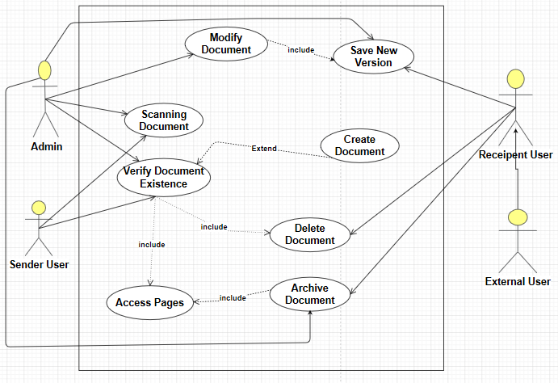

FIGURE 1 USECASE DIAGRAM

3.2 CLASS DIAGRAM
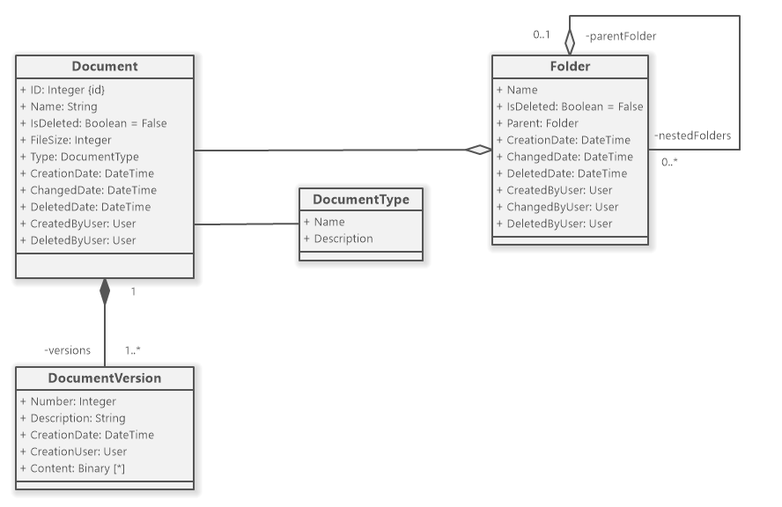

FIGURE 2 CLASS DIAGRAM

CHAPTER 4
MODULE DESCRIPTION

4.1 App Module
This is the main React component that acts as the root of the application. It manages routing and renders other components such as Login, Register, Document Upload, and Document List. It also links global CSS styles and controls the overall user interface flow.

4.2 Component Module
4.2.1 Login Component
Handles user authentication by providing a login form. It accepts user input for email and password and communicates with the backend API to verify credentials and manage user sessions.
4.2.2 Register Component
Manages new user registration by collecting user details like username, email, and password. It performs client-side validation and submits the data to the backend for creating new user accounts.
4.2.3 Document Upload Component
Allows users to upload documents in supported formats. It includes forms for selecting files and entering document metadata, and handles file transfer to AWS S3 through the backend.
4.2.4 Document List Component
Displays all uploaded documents accessible to the user. It shows document details such as title, version, upload date, and provides options to view, download, edit, or delete documents.
4.2.5 Document Version Control Component
Enables users to view previous versions of a document, compare changes, and revert to an earlier version if needed.
4.2.6 Version Access Permissions
Allows administrators to set permissions on who can view, compare, or revert document versions, ensuring secure and controlled version management.
4.2.7 Automatic Versioning
Automatically creates a new version of the document upon each save or significant
CHAPTER 5
IMPLEMENTATION

COMPONENTS:

FRONTEND

1.APP.JS
import React from "react";
import { BrowserRouter as Router, Routes, Route } from "react-router-dom";
import Login from "./Login";
import Register from "./Register";
import DocumentUpload from "./DocumentUpload";
import "./styles.css";

function App() {
return (
<Router>
<div className="app-container">
<Routes>
<Route path="/" element={<Login />} />
<Route path="/register" element={<Register />} />
<Route path="/upload" element={<DocumentUpload />} />
</Routes>
</div>
</Router>
);
}

export default App;
2.LOGIN.JS
import React, { useState } from "react";
import { useNavigate } from "react-router-dom";

function Login() {
const [email, setEmail] = useState("");
const [password, setPassword] = useState("");
const navigate = useNavigate();

const handleLogin = async (e) => {
e.preventDefault();
// TODO: Replace URL with your backend API endpoint
const response = await fetch("/api/login", {
method: "POST",
headers: { "Content-Type": "application/json" },
body: JSON.stringify({ email, password }),
});
if (response.ok) {
navigate("/upload");
} else {
alert("Login failed");
}
};

return (
<form onSubmit={handleLogin} className="form-container">
<h2>Login</h2>
<input
type="email"
placeholder="Email"
value={email}
onChange={(e) => setEmail(e.target.value)}
required
/>
<input
type="password"
placeholder="Password"
value={password}
onChange={(e) => setPassword(e.target.value)}
required
/>
<button type="submit">Login</button>
</form>
);
}
export default Login;

3.REGISTER.JS
import React, { useState } from "react";
import { useNavigate } from "react-router-dom";

function Register() {
const [username, setUsername] = useState("");
const [email, setEmail] = useState("");
const [password, setPassword] = useState("");
const navigate = useNavigate();

const handleRegister = async (e) => {
e.preventDefault();
const response = await fetch("/api/register", {
method: "POST",
headers: { "Content-Type": "application/json" },
body: JSON.stringify({ username, email, password }),
});
if (response.ok) {
alert("Registration successful");
navigate("/");
} else {
alert("Registration failed");
}
};

return (
<form onSubmit={handleRegister} className="form-container">
<h2>Register</h2>
<input
type="text"
placeholder="Username"
value={username}
onChange={(e) => setUsername(e.target.value)}
required
/>
<input
type="email"
placeholder="Email"
value={email}
onChange={(e) => setEmail(e.target.value)}
required
/>
<input
type="password"
placeholder="Password"
value={password}
onChange={(e) => setPassword(e.target.value)}
required
/>
<button type="submit">Register</button>
</form>
);
}
export default Register;

4. DOCUMENTUPLOAD.JS
import React, { useState } from "react";

function DocumentUpload() {
const [file, setFile] = useState(null);

const handleFileChange = (e) => {
setFile(e.target.files[0]);
};

const handleUpload = async (e) => {
e.preventDefault();
if (!file) return alert("Please select a file");

const formData = new FormData();
formData.append("document", file);

const response = await fetch("/api/upload", {
method: "POST",
body: formData,
});

if (response.ok) {
alert("File uploaded successfully");
setFile(null);
} else {
alert("Upload failed");
}
};

return (
<form onSubmit={handleUpload} className="form-container">
<h2>Upload Document</h2>
<input type="file" onChange={handleFileChange} />
<button type="submit">Upload</button>
</form>
);
}
export default DocumentUpload;

5.STYLES.CSS
.app-container {
max-width: 500px;
margin: 50px auto;
font-family: Arial, sans-serif;
}

.form-container {
display: flex;
flex-direction: column;
gap: 12px;
padding: 20px;
border: 1px solid #ddd;
border-radius: 8px;
}

input[type="email"],
input[type="password"],
input[type="text"],
input[type="file"] {
padding: 8px;
font-size: 16px;
}

button {
padding: 10px;
background-color: #007bff;
color: white;
border: none;
cursor: pointer;
font-weight: bold;
border-radius: 4px;
}

button:hover {
background-color: #0056b3;
}

BACKEND AND DATABASE:
1.MODELS/USER.JS
const mongoose = require("mongoose");

const userSchema = new mongoose.Schema({
username: { type: String, required: true },
email: { type: String, required: true, unique: true },
password: { type: String, required: true },
});

module.exports = mongoose.model("User", userSchema);

2.MODELS/DOCUMENT.JS
const mongoose = require("mongoose");

const documentSchema = new mongoose.Schema({
filename: { type: String, required: true },
originalName: { type: String, required: true },
userId: { type: mongoose.Schema.Types.ObjectId, ref: "User" },
uploadDate: { type: Date, default: Date.now },
version: { type: Number, default: 1 },
});

module.exports = mongoose.model("Document", documentSchema);
3.DB.JS
const mongoose = require("mongoose");
require("dotenv").config();

const connectDB = async () => {
try {
await mongoose.connect(process.env.MONGO_URI, {
useNewUrlParser: true,
useUnifiedTopology: true,
});
console.log("MongoDB connected");
} catch (err) {
console.error("MongoDB connection error:", err.message);
process.exit(1);
}
};

module.exports = connectDB;
4.SERVER.JS
const express = require("express");
const cors = require("cors");
const bcrypt = require("bcryptjs");
const jwt = require("jsonwebtoken");
const AWS = require("aws-sdk");
const multer = require("multer");
const multerS3 = require("multer-s3");
const path = require("path");
require("dotenv").config();

const connectDB = require("./db");
const User = require("./models/User");
const Document = require("./models/Document");

connectDB();

const app = express();
app.use(cors());
app.use(express.json());

const s3 = new AWS.S3({
accessKeyId: process.env.AWS_ACCESS_KEY_ID,
secretAccessKey: process.env.AWS_SECRET_ACCESS_KEY,
region: process.env.AWS_REGION,
});

// JWT middleware to protect routes
const authenticateToken = (req, res, next) => {
const token = req.headers["authorization"];
if (!token) return res.sendStatus(401);

jwt.verify(token.split(" ")[1], process.env.JWT_SECRET, (err, user) => {
if (err) return res.sendStatus(403);
req.user = user;
next();
});
};

// Multer S3 config
const upload = multer({
storage: multerS3({
s3,
bucket: process.env.AWS_S3_BUCKET,
acl: "private",
metadata: (req, file, cb) => {
cb(null, { fieldName: file.fieldname });
},
key: (req, file, cb) => {
const ext = path.extname(file.originalname);
cb(null, `documents/${Date.now().toString()}${ext}`);
},
}),
});

// Register user
app.post("/api/register", async (req, res) => {
const { username, email, password } = req.body;
try {
let user = await User.findOne({ email });
if (user) return res.status(400).json({ message: "User already exists" });

const hashedPassword = await bcrypt.hash(password, 10);
user = new User({ username, email, password: hashedPassword });
await user.save();

res.status(201).json({ message: "User registered successfully" });
} catch (err) {
res.status(500).json({ message: "Server error" });
}
});

// Login user
app.post("/api/login", async (req, res) => {
const { email, password } = req.body;
try {
const user = await User.findOne({ email });
if (!user) return res.status(400).json({ message: "Invalid credentials" });

const isMatch = await bcrypt.compare(password, user.password);
if (!isMatch) return res.status(400).json({ message: "Invalid credentials" });

const token = jwt.sign({ id: user._id, email: user.email }, process.env.JWT_SECRET, {
expiresIn: "1h",
});

res.json({ token, username: user.username });
} catch (err) {
res.status(500).json({ message: "Server error" });
}
});

// Upload document (protected route)
app.post("/api/upload", authenticateToken, upload.single("document"), async (req, res) => {
try {
const doc = new Document({
filename: req.file.key,
originalName: req.file.originalname,
userId: req.user.id,
version: 1,
}}

CHAPTER 6
RESULTS AND DISCUSSIONS
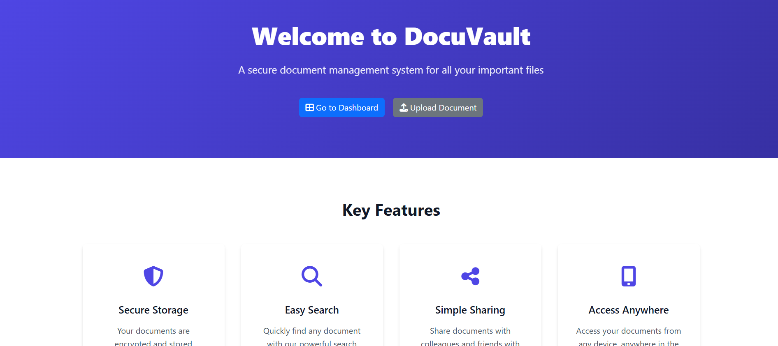 FIGURE 3 HOME PAGE
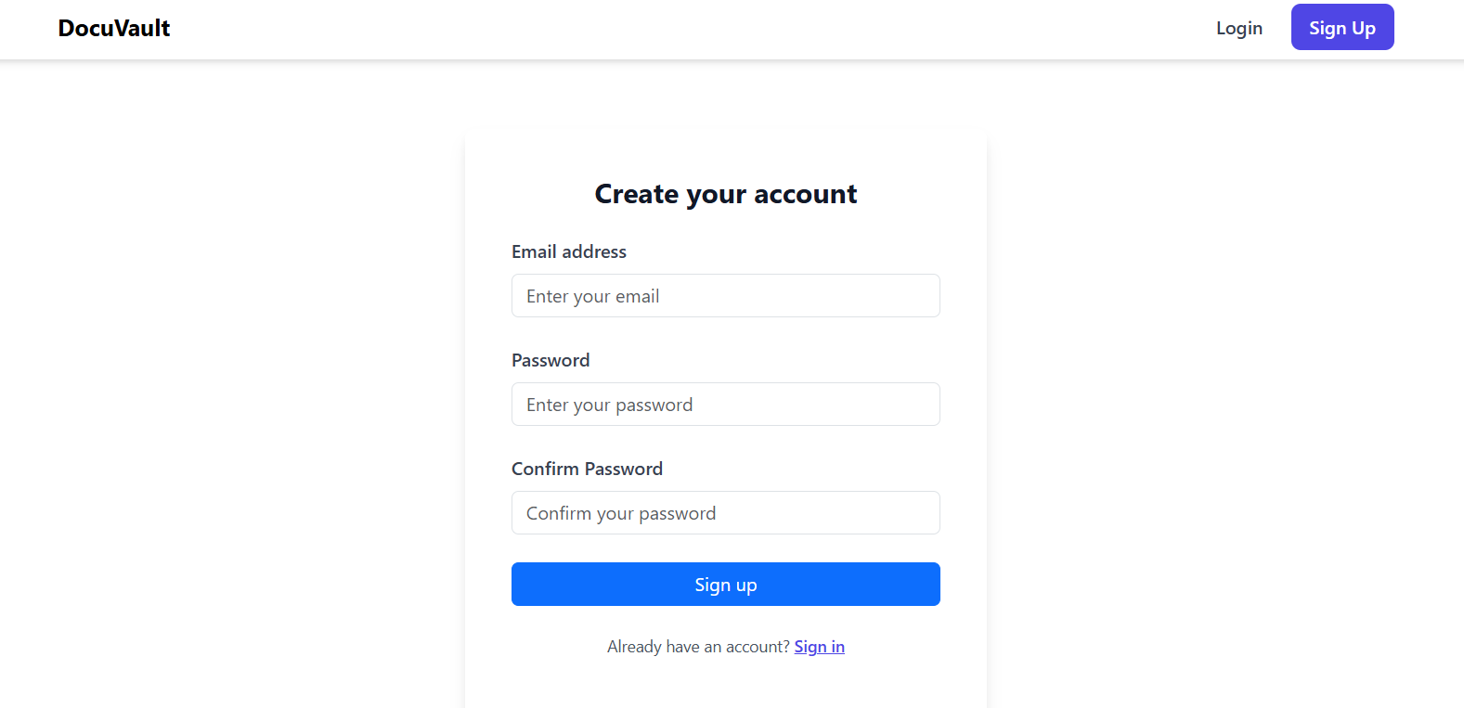
FIGURE 4 REGISTER PAGE

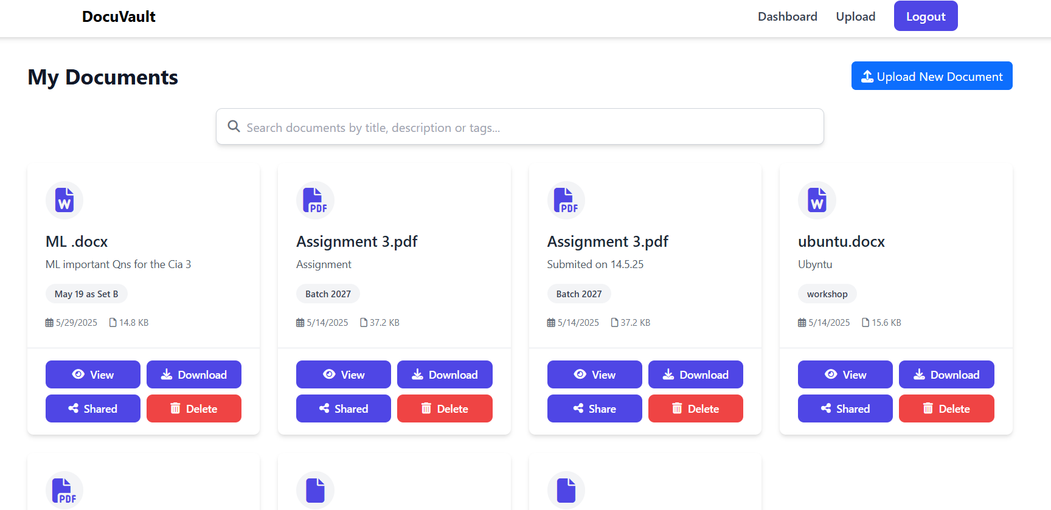 FIGURE 5 DASHBOARD PAGE
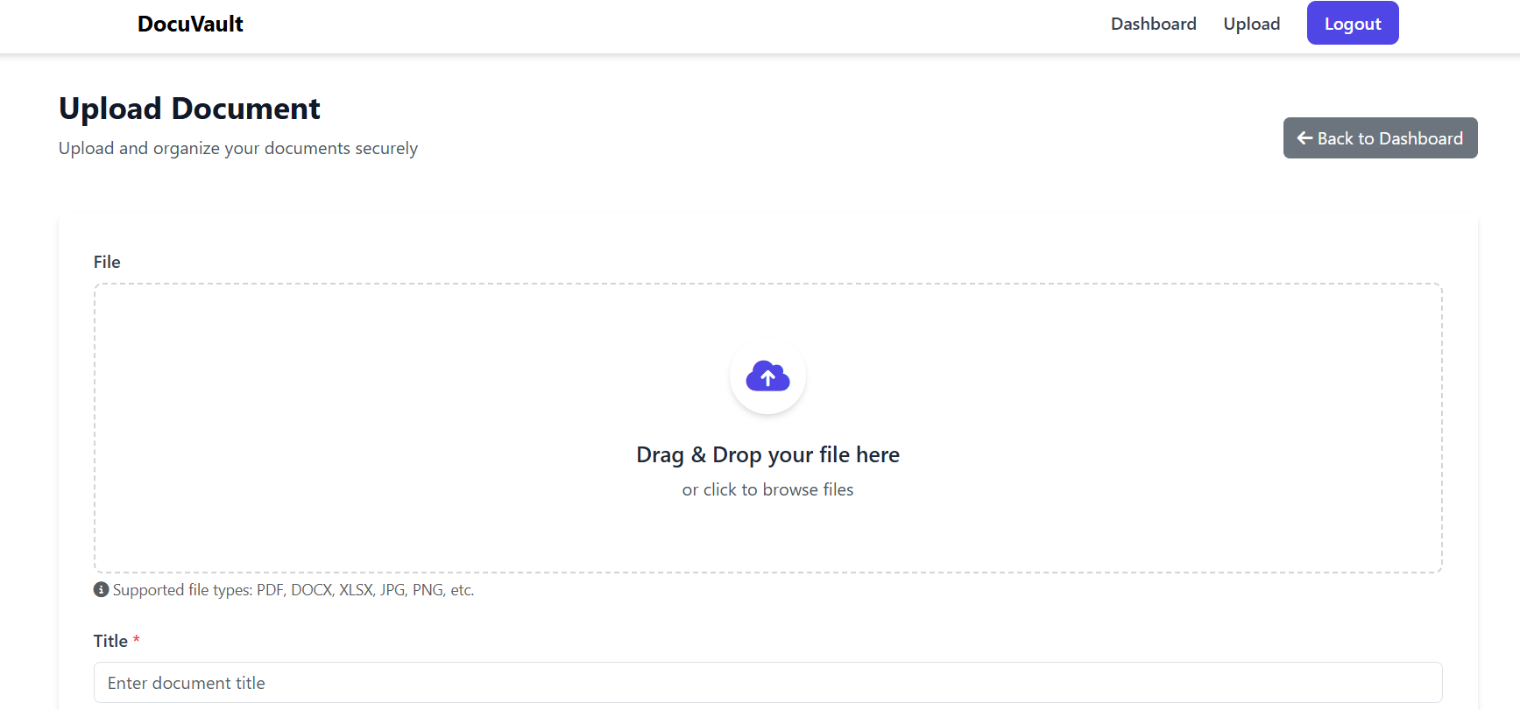 FIGURE 6 UPLOAD PAGE

CHAPTER 7
CONCLUSION AND FUTURE ENHANCEMENT

The Document Management System developed in this project effectively streamlines the process of uploading, organizing, and managing documents in a secure and efficient manner. By implementing essential features such as version control, role-based access permissions, and document sharing, the system resolves many challenges associated with traditional document handling methods. The integration of technologies like ReactJS for the frontend, NodeJS and ExpressJS for the backend, MongoDB for data storage, and AWS S3 for scalable file storage provides a strong foundation for performance, reliability, and security.

This system enhances productivity by enabling quick document retrieval through robust search functionality and ensuring data integrity with version tracking. The user-friendly interface allows seamless navigation across different modules, making it accessible to users with varying technical skills.
For future enhancements, several improvements can be considered to increase the system’s capabilities and usability. These include incorporating real-time collaborative editing features that allow multiple users to work on documents simultaneously, integrating AI and machine learning techniques for automated document tagging, classification, and content summarization, and supporting mobile applications for better accessibility on the go. Moreover, implementing detailed audit logs, multi-factor authentication, and more granular permission controls will strengthen security and compliance, especially for enterprise environments. Finally, integration with popular third-party tools such as Google Workspace, Microsoft Office 365, and Slack can facilitate smoother workflows and better adoption.

REFERENCES

- ReactJS Documentation. Available at: https://reactjs.org/docs/getting-started.html
- Node.js Official Documentation. Available at: https://nodejs.org/en/docs/
- Express.js Guide. Available at: https://expressjs.com/en/starter/installing.html
- MongoDB Manual. Available at: https://docs.mongodb.com/manual/
- AWS S3 Developer Guide. Available at: https://docs.aws.amazon.com/s3/index.html
- JSON Web Tokens (JWT) Introduction. Available at: https://jwt.io/introduction/
- bcrypt Documentation for Node.js. Available at: https://www.npmjs.com/package/bcrypt
- W3Schools - HTML, CSS, JavaScript Tutorials. Available at: https://www.w3schools.com/
- MDN Web Docs - Web Development Resources. Available at: https://developer.mozilla.org/en-US/
- Netlify-Document Mangment System (https.//Netlify.aws.ac.in/s1/index.html)

