**TASK-14**

**PIPES:**

Pipes are used to transform and format data before displaying it in the template. They allow us to modify the appearance and behavior of values without changing the underlying data.

Built-in Pipes:

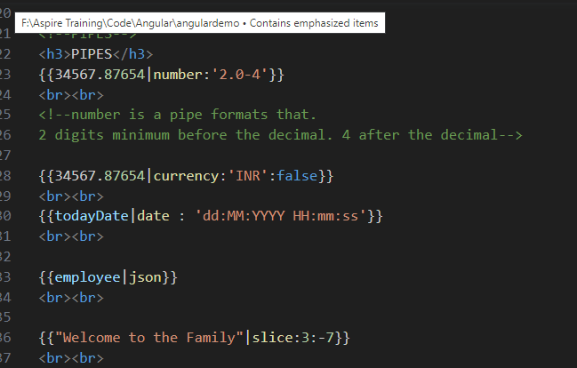

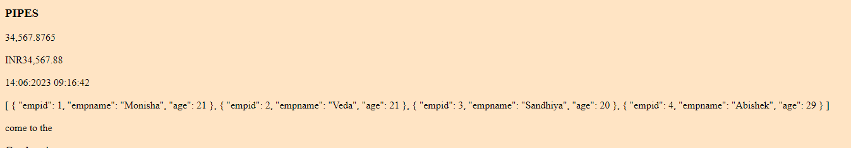

Customized pipe:

