**Task-15**

**Services:**

Services are a fundamental part of the architecture and are used to encapsulate reusable functionality that can be shared across different components. Services provide a way to organize and share data, logic, and functionality between components, ensuring a modular and maintainable codebase.

**cart service:**

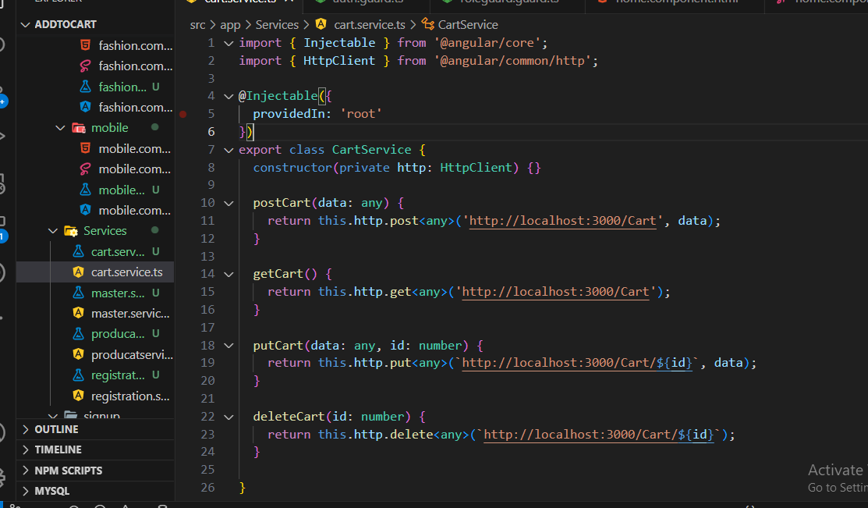

**cart service used in cart component:**

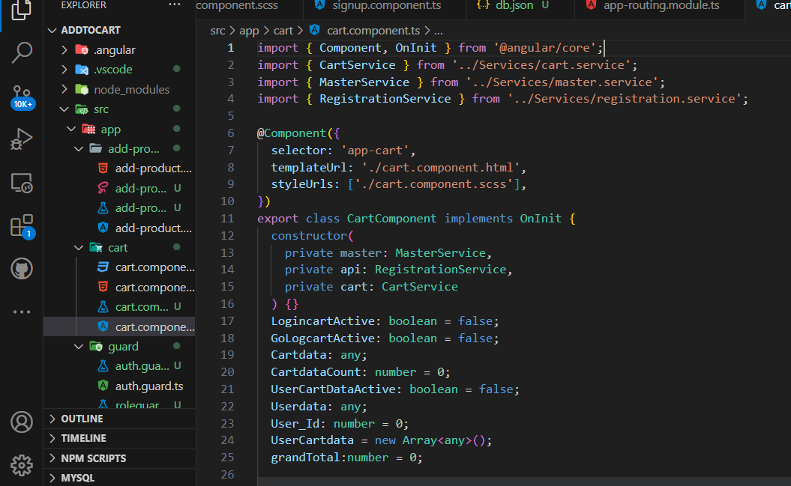

**cart service used in home component:**

