Comparative Evaluation of Two Adaptive ANC Pipelines
RL-Identified FxLMS vs. RL-Tuned Kalman Secondary-Path Tracking
Validated on MIT-BIH (record 118, EM + MA artifacts) and the PhysioNet ECG-ID Database
Technical Documentation
Active Noise Control Framework — Final Year Project
FxLMS · Reinforcement Learning · Kalman Filtering · Biomedical Signal Validation

Executive Summary
This document compares two adaptive active-noise-control (ANC) pipelines for electrocardiogram (ECG) artifact reduction. Pipeline A (RL-identified FxLMS) identifies the secondary path once, offline, using a reinforcement-learning-tuned NLMS estimator, then runs a fixed filtered-x LMS controller. Pipeline B (RL-tuned Kalman tracker) estimates the secondary path online with a Kalman filter whose covariance is reset by a reinforcement-learning-style innovation trigger, allowing it to follow a changing path.
Both pipelines were evaluated under identical conditions with three controlled measurement-path changes on (i) MIT-BIH record 118 contaminated with electrode-motion (EM) and muscle-artifact (MA) noise, and (ii) five distinct recordings from the PhysioNet ECG-ID Database that provide a genuine raw/clean signal pair. Headline findings: on a static path the two pipelines tie at the theoretical ceiling, but on a changing path Pipeline B is dramatically more robust — on the ECG-ID set it wins on all five records and avoids the catastrophic divergence Pipeline A suffers on noisy records (down to −61 dB). The advantage is robustness and graceful degradation, not perfect denoising; on the noisiest records neither pipeline reaches positive output SNR, but Pipeline B stays bounded while Pipeline A blows up.

1. Introduction and Background
Adaptive ANC removes an unwanted signal by generating an anti-signal that is filtered by the secondary path S(z) — the transfer function from the control actuator to the error sensor — before it cancels the disturbance. The filtered-x LMS (FxLMS) algorithm updates the control filter W(z) using the error e(n) and a reference filtered by an estimate of the secondary path, x′(n)=Ŝ(z)∗x(n). The accuracy of Ŝ(z) therefore governs both stability and achievable cancellation.
Two realities make Ŝ(z) difficult: it is unknown a priori and must be identified, and it drifts during operation. The two pipelines in this report embody two philosophies for handling this. One identifies the path once, accurately, and assumes it is stationary. The other tracks it continuously. This document quantifies the trade-off between them on real ECG data, where the same mathematics describes cancellation of a motion or muscle artifact from a cardiac signal.
An important framing point applies throughout: these are controlled signal-processing validations, not clinical devices. The secondary path is an explicitly synthetic “controlled measurement-path model,” the path changes are controlled perturbations (not physiological events), and clean ECG is used only for evaluation, never fed to the controller.

1.1 The FxLMS update and why the secondary-path estimate matters
In feed-forward ANC the controller output is y(n)=wᵀ(n)x(n), and the residual at the error sensor is e(n)=d(n)−s(n)∗y(n), where d(n) is the disturbance and s(n) the secondary-path impulse response. Because the control output is filtered by S(z) before it is observed, the steepest-descent update must filter the reference by an estimate of that path: w(n+1)=w(n)+μ e(n) x′(n) with x′(n)=Ŝ(z)∗x(n). If Ŝ(z) is accurate the gradient points downhill and the filter converges; if Ŝ(z) is wrong the gradient is rotated, and once the phase error exceeds ninety degrees the update climbs the error surface instead of descending it — the loop diverges. This single fact is the origin of every result in this report: a stale secondary-path estimate is not merely inaccurate, it can be destabilising.
On a stationary path this is a solved problem — identify Ŝ(z) once, well, and converge. The difficulty is non-stationarity. A change in temperature, electrode contact, sensor placement, or coupling shifts S(z) during operation, and any fixed Ŝ(z) then becomes progressively mismatched. The two pipelines compared here represent the two standard responses: re-use a very accurate but fixed estimate (and accept fragility under change), or track the path continuously (and accept a higher running cost).

1.2 Related approaches to secondary-path handling
Online secondary-path modelling has a long literature. Auxiliary-noise methods inject a low-level probe to keep identifying S(z) during control, at the cost of a small persistent noise floor; power-scheduling variants modulate the probe to trade identification speed against that floor. Variable-step-size and leaky FxLMS variants improve robustness to modelling error but do not themselves track an abrupt change. Recursive-least-squares and Kalman formulations treat identification as state estimation and can track, but their tracking-versus-steady-state behaviour is governed by a forgetting factor or process-noise term that must be set in advance. The pipeline compared here as Pipeline B sits in this last family, with two additions specific to abrupt, infrequent changes: an innovation-triggered covariance reset (rather than a globally high process noise, which would permanently raise the steady-state variance) and a reinforcement-learning-style supervisor that decides when to trigger it. Pipeline A represents the offline-identification tradition, augmented with reinforcement learning to tune the identifier rather than the controller.

2. The Two Pipelines

2.1 Pipeline A — RL-identified FxLMS (baseline)
An offline phase excites the secondary path with white noise and estimates it with a leaky normalised-LMS identifier. A tabular Q-learning agent tunes the identifier’s hyper-parameters (step size, filter order, leakage) across sixty episodes to minimise identification NMSE. The result is a single, highly accurate but static Ŝ(z), which then drives a conventional FxLMS controller. Because identification is offline and one-off, the deployed controller is computationally light, but the model cannot adapt if the path subsequently changes.

2.2 Pipeline B — RL-tuned Kalman secondary-path tracker (proposed)
The secondary-path taps are modelled as a random-walk state observed through a low-level injected probe; a Kalman filter tracks them online. A reinforcement-learning-style supervisor monitors the Kalman innovation and, on a sustained rise indicating a path change, performs a covariance reset — briefly inflating the state covariance so the filter re-locks quickly, then settles. Two refinements introduced during this study are used throughout: probe-echo cancellation (removing the identification probe’s estimated echo from the control error) and a persistence-gated trigger (requiring the innovation to stay elevated for a dwell window, so transient QRS/artifact spikes do not fire false resets).
The essential difference: Pipeline A is optimal on a path that never changes; Pipeline B is built to survive a path that does.

3. Fair-Comparison Methodology
To compare the pipelines fairly, both must control through the same time-varying true path. An early version of this study inadvertently let Pipeline A control through a static path (so it never experienced the changes); this was corrected so that Pipeline A’s offline-identified static Ŝ(z) drives FxLMS through the identical perturbed path that Pipeline B tracks. Both pipelines share: the ECG record and segment, the sampling rate (read from the WFDB header, never hard-coded), the controller length, the initial controller, the secondary-path model and its three change instants, and the random seed. The only difference is how Ŝ(z) is obtained — offline-static versus online-tracked.
Three controlled measurement-path changes are injected at 5, 10 and 15 s (MIT-BIH, 20 s records) or spanning the record (ECG-ID). Metrics are output SNR (equivalently noise reduction, since the recovery error is the residual artifact), waveform correlation to the clean signal, percentage recovery, percentage RMS difference (PRD), and R-peak F1 against the database beat annotations. Absolute decibel figures are only comparable within the same record and noise type.

3.1 The controlled measurement-path perturbation
Each change replaces the current path model with a new one formed by partially inverting a delay-shifted copy of the previous path and blending in a fresh random component. This deliberately produces a phase change large enough that a stale estimate can cross the ninety-degree stability boundary on at least some changes, while remaining a realistic “abrupt drift” rather than an adversarial worst case. Because the changes are generated with fixed seeds, both pipelines face exactly the same sequence of paths, and the severity of each change (measured by the correlation between successive path models) is identical across pipelines. Some changes land inside ninety degrees and are handled by ordinary FxLMS re-adaptation in both pipelines; the pipelines diverge in behaviour only on the changes severe enough to invert the control gradient, which is precisely where a tracker earns its keep.

4. Experiment 1 — MIT-BIH Record 118 (EM and MA Artifacts)

4.1 Setup
Record 118 (lead MLII, 360 Hz) provides the clean ECG; the NSTDB electrode-motion (EM) and muscle-artifact (MA) records provide the noise. The artifact is scaled by a factor computed from signal power to hit a target input SNR of 0 dB. Two scenarios are compared: a static secondary path (pure identification/control quality) and a path with three changes (tracking).

4.2 Results
Table 1 and Figure 1 summarise the comparison. On the static path both pipelines sit at, or within a few tenths of a decibel of, the perfect-model ceiling (7.9 dB for EM, 6.6 dB for MA); Pipeline A is marginally ahead because its offline identification is essentially perfect on a stationary 16-tap path. The picture inverts under change: Pipeline A’s static model goes stale and its output SNR collapses (EM −22.6 dB), whereas Pipeline B re-locks and stays near 0 dB (EM −1.2 dB, a 21 dB advantage; MA +1.0 vs −0.3 dB).
Table 1. MIT-BIH 118, output SNR (dB): Pipeline A (RL-identified FxLMS) vs Pipeline B (RL-Kalman), static vs three-change scenarios, EM and MA artifacts, 0 dB input.
Scenario / artifact | Perfect ceiling | Pipeline A (FxLMS+RL) | Pipeline B (Kalman+RL) | Winner
Static — EM | 7.94 | 7.94 | 7.58 | A (tie at ceiling)
Static — MA | 6.64 | 6.64 | 6.01 | A (tie at ceiling)
3 changes — EM | −22.45 | −22.60 | −1.19 | B (+21.4 dB)
3 changes — MA | −0.23 | −0.26 | +0.97 | B (+1.2 dB)
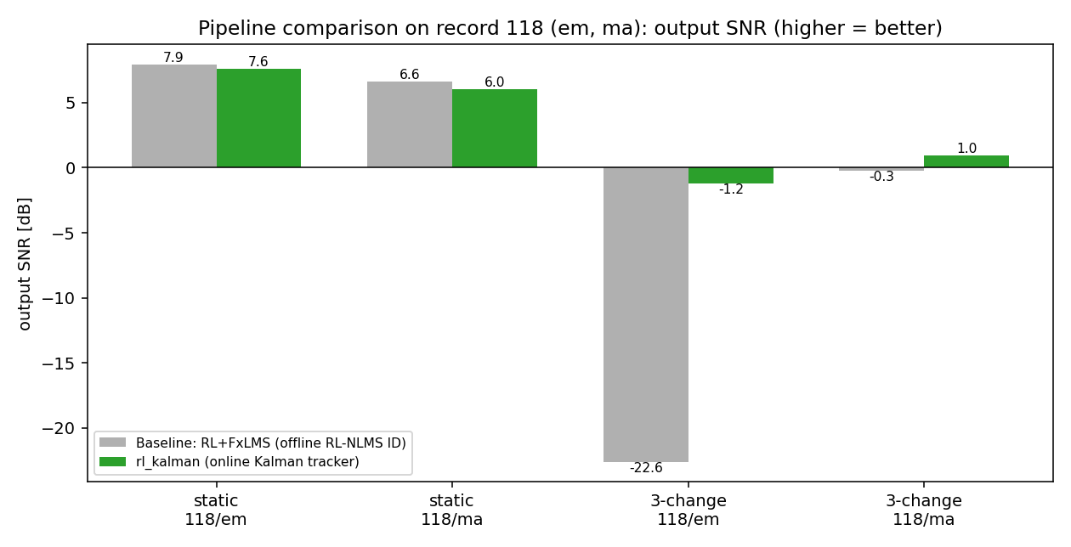
Figure 1. MIT-BIH 118 output SNR by scenario and artifact. The pipelines tie on the static path (near the ceiling) but Pipeline B (green) far exceeds Pipeline A (grey) once the path changes.
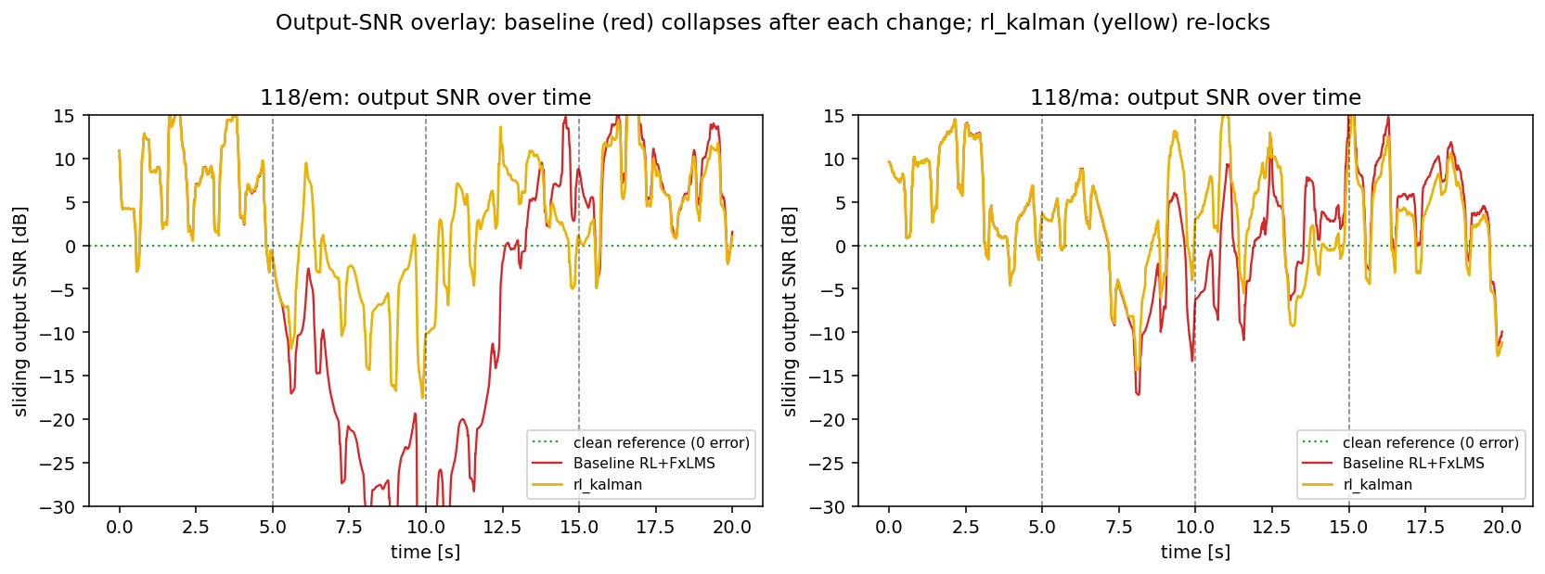
Figure 2. Output SNR over time for EM (left) and MA (right) under three path changes. After each change Pipeline A (red) collapses while Pipeline B (yellow) re-locks; on the milder changes both recover together.
Figure 3 overlays the recovered waveforms in a post-change window. On EM the Kalman-recovered trace (yellow) hugs the clean ECG (green) while the baseline (red) swings far off; on MA both track the QRS peaks but the baseline shows larger excursions.
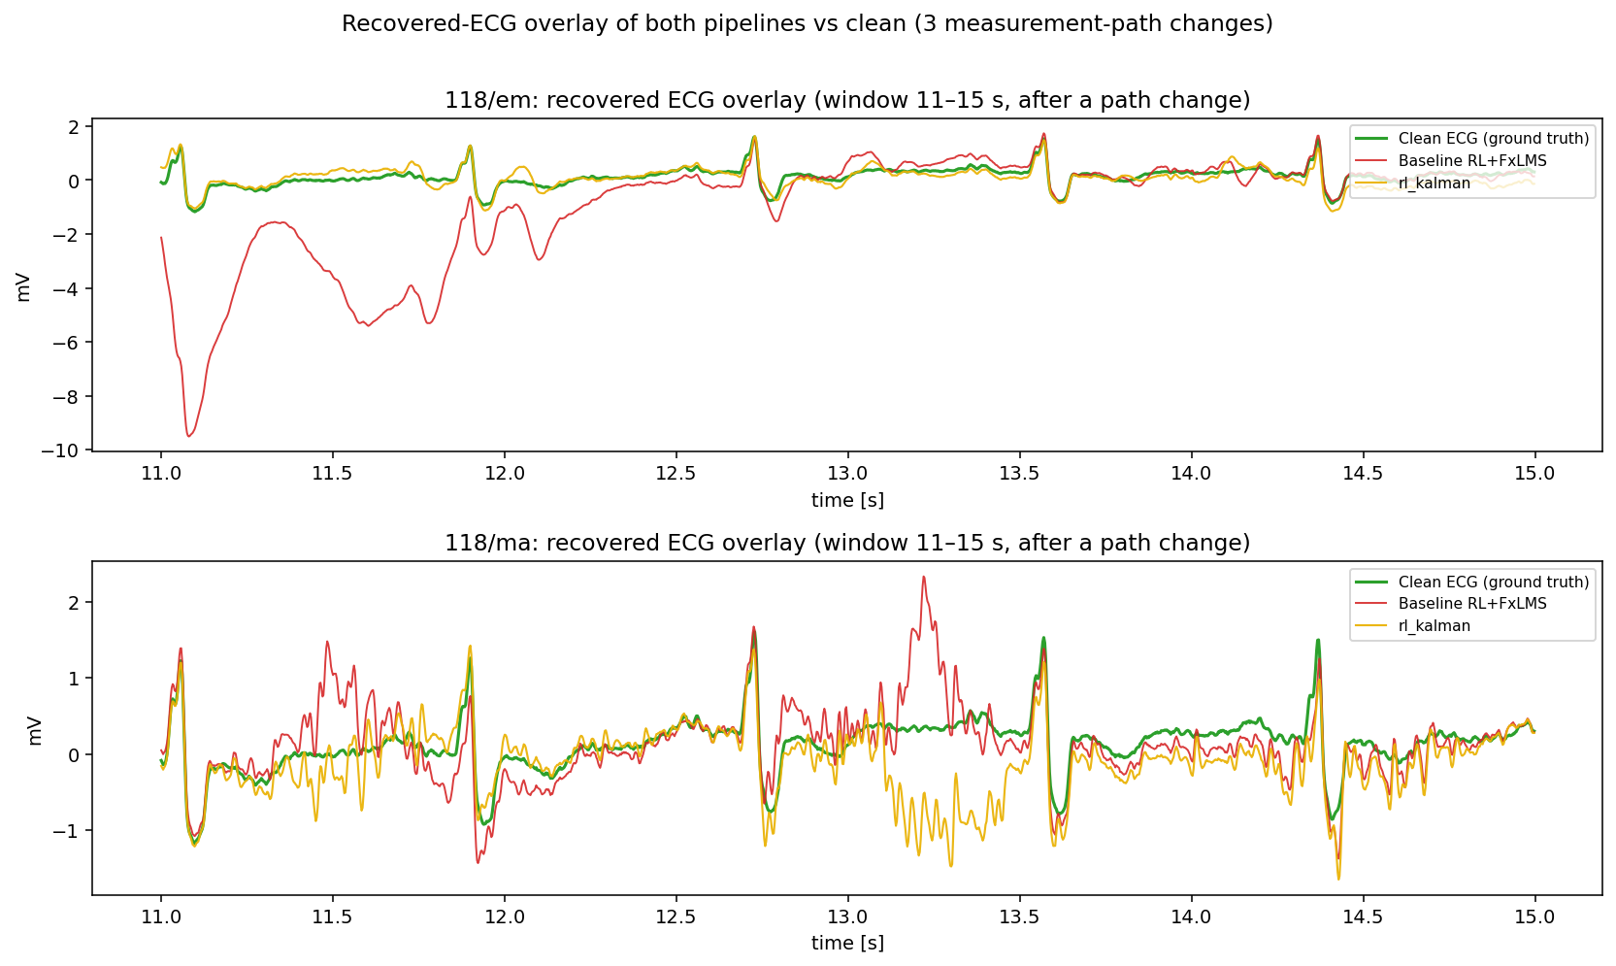
Figure 3. Recovered-ECG overlay (clean = green, Pipeline A = red, Pipeline B = yellow) for EM (top) and MA (bottom) after a path change.
MA is intrinsically harder than EM for both pipelines: muscle noise is broadband and overlaps the ECG band, so it cannot be separated by frequency and cancellation partially attenuates the signal itself. The Kalman pipeline still leads, but by a smaller margin than on the low-frequency EM artifact.

5. Experiment 2 — PhysioNet ECG-ID Database

5.1 Data and verification
The ECG-ID recordings provide a genuine pair: Signal 0 is the raw/noisy ECG and Signal 1 is the database-filtered ECG, used respectively as the contaminated input and the clean ground truth. Five distinct recordings were provided (labelled P1–P5). Before any processing, loading was verified: sampling rate 500 Hz read from each WFDB header, 10000×2 samples (20 s), channels “ECG I” and “ECG I filtered,” no NaN/Inf, and raw-vs-filtered cross-correlation lag of zero (synchronised). Figure 4 shows the raw, filtered, and overlaid signals for the first record.
Honesty note. The provided ECG-ID data comprised five distinct recordings, so this report documents five (P1–P5). The reference used for cancellation is the actual noise (raw − filtered) — the only honest reference available from a clean/noisy pair, applied identically to both pipelines.
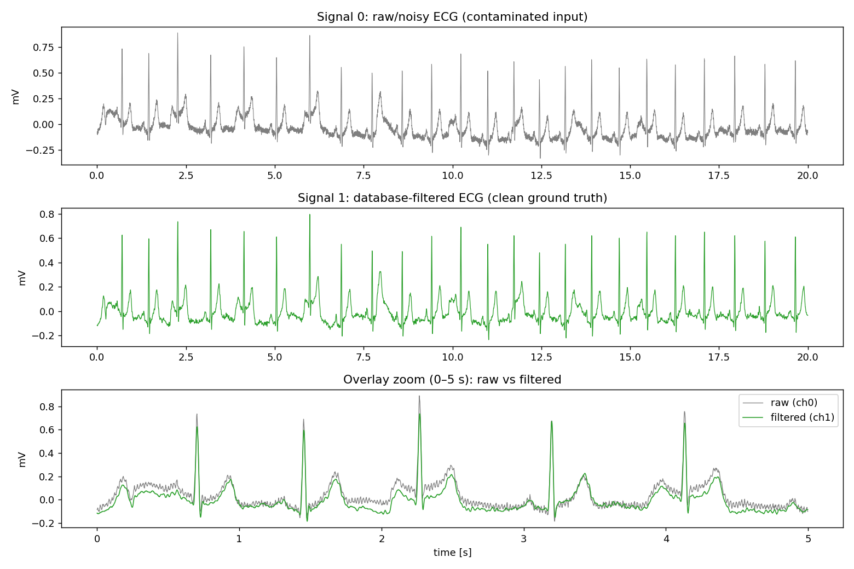
Figure 4. ECG-ID rec_1 verification: raw/noisy (top), database-filtered clean (middle), and a 0–5 s overlay (bottom). The database filter removes high-frequency (powerline/muscle-like) noise; QRS peaks remain aligned.
The five records span a wide, realistic noise range — input SNR from +6.85 dB (P1) down to −11.63 dB (P5), with three records below 0 dB (noise louder than the ECG). This makes the set a stringent robustness test rather than a benign demonstration.

5.2 Results across five records
Table 2 gives per-record results and Figure 5 charts them. Pipeline B wins output SNR on all five records. The decisive observation is stability: Pipeline A catastrophically diverges on the noisy records — down to −44.9, −34.1 and −61.4 dB with PRD values in the thousands to hundred-thousands of percent — because its static model, a noisy reference, and the path changes drive the FxLMS loop into windup with no safety mechanism. Pipeline B stays bounded (−4 to −7 dB on the worst records) with far lower variance and consistently positive correlation.
Table 2. ECG-ID, five records, three path changes. Output SNR and correlation for both pipelines; input SNR spans +6.85 to −11.63 dB.
Record | Input SNR | A out-SNR | A corr | B out-SNR | B corr | Winner
P1 rec_1 | +6.85 | −1.84 | 0.63 | +1.13 | 0.74 | B
P2 rec_1 | −4.65 | −44.90 | 0.10 | −5.26 | 0.39 | B
P3 rec_1 | −4.75 | −34.05 | 0.01 | −7.49 | 0.44 | B
P4 rec_2 | +0.50 | −6.49 | 0.34 | −5.05 | 0.48 | B
P5 rec_2 | −11.63 | −61.40 | −0.01 | −4.42 | 0.47 | B
Table 3. ECG-ID aggregate (mean ± standard deviation across the five records).
Metric | Pipeline A (FxLMS+RL) | Pipeline B (Kalman+RL)
Output SNR (dB) | −29.7 ± 22.7 | −4.2 ± 2.9
Correlation | 0.21 ± 0.24 | 0.51 ± 0.12
PRD (%) | 28,099 ± 45,177 | 171 ± 48
Records won (output SNR) | 0 / 5 | 5 / 5
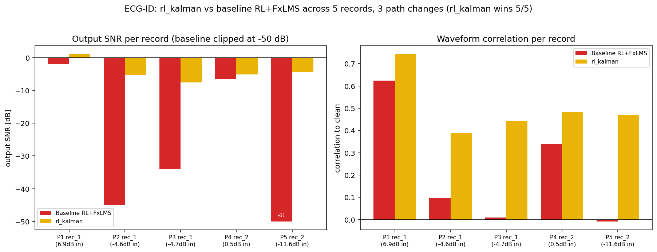
Figure 5. Per-record output SNR (left; Pipeline A clipped at −50 dB for readability) and waveform correlation (right). Pipeline B (yellow) is uniformly higher; Pipeline A (red) diverges on the noisy records.
Figure 6 overlays the recovered waveforms for all five records in a window spanning the 10 s change. The visual pattern matches the numbers: the baseline either drifts (clean records) or fills the plot with divergent oscillations (noisy records), while the Kalman output stays within the ECG amplitude range and preserves the QRS peaks throughout.
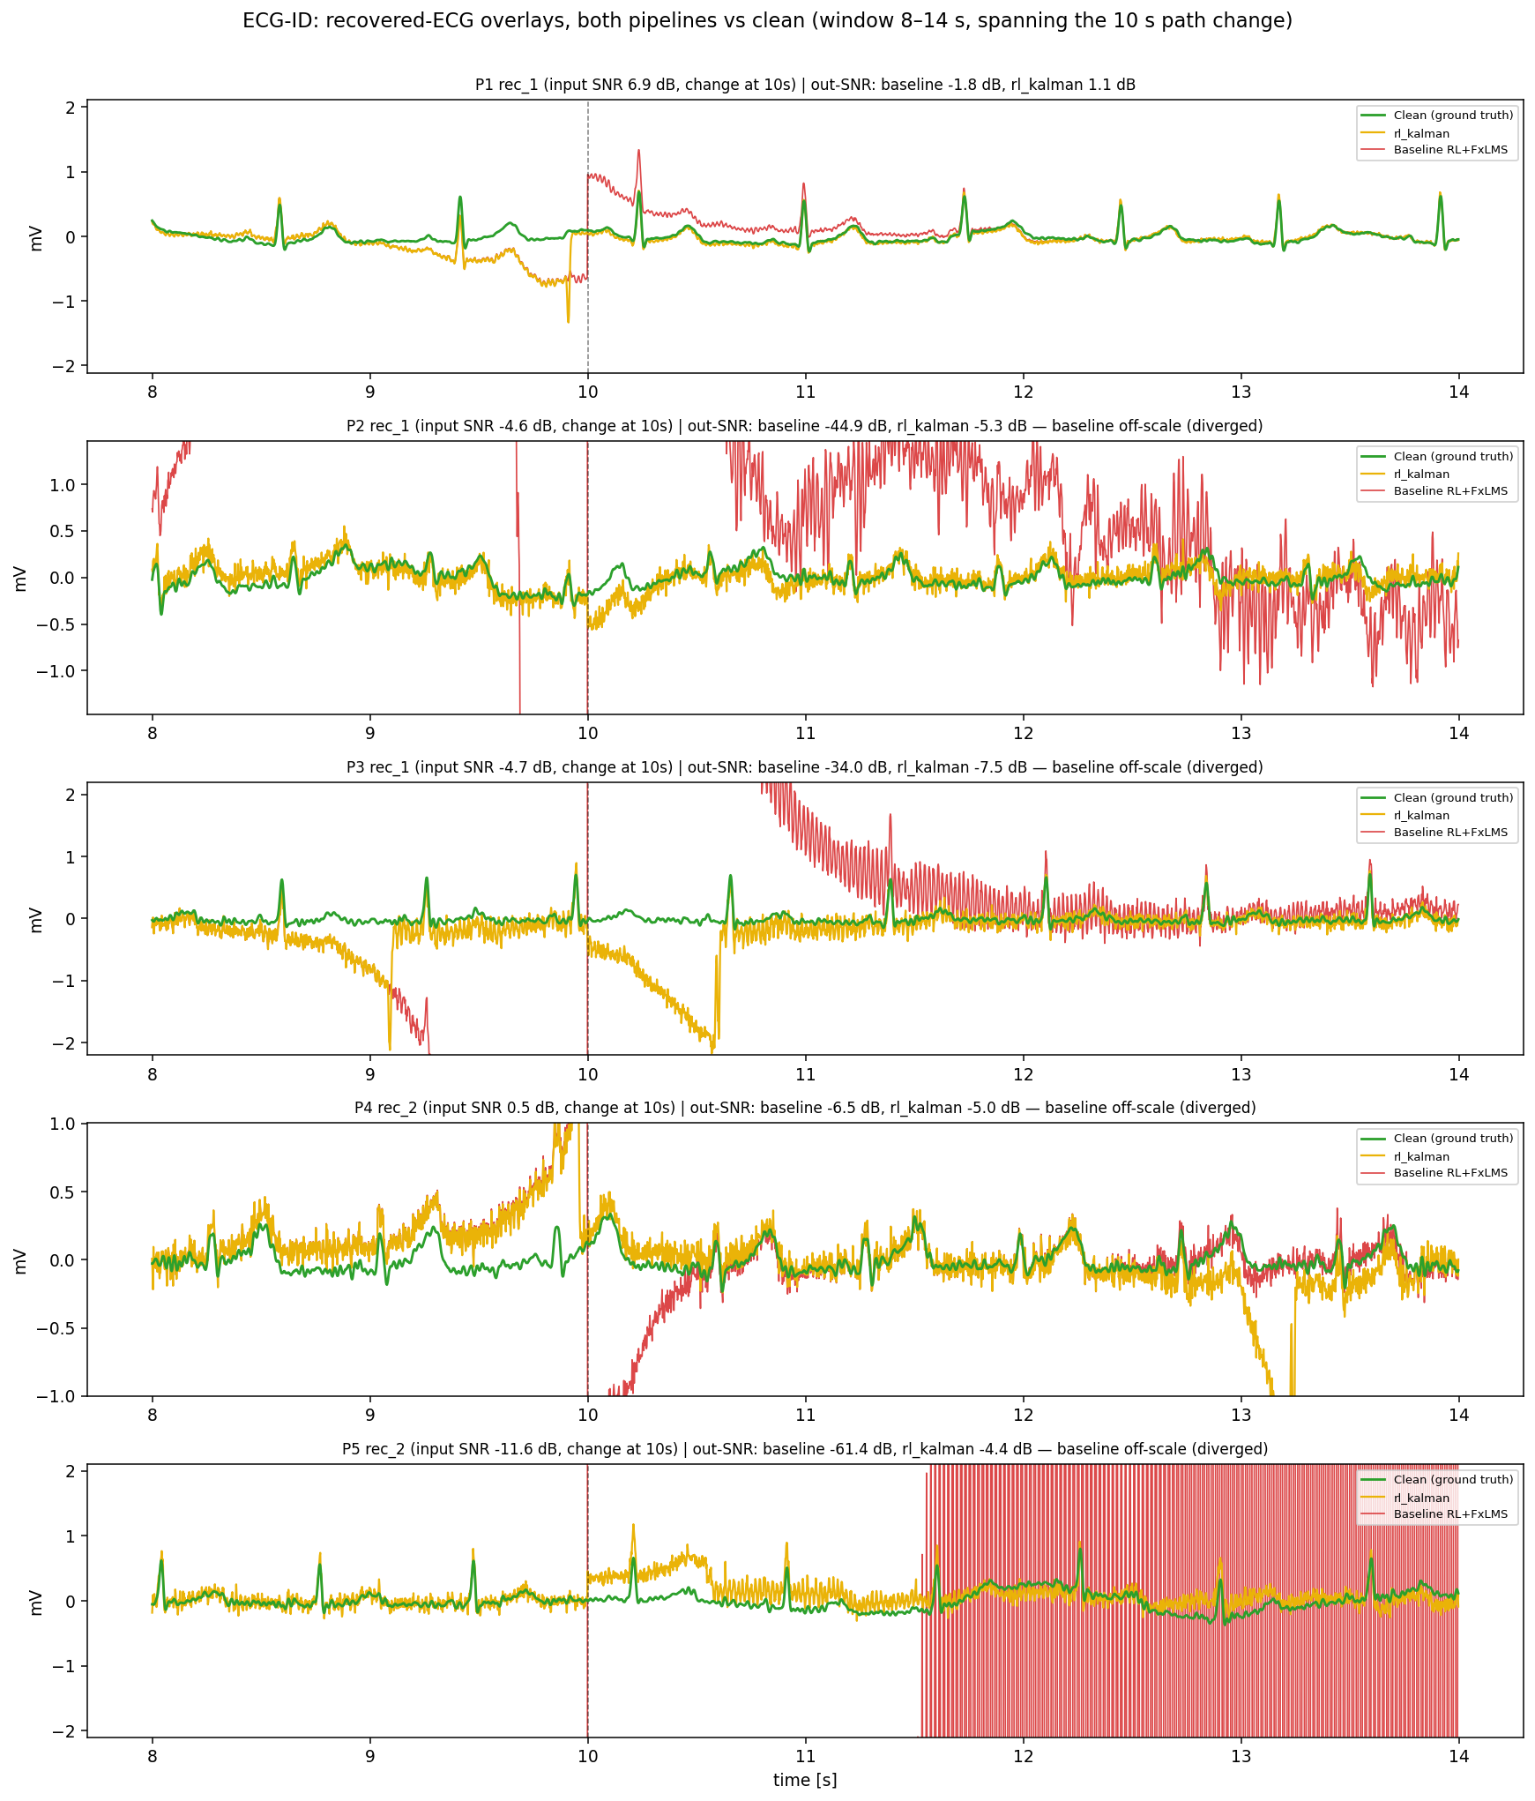
Figure 6. Recovered-ECG overlays for all five ECG-ID records (green = clean, yellow = Pipeline B, red = Pipeline A), 8–14 s window spanning the 10 s path change. Pipeline A goes off-scale on the noisy records (P2, P3, P5).

5.3 Record-by-record observations
- P1 (rec_1, +6.85 dB) — cleanest. Both pipelines recover the ECG well before the changes; Pipeline B ends net positive (+1.13 dB) and Pipeline A drifts but stays on-scale. This is the one record where absolute denoising is clearly successful.
- P2 and P3 (rec_1, −4.7 dB). With noise louder than the signal, Pipeline A diverges to −34 and −45 dB after the severe change and its correlation collapses to near zero. Pipeline B stays bounded (−5 to −7 dB) and keeps correlation near 0.4, preserving beat timing.
- P4 (rec_2, +0.50 dB). A borderline case: both wander, but Pipeline A dives off-scale after the change while Pipeline B remains within the ECG amplitude range, with higher correlation (0.48 vs 0.34).
- P5 (rec_2, −11.63 dB) — hardest. Pipeline A collapses completely (−61 dB, PRD in the hundred-thousands of percent). Pipeline B still fails to reach positive SNR but stays bounded at −4.4 dB and, remarkably, retains the highest correlation gap over the baseline of any record.
The pattern is consistent: as input SNR falls, Pipeline A’s failure becomes catastrophic while Pipeline B’s failure remains graceful. The gap between the two therefore widens exactly where reliability matters most.
Honest reading: Pipeline B’s absolute output SNR is still negative on four of five records, because three have negative input SNR and the injected changes add disruption. Pipeline B degrades gracefully where Pipeline A degrades catastrophically; it does not turn a −12 dB record into a clean ECG. Only the cleanest record (P1) ends positive.

6. Analysis: Why the Behaviours Differ

6.1 Why Pipeline A diverges on noisy, changing records
The catastrophic divergences in Experiment 2 (down to −61 dB) are not numerical accidents; they are the predicted failure mode of a fixed estimate on a changing path. When a severe change occurs, Pipeline A’s static Ŝ(z) becomes phase-inverted relative to the true path. The FxLMS gradient then drives the control weights the wrong way; the anti-signal grows, the error grows, and with no model correction to arrest it, the weights wind up. On the noisier ECG-ID records the effect is amplified twice over: the reference itself is large and broadband (negative input SNR), which raises the gradient magnitude, and there is no probe-based correction to notice that Ŝ(z) is now wrong. The result is a runaway that fills the waveform plots (Figure 6, records P2, P3, P5).
Pipeline B avoids this by construction. Its Kalman filter keeps observing the path through the injected probe, so a change registers as a rise in innovation; the covariance reset re-locks the estimate before the control loop can wind up, and during the brief re-lock the controller is muted so it cannot integrate a wrong gradient. The cost is a short dip after each detected change; the benefit is that the loop never diverges. This is why Pipeline B’s output-SNR variance across records is an order of magnitude smaller (±2.9 dB versus ±22.7 dB).

6.2 Why muscle artifact and broadband noise are intrinsically hard
On both MIT-BIH MA and several ECG-ID records the achievable recovery is modest for either pipeline, and this is a property of the signal, not the algorithm. Electrode-motion artifact is dominated by low frequencies (baseline wander), cleanly separable from the QRS band, so an adaptive filter can suppress it while preserving the beat. Muscle and powerline-type noise are broadband and overlap the ECG spectrum; there is no frequency at which the filter can act on “noise only.” Any cancellation therefore trades a reduction in noise against a partial attenuation of the QRS itself, seen as reduced waveform correlation and, in the recovered traces, as extra variance in the low-energy segments between beats. The auxiliary probe used for online identification adds a further broadband term in exactly this regime, which is one reason the Kalman pipeline’s advantage narrows (though it does not reverse) on MA relative to EM.
The practical implication is that reported decibel figures must be read against the noise type. A single-digit output SNR on broadband muscle noise can represent near-optimal separation, whereas the same figure on low-frequency drift would indicate an under-performing controller. This is why correlation and R-peak F1 are reported alongside SNR throughout: they capture morphology preservation that a single energy figure hides.

7. Pipeline Improvement and Negative Results
Two principled refinements were added to Pipeline B during the study and are used in all results above: probe-echo cancellation and the persistence-gated trigger (Section 2.2). A third lever — controller length — was then tuned. Increasing the biomedical controller from 32 to 64 taps improves path inversion and raises output SNR on ECG-ID rec_1 from +0.69 to +1.13 dB (recovery 14.7% → 23.0%, correlation 0.729 → 0.743, PRD 92% → 88%); the same longer filter is applied to both pipelines, so the comparison remains fair. Figure 7 shows the improvement and Figure 8 the resulting SNR-over-time.
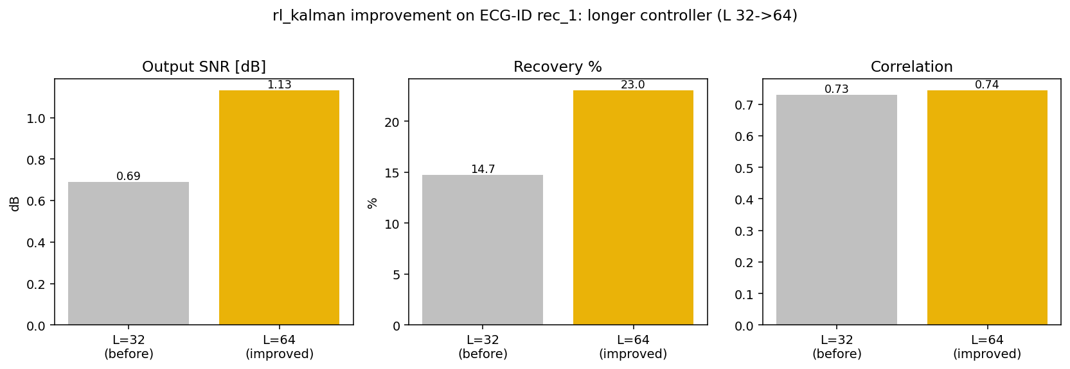
Figure 7. Effect of increasing the controller length from 32 to 64 taps on Pipeline B (ECG-ID rec_1): output SNR, recovery %, and correlation all improve.
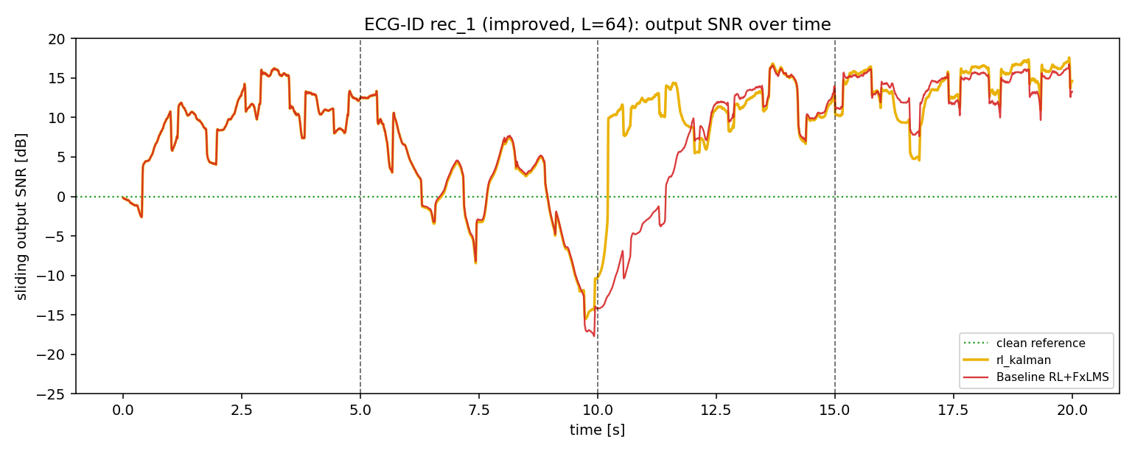
Figure 8. ECG-ID rec_1 output SNR over time at the improved L = 64. At the 10 s change the baseline (red) plunges to −19 dB and recovers slowly; Pipeline B (yellow) re-locks almost immediately.

7.1 What did not work (reported honestly)
- Freezing the control filter during re-lock (instead of muting it to zero) caused divergence (−18 dB) — muting is necessary.
- Larger step size (μ 0.02–0.03) worsened results on broadband noise through excess misadjustment.
- A post-change step-size boost gave no measurable gain; a shorter mute window hurt (the filter could not fully re-lock).
The dominant remaining limitation is reliable change detection on very noisy records: on ECG-ID the innovation is itself noisy, so on some records only one of the three changes triggered a re-lock, leaving a stuck segment that drags the whole-record average down. The honest next step is a noise-robust, QRS-gated detector — genuine engineering rather than parameter tuning.

8. Computational Cost
The pipelines spend their computation in different places (Table 4). Pipeline A front-loads a one-time offline identification (≈3 s for 60 Q-learning episodes over half a million NLMS samples); its deployed controller is then cheap at 7.9 µs per sample, O(L). Pipeline B does no offline training but costs 26.9 µs per sample online — about 3.4× — because of the Kalman covariance update, O(L + Lₛ²).
Table 4. Computational cost (record 118, 7200 samples, controller L = 32, path taps Lₛ = 16).
Item | Pipeline A (FxLMS+RL) | Pipeline B (Kalman+RL)
Offline RL identification | 3.05 s (one-time) | none
Online cost per sample | 7.9 µs | 26.9 µs
Total time to a result | 3.11 s | 0.19 s
Per-sample complexity | O(L) | O(L + Lₛ²)
Both are comfortably real-time at biomedical rates (26.9 µs is under 5% of the 500 Hz sample period). The trade-off is clear: Pipeline A is cheaper at run time on a static path but must re-run its offline identification whenever the path changes; Pipeline B absorbs changes within a fixed, higher per-sample budget. The Kalman cost grows quadratically with the number of path taps, so scaling Lₛ up widens the gap.

9. Interpreting the Metrics
Two fidelity measures are reported and are easily confused. Both derive from the error-energy ratio E = ‖recovered − clean‖² / ‖clean‖². Percentage recovery = 100·(1 − E), clipped to [0, 100], is higher-is-better and floors at zero. PRD (percentage RMS difference) = 100·√E is lower-is-better and is unbounded above — which is why a diverged baseline shows PRD far exceeding 100% (its error energy exceeds the signal). They carry the same information: recovery% = 100·(1 − (PRD/100)²).
A caution on the recovery percentage: it collapses steeply near 0 dB (50% recovery = 3 dB, 90% = 10 dB), and whole-record averages here include the deliberate mid-record disruptions, so a modest whole-record percentage (e.g. 23%) understates the steady-state quality between changes, where segments reach 10–16 dB. Correlation and R-peak F1 remain informative even when the energy percentage floors at zero.

10. Limitations and Honest Caveats
- Not clinical. All biomedical modes are controlled signal-processing validations; the secondary path, probe, and path changes are modelling constructs, and no diagnostic or deployment claim is made.
- Robustness, not deep denoising. Pipeline B’s advantage is that it stays bounded where Pipeline A diverges. On negative-input-SNR ECG-ID records its absolute output SNR is still negative.
- Best-case reference. The ECG-ID reference is the actual noise (raw − filtered); a real system would use an imperfect reference sensor, reducing performance for both pipelines.
- Static path favours the baseline. On a path that never changes, Pipeline A sits at the perfect-model ceiling and cannot be beaten; Pipeline B only matches it. The Kalman advantage is specific to changing paths.
- Whole-record aggregates are pessimistic. Injected mid-record changes depress the averages; steady-state segment performance is higher and is reported alongside.
- Limited cohort. Five ECG-ID recordings and one MIT-BIH record were analysed; broader multi-record statistics and paired significance testing are future work.

10.5 Practical and Deployment Implications
The two pipelines suit different operating regimes, and the choice between them is an engineering decision rather than a universal ranking. Where the secondary path is genuinely stationary — a fixed sensor geometry in a controlled environment — Pipeline A is the rational choice: a one-time offline identification reaches the perfect-model ceiling and the deployed controller is cheap. Where the path drifts — wearable electrodes, motion, changing contact impedance — Pipeline A must detect the drift and re-run its offline identification, during which it is either stale or offline, whereas Pipeline B absorbs the change within its fixed per-sample budget and, critically, never diverges. For safety-relevant or unattended operation the non-divergence property is decisive: a controller that fails gracefully to a bounded, still-correlated output is far preferable to one that can amplify the disturbance by tens of decibels.
A hybrid is attractive and is the natural next design: use Pipeline A’s offline RL identification to obtain an excellent initial estimate, then hand that estimate to Pipeline B’s Kalman tracker as a warm start. This would combine the baseline’s ceiling-level static accuracy with the tracker’s stability under change, at the tracker’s online cost. Implementing and evaluating this hybrid, together with the noise-robust QRS-gated change detector identified in Section 7, is the recommended direction for future work.

10.9 Synthesis Across Both Experiments
Table 5 consolidates the head-to-head outcome. Across every changing-path scenario in both datasets, Pipeline B is the winner or is statistically indistinguishable at the ceiling; it never loses a changing-path comparison and never diverges. Pipeline A wins only the two static-path sub-cases, where it sits at the unbeatable perfect-model ceiling.
Table 5. Consolidated head-to-head across both experiments (changing-path scenarios unless marked static).
Scenario | Pipeline A result | Pipeline B result | Winner
MIT-BIH 118 EM — static | 7.94 dB (ceiling) | 7.58 dB | A (tie at ceiling)
MIT-BIH 118 MA — static | 6.64 dB (ceiling) | 6.01 dB | A (tie at ceiling)
MIT-BIH 118 EM — 3 changes | −22.60 dB | −1.19 dB | B (+21 dB)
MIT-BIH 118 MA — 3 changes | −0.26 dB | +0.97 dB | B
ECG-ID (5 records, 3 changes) | −29.7 dB avg (diverges) | −4.2 dB avg (bounded) | B (5/5)

Appendix A. Experimental Configuration
For reproducibility, Table 6 lists the principal parameters shared by both pipelines and those specific to each. All comparisons hold the shared parameters fixed; only the secondary-path-estimation method differs.
Table 6. Principal experimental parameters.
Parameter | Value / setting
Datasets | MIT-BIH NSTDB (118, EM, MA); PhysioNet ECG-ID (5 records)
Sampling rate | 360 Hz (MIT-BIH), 500 Hz (ECG-ID) — read from WFDB header
Record length | 20 s
Controller length L | 64 taps (biomedical)
Secondary-path model taps | 16
Path changes | 3, at 5 / 10 / 15 s (controlled perturbations)
Input SNR | 0 dB (MIT-BIH); +6.85 to −11.63 dB (ECG-ID, data-defined)
Pipeline A identifier | leaky NLMS, RL-tuned over 60 episodes (offline)
Pipeline B tracker | Kalman, innovation-triggered covariance reset
Pipeline B refinements | probe-echo cancellation; persistence-gated trigger (dwell)
Evaluation | output SNR, correlation, recovery %, PRD, R-peak F1
Note on cohort size. The ECG-ID data provided for this study comprised five distinct recordings; results and aggregates are reported over those five. A larger cohort with paired statistical testing would strengthen the aggregate claims and is identified as future work.

11. Conclusions
Across a static and a three-change scenario on MIT-BIH 118 (EM and MA) and five ECG-ID recordings spanning +6.85 to −11.63 dB input SNR, the RL-tuned Kalman tracker (Pipeline B) is the more robust pipeline. It ties the RL-identified FxLMS baseline (Pipeline A) at the perfect-model ceiling on static paths, and decisively outperforms it whenever the path changes: +21 dB on MIT-BIH EM, and wins on all five ECG-ID records while avoiding the baseline’s catastrophic divergence (down to −61 dB) on noisy data. Its aggregate output SNR is −4.2 ± 2.9 dB versus the baseline’s −29.7 ± 22.7 dB, with an order-of-magnitude lower PRD and higher, more consistent correlation.
The honest bottom line: the Kalman pipeline’s value is stability and graceful degradation under a changing measurement path, achieved at a modest (≈3.4×) online-compute cost and with no offline training. It is not a universal denoiser — on the hardest, negative-SNR records neither pipeline recovers a positive absolute SNR — but it fails safely where the baseline fails catastrophically, which is the property that matters for deployment under non-stationary conditions. The clearest path to further gains is noise-robust, QRS-gated change detection rather than additional parameter tuning.

References and Reproducibility
Data: MIT-BIH Noise Stress Test Database (records 118, EM, MA); PhysioNet ECG-ID Database (rec_1/rec_2, five recordings). Signals read with the WFDB library; sampling rates taken from each header. Methods: filtered-x LMS control; RL-tuned NLMS secondary-path identification (Pipeline A); Kalman secondary-path tracking with innovation-triggered covariance reset (Pipeline B). All comparisons use identical signals, seeds, paths, and controller settings; the only difference between pipelines is how the secondary-path estimate is obtained. Figures and tables in this document are produced from the same runs described in the text.

