**EQUIPMENT**

## Endotracheal tube (ETT)

UNcuffed ETT

| **AGE** | **WT(KG)** | **\*ID**  **(MM)** | **\*\*ORAL LENGTH (MM)** | **\*\*NASAL LENGTH (MM)** |
| --- | --- | --- | --- | --- |
| neonate | < 1 (less than 28 weeks gestational age) | 2.5 | 5.5 | 7 |
| neonate | 1- 2  (28-34 weeks gestational age) | 3.0 | 7- 8 | 8.5- 10 |
| neonate | > 2-4  (34 weeks to term neonate) | 3.5 | 9-10 | 11-12 |
| 3 months | 6 | 3.5-4 | 10 | 12 |
| 6 months | 8 | 4.0 | 10-11 | 12-13 |
| 12 months | 10 | 4.5 | 11-12 | 13-14 |

It is the usual practice to prepare, in addition, ETTs that are half a size larger and smaller than the estimated size. The tube should not fit tightly, a small leak is advisable. Always test for leak by holding a sustained pressure of about 15 cm H2O. After intubation, always listen in both axillae and epigastric areas.

In general, the following formulae can be used for uncuffed ETTs in children:

| ETT size (ID) : age(yrs)/4 + 4 or 4.5 for patients >2 years |
| --- |

For our local population, the formula ETT size (uncuff ID): age (yrs)/4 +4.5 appears to be more appropriate

* ID internal diameter ** estimated depth of ETT insertion

Cuffed Paediatric ETT

Traditionally, cuffed ETTs were recommended for children >8yrs.

However, the Microcuff* ETT is designed specifically for the pediatric airway, and has a short cylindrical high volume low pressure cuff near the ETT tip. It affords a lower risk of airway trauma and mucosal tissue injury. The use of Microcuff tube should be used only for infants who would otherwise be intubated with uncuffed ETT size 3.5mm ID and larger. The use of a low pressure cuffed ETT affords fewer ETT exchanges due to incorrect sizing of ETT and less leakage during ventilation without causing an increase in acute postextubation complications and complications associated with multiple laryngoscopy and intubation attempts. The cuff pressure must be measured and ideally kept at 20 cm H2O or below. Cuff tubes should not be used in premature neonates.

In general, the following formula can be used for cuffed ETTs in children:

| ETT size (ID): age/4 + 3.5 (except neonates) |
| --- |

Microcuff ETT

Recommended Sizing for Children (Halyard health):

| Microcuff ETT ID (mm) | Age |
| --- | --- |
| 3.0 | Term ≥ 3 kg- < 8 months |
| 3.5 | 8 months- < 2 years |
| 4.0 | 2 years- < 4 years |
| 4.5 | 4 years- < 6 years |
| 5.0 | 6 years- < 8 years |
| 5.5 | 8 years- < 10 years |
| 6.0 | 10 years - < 12 years |
| 6.5 | 12 years- < 14 years |
| 7.0 | 14 years- < 16 years |

ETT Insertion Depth

Although various formulae exist to predict the correct ETT insertion depth, these formulae generally have a poor accuracy rate particularly weight based formulae because the growth of children is non linear. Nevertheless they can be used as a guide for initial placement. Alternatively, the depth marker on the ETT (located at the distal end of the ETT) can be used to guide placement at the vocal cord level but these depth markers can vary between ETT manufacturers and studies have shown these do not guarantee optimal placement.

Therefore, it is important after intubation to auscultate the lungs to confirm the absence of endobronchial intubation and have the position of the ETT confirmed with Chest X Ray if the patient needs to remain intubated postoperatively. Ideally the ETT tip should sit mid tracheal. It is important to realise that neck movements in the neonate or young infant can result in substantial movement of the ETT, making it possible for inadvertent extubation with neck extension and endobronchial intubation with neck flexion. The ideal position is for the tip of the ETT to be at the junction between the middle and distal third of the trachea.

For children over 1 year of age:

* Insertion depth (cm) for orotracheal intubation =

age/2+13 or height (cm)×0.1+3

* Insertion depth (cm) for nasotracheal intubation = age/2+15

For children under 1 year of age:

* Insertion depth (cm) for orotracheal intubation =

weight/2+8 or weight (kg)+6

* Insertion depth (cm) for nasotracheal intubation=weight/2+9

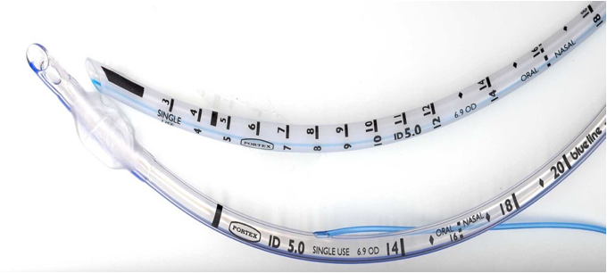

Photo showing the depth marker on the Portex ETT

A recent study of 167 intubated children ranging from infants beyond the first 28 days of life to 17.9 years had their chest X-rays analysed for optimal positioning of the tip of the ETT situated between middle and third of the trachea based on age, weight and height to develop regression models and tables/graphs to allow for fast and accurate determination of ETT insertion depths in children. Generally age and height based formulae predict optimal ETT depth more accurately for children less than weight based formulae. The results are summarised in the 2 tables below.

## B. Laryngeal Mask Airway (LMA)

Recommended sizes are:

| **Size** | **Weight (kg)** | **Max cuff inflation vol (ml)** |
| --- | --- | --- |
| 1 | 5 | up to 4 |
| 1.5 | 5 - 10 | up to 7 |
| 2 | 10 - 20 | up to 10 |
| 2.5 | 20 - 30 | up to 14 |
| 3 | 30 - 50 | up to 20 |
| 4 | 50 - 70 | up to 30 |
| 5 | 70 - 100 | up to 40 |

Cuff pressures must be checked and confirmed not to exceed 60 cm H2O, although ideally keeping the cuff pressure 40-50cm H2O is recommended.

Generally it is suitable to use size 2.5 for children 17 kg and above.

ProSeal LMA

ProSeal LMA is available for use in well fasted patients with no risk of regurgitation or aspiration. Choose size as for regular LMAs.

Intubation via LMA

Patients can be intubated via LMAs.

The largest ETT & fiberoptic bronchoscope (FOB) that can be used with each LMA is given in the table below.

Recommended LMA , FOB and ETT Size (mm) for intubation:

| **LMA Size** | **Maximum FOB Size** | **Maximum ETT size** |
| --- | --- | --- |
| 1 | 2.8mm | 3.5mm Uncuffed |
| 1.5 | 3.0mm | 4.0mm Uncuffed |
| 2 | 3.5mm | 4.5mm Uncuffed |
| 2.5 | 4.0mm | 5.0mm Uncuffed |
| 3 | 5.0mm | 6.0mm Cuffed |
| 4 | 5.0mm | 6.0mm Cuffed |
| 5 | 5.5mm | 7.0mm Cuffed |

*FOB: FiberOptic Bronchoscope

The table below indicates the smallest ETT & LMA that can be used with each FOB.

| **FOB** | **Diameter (mm)** | **Smallest ETT** | **Smallest LMA** |
| --- | --- | --- | --- |
| paed | 2.8 | 3.5* | 1.0 |
| neonatal | 2.2 | 2.5* | 1.0 |

* snug fit- must remove ETT blue connector before railroading over FOB. FOB

must be well lubricated with silicone spray.

## C. One Lung Ventilation (OLV) in Children

As in adults, OLV in children may be indicated to facilitate surgical exposure or alveolar lavage, anatomically isolate the lungs to avoid cross contamination in cases of empyema or pulmonary hemorrhage or to facilitate more effective ventilation in cases of bronchial disruption or bronchopulmonary fistula.

The options available are:

1. endobronchial intubation
2. bronchial blocker
3. double lumen tube

ETT sizes for endobronchial intubation

| Age | Mainstem bronchus | | Endobronchial intubation with uncuffed ETT (Outer diameter of tube in mm) | | Endobronchial intubation with cuffed ETT (Outer diameter of tube in mm) | |
| --- | --- | --- | --- | --- | --- | --- |
|  | R | L | R | L | R | L |
| 0-3 months | 4.4 | 3.6 | 3 (4.2) | 2.5 (3.6) | 3 (4.3) | - |
| 3-6 months | 4.7 | 3.9 | 3 (4.2) | 2.5 (3.6) | 3 (4.3) | - |
| 6-12 months | 5.4 | 4.2 | 3.5 (4.9) | 3 (4.2) | 3.5 (4.9) | 3 (4.3) |
| 1-2 years | 5.4 | 5.6 | 4 (5.2) | 3.5 (4.9) | 4 (5.6) | 3.5 (4.9) |
| 2-4 years | 7.5 | 6.6 | 4.5 (6.2) | 3.5 (4.9) | 4.5 (6.2) | 3.5 (4.9) |
| 4-6 years | 8.3 | 7.3 | 4.5 (6.2) | 4 (5.5) | 4.5 (6.2) | 4 (5.6) |
| 6-8 years | 8.9 | 7.8 | 5.5 (7.5) | 5 (6.9) | 5.5 (7.5) | 5 (6.9) |
| 8-10 years | 9.9 | 8.8 |  |  | 6 (8.2) | 5 (6.9) |
| 10-12 years | 10 | 7.7 |  |  | 6.5 | 6 |
| 12-14 years | 11.2 | 8.6 |  |  | 7 | 6.5 |
| 14-16 | 12 | 9.2 |  |  | 7 | 6.5 |
| 16-18 | 11.8 (F)  13.5 (M) | 9  (F)  10.4 (M) |  |  | 7-7.5 | 6.5-7 |

*References:*

*0-10 years: source (An Update on One-Lung Ventilation in Children. Anesthesia & Analgesia, 2020 )*

*10-18 years: source (Paediatric lung isolation. BJA Education, 17 (2): 57–62 (2017)*

Anatomical considerations:

1. The left bronchus is consistently smaller than the right bronchus so a smaller ETT has to be chosen for endobronchial intubation
2. It is technically more challenging to isolate the right lung because of the take off for the right upper lobe remains very close to the carina (≤1 cm) in patients up to 8 years
3. It is technically easier to achieve left lung isolation and safely adjust the position of bronchial blockers because the take off for the left upper lobe bronchus is 3 times the distance compared to the take off for the right upper lobe bronchus from the carina.

Recommended sizes of OLV devices in children of different ages

| **Options for Lung Isolation** | **Sizes available for paediatric use** | **Preferred method for ages** |
| --- | --- | --- |
| Single-lumen ETT (endobronchial) | 2.5 mm ID and up | 0-6 months |
| Vascular balloon catheter (Fogarty) | 3,4,5 French (Fr) | 6 months --8 years  below 2 years (external placement)  above 2 years (internal or external placement) |
| Arndt bronchial blocker | 5 Fr (OD 2.5mm)  7 Fr (OD 2.3 mm) | 6 months -8 years  below 2 years (external placement)  above 2 years (internal or external placement) |
| Uniblocker tube  (Fuji Systems) | 5 Fr (OD 1.7mm)  9 Fr (OD 3.0mm) | 6 months -8 years  below 2 years (external placement)  above 2 years (internal or external placement) |
| Univent tube | 3.5 mm ID  (OD 7.5/8mm*) | 6-8 years |
|  | 4.5 mm ID  (OD 8.5/9.0mm*) | 10-12 years |
| Double-lumen tube | 26 Fr (OD 8.7mm)  28 Fr (OD 9.3mm)  35 Fr (OD 10.7mm)  37 Fr (OD 12.3mm) | 8-18 years |

* Sagittal/transverse

In order for a bronchial blocker and bronchoscope to physically fit together inside the lumen of the tracheal tube (coaxial technique), the

OD of the bronchial blocker (ODBB) and the OD of the bronchoscope (ODB) added together needs to be <90% of the ID of the tracheal tube.

To allow for adequate ventilation during bronchoscopy, the tracheal tube should not be >50% blocked.

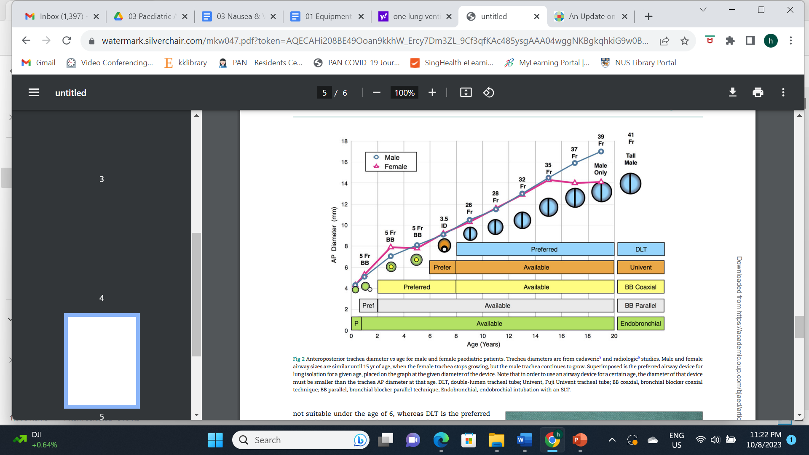

*Reference:*

*Paediatric lung isolation. BJA Education, 17 (2): 57–62 (2017)*

The table below shows the recommended sizing of each of the techniques described above, according to the age of the infant or child.

As with all equipment, however, correct sizing will vary between patients of the same age and so it is essential to have a range of sizes available

| **Age (yr)** | **Ardnt (Fr)** | **Fuji**  **Uniblocker (Fr)** | **Univent (ID mm)** | **DLT (Fr)** |
| --- | --- | --- | --- | --- |
| 0-3 months | 5 (E) | 5 (E) |  |  |
| 3-6 | 5 (E) | 5 (E) |  |  |
| 6-12 | 5 (E)) | 5 (E) |  |  |
| 1-2 | 5 (E) | 5 (E) |  |  |
| 2-4 | 5 (E/I), 7(E) | 5 (E/I) |  |  |
| 4-6 | 5 (E/I) 7(E) | 5 (E/I) |  |  |
| 6-8 | 5 (E/I)  7(E/I) | 5 (E/I) | 3.5 |  |
| 8-10 | 7 (E/I)  9(E/I) | 9 (E/I) | 3.5 | 26 |
| 10-12 | 9 (E/I) | 9 (E/I) | 4.5 | 26,28 |
| 12-14 | 9 | 9 | 6 | 32 |
| 14-16 | 9 | 9 | 6.5 | 35, 37 |
| 16-18 | 9 | 9 | 7.0 | 37,39, 41 |

E: bronchial blocker placed external to the endotracheal tube

I: bronchial blocker placed internal to the endotracheal tube

Fogarty Catheter- balloon inflation volume & diameter

| **Size (F)** | **3** | **4** | **5** |
| --- | --- | --- | --- |
| Inflation volume (ml) | 0.25 | 0.5 | 0.75 |
| Diameter (mm) | 8 | 9 | 10 |

## D. Laryngoscopes

* Straight blade (Miller and Seward): for use in neonates and those younger than 3 months old.
* Small curved blade (Magill) can be used for those older than 3 months old.
* VideoLaryngoscopes:

Glidescope- recommended stat sizes for children

| **STAT Size** | **Body Weight** |
| --- | --- |
| stat 0 | < 1.5 kg |
| stat 1 | 1.5- 3.6 kg |
| stat 2 | 1.8- 10 kg |
| stat 2.5 | 10- 28 kg |

## 

## E. Breathing Systems

Ayre’s T- piece with Jackson Rees modification (Mapleson F)

Advantages: low resistance (no valves), minimal dead space lightweight, long compression volume allowing the operator to have a good feel of lung compliance and inexpensive. This makes it a suitable choice if rapid volatile anaesthetic induction is desired in small children less than 10kg, even though this circuit may be used for children up to 20kg.

Unless attached to a heated humidifier, gas delivered to the patient will be cold and dry, predisposing the patient to heat loss from the respiratory system.

A pressure gauge should be used to measure ventilating pressures when ventilating on a T piece circuit.

In order to prevent rebreathing of carbon dioxide in the circuit, a minimal gas flow rate of 2-3 times the minute ventilation of the patient who is spontaneously breathing should be set, with a minimal flow rate of 3L/min. As such, running a volatile anaesthetic using this circuit will not be economical in bigger children.

The bag may be replaced with a mechanical ventilator if controlled ventilation is desired. If so, the fresh gas flow rate to achieve normocapnia is 1000 ml + 100-200ml/kg/min. Controlled ventilation with this circuit is rarely practiced these days, with a preference to switch to a circle system which has greater advantages such as allowance for positive end expiratory pressure (PEEP) and low flow anaesthesia.

Circle system

Advantages: ability to conserve moisture and heat, lower gas flows down to less than 1 L/min may be used making it more economical when using expensive inhalational agents e.g. sevoflurane.

It can be used for spontaneous respiration or controlled positive ventilation. However because there are valves and the presence of a carbon dioxide absorber in the circuit, the resistance in the circuit may increase the work of breathing for spontaneously breathing children less than 10kg, in which case pressure support ventilation is advised. The dead space is also considerable, resulting in delays to changes to the concentration of volatile anaesthetics in the circuit. Different circuit diameters are used for neonates, children less than 30kg and those 30 kg and above.

## F. Invasive Monitoring Lines

The following are general recommendations based on an average sized child. If the patient is smaller or larger than expected, up or downsize as appropriate.

* RADIAL Arterial lines :

Up to 3/12 or weight < 5kg :24G terumo venula

> 3/12 or weight > 10kg :22G terumo venula

> 10yr or weight > 40kg :22-20G terumo venula

* FEMORAL Arterial lines:

Leaderflex catheters 22G 4cm for children < 10kg

Leadercath catheters 20G & 18G 8 cm for children >10kg

Or whatever is available and appropriate in your institution.

**Check lower limb perfusion after cannulation of femoral vessels

* CENTRAL Lines

Single lumen (leadercath)

| Preterm neonate | <2kg | 22G, 4 cm |
| --- | --- | --- |
| Term neonate | 2-4kg | 20G, 8 cm |
| Child |  | 20G, 18G, 8 cm |

Double lumen

| 0-6 months | < 10 kg | 4Fr, 5cm |
| --- | --- | --- |

Triple lumen

| 0-6 months | <10kg | 4.5Fr, 6cm |
| --- | --- | --- |
| 6 months - 12yrs | 10-40kg | 5.5Fr, 5cm, 8cm, 13cm |
| >12yrs | >40kg | 7Fr, 16cm |

Table showing catheter size for peripheral vascular access devices versus appropriate vein diameter from ultrasound assessment

| **French size** | **Gauge size** | **Vessel size needed (mm)** |
| --- | --- | --- |
| 2 | 24 | 2 |
| 2.5 | 22 | 2.5 |
| 3 | 20 | 3 |
| 3.5 | 19 | 3.5 |
| 4 | 18 | 4 |
| 4.5 | 17 | 4.5 |
| 5 | 16 | 5 |
| 5.5 | 15 | 5.5 |
| 6 | 14 | 6 |
| 7 |  | 7 |
| 8 | 12 | 8 |

*Reference:*

*Adapted from www.piccexcellence.com*

*References:*

1. *Froese AB, Rose DK. A detailed analysis of T-piece systems. In: Steward, DJ (ed.) Aspects of Paediatric Anaesthesia. Amsterdam: Excerpta Medica, 1982; 101-136.*
2. *Lindhal SGE, Hulse MJ, Hatch DJ. Ventilation and gas exchange during anaesthesia and surgery in spontaneously breathing infants and children. Br J Anaesth 1984; 56: 121-129.*
3. *Lisa Leong, A E. Black. The design of pediatric tracheal tubes. Paediatric Anaesthesia Vol 19, Issue supplement s1, 38-45*
4. *Michelle C White, T Cook, P. Stoddart. A critique of elective paediatric suproglottic airway devices. Paediatric Anaesthesia Vol 19, Issue Supplement s1*
5. *One lung ventilation strategies for infants and children undergoing video assisted thoracoscopic surgery. Indian J Anaesth. 2013 July-Aug; 57(4): 339-344*
6. *Practical Anatomic Landmarks for Determining the Insertion Depth of Central Venous Catheter in Paediatric Patients. H. S. Na et al. BJA 2009;102(6):820-823.*
7. *Templeton TW, Piccioni F, Chatterjee D An Update on One-Lung Ventilation in Children. Anesthesia & Analgesia 132(5):p 1389-1399, May 2021. | DOI: 10.1213/ANE.0000000000005077*
8. *Letal M, Theam M. Paediatric lung isolation.BJA Education, 17 (2): 57–62 (2017)*