**PRE-MEDICATION**

Anxiolytic / Sedative Premedication

Premedication to relieve anxiety is not routinely prescribed as play therapy and parental presence are generally effective. However some children with special needs, learning disabilities, who require repeated anaesthetics, or children who are particularly anxious or fretful may require and benefit from anxiolysis or sedation before induction of anaesthesia. It is worth checking previous anaesthetic charts and talking to the parent/caregiver regarding the need for premedication.

Premedication is administered most commonly in oral form, but intranasal and intramuscular routes have also been employed. The most commonly used anxiolytic agent is midazolam. It is either given as a syrup formulation, or the IV formulation of midazolam is diluted in a sugar syrup to mask its bitter taste.

Common sites for IM INJECTIONS include:

1. deltoid muscle (upper arm)

2. vastus lateralis (side of thigh)

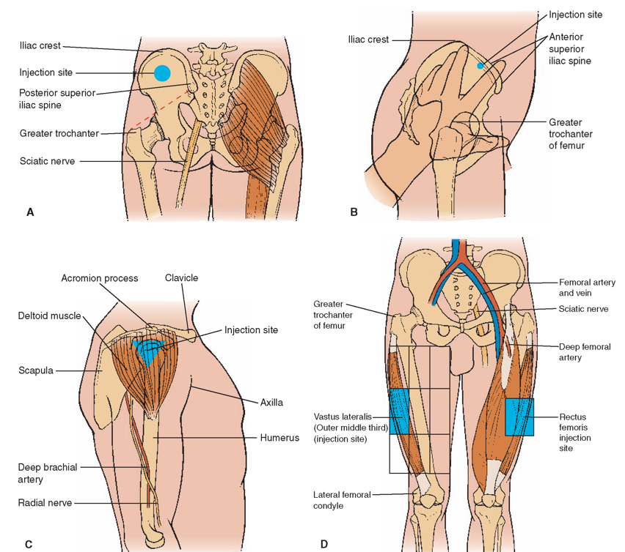

Recommended needle size & length: 22- 25 G; 1 inch

Cone-shaped mucosal atomization devices (MAD®) are available for intranasal drug application.

Sedative Premedication is NOT ordered in the ward; it is prescribed and given only at our Operating Theatre reception.

Parents or caregivers should be cautioned to keep a close eye on the child in the play area to avoid accidental injury from falls. The premedicated child should be given a bed on which to play or watch cartoons while parents and nursing staff keep a close eye on him or her.

A member of the healthcare team must stay with the sedated child.

* Refer to Anaesthesia Drug Calculator for commonly used Sedative Premedication.

Oral 33% Sucrose

Mild analgesic; Most effective under the age of one year.

Mechanism of analgesic action not fully understood, but thought to be related to the sweet taste rather than ingestion of the sucrose per se. As such, sucrose solution on a pacifier also produces a calming/analgesic effect.

| **Corrected gestation age** | **Dose per procedure** |
| --- | --- |
| <37 week | 0.5ml |
| ≥ 37 week | 1ml absolute dose, up to 0.2ml/kg |

Antisialagogue

When a patient is scheduled for instrumentation of the airway eg: microlaryngobronchoscopy (MLB) or bronchoscopy, an antisialogogue agent like atropine or glycopyrrolate may be administered.

Topical Anaesthetic (Ametop® or EMLA® cream)

Ametop® is to be applied over visible veins 30- 45 minutes prior to venepuncture when intravenous induction is planned (to order for it to be applied on call to the operating theatre). Its numbing effect lasts 4-6 hours after a 30-45 min application. It should NOT BE LEFT LONGER THAN 45 MIN on a patient due to higher incidence of erythema thereafter. It may be reapplied after a minimum period of 5 hours. Ametop® does not cause vasoconstriction but there may be redness, swelling or itch noted over the application site. If blistering is noted, the gel should be removed immediately.

EMLA® requires an application time of at least 45-60 min for optimal effect. EMLA® may cause vasoconstriction and should not be used in patients with very fine veins.

Instructions for Application:

The cream should not be applied to broken or inflamed skin. It should NOT BE USED IN NEONATES OR PREMATURE BABIES LESS THAN 44 WEEKS CORRECTED AGE, or in patients with known allergies to local anaesthetics.

Select a suitable venipuncture site on the dorsum of the hand or foot. Mark a small circle around the vein approximately the size of a $1 coin.



Apply a generous amount of cream over the circle or vein. You should not be able to see the vein through the cream. Do not rub the cream into the skin.

Cover the dorsum of the hand with a transparent dressing such as Tegaderm® or Opsite®, making sure that the cream stays within the boundaries of the dressing. Remove the paper backing of the edge and seal the dressing. Do *not* spread the cream out into a thin film. Make sure young children do not remove dressing or eat the cream.



If the cream has been applied for an insufficient period of time and intravenous cannulation is desired in a child who is cooperative, getting the child to breathe a mixture of nitrous oxide and oxygen may help facilitate the process.