Predicting Employee Retention

Logistic Regression Analysis & Report

Group Members
Mohammed Qalandar Shah Quazi | Ramyata Rohan Mendhe | Teja P | Pratiksha Hanumant Wagaj

Assignment ID | LogR/01
Group Name | PER101
Language | Python 3
Data Source | Kaggle – Employee Retention Dataset
Report Date | May 2026
GitHub Repository | https://github.com/

1. Problem Statement

A mid-sized technology company wants to proactively identify employees likely to stay and understand factors contributing to their loyalty. A Logistic Regression model is built to predict employee retention using demographic details, job satisfaction scores, performance metrics, and tenure.

Attribute | Detail
Total Records | 74,610 rows | 24 columns
After Cleaning | 70,635 rows (94.67% retained)
Missing Values | Distance from Home: 1,912 | Company Tenure: 2,413
Redundant Columns Dropped | Employee ID (non-predictive identifier)
Target Variable | Attrition – Stayed / Left
Train / Validation Split | 70% training (49,444) | 30% validation (21,191)
Table 1: Dataset Overview

2. Exploratory Data Analysis (EDA)

2.1 Class Balance
Training set is near-balanced: Stayed 52.15% Left 47.85%. No oversampling required.
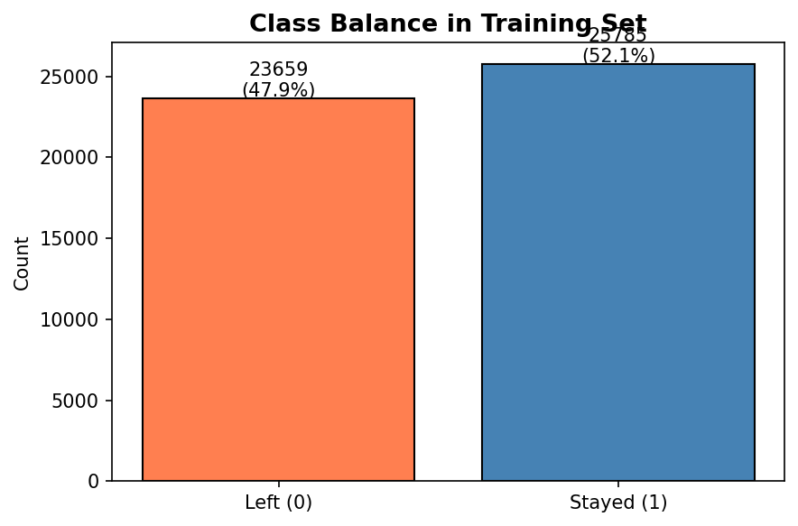
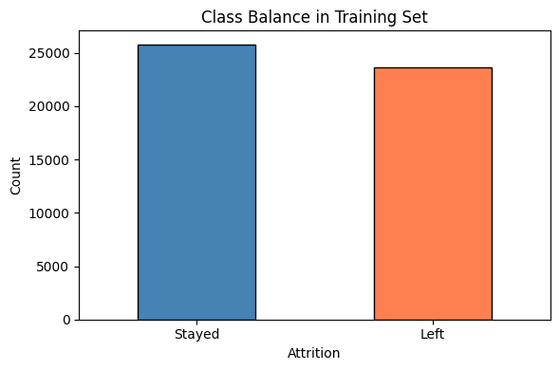
Figure 1: Class distribution of Attrition in the training set

2.2 Univariate Analysis – Numerical Features
Distributions of all 7 numerical features are examined below. Monthly Income is right-skewed; most other features are approximately uniform or normally distributed.
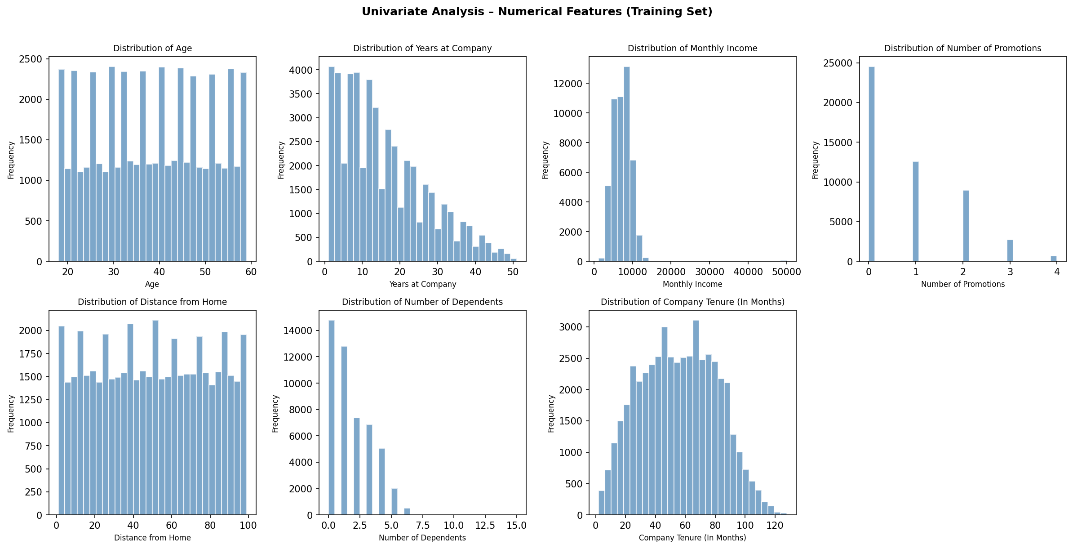
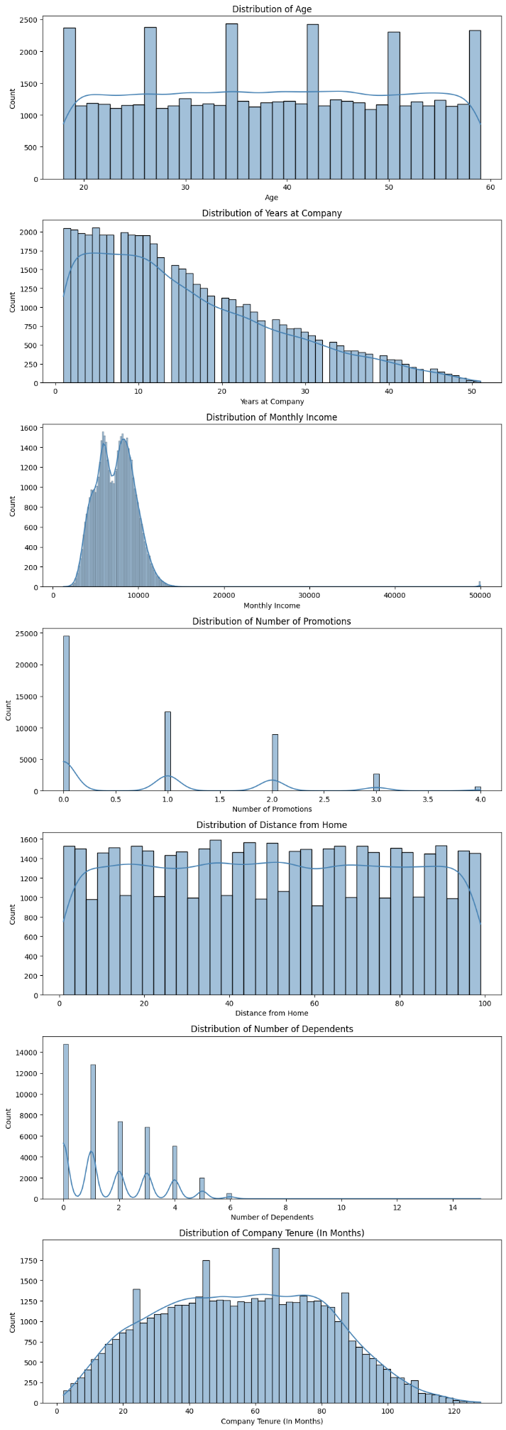
Figure 2: Distribution of numerical features in the training set

2.3 Correlation Analysis
Numerical features are largely uncorrelated with each other (all pairwise correlations < 0.15), confirming low multicollinearity in the continuous predictors.
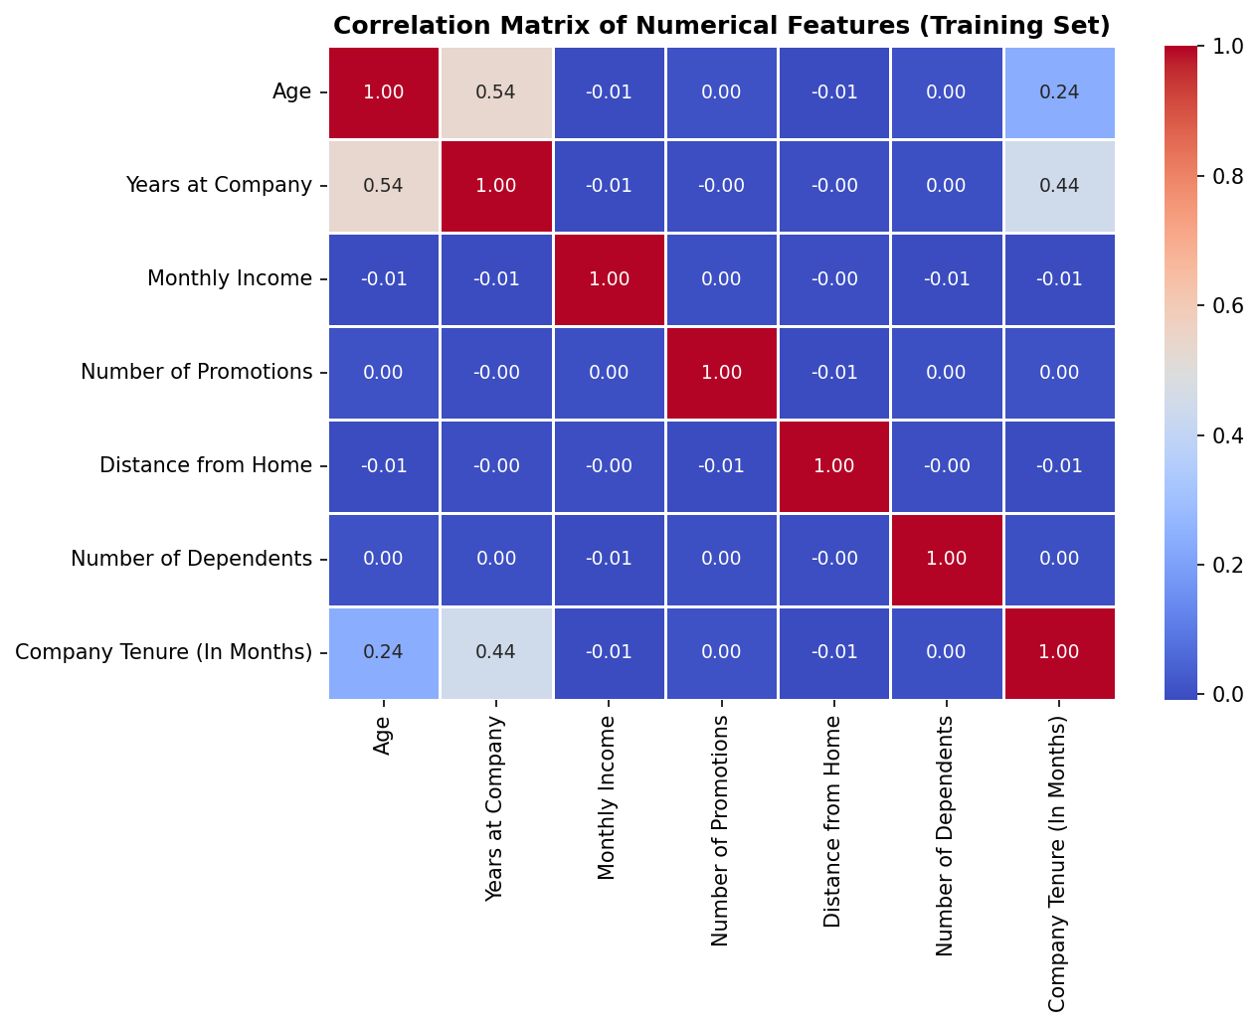
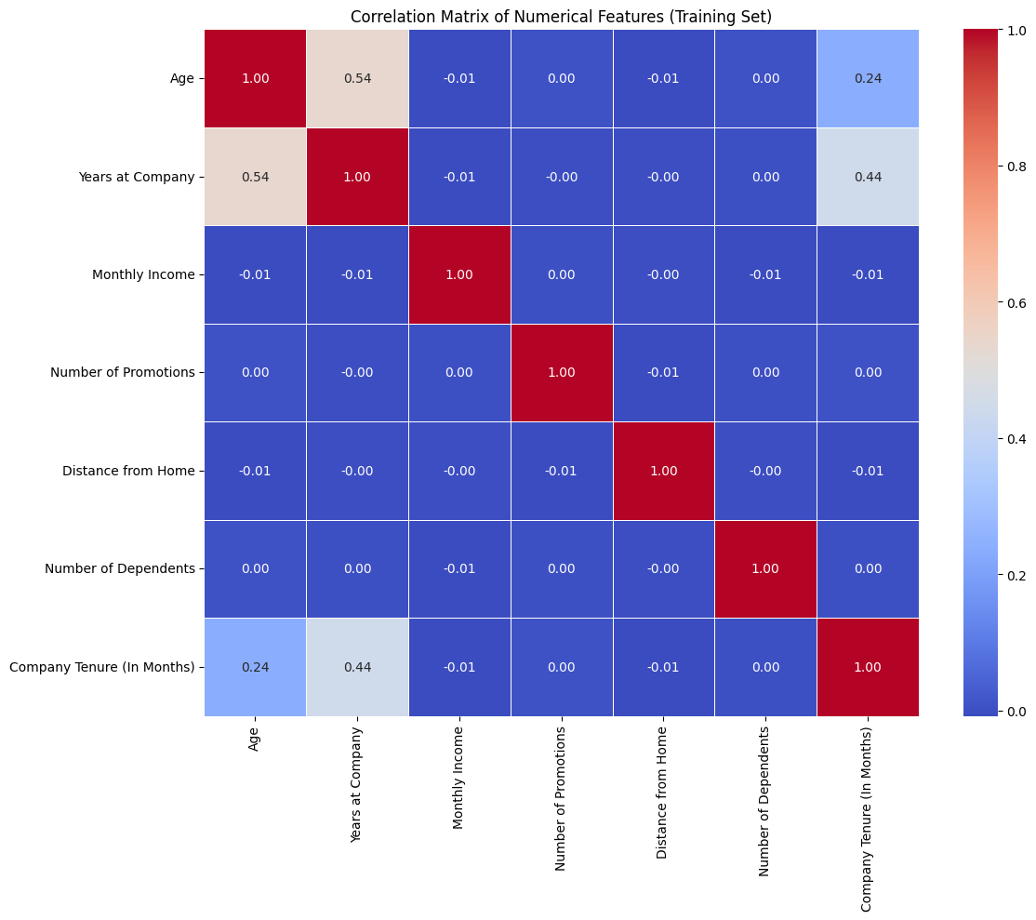
Figure 3: Correlation heatmap of numerical features (training set)

2.4 Bivariate Analysis – Categorical Features vs Attrition
Key observations: employees with poor Work-Life Balance, Low Job Satisfaction, Low Performance Rating, Low Employee Recognition, and Poor Company Reputation all show significantly higher departure rates.
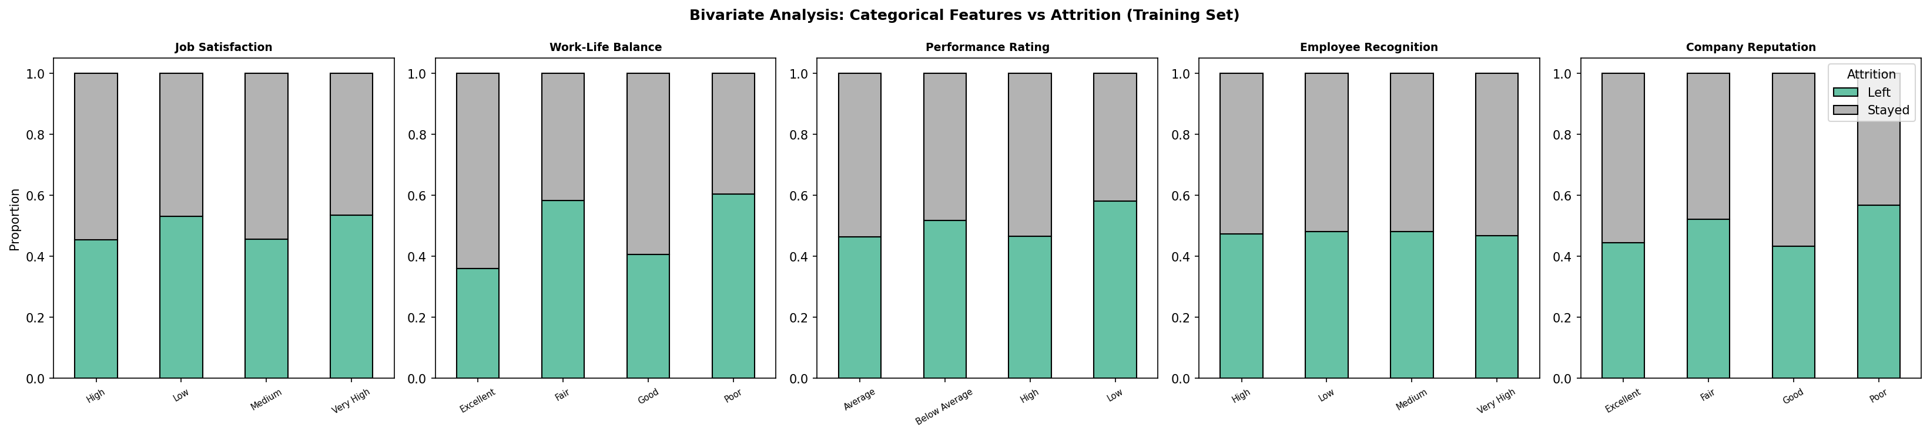
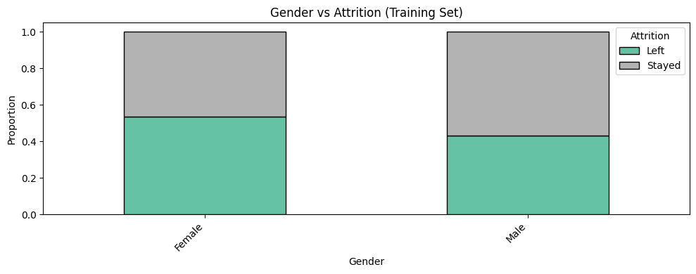
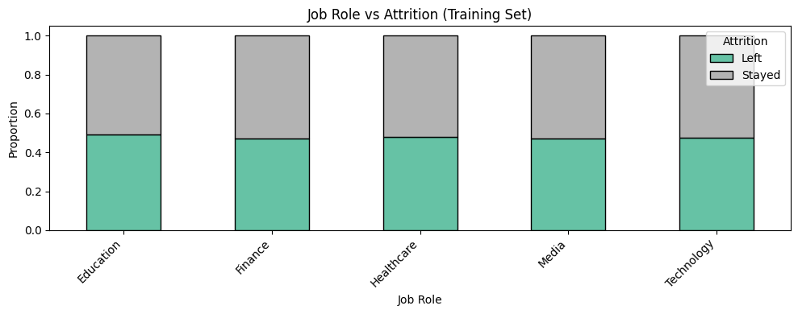
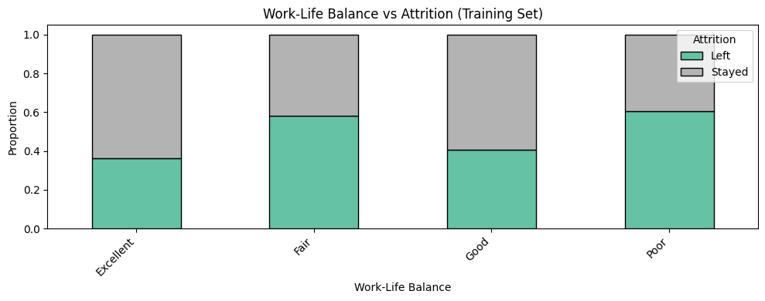
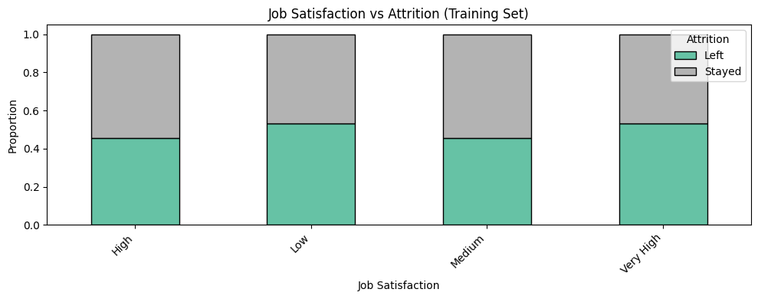
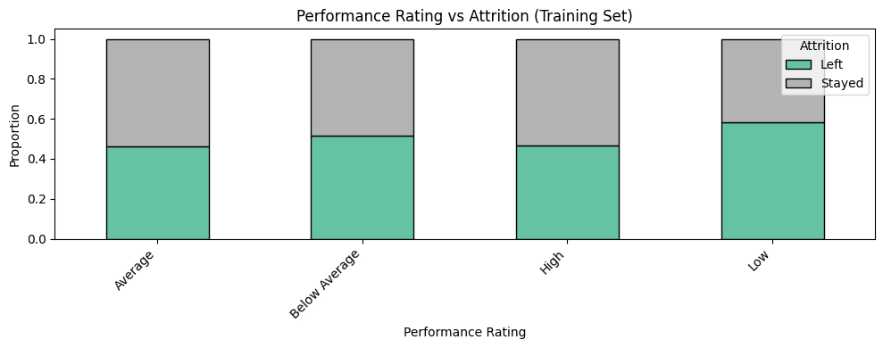
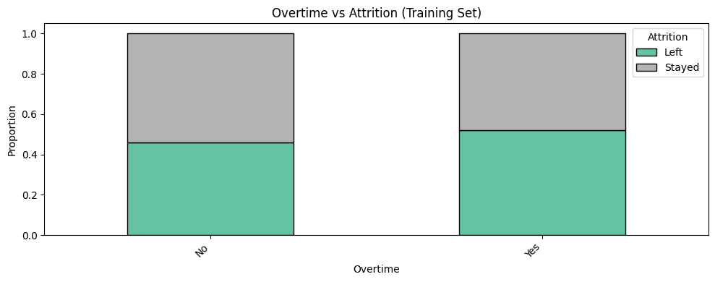
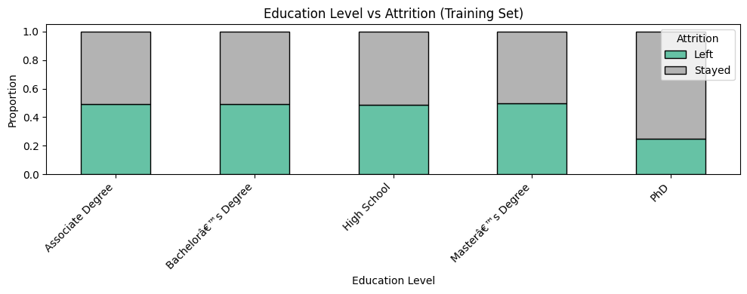
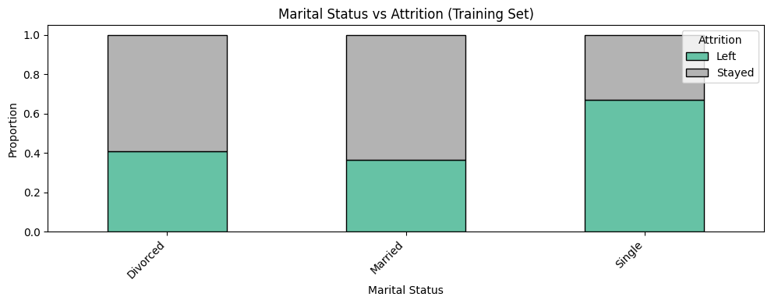
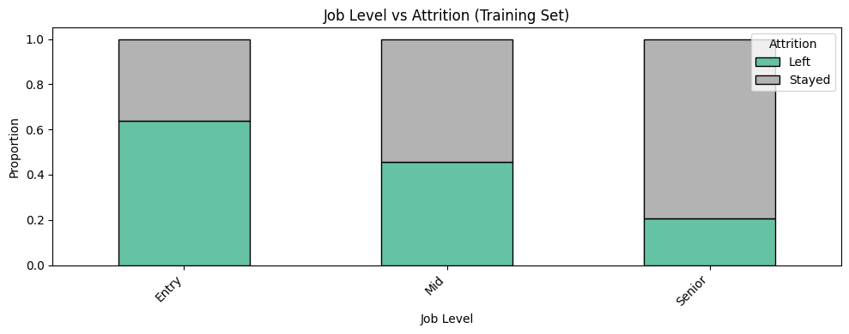
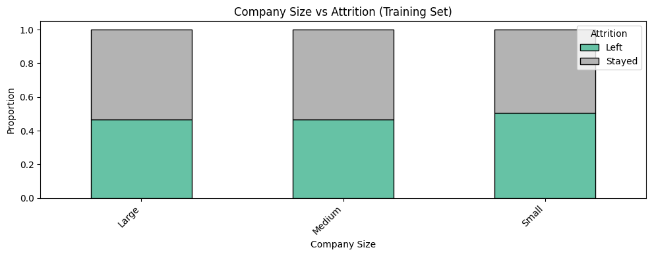
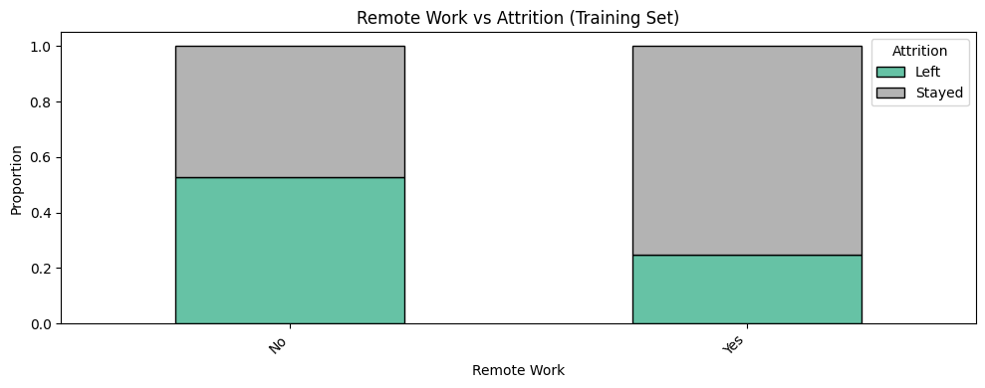
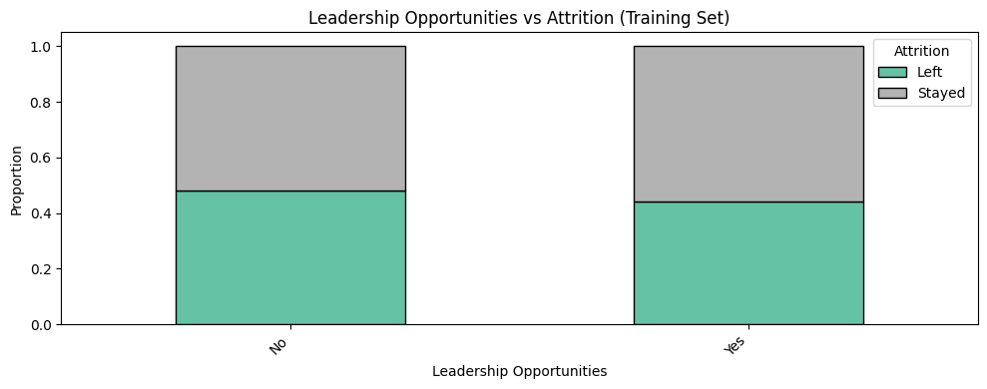
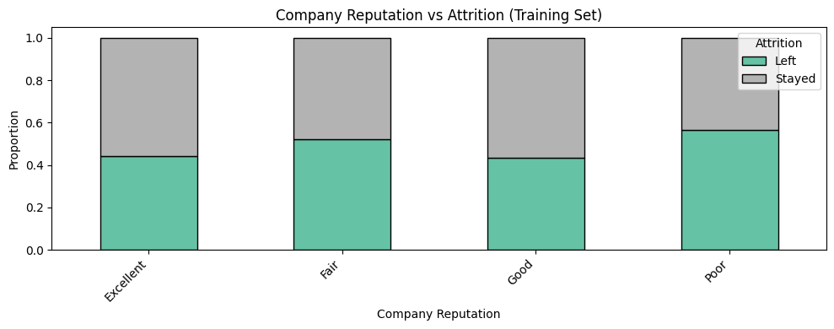
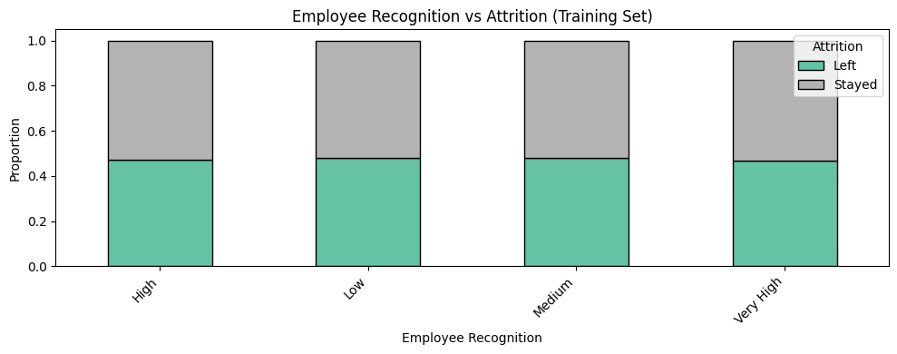
Figure 4: Proportion of Stayed vs Left across five key categorical features

3. Feature Engineering

- Dummy Encoding: One-hot encoding applied to all 15 categorical columns (drop_first=True). Feature matrix expanded to 52 columns.
- Feature Scaling: StandardScaler fitted on training data only, then applied to validation set to prevent data leakage.
- RFE Feature Selection: Top 15 features selected using Recursive Feature Elimination with Logistic Regression as estimator.

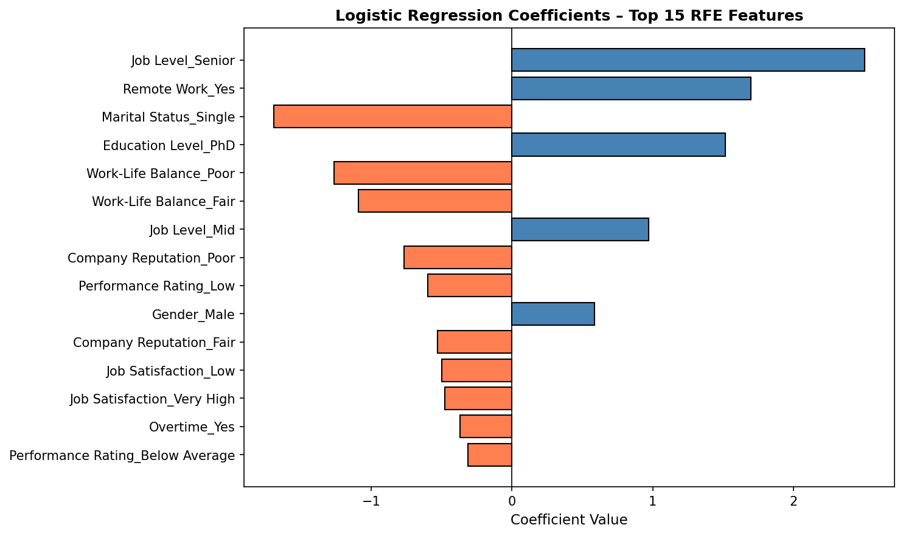
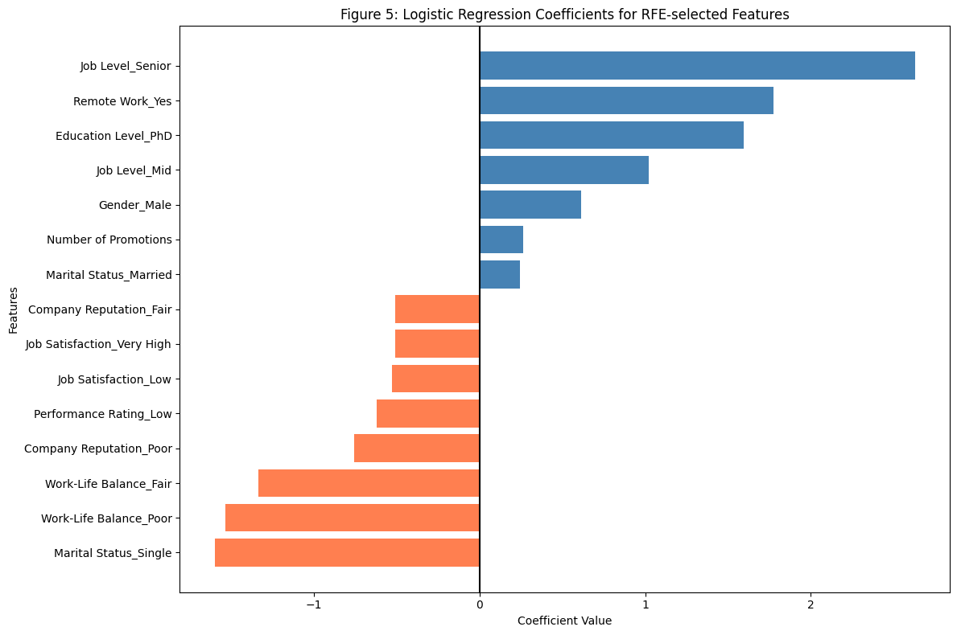
Figure 5: Logistic Regression coefficients for RFE-selected features (Blue = positive/retention, Coral = negative/attrition)

Feature | Category | Coefficient
Job Level – Senior | Career | +2.51
Remote Work – Yes | Work Arrangement | +1.70
Marital Status – Single | Demographics | -1.69
Education Level – PhD | Education | +1.52
Work-Life Balance – Poor | Well-being | -1.26
Work-Life Balance – Fair | Well-being | -1.09
Job Level – Mid | Career | +0.97
Company Reputation – Poor | Employer Brand | -0.77
Performance Rating – Low | Performance | -0.60
Gender – Male | Demographics | +0.59
Company Reputation – Fair | Employer Brand | -0.53
Job Satisfaction – Low | Engagement | -0.50
Job Satisfaction – Very High | Engagement | -0.48
Overtime – Yes | Work Conditions | -0.37
Performance Rating – Below Avg | Performance | -0.31
Table 2: Top 15 RFE-selected features and their model coefficients

4. Model Building & Threshold Optimisation

4.1 ROC Curve – Training Set
Training AUC = 0.826, indicating strong separability between retained and departed employees.
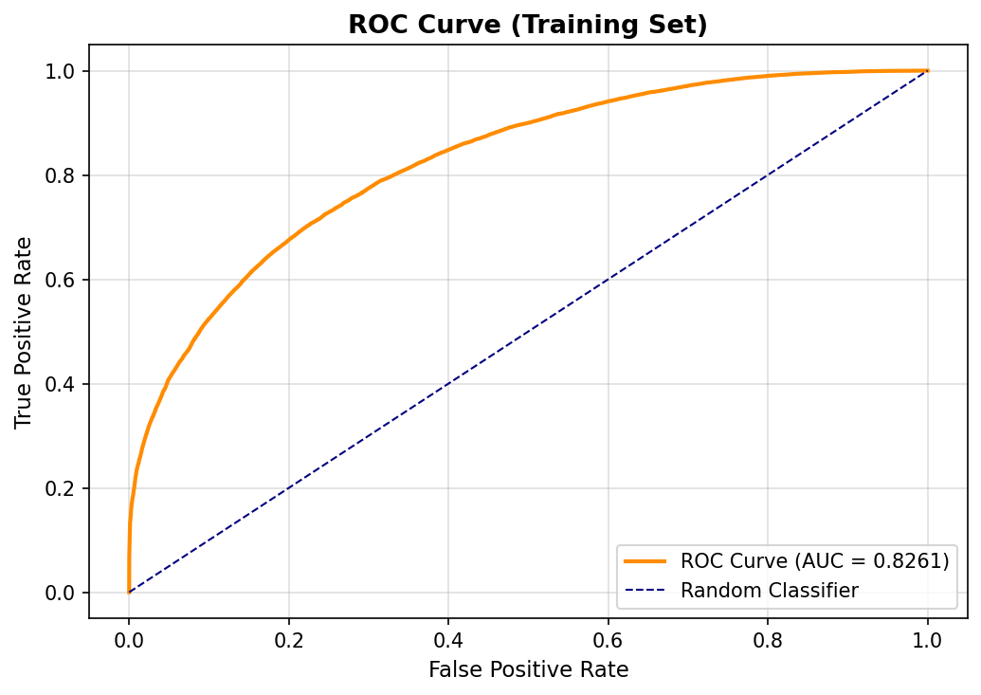
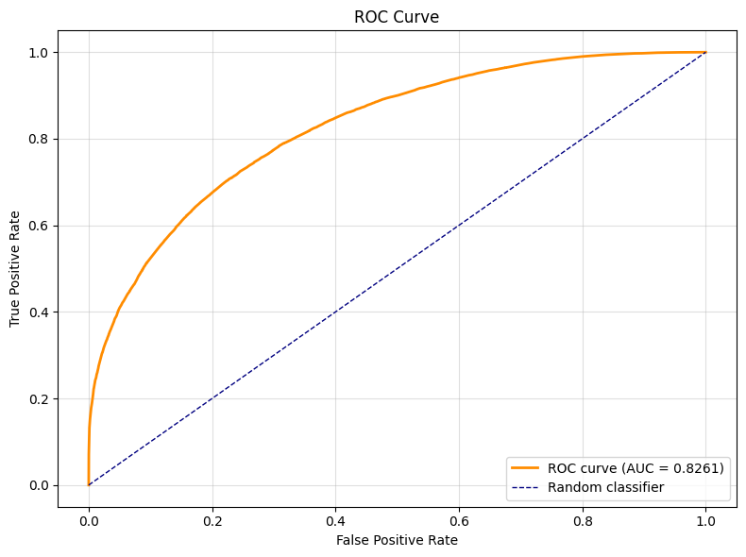
Figure 6: ROC Curve – Training Set (AUC = 0.826)

4.2 Optimal Threshold Selection
The optimal cutoff (0.5) is where |Sensitivity – Specificity| is minimised, balancing the ability to correctly identify both retained and departed employees.
Cutoff | Accuracy | Sensitivity | Specificity
0.3 | 70.45% | 90.65% | 48.44%
0.4 | 73.13% | 84.08% | 61.19%
0.5 * | 73.92% | 75.48% | 72.22%
0.6 | 73.12% | 64.49% | 82.51%
0.7 | 70.93% | 54.47% | 88.87%
Table 3: Performance metrics at selected cutoffs (* = optimal)

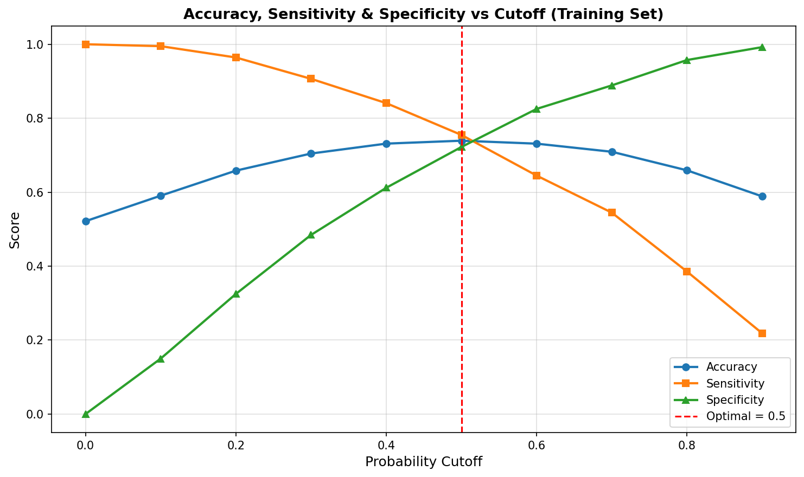
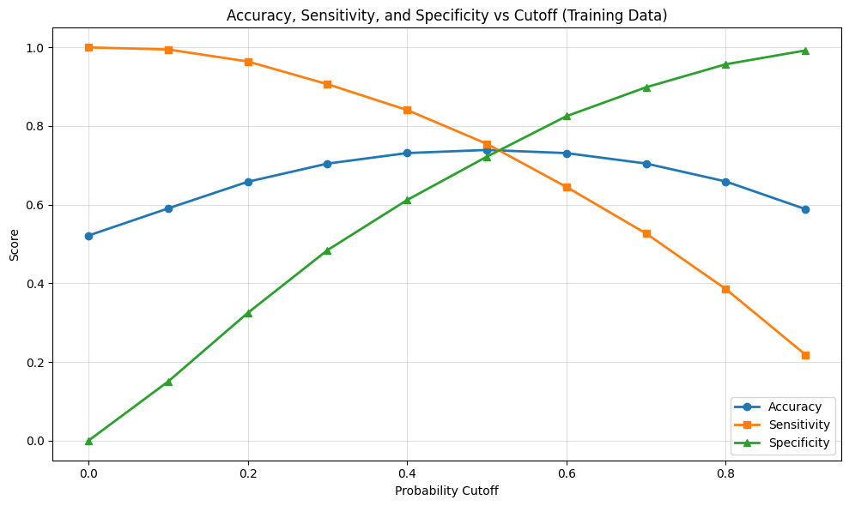
Figure 7: Accuracy, Sensitivity & Specificity across cutoff values (training set)

5. Model Evaluation – Validation Set

Accuracy | AUC-ROC | Sensitivity | Specificity | Precision
73.64% | 0.8239 | 74.78% | 72.41% | 74.61%

5.1 Confusion Matrix
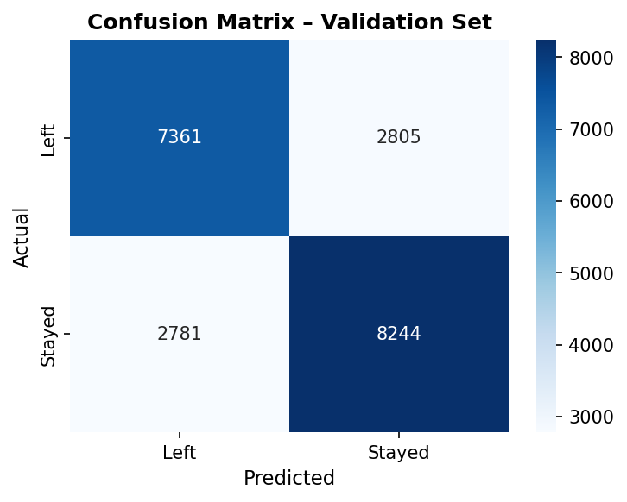  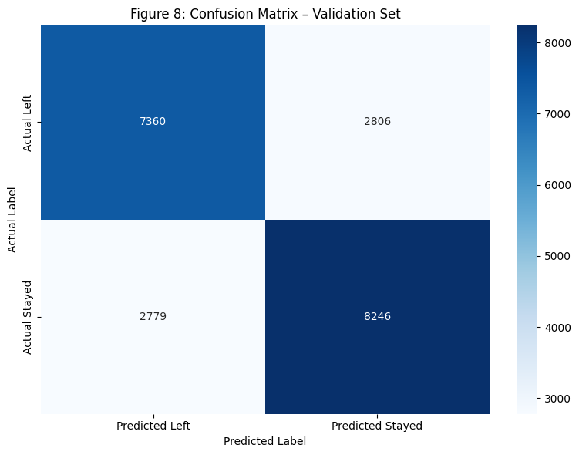  Figure 8: Confusion Matrix – Validation Set | 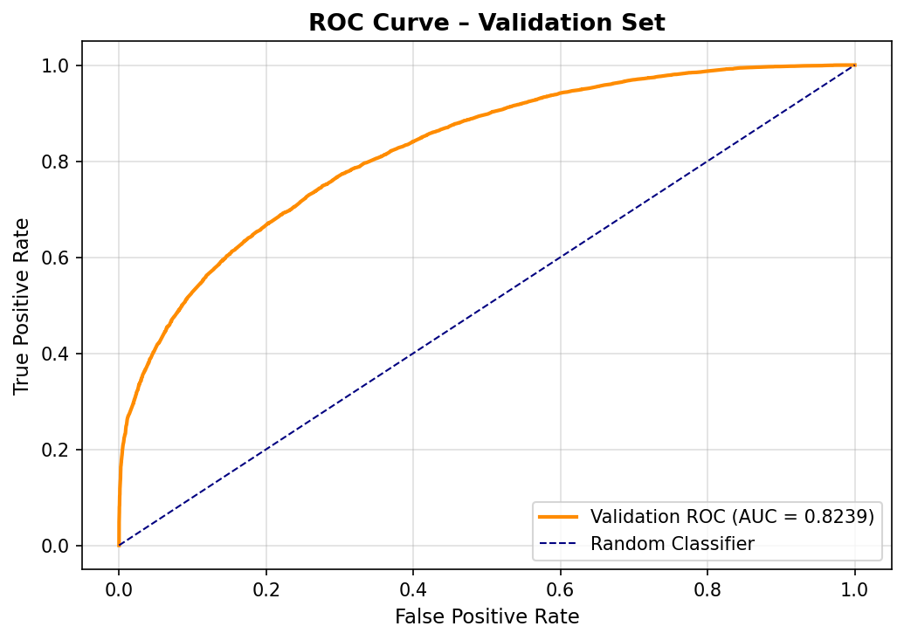  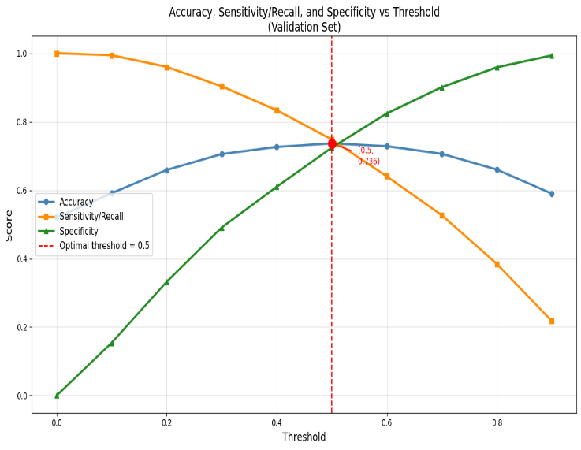  Figure 9: ROC Curve – Validation Set (AUC = 0.824)

Metric | Value | Interpretation
True Positives (TP) | 8,244 | Correctly predicted as Stayed
True Negatives (TN) | 7,361 | Correctly predicted as Left
False Positives (FP) | 2,805 | Predicted Stayed, actually Left
False Negatives (FN) | 2,781 | Predicted Left, actually Stayed
Table 4: Confusion matrix breakdown

6. Key Insights

- Job Level is the strongest retention predictor. Senior (+2.51) and Mid-level (+0.97) employees are far more likely to stay; entry-level staff show the highest churn risk.
- Remote Work significantly boosts retention. Remote-enabled employees are much more likely to stay (+1.70); flexibility is a key differentiator.
- Poor Work-Life Balance strongly drives attrition. Poor (-1.26) and Fair (-1.09) balance scores are top predictors of departure.
- Single employees leave more often. Greater geographic mobility and fewer local ties make single employees higher flight risks (-1.69).
- Company Reputation impacts retention. Poor (-0.77) and Fair (-0.53) reputation perceptions significantly increase departure likelihood.
- Low Performance Ratings correlate with attrition. Low (-0.60) and Below-Average (-0.31) rated employees are more likely to leave.
- Job Satisfaction extremes both predict departure. Low satisfaction (-0.50) and, surprisingly, Very High satisfaction (-0.48) are both departure signals.

7. Recommendations

# | Recommendation | Expected Impact
1 | Build structured career paths from Entry to Senior with transparent promotion timelines. | High
2 | Expand remote / hybrid work policy and communicate it during onboarding and reviews. | High
3 | Run quarterly Work-Life Balance surveys; flag and address teams with Poor/Fair scores. | High
4 | Launch engagement programmes for single employees — mentorship, social events, relocation support. | Medium
5 | Conduct bi-annual employer brand audits and publish improvements transparently. | Medium–High
6 | Introduce a monthly Employee Recognition Programme (spot awards, peer shoutouts). | Medium
7 | Use the model monthly to generate a flight-risk score per employee for proactive HR interventions. | High
Table 5: Data-driven retention recommendations

