# Portes ouvertes virtuelles de l'INSA Toulouse

# **General description**

The sensor consists in a strain gauge designed on a piece of paper with a graphite layer (graphite nanoparticles stick to the paper). Those particles create a conductive layer where a current, based on the tunnel effect and proportional to the distance between particles, can flow.

So, any deflection or contraction of the distance between the particles leads to a difference of the resulting resistance.

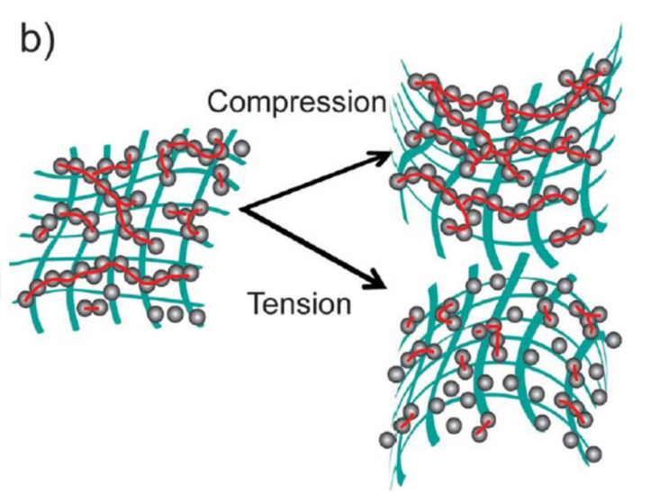  
The resistance is measured and displayed thanks to:

* an electronic circuit including a transimpedance operational amplifier
* a HC-05 Bluetooth interface which allows to connect a phone to the device
* an OLED which displays the values measured

This resistance, which leads to the deformation, is different according to the quantity of graphite leaved behind on the sensor.

# **Mechanical Specifications:**

Lice Cycle: < 100

Height: 0,3 mm

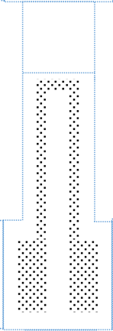Temperature Range: 10°C-25°C

Humidity Range: 40-70%

10 mm

2 mm

34 mm

4 mm

**Graphite Strain Gauge**

**coupled to an electronic circuit**

# **General features**

* Passive
* Angle displacement measurement
* Easy-to-use and produce
* Open source
* Low cost and Low tech
* Detection of inward deflection
* Detection of outward deflection
* Bluetooth connection

|  |  |
| --- | --- |
| Type | Passive sensor  Strain Gauge |
| Transducer | Graphite (from a pencil) on paper |
| Transducer supply | 5V |
| Measurand | Resistance |
| Metering | Analog voltage |
| Measurement | Angle of displacement |
| Response time | < 1us |

# **Electrical specification:**

Supply: 5V

Sensor Resistance: 2-500 MOhm

Sensor Voltage: 0 – 4,99 V

# **Sensor characteristics**

* **B graphite type**
  + *In compression*

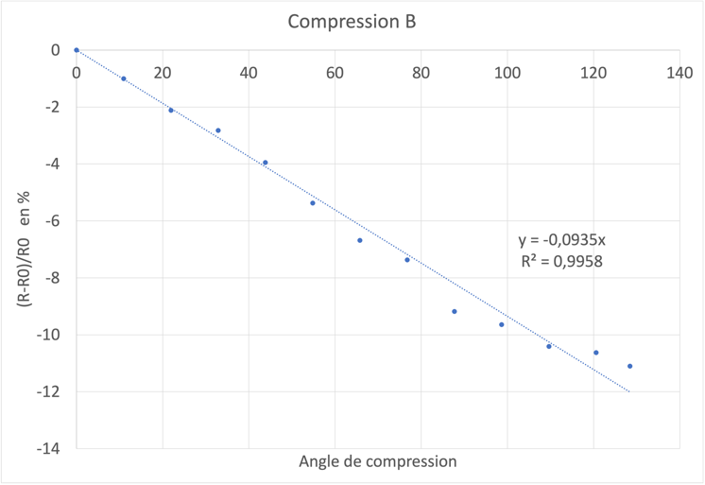

* + *In extension*

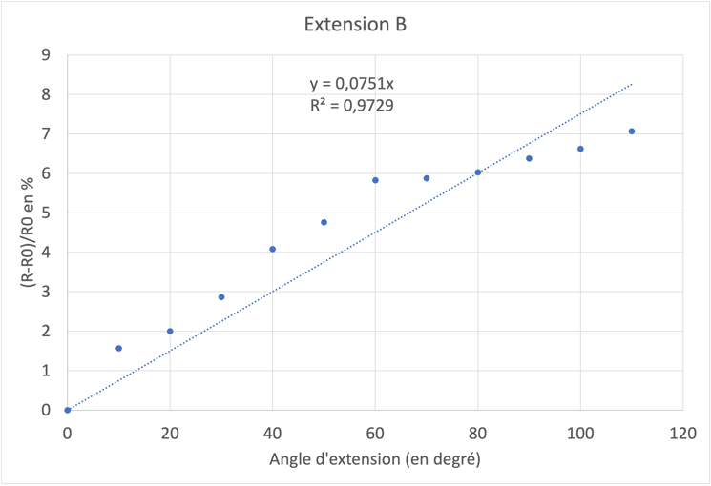

* **HB graphite type:**
  + *In compression*

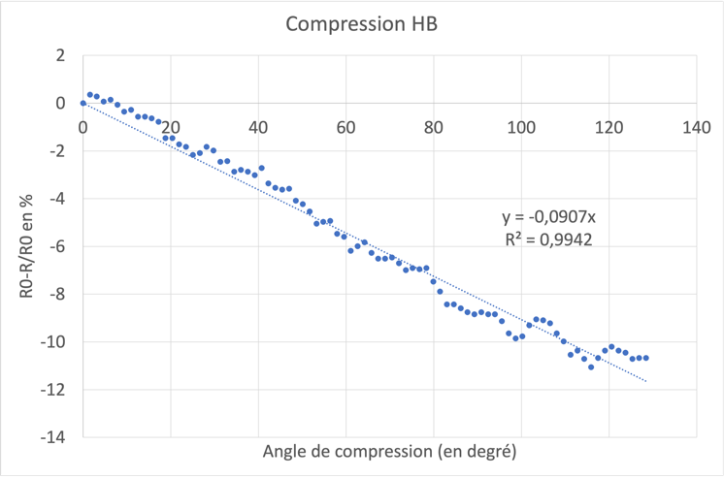

* + *In extension*

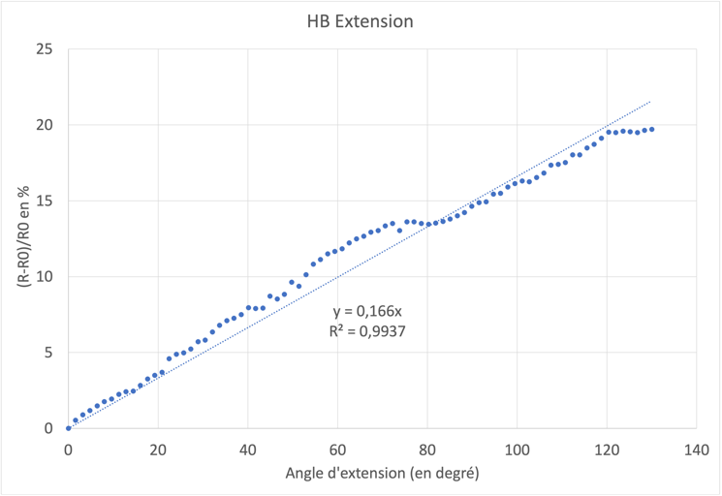

# **Conditioner proposition**

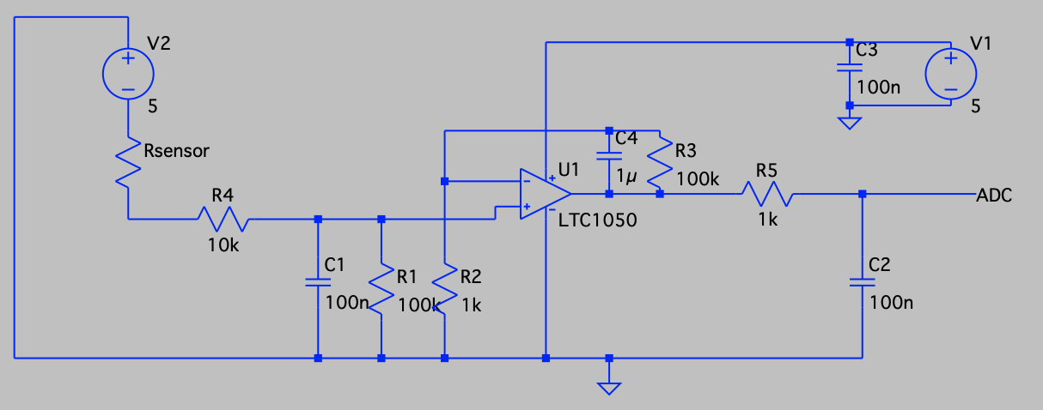

*Typical conditioner for the sensor*

$$R_{sensor}=\left(1+\frac{R3}{R2}\right)\frac{R1}{R2}\frac{Vcc}{ADC}-R1-R5$$

The sensor is connected to a transimpedance amplifier circuit. It consists of an LTC1050 operational amplifier which provide a sufficient voltage signal to the analogue-to-digital converter (ADC) of an Arduino UNO microcontroller.

The circuit has three filter stages:

* at the input, a low-pass filter (R1-C1) with a cut-off frequency of 16 Hz is used to filter the current noise on the input signal
* another low-pass filter of 1.6 Hz (R3-C4) coupled to the PDO filters out the 50 Hz noise component from the input signal component of the 50 Hz noise from the electrical network
* at the output of the amplifier, a final filter (R5-C2) of 1.6 kHz is used to process the noise due to noise from the ADC sampling

The capacitor C3 is used to filter out irregularities in the amplifier supply voltage.

Resistor R2 is used to calibrate the amplifier to the desired voltage range, which is the microcontroller ADC.

The resistor R4 protects the OPAMP from electrostatic discharge and forms an RC filter with capacitor C1 for voltage noise.

# **Advice for use:**

This sensor is suitable for measuring small angles because:

* It is accurate and linear even for small angles
* Low angles deteriorate the sensor less over time and therefore extend its service life