Technical Datasheet

**Gas Sensor based on tungsten trioxide nanoparticles (WO₃)**

**Features :**

* Hight sensitivity and selectivity
* Low power consumption
* Detection of wide variety gas (NH₃, C₆H₂O)
* Easy to integrate
* Small size
* Low cost
* Short response time
* Temperature sensor included
* 2 Integrated gas sensor
* Heater included (resistor)

**Applications :**

* Domestic gas leak detector and alarm
* Portable gas detector
* Medicine
* Automotive industry
* Food industry

**Description :**

This gas sensor is based on WO₃ nanoparticles (NPs), it is developed at the AIME laboratory of Toulouse. The sensing element is composed of two interdigitated electrodes which host the layer of nanoparticles and which then become sensors sensitive to the gaseous environment. A buried heater (n-doped polysilicon) can increase the temperature up to 300°C. An aluminium resistance located at the surface of the chips is used as a thermistor to measure the local temperature. Therefore, an external electronic measuring device may determine the nature and concentration of gas based on the variation of resistances.

**Pin Mapping :**

|  |  |
| --- | --- |
| **Pin Number** | **Usage** |
| 1/6 | Temperature sensor (Aluminium resistor) |
| 2/4 | Gas sensor_1 |
| 3/8 | Heater resistor |
| 7/9 | Gas sensor_1 |
| 5/10 | Not Connected |

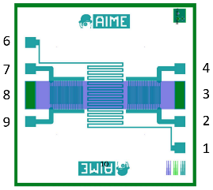

**Specifications :**

|  |  |
| --- | --- |
| **Type** | Nanoparticle based sensor |
| **Materials** | Silicon  N-doped poly-silicon (heater)  Aluminium (temperature measurement)  Nanoparticles of tungsten trioxide (WO₃) |
| **Sensor type** | Active (power supply required) |
| **Output signal** | Analog |
| **Gas measurement** | Resistive measure |
| **Temperature measurement** | Resistive measure |
| **Detectable gas** | Ammonia (NH₃)  Ethanol (C₂H₆O) |
| **Package** | 10-Lead TO-5 metal |
| **Diameter** | 9.5mm |
| **Mounting** | Through hole fixed |
| **Time response** | Ethanol <15s  Ammonia |

**Standard use condition :**

|  |  |  |
| --- | --- | --- |
|  | **Unit** | **Typical Value** |
| Temperature | °C | 20±5 |
| Humidity | % | 60±5 |
| Air quality | %N₂/O₂ | 80/20 |

**Electrical characteristics :**

|  |  |  |  |  |
| --- | --- | --- | --- | --- |
|  | **Unit** | **Value** | | |
|  | **Min** | **Typical** | **Max** |
| Gas sensor resistance | MΩ | 0,01 | 1 | 100 |
| Temperature sensor resistance | Ω | 150 | 150 | 350 |
| Heater resistance | Ω | 70 | 80 | 100 |
| Gas sensor voltage | V | - | 3,3 | - |
| Temperature sensor | V | 3,3 | 5 | - |
| Heater | V | 10 | 15 | 20 |

**Temperature sensor characteristics:**

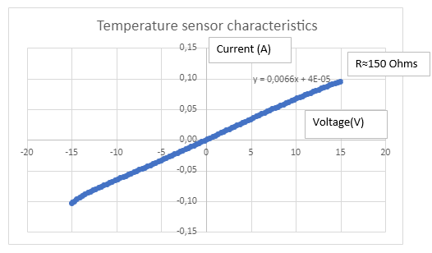

*Current/Voltage characteristics of the sensor (aluminium) at 20°C*

**Heating resistor characteristics:**

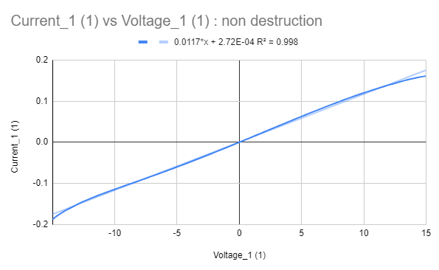

R≈80Ω

*Current/Voltage characteristics of the Heating resistor (Polysilicon) at 20°C*

**Gas sensor characteristics:**

The characterisation of the gas sensor has been performed around several temperatures, following a specific gas exposure procedure.

**Example of integration :**

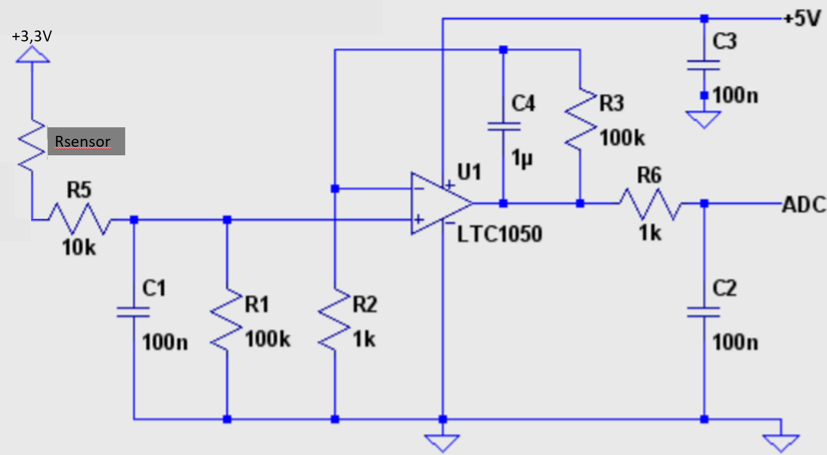

*Typical conditioner circuit*

**Package dimensions :**

The package is a 10-Lead TO-5 metal :

