**CG-4127-GAF**

**Low-tech strain gauge sensor based on graphite pencil**

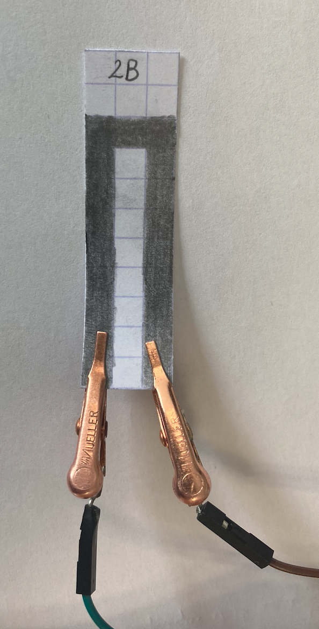

**General features**

-Low power consumption

-Easy-to-use

-Flexible

-Small size

-Ultra-light

-Low cost

-Environment friendly

-Bluetooth connection

**Description**

This graphite-based sensor can be likened to a strain gauge. It is constituted by a piece of paper and pencil traces are drawn on it in the shape of the letter U. The system is granular, there is a link between the electrical conductivity and the space between the nanoparticles of graphite. The pencil traces are conductive thin films made of percolated graphite particle networks. Deformations can be applied, in tension or in compression.

In tension, the percolated network is extended, the distance between nanoparticles increases, percolation paths are broken, the material’s conduction decreases and the resistance of the graphite layer increases.

In compression, it is the opposite. the percolated network is compressed, the distance between particles decreases, new paths are created. The conductivity increases and the resistance of the graphite layer decreases.

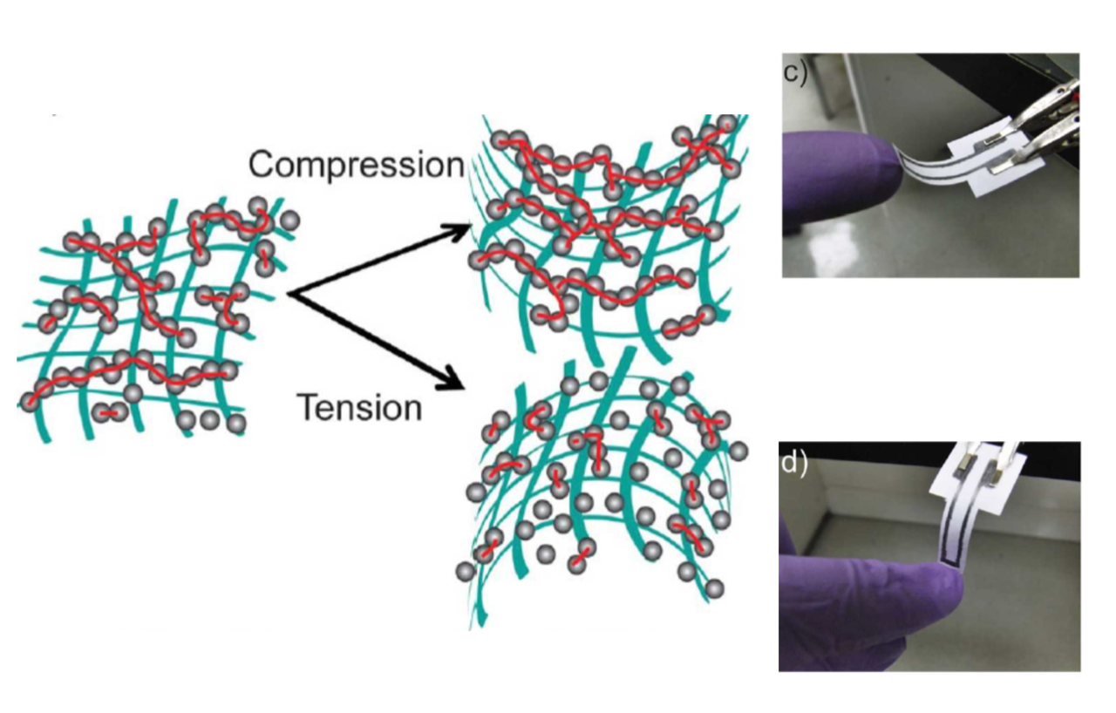

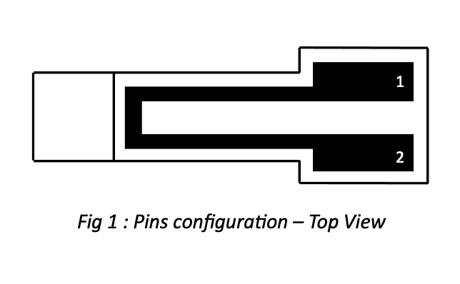**Pin description/configuration**

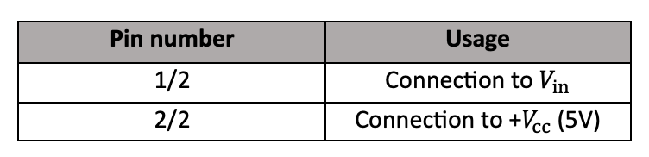

**Specifications**

|  |  |
| --- | --- |
| **Type** | Graphite-based strain sensor |
| **Materials** | * Paper * Graphite (2B, HB, B pencils) |
| **Sensor type** | Passive |
| **Nature of mesurand** | Resistance |
| **Typical application** | Deformation by compression and tension |

**Standart use condition**

|  |  |  |
| --- | --- | --- |
|  | **Typical Value** | **Unit** |
| Temperature | 205 | °C |
| Humidity | 505 | % |
| Bluetooth distance | 14 | m |

**Electrical characteristics**

|  |  |  |  |  |
| --- | --- | --- | --- | --- |
|  | **Unité** | **Value** | | |
| **Min** | **Typ** | **Max** |
| **Power supply** | V | 0 | / | 5 |
| **2B** | M | 2 | 90 | 110 |
| **HB** | M | 10 | 20 | 26 |
| **H** | M | 19 | 36 | 49 |

**Characteristic graphs**

Here are the curves we get with 3 different types of pencils, namely 2B, H and HB. For each pencil, we have two curves. In one, we put the sensor in tension, percolation paths are broken, the resistance of the sensor increases. In the other, we put the sensor in compression, i.e. the graphite particles will move closer to each other facilitating conduction in the percolated network.

Pencil 2B

Pencil HB

Pencil H

*Fig 2: Influence of the deformation on the sensor - Tension*



Pencil 2B

Pencil HB

Pencil H

*Fig 3: Influence of the deformation on the sensor - Compression*

The sensor works well in the deformation range where the curve is linear.

The deformation range where the curve is linear is the one with pencil 2B. The HB and H pencil domains have a slightly narrower linear range, especially for tension deformation, while compression is rather linear in all three cases.

The fatter the pencil, the more graphite particles it will deposit, in this case, pencil 2B. This pencil will have less sensitivity than the other two pencils HB and H, which are drier. As they deposit less graphite, there will be more broken percolation paths when the sensor deforms, and therefore a higher sensitivity.

**Dimensions**

*Fig 4: Top view -Dimensions (mm)*

**Example of integration**

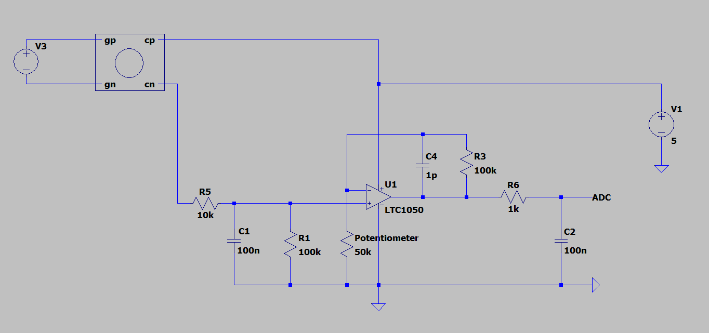

This is a typical application of the sensor in an analogue circuit. The gain sensor is connected to a low pass filter and a potentiometer. The incoming voltage is amplified by the LTC1050 Une image contenant logo
and then filtered by two further low pass filters. The voltage from the ADC label can be connected to a 5V ADC, such as an Arduino.

The first low-pass filter, composed of R1 in parallel with C1, filters the noise on the input signal.

The second, composed of R3 and C3 in parallel, filters the 50Hz noise from the mains.

The last one, R6C2, filters the noise generated by the ADC sampling.

The potentiometer allows the value of the resistor to be changed to avoid saturation at the ADC output.