Datasheet Low-tech of graphite flex sensor

# Main features:

* Low-tech
* Easily replaceable
* Easy-to-use
* Low cost

Figure 1 : Picture of a graphite flex sensor

# Description

This low-tech flex sensor consists of pencil marks on paper. It can detect compression and extension.

The dimensions of the captor are the flowing:

Thickness = 0,02 mm

Figure 2 : Scheme of the graphite flex sensor

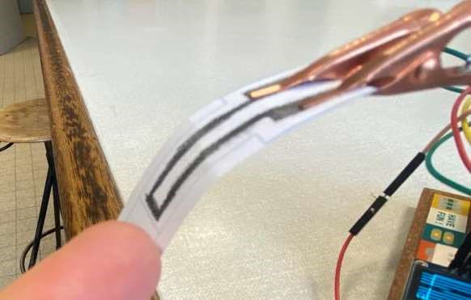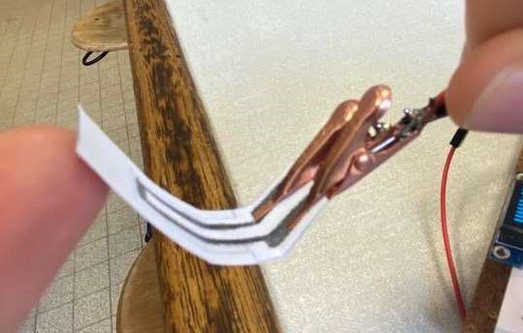

Sensor in tension mode Sensor in compression mode

Figure 3 : Picture of the sensor in tension and compression mode

# Physical explanation

# Specifications

Table 1 : Specification of the graphite flex sensor

|  |  |
| --- | --- |
| Type | Flex Sensor |
| Sensing type | Passive Sensor |
| Materials | ⚬ Paper  ⚬ Graphite  ⚬ Crocodile Clips |
| Power supply requirement | 5V |
| Nature of output signals | Analog |
| Lifetime | 5 to 20 uses |

# Pin connection

# 

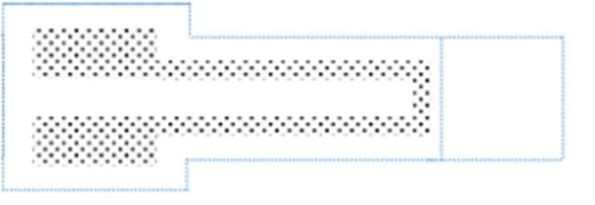Pin 1

Figure 4 : Scheme of pin

Pin 2

# Example of integration

Figure 5 : Electrical scheme of an example of integration

You can see here an example of an integration for the graphite flex sensor. It can be used with an Arduino. The operational amplifier will convert and amplify a current proportional to the resistance of the sensor, here capteur1, to a voltage signal.

# Disclaimer

The sensor we use depends on the disposition of graphene particles on the sheet of paper, this can induce differences between each test due to :

* Paper Degradation
* Graphene particles being removed by the clips
* Randomness of the particles disposition

This implies that a calibration is needed before using the strain sensor.

# Electrical specifications

Table 2 : Electrical specifications

|  |  |  |  |  |
| --- | --- | --- | --- | --- |
|  | Units |  | Values |  |
| Min | Typical | Max |
| 4H | MΩ | 30 | 60 | 120 |
| HB | MΩ | 6 | 7 | 8 |
| 4B | MΩ | 0,9 | 1,1 | 1,3 |

# Typical performance characteristics

Here you can see the typical performance characteristics. The graph represents the relative resistance variation in regard with the deformation $ε=\frac{thikness}{bending radius}$

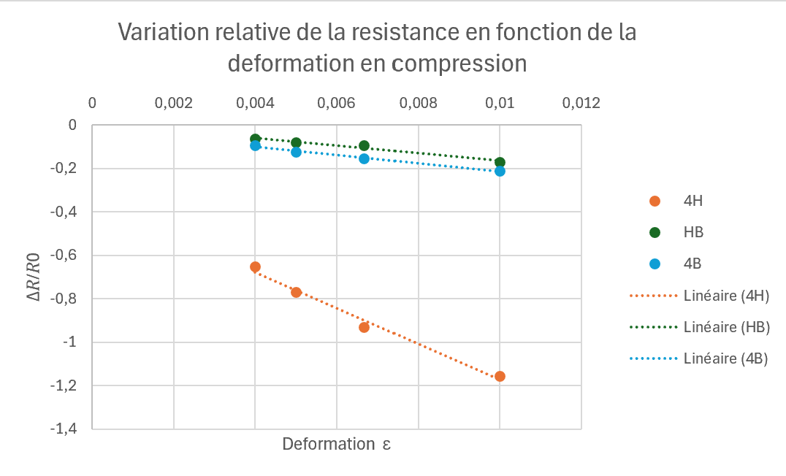

Figure 6 : Graphic representations of the typical characteristics in tension

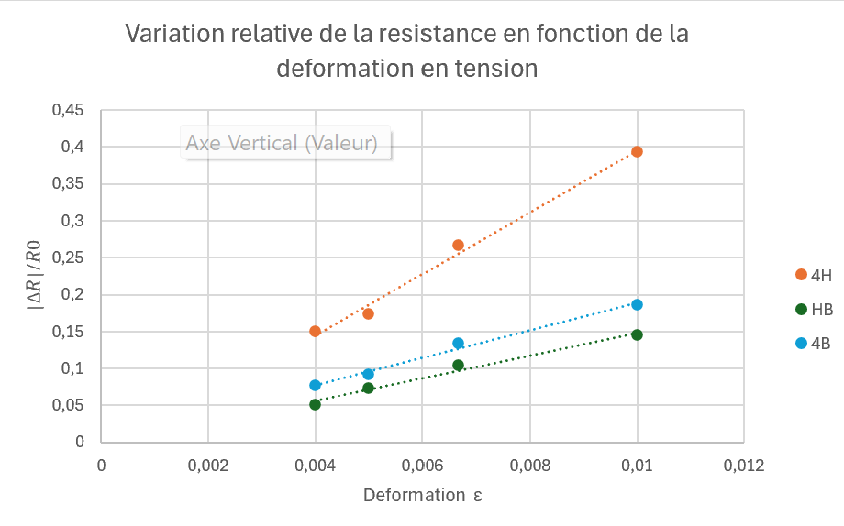

Figure 7 : Graphic representations of the typical characteristics in compression