***GrapheSenso***

**Low-tech strain gauge sensor based on graphite pencil**

## General features

* Low power consumption
* **A black and blue line

  Description automatically generated**Easy-to-use
* Flexible
* Small size
* Ultra-light
* Low cost
* Environment friendly
* Bluetooth connection
* Short response time

## Description: The *GrapheSenso* Strain Gauge - A Simple Tool for Learning Strain Sensing

The *GrapheSenso* (fig.2) strain gauge is a low-cost, student-developed educational tool designed to introduce the basic principles of strain sensing. It offers a simple design using readily available materials, making it suitable for classroom demonstrations and experimentation.

### **How it works:**

* **Sensor Construction**: The sensor is made by drawing a "U" shape with a pencil on a sheet of paper. This creates a network of graphite particles from the pencil lead.
* **Strain and Resistance**: The resistance of this graphite network changes depending on the applied strain (stretching or squeezing) and the type of pencil used (hardness grade).
* **Percolation Theory** (fig.1): This behavior relies on the concept of percolation in granular systems. As the pencil trace acts like a network of particles, the distance between them affects conductivity.
  + *Tension (Stretching)*: When stretched, the network expands. This increases the distance between graphite particles, disrupting conductive paths. This leads to a decrease in conductivity and an increase in measured resistance.
  + *Compression (Squeezing)*: Compression squeezes the network, bringing particles closer and creating new conductive paths. This increases conductivity and lowers the measured resistance.

### **Data Acquisition and Display:**

* **Circuit and Arduino**: To measure these resistance changes, the sensor is paired with a transimpedance amplifier circuit connected to an Arduino Uno board. This setup allows for convenient and accurate resistance measurements.
* **Real-time Monitoring**: The resistance data can be displayed on a connected OLED screen for real-time visualization of the strain applied to the sensor.
* **Wireless Data Transmission**: For remote data acquisition, a Bluetooth module can be added to transmit sensor data wirelessly to an Android phone using a custom application built with MIT App Inventor.

### **Performance Evaluation:**

To assess the sensor's effectiveness, its performance can be compared with a commercially available flex sensor under similar testing conditions. This comparison helps evaluate the sensitivity and efficacy of the student-designed sensor.

### **Educational Value:**

While not intended for high-precision applications, the *GrapheSenso* strain gauge offers a valuable and cost-effective platform for students to:

* Gain hands-on experience with building a basic strain gauge.
* Understand the relationship between strain and resistance.
* Explore the principles of percolation theory in a practical setting.
* 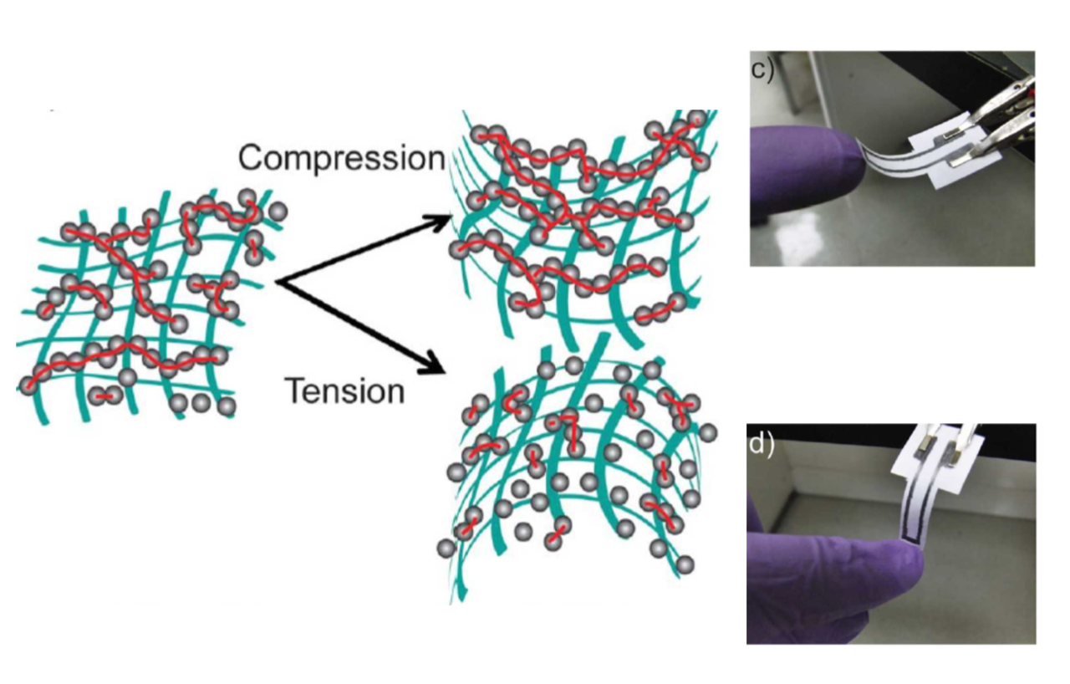Learn about basic data acquisition and display techniques.

**Figure 1: Variation of the number of connected graphite particle chains depending on the types of deformation.**

## A drawing of a line with black dots Description automatically generatedSpecifications

|  |  |
| --- | --- |
| **Dimensions** | Paper thickness: 0.2mm |
| **Connections** | 1: transimpedance amplifier circuit input  2: power supply |
| **Sensor type** | Passive graphite strain gauge sensor |
| **Materials** | Graphite: carbon  Paper: cellulosic plant fibres  Clay ions: carbon, magnesium, aluminium, silicon |
| **Measurand** | Resistance |
| **Output signal type** | Analog |
| **Power supply** | 5V |
| **Typical response time** | <100ms |

**Figure 2: *GrapheSenso* schematic**

**Table 1 : Specifications**

## Standard use conditions

|  |  |  |
| --- | --- | --- |
|  | **Typical Value** | **Unit** |
| Temperature | 205 | °C |
| Humidity | 605 | % |
| Bluetooth distance | 22 | m |

**Table 2: Standard use conditions**

## Electrical characteristics

|  |  |  |  |
| --- | --- | --- | --- |
| **Pencil type** | **Unit** | **Measured R range** | **Typical R0 range** |
| HB | MΩ | 2.00 – 3.00 | 2.30 – 2.70 |
| B | 1.85 – 3.20 | 2.00 – 2.60 |
| 2B | 3.90 – 5.40 | 4.00 – 5.00 |

**Table 3:** **Electrical characteristics**

## Characteristic graphs

**Figure 3: Variation of resistance in function of the deformation in tension**

**Figure 4: Variation of resistance in function of the deformation in compression**

Here are the curves (fig.3 and fig.4) we get with 3 different types of pencils, namely 2B, B and HB. For each pencil, we have two curves. In one, we put the sensor in tension, percolation paths are broken, the resistance of the sensor increases. In the other, we put the sensor in compression, i.e. the graphite particles will move closer to each other facilitating conduction in the percolated network.

## Test bench

To characterize the deformation of the sensor, we use the following test bench (fig.5):

**Figure 5: Test bench schematic**

This test bench is made up of 7 half cylinders of different diameters ranging from 2 to 5 cm with a step of 0.5 cm. We put the sensor on each of the cylinders and therefore apply a deformation to it.

We can determine the curvature of the sensor for each radius, and then use the following  
formula to calculate the relative variation of resistance with respect to the deformation:

where ε is the deformation, 𝑒 is the thickness of the paper sheet, 𝑟 is the radius.

## A diagram of a circuit Description automatically generatedExample of integration

**Figure 6:** **SPICE model of a typical application of the sensor in an analogic circuit**

This is a typical application of the sensor in an analogue circuit (fig.6). The circuit uses a transimpedance amplifier which converts a current input signal into a voltage output signal.

The circuit has three filtering stages:

* At the input, a low-pass filter (R1C1) with a cutoff frequency of 16 Hz is used to filter out current noise from the input signal.
* Another low-pass filter with a cutoff frequency of 1.6 Hz (R3C2) is used to filter out the 50 Hz noise component originating from the power grid.
* At the output of the amplifier, a final filter (R4C4) with a cutoff frequency of 1.6 kHz is used to address the noise introduced by the ADC sampling.

Capacitor C3 is used to filter out irregularities in the amplifier's power supply voltage. Resistor R2 is used to calibrate the amplifier to the desired voltage range of the microcontroller's ADC. A digital potentiometer was used during the circuit prototyping phase to find the value for resistor R2. Resistor R5 protects the transimpedance amplifier against electrostatic discharge and forms an RC filter with capacitor C1 to address voltage noise.

The resistance value of *GrapheSenso* is obtained by:

## Contact Info:

* Tan Anh Khoa NGO: [takngo@insa-toulouse.fr](mailto:takngo@insa-toulouse.fr)
* Le Duc Minh TRAN: [ltra@insa-toulouse.fr](mailto:ltra@insa-toulouse.fr)

For more detailed information about GrapheSenso, our GitHub page is [here](https://github.com/MOSH-Insa-Toulouse/2023-2024_4GP_NGO-TRAN).