# Model

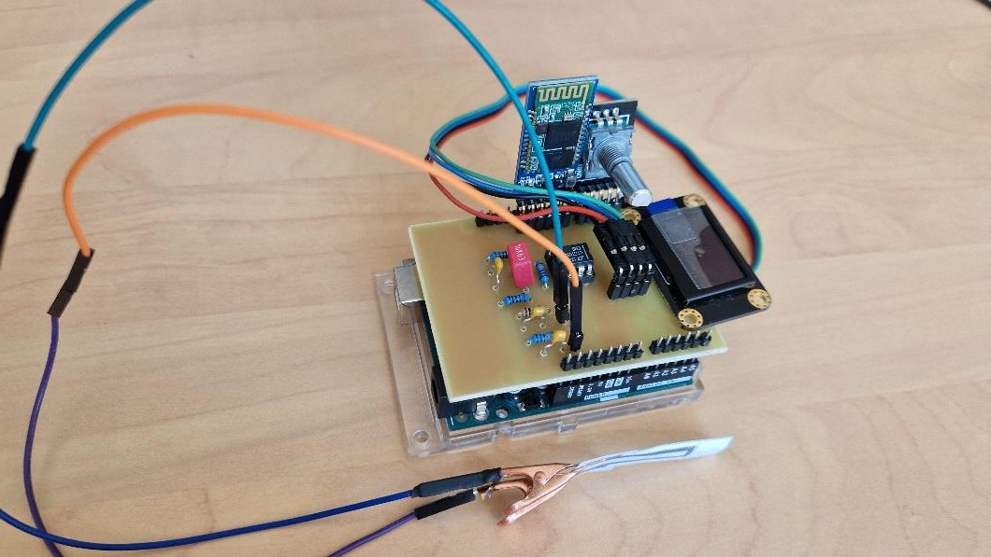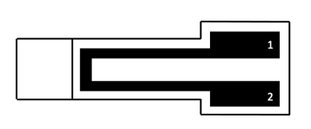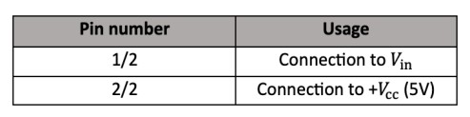

Description

The sensor is a paper sheet with deposited graphite, acting as a strain gauge. When mechanical stress is applied, the distance between graphite particles changes, affecting current resistance. Closer particles decrease resistance, while moving away increases resistance.

By measuring resistance, the strain gauge angle can be determined. Different pencil types (B, HB, 6B, 2B, H, 2H) affect conductivity.

We used a transimpedance amplifier and Arduino Uno with OLED screen or Bluetooth module to read resistance values on an Android phone. Results can be compared to flex sensor for quality evaluation.

## Main features

* Low power consumption
* Easy to use
* Thin, Light
* Low cost
* Flexible, Portable
* Environmentally friendly

# AWARDS

* GP’s Annual Enterprise Award 2020
* E&Y Entrepreneur of the Year 2021
* Beacon of GP Start-up Award for 2022

TRUONG Minh Thang 4GP 2022-2023

PHAN Nhat Tien



Low-tech graphite based on strain sensor.

Tan Anh Khoa NGO – Le Duc Minh TRAN – 4GP INSA





## Dimensions

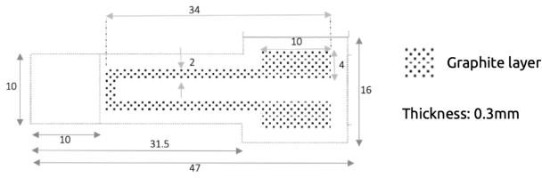

**Specifications**

Figure 1: Top view – Dimensions (mm)

|  |  |
| --- | --- |
| **Type** | Graphite-based strain sensor |
| **Materials** | * Paper * Graphite (2H, HB pencils) |
| **Sensor type** | Passive |
| **Nature of mesurand** | Resistance |
| **Typical application** | Deformation by compression and tension |

## Standard use condition

|  |  |  |
| --- | --- | --- |
|  | **Typical Value** | **Unit** |
| Temperature | 20±5 | °C |
| Humidity | 60±5 | % |
| Bluetooth distance | 2±2 | m |

**Example of integration**

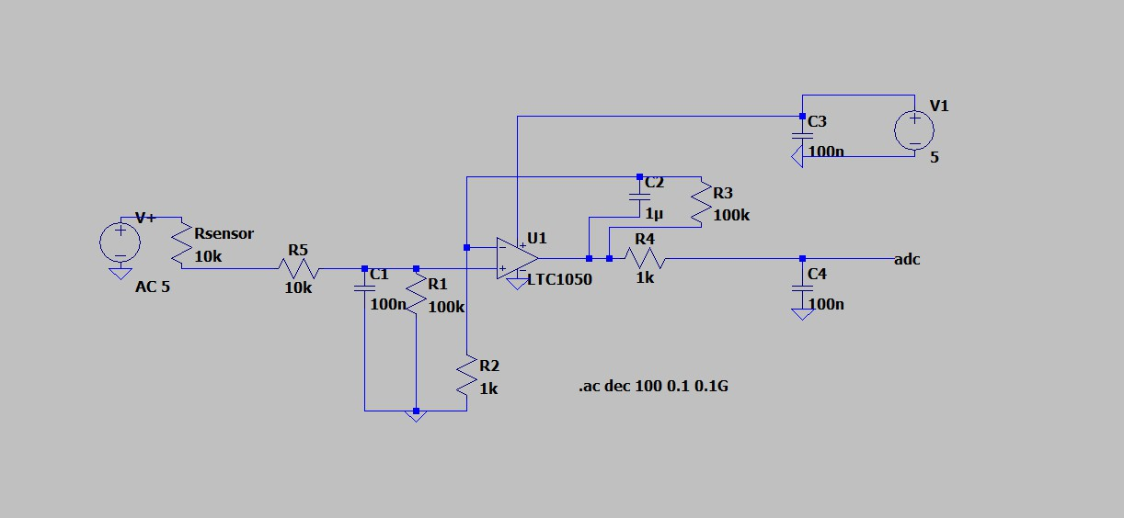

Based on this AOP, we are designing the architecture of the amplifier circuit (see Figure 1a). It has three filtering stages:

* At the input, a low-pass filter (R1C1) with a cutoff frequency of 16 Hz is used to filter out current noise from the input signal.
* Another low-pass filter with a cutoff frequency of 1.6 Hz (R3C2), connected to the operational amplifier (AOP), is used to filter out the 50 Hz noise component originating from the power grid.
* At the output of the amplifier, a final filter (R4C4) with a cutoff frequency of 1.6 kHz is used to address the noise introduced by the ADC sampling.

The capacitor C3 is used to filter out irregularities in the amplifier's power supply voltage. The resistor R2 is used to calibrate the amplifier to the desired voltage range, which is that of the microcontroller's ADC. During the circuit prototyping phase, we used a digital potentiometer instead of this resistor to find its value. Lastly, the resistor R5 protects the operational amplifier against electrostatic discharge and forms an RC filter with capacitor C1 to address voltage noise.

## Test bench

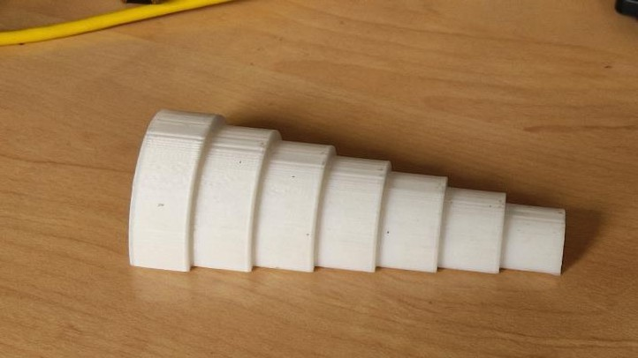

This test bench made up of 7 half cylinders of different diameters ranging from 2 to 5 cm with a step of 0.5 cm. We put the sensor on each of the cylinders and therefore apply a deformation to it. This deformation is found with the formula below:



The deformation ε depends on the thickness (e) of the sheet of the sensor (we took for that 0.16mm which is the grammage of sheet 140g/m²) and on the radius of curvature of the circles (r) therefore the radius of each half cylinder. We performed compression and tension measurements for each of our sensors.

