**Low budget Graphite strain sensor**

**coupled to an analog electronic circuit**

**General features**

* Low Power consumption
* Open source
* Low cost
* Voltage and resistance analyse
* Bluetooth connexion available
* OLED screen display
* Low precision for HB/2H

**Description**

This strain sensor is based on a graphite’s resistance and voltage detector. When a pencil trace is drawn on a paper, graphite particles rub off and stick to the paper. Those particles will create a thin conductive film where the current will flow. Indeed, between each particles of the graphite films, exist a tunnelling current proportional of the distance between the particles. Therefore, any expansion or contraction of the paper will affect of the inter particles contact and so the resulting current. The resistance we measure thanks to the sensor highly depends on the type of pencil we used. Indeed, each pencil does not leave the same amount of graphite resulting in a variation of resistance.

**Specifications**

|  |  |
| --- | --- |
| Type | Deformation sensor |
| Sensing principal |  |
| Materials | Cooper, plastic, graphite |
| Power supply | 5V |
| Overall dimensions | Arduino Uno size: 1.8x4.8x6.4cm |
| Measurands | Voltage |
| Nature of Output signal | Analog |
| Voltage output range | 0-5 V |
| Resistance output range | B: 20-100 MΩ  2H: 600-2000 MΩ  HB: 1000-3000 MΩ |
| Response time | <100ms |
| Working time | 1 hour for 1 graphite paper |
| Pin used | A0 and 5V |
| Typical application | Resistance and voltage monitoring due to deflection of graphite |

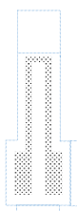**Detailed sensor**

35mm

5mm

15mm

As mentioned above, the sensor uses a U-shaped drawing paper to measure the voltage and resistance of the graphite. The bared area represents the graphite drawing

Figure 1 Strain gauge

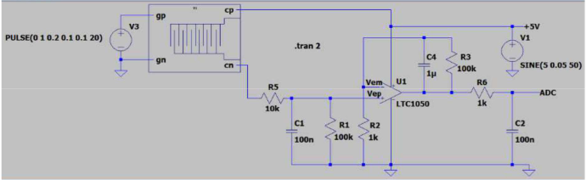The sensor is made of two cooper’s clips that are disposed on the drawing part of the paper. One clip is plugged to the analogic pin A0 of the Arduino Uno board through the shield. The other one is linked to the 5V power supply of the Arduino Uno. Because the resistance we measure are extremely high we have to include a transimpedance circuit. This transimpedance circuit is show below (figure 2 and 3). The two clips are represented by the cp and cn branches.

Figure 2 Transimpedance circuit

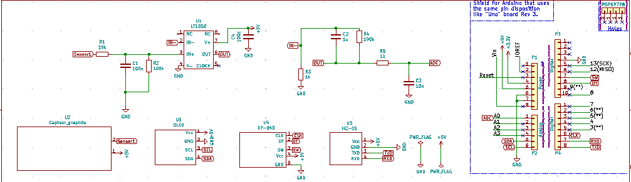In order to plug all of our component we use a shield. The shield characteristic and routing are represented in figure 3. The pin we use are listed below.

Figure 3 Overall circuit

|  |  |  |
| --- | --- | --- |
| Device | Pin number of the Arduino Uno board | Pin device |
| Strain sensor | A0 | 1 |
| 5V | 2 |
|  | | |
| OLED screen | Vin | VCC |
| GND | GND |
| A5 | SCL |
| A4 | SDA |
|  | | |
| HC-05 Bluetooth module | Vin | VCC |
| GND | GND |
| 0 | TX |
| 1 | RX |
|  | | |
| KY-040 | Vin | V+ |
| GND | GND |
| 11 | SW |
| 10 | DT |
| 2 | CLK |