**Resistance sensor based on graphite strain gauge**

**Main features**

* Bluetooth connected to any android smartphone
* Small size
* Low power consumption
* Low cost
* Easy-to-use
* Interchangeable sensor paper
* Premade drawing pattern
* Does not generate potentially negative environmental impact during and after fabrication

**General description**

This resistance sensor based on graphite was developed as a part of an INSA Toulouse *applied physics- sensors* major project. The sensing element is made of a sheet of paper with a premade drawing pattern filled with graphite form a type B pencil. When the sensor is under mechanical stress the linear atomic links from the graphite pattern exhibits reversible resistance changes. Compression or depression of the graphite particle network show variations on the sensor’s resistance. Behind the sensor lies an ARDUINO UNO powered shield with a transimpedance amplifier (LTC1050), a Bluetooth module, OLED screen and a rotational encoder to respectively, amplify, transport and communicate the measured resistance. This sensor has high sensibility and selectivity which can be adjusted through the app on any android smartphone.

|  |  |
| --- | --- |
| Pin number | Function |
| 10/11/GND/ | Bluetooth module (RX, TX, power) |
|  | LTC-1050 Operational Amplifier |
| A5/A6/+5V | OLED screen (SDA, SCK, VCC, GND) |
| 4/5/6/7 | Rotatory encoder (CLK, DATA, SWITCH, VC, GND) |

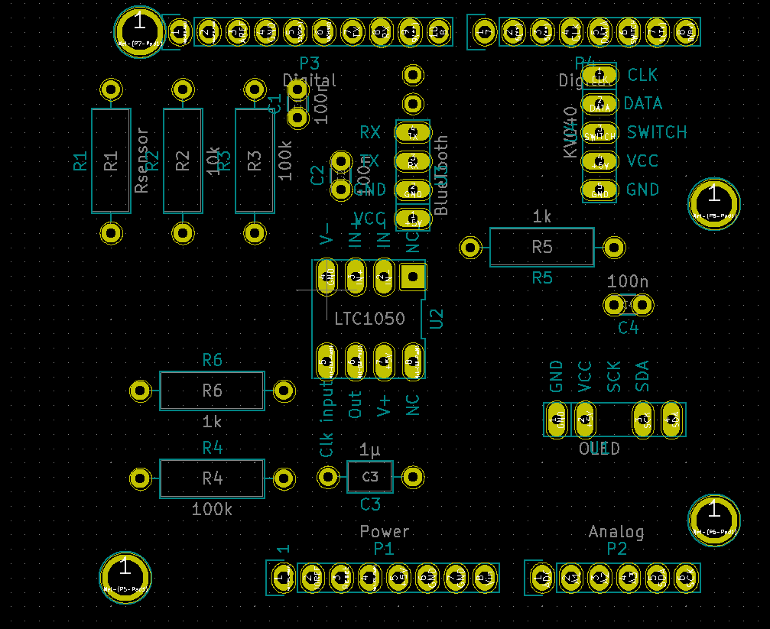**Pin description**

**Specifications**

|  |  |
| --- | --- |
| **Type** | Strain gauge resistance sensor |
| **Sensing** **principle** | Electron transport |
| **Materials** | * Graphite * Paper sheet |
| **Power supply requirement** | Active sensor |
| **Nature of output signal** | Analog |
| **Nature of measurands** | Resistance |
| **Shield length** | 68 mm |
| **Shield width** | 59 mm |
| **Sensor length** | 47 mm |
| **Sensor width** | 18 mm |
| **Graphite sensor pattern length** | 39 mm |
| **Graphite sensor pattern width** | 11 mm |
| **Pin diameter** | <0.6 mm |
| **Mounting** | Soldering |
| **Detectable strains** | * Compressive deflection * Tensile deflection |
| **Typical detection range** | 0-5 V |
| **Typical response time** | 500ms |
| **Typical recuperation time** | 150ms |
| **Service resistance range** | 1e7-1e10 Ω |
| **Typical applications** | Noncritical angle measurements |

**Warning**

This sensor must not be in contact with water because of injury risk in case of malfunctioning.  
The graphite pattern wears off after a few uses so make sure that the one you are testing is not constantly at 0.

Calibration may be needed with a rotational encoder to have the most accurate results.

|  |  |
| --- | --- |
| **Unit** | **Typical Value** |
| **Temperature** | °C | 20±5 | |
| **Humidity** | % | 60±5 | |
| **Air** **Quality** | %N2/O2 | 80/20 | |

**Standard use condition**

**Electrical characteristics**

|  |  |  |  |
| --- | --- | --- | --- |
| **Unit** | **Min value** | **Typical value** | **Maximum value** |
| **Graphite sensor resistance** | °MΩ | 1 | 37 | 1000 |

**Resistance sensor characteristics**

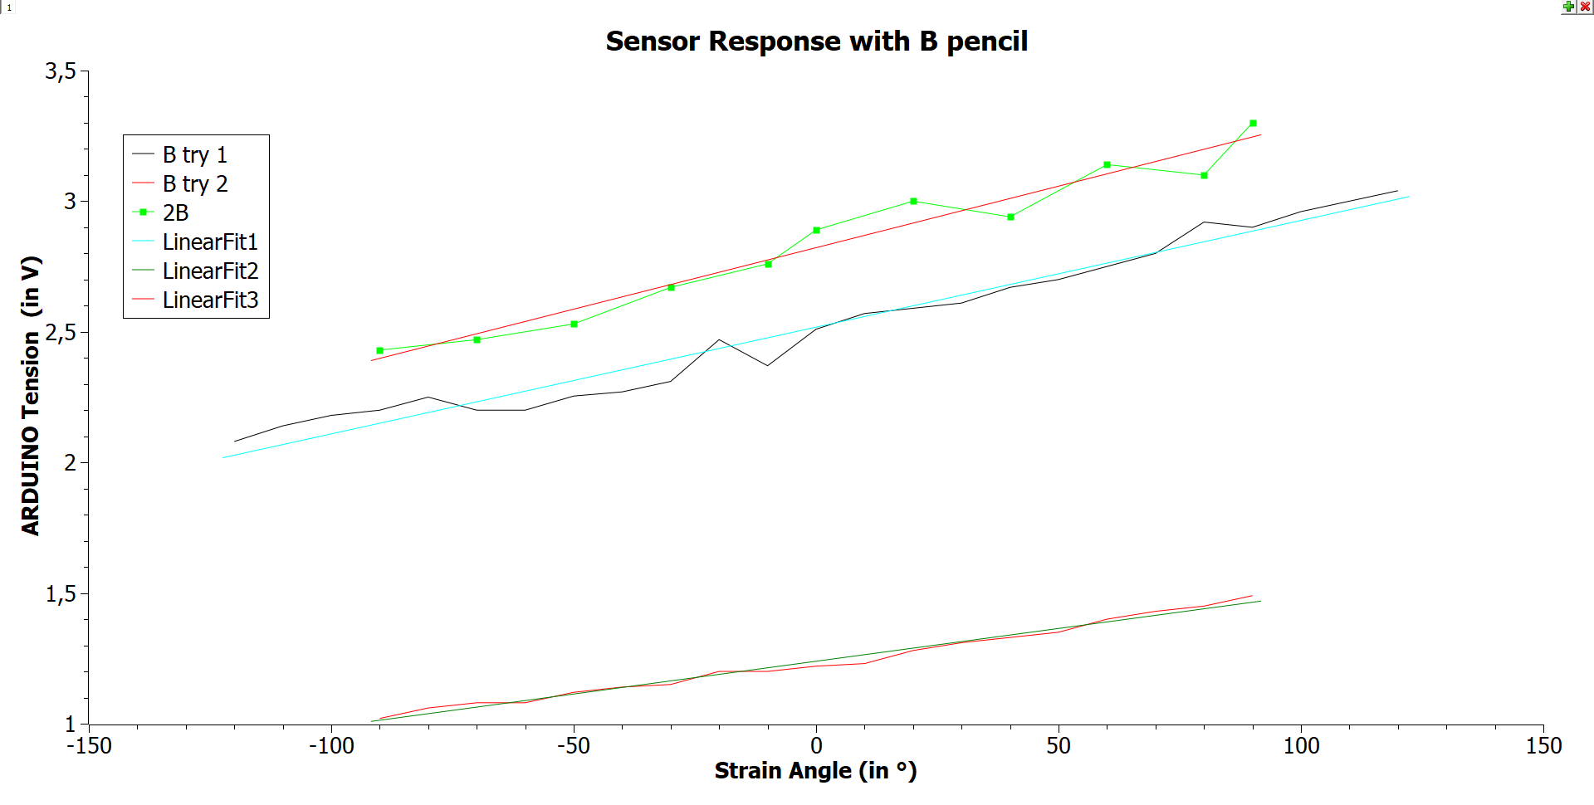Current sensor as a function of the stain angle

|  |  |  |
| --- | --- | --- |
| **B try 1** | **B try 2** | **2B** |
| **Linear fit coefficient** | 4.08e-3 | 2.51e-3 | 4.71e-3 |
| **Resistance range** | 16.36MΩ– 23.78MΩ | 33.47MΩ – 48.93MΩ | 15.06MΩ – 20.48MΩ |

**Dimensions**

Resistance sensor

11mm

34mm

**Typical applications**

Sensor connections

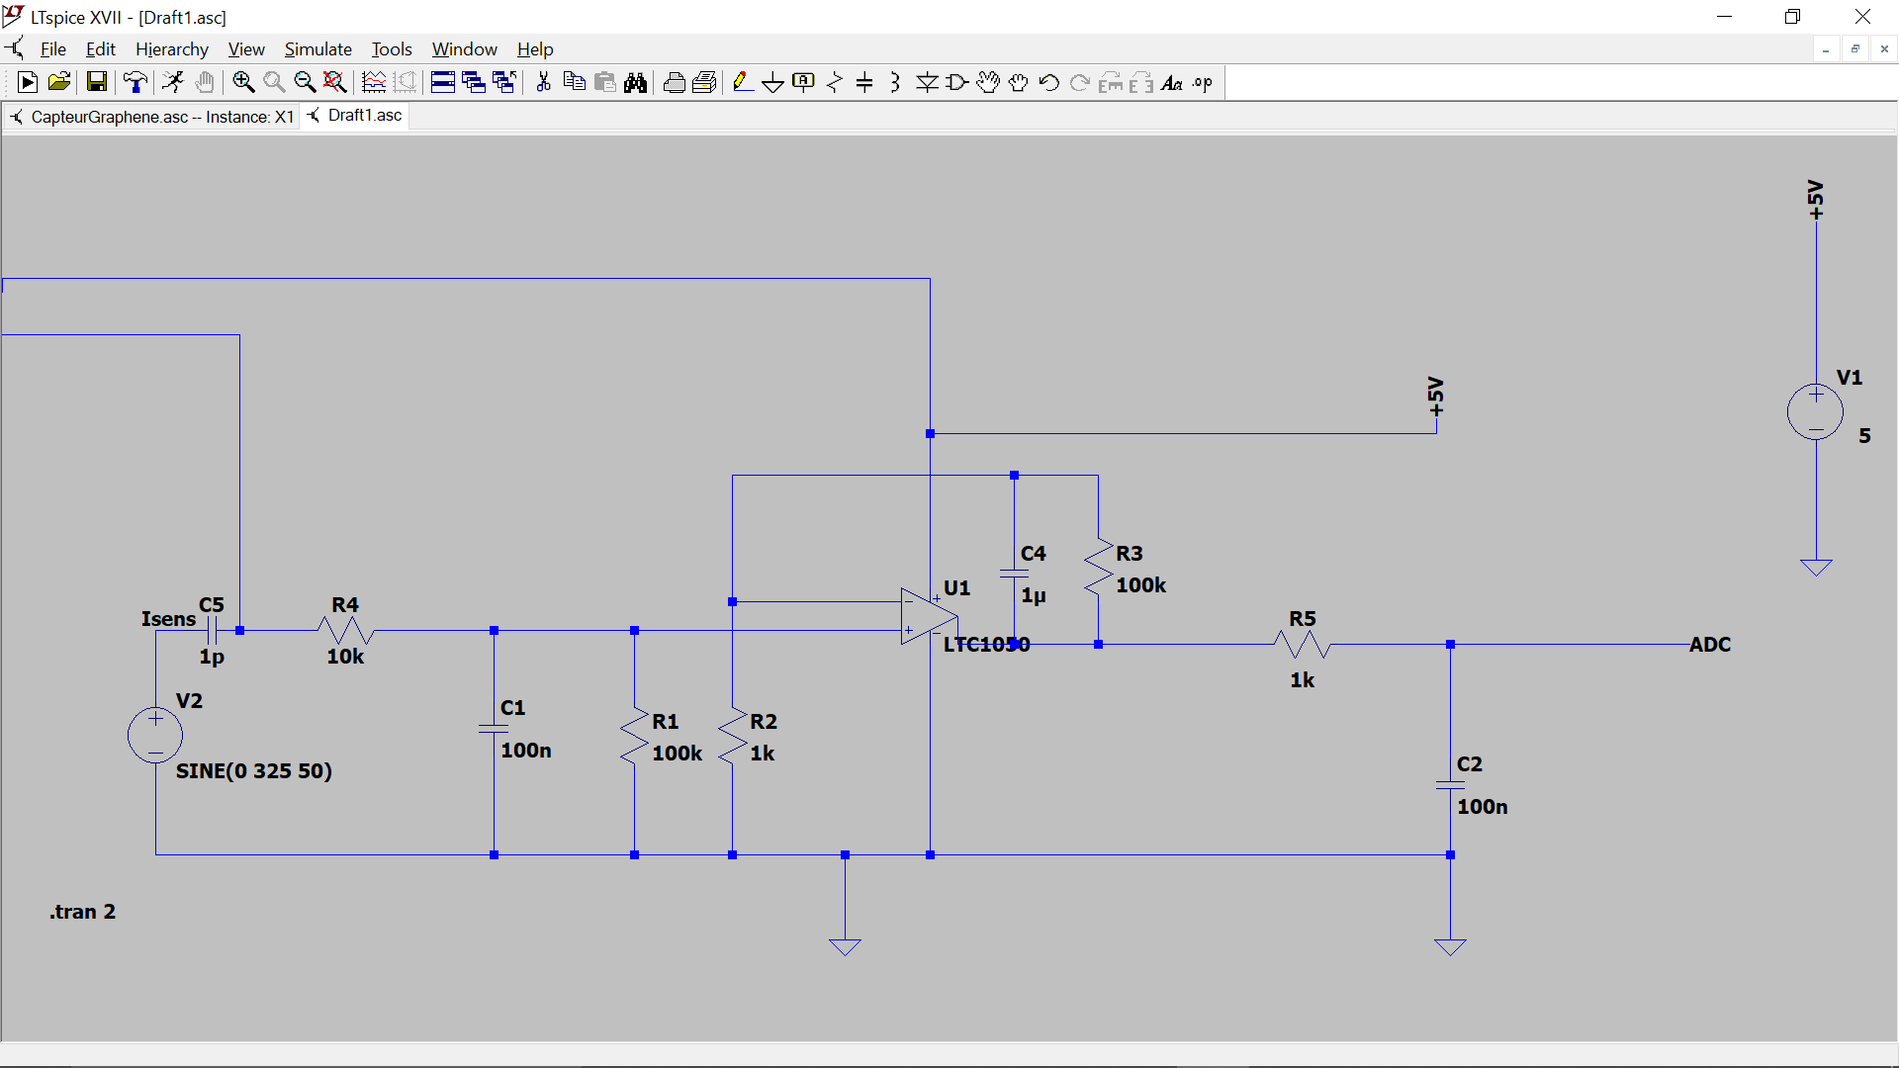Above is the typical application for the resistance strain sensor in an analogic circuit. The sensor is connected in parallel with the operational amplifier which will convert and amplify a current proportional to the resistance of the graphite strain sensor (here Rsensor) to a voltage signal which will be read by the Arduino. In the diagram above “ADC “is the reference for the Arduino input.