**Assignment**

**CSA0805 – Python Programming**

|  |  |
| --- | --- |
| **Register Number** | **192324310** |
| **Name** | **m.vikas chowdary** |

**Title:**

**"Markdown Table Generator: Python Program for Customizable Markdown Tables from CSV and Database Data**

**Problem Statement:**

**Develop a Python program that converts structured data from CSV files or database queries into Markdown-formatted tables, with customizable column alignments and formatting options.**

**Code:**

**import e pandas as pd**

**def read_csv(file_path):**

**"""Read CSV file and return a DataFrame."""**

**return pd.read_csv(file_path)**

**def format_markdown_table(df, alignments):**

**"""Format DataFrame into Markdown table with custom alignments."""**

**def format_row(row):**

**return "| " + " | ".join(f"{str(val).strip()}" for val in row) + " |"**

**def format_separator(alignments):**

**return "| " + " | ".join({**

**'left': ":--",**

**'center': ":--:",**

**'right': "--:"**

**}.get(alignment, "--") for alignment in alignments) + " |"**

**headers = df.columns.tolist()**

**rows = df.values.tolist()**

**# Format the table**

**header_row = format_row(headers)**

**separator_row = format_separator(alignments)**

**data_rows = [format_row(row) for row in rows]**

**markdown_table = "\n".join([header_row, separator_row] + data_rows)**

**return markdown_table**

**def main():**

**# Customize these variables**

**csv_file_path = 'data.csv' # Path to your CSV file**

**column_alignments = ['left', 'center', 'right'] # Adjust alignments to match your columns**

**# Read the CSV file**

**df = read_csv(csv_file_path)**

**# Generate the Markdown table**

**markdown_table = format_markdown_table(df, column_alignments)**

**# Output the Markdown table**

**print(markdown_table)**

**if __name__ == "__main__":**

**main()**

**Output Screen Shots:**

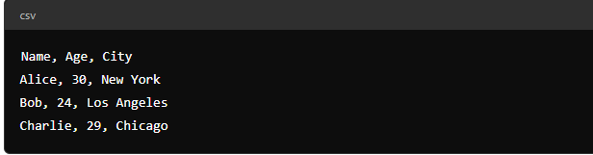

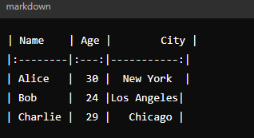

**Conclusion;**

**The Python program efficiently converts structured data from CSV files into customizable Markdown tables. By leveraging the pandas library, it simplifies data handling and table formatting, allowing for easy adjustments in column alignments. This tool enhances documentation and reporting by automating table creation, making it a valuable asset for users needing well-formatted Markdown tables**