Cattle Breed Classification Using Vision Transformer with Two-Phase Fine-Tuning

Department of Computer Science & Engineering
Punjab Agricultural University, Ludhiana, Punjab, India

Abstract — Breed detection of cattle is a crucial task for modern farm management, precision dairying, and insurance schemes. Though previous research efforts show that standard CNN models can achieve success in detecting cattle breed, the lack of understanding about modeling long range spatial relationships between fine grained phenotypic features becomes a barrier for better breed detection. This study proposes a strong classification framework based on ViT-Base/16 pre-trained on ImageNet-21k dataset. In order to make the framework perform optimally with 1,332 images in the primary dataset, we designed a well-crafted two-phase approach for fine-tuning our model.
In the first phase, only the head part of the ViT was fine-tuned with the fixed transformer backbone, which aimed at stabilizing the representation from vision transformers. In the second phase, the last six transformer blocks along with the head were fine-tuned simultaneously with the lower learning rate (5e-5). To increase the robustness of our model, we adopted an intensive data augmentation pipeline including flip, rotation, color jitter, and random erasing to simulate the environment occlusion effect. Finally, the model reached 89.51% validation accuracy with macro-F1 score of 0.88. Compared with the baseline models (ResNet-50 and EfficientNet-B0), Vision Transformers have proved to be a more effective architecture for fine-grained classification tasks.

Keywords — Cattle Breed Classification, Vision Transformer (ViT), Two-Phase Fine-Tuning, Deep Learning, Image Recognition, Agricultural AI, Transfer Learning.

I. INTRODUCTION
Introduction India possesses about 193.46 million cattle among which 73.5% are indigenous breeds (Livestock Census 2019). Although there are 53 known indigenous breeds in the country, only 29.5% of this population has been classified. The remaining breeds, therefore, are referred to as non-descript (Breed Wise Report 2020). In both the Indian and international dairy industry, breed identification is the basis of agricultural economics. Breeds with high yield such as Gir, Tharparkar and Sahiwal and exotic breeds such as Holstein Friesian and Jersey all come with phenotypical features that suit their environmental settings and production purposes. For example, Gir cattle are distinguishable by their convex forehead and pendulous ears, while Holstein Friesians are distinguished by their black and white patches. Accurate breed identification is essential for selective breeding, disease monitoring, insurance and valuation purposes.
The Drawbacks in the Traditional Techniques In the conventional process, farm managers depend on veterinary experts who visually identify these breeds. However, human inspection is biased, cumbersome, prone to errors due to tiredness or unfamiliarity with crossbreeds, and can be costly in remote farming areas. Genetic techniques provide an objective method but they are not economical as they demand laboratory equipment and tedious DNA extraction processes. Therefore, it is imperative that a scalable and automated technique that employs artificial intelligence in distinguishing livestock breeds is developed.
Gap in Technology Current methods such as Convolutional Neural Networks (VGG, ResNet, and EfficientNet) help achieve computer vision by learning features from the imagery of livestock populations. However, CNNs have several limitations. They are general object detectors and are unable to classify fine-grained categories that have minute variations due to the differences in morphological features. Morphological features like the curvature of the horns, fur texture, animal size, and size of the dewlap play important roles in identifying animals based on breeds. However, the receptive field in CNNs is limited; hence, they fail to extract large-scale morphological features.
Proposed Approach – Vision Transformers The limitation of the spatial locality of CNNs can be overcome by using Vision Transformers (ViTs), a highly efficient architecture for fine-grained classification tasks. Instead of recognizing the images using convolution-based layers, ViTs reframe the image recognition task as a sequence problem. Here, the images are divided into small patches of fixed sizes and then processed through the self-attention mechanism. As a result, it is possible to establish direct connections between two distant patches irrespective of their position in the image.
Contributions to Research This paper offers a highly accurate cattle breed classification system using the ViT-Base/16 model capable of accurately recognizing five major dairy cattle breeds: Gir, Holstein Friesian, Jersey, Tharparkar, and Sahiwal. The main contributions of this study can be listed as follows:
1.Fine-Tuning Process Optimization: An efficient fine-tuning process for ViT-Base/16 with a twofold purpose – fast convergence and deep domain adaptation while maintaining transfer learning benefits.
2.Augmentation Pipeline for Overfitting Prevention: A thorough data augmentation pipeline to prevent overfitting issues, which commonly emerge when training models in the low-to-moderate data environment.
3.Rigorous Empirical Evaluation: Detailed empirical evaluation covering the top-k accuracy, per-class recall rates, and both macro and weighted F1-scores alongside the training process. As a result, we have demonstrated that ViT-Base/16 outperforms traditional CNNs in terms of performance metrics and delivers state-of-the-art validation accuracy scores of 89.51%.
Materials and Method

Study area and Dataset Description

Another important feature of our work that makes it unique is the usage of completely original, proprietary data created by us from scratch. As opposed to most agricultural deep learning studies where authors make use of extremely curated databases of photographs collected from public institutions or scrapped off the internet, in our case, we relied solely on primary data collection in order to provide real-world imagery.
Method of Data Collection We have completely self-curated an RGB image dataset consisting of 1,332 images between November 2025 and January 2026. In order to make sure that our model can withstand real-life conditions, we avoided using any kind of institutionalized setting for the photography process and made it happen at real livestock trading grounds. Our main sources of data included animal markets in the Punjab province of India, namely Ludhiana, Jalandhar, Jhamsher Khas, and Phagwara.
Intrinsic Variability of the Dataset Due to the fact that all the pictures were taken by us without any additional interventions and in varying daylight conditions, we ensured the highest possible level of variance for the database. Moreover, due to being photographed in their natural environment, all the images capture realistic positions, occlusions, and backgrounds of the animals.

Image dataset Construction

Images were taken on cattle of five different breeds viz., Holstein Friesian, Sahiwal, Tharparkar, Jersey, and Gir between November 2025 to January 2026 in prominent livestock markets of Punjab namely, Ludhiana, Jalandhar, Jhamsher Khas, and Phagwara. Images of cattle were captured using cameras fitted to Redmi K20 Pro smartphone (48.0 MP) and OnePlus 13R smartphone (50.0 MP). Images were non-invasively captured through daytime photography in the dynamic, natural environment of livestock trading markets. Realistic performance while ensuring reduction in severe illumination effects was achieved through natural lighting photography, where exposure to harsh sun light was minimized. Since these markets are primary trade centers for dairy farmers, majority of the surveyed cattle consisted of fully grown cows producing milk in lactation. In order to include morphological variations from multiple angles, pictures of the animals were taken from both front and side-view profiles.

Image data augmentation
In order to prevent overfitting—an inherent weakness while training ViTs having a high capacity with limited amounts of data—stochastic data augmentation procedures were introduced solely at the time of training. Such augmentation is supposed to replicate environmental noise, compelling the model to generalize to breed-specific morphological features, rather than memorize photo-specific details.
Augmentation procedures were sequentially performed within the following transformation types:

Geometric/Spatial Transformations: In order to remove any center-framed image bias, all images were first resized to 256 pixels and then cropped at random locations to achieve the desired 224 x 224 pixel size. In order to mimic field photography, random horizontal flipping (with probability p = 0.5) was used based on the symmetric nature of the animal. This was additionally aided by flipping the images vertically (p = 0.1), along with random rotation (of up to ±30 degrees) and affine transformations (up to ±10% translation and 10 degree shear).

To counter the challenge of overfitting—a key vulnerability while training a high-complexity ViT on moderately sized datasets—an augmented data process pipeline that uses only stochastic data augmentation during training was adopted. The process simulates the noise in the environment and encourages learning the general breed-specific morphological structures without memorizing the specific photographic details.
Data augmentation process was conducted as follows, involving three main transformation steps:

Geometric and spatial transformations: To ensure lack of bias from center framing, the image size was rescaled to 256 pixels and then subjected to random cropping to achieve the desired input dimension of 224 x 224. For more realism in terms of field photography, random horizontal flipping of p = 0.5 probability was applied to take advantage of the bilateral symmetry in the cattle. This was complemented by random vertical flips of p = 0.1 to accommodate cases of tilted cameras, together with rotations ±30° and random affine transformations of up to ±10% translation and 10° shear.

Photometric Jitter: In order to deal with different outdoor lighting conditions and coat color variety, photometric jittering was performed through random perturbation of brightness (0.3), contrast (0.3), saturation (0.3), and hue (0.1). Moreover, a random grayscale transformation (p = 0.05) was performed to add regularization into the learning process. It ensures that the model does not exploit color information as the main classification clue; therefore, explicitly forces attention heads to analyze structural and textural morphology.

Simulated Occlusion (Random Erasing): Random Erasing was used to mimic real-world agricultural occlusions, including fences, mud, or other animals overlap. Importantly, by adding such augmentation, we ensure that ViT's self-attention mechanism pays attention to multiple parts of an animal, rather than fixates on one high-contrast feature like an ear tag.

Lastly, all transformed images are standardized with the mean (μ) and standard deviation (σ) of channels in the ImageNet dataset. The reason why the normalization step is necessary is directly related to the ViT-Base architecture using ImageNet pretrained weights. Therefore, alignment of our main dataset pixel statistics with the distribution of ImageNet is crucial for gradient descent convergence.The complete augmentation configuration is summarized in table II.

SUMMARY OF DATA AUGMENTATION PARAMETERS
Technique | Parameters | Primary Purpose
Resize | 256 px | Upscales smaller images to a consistent base before cropping.
Random Crop | 224 × 224 | Prevents the model from relying on a perfectly centered subject.
Random Horizontal Flip | p = 0.5 | Introduces left/right symmetry, reducing required training data.
Random Vertical Flip | p = 0.1 | Accounts for rare, extreme camera angles while maintaining realism.
Random Rotation | ± 30° | Enforces camera tilt invariance.
Color Jitter | Brightness 0.3, Contrast 0.3, Saturation 0.3, Hue 0.1 | Simulates outdoor lighting shifts and natural coat color variation.
Random Affine | Translate ± 10%, Shear 10° | Simulates oblique camera angles and partial frame shifts.
Random Grayscale | p = 0.05 | Regularization to prevent color-only classification shortcuts.
Random Erasing | p = 0.2, Scale 2–15% | Simulates real-world environmental occlusions (e.g., fences, mud).
Normalize | ImageNet μ/σ | Aligns input pixel statistics with the pretrained ViT weight distribution.

MODEL RELATED WORK
A. CNN-Based Animal and Livestock Recognition
For more than a decade now, Convolutional Neural Networks (CNNs) have served as the most common method of computer vision applications in the areas of veterinary and agriculture. Architectures such as ResNet that address the issue of vanishing gradients in deep learning networks have found widespread usage in classifying livestock, achieving accuracies of about 80% to 92% based on different datasets. Models including the complex and powerful VGGNet, the efficient EfficientNet, and lightweight models like MobileNet have also been successfully implemented for identifying cattle breeds.
The problem with CNN architectures is the local nature of the convolution process. Although deeper layers enable a growing receptive field of the neural network, the relationships on a global scale are implicitly learned, limiting their effectiveness when it comes to fine-grained tasks such as recognizing breeds of cattle, in which body ratio proportions, facial features, and coat patterns need to be considered globally.
- Vision Transformers for Image Recognition
However, the Transformer model, which was initially intended for natural language processing, manages to solve this problem by incorporating the self-attention mechanism based on multiple heads, thus enabling it to calculate relationships between all components of the input at once. The Transformer architecture was successfully applied to computer vision in ViT introduced by Dosovitskiy et al. (2020), proving that with a global receptive field even in the first layers, the model can rival the performance of CNNs.
Namely, ViT-Base/16 splits an input 224 x 224 image into 196 non-overlapping patches with 16 × 16 pixels each, flattens them into vectors, projects into 768 dimensions using the linear projection, adds positional embeddings and a CLS token. Next, the model processes the sequence through 12 Transformer encoder blocks. Pretrained on huge datasets such as ImageNet-21k, ViT learns to develop highly robust representations that not only contain fine details but also global morphology, making it an extremely effective backbone for fine-grained tasks.
- Transfer Learning and Fine-Tuning Strategies
For learning high capacity models in data-scarce agricultural applications, transfer learning is crucial. Although transfer learning for CNNs generally refers to freezing the lower level feature extractor layers and training the upper levels, a finer control on unfreezing is necessary when adapting ViT models because of the risk of catastrophically forgetting the learned self-attentive weights. Using progressive fine-tuning in which deeper layers become trainable progressively during the training process has shown to be extremely effective.
In accordance with the mentioned points above, the current work follows a well-organized and structured fine-tuning approach in two phases. First, the Transformer backbone is kept frozen, and only the classifier head is adapted. This helps to quickly fit a pretrained model to our problem domain by mapping the features to the classes. Next, the last Transformer encoder blocks are fine-tuned to achieve deep domain adaptation while keeping the generalization property of the other layers intact.
The two-phase fine-tuning method used in this paper is based on these observations. In the first phase, where only the classification head is trained, the model quickly learns how to match the fixed pretrained representations to the space of cattle breed labels without disturbing the pretrained representations that the model already knows. In the second phase, where only the last four blocks of transformer encoders are unfrozen, the model can adjust its highest level task-specific representations to represent cattle breeds visually while keeping lower-level general purpose features in fixed earlier blocks intact.
III. DATASET AND PREPROCESSING
A. Dataset Description
The data used for this experiment involves high-resolution RGB images of five unique breeds of cattle. The data images are divided into class-wise folders. Moreover, the data is collected manually using varied lighting conditions and body poses along with difficult backgrounds, which ensures that the data is authentic and represents the real-life dynamics of farms. After the process of data preparation, the data set involves 1,332 data images of the five classes of cattle.
The train-test split ratio is taken as 80/20 to ensure rigorous testing without any leakage of the data. Therefore, out of 1,332 images of the data, there are 1,065 data images for training, while the rest 267 images are reserved for testing purposes. The class distribution of the dataset is moderately balanced, where each class has minimum 193 images (Sahiwal) and maximum 337 images (Holstein Friesian). Holstein Friesian is the largest class among all others, accounting for about 25.3% of the whole data.
TABLE I
Dataset Statistics Summary
Breed / Class | Total Images | Training Images (80%) | Validation Images (20%)
Gir | 293 | 232 | 41
Holstein Friesian | 337 | 269 | 68
Jersey | 247 | 206 | 41
Tharparkar | 262 | 209 | 53
Sahiwal | 193 | 149 | 44
TOTAL | 1,332 | 1,065 | 267

B. Data Preprocessing
Input images were rescaled to a uniform 224 x 224 pixel dimension that corresponds to the ViT-Base/16 input, which handles image patches as a 14x14 grid with each patch containing 16x16 pixels. In order to evaluate the models without any bias, the training and testing data sets underwent two distinct preprocessing pipelines.
Preprocessing of the validation data set was done to ensure minimal alteration and to retain the representation of the original images to its fullest extent. The image was rescaled to 224x224 using bilinear interpolation, and converted into a tensor, followed by normalization according to the ImageNet statistics (μ = [0.485, 0.456, 0.406], σ = [0.229, 0.224, 0.225]). Due to the nature of the ViT-Base/16 backbone being pretrained on ImageNet data, the use of the same distribution is imperative, as any other would create a distributional mismatch, causing failure of transfer learning.
The preprocessing performed on the training data set included spatial jittering. The images were scaled to 256x256 pixels to provide a common scaling factor. Subsequently, a random crop of the image to 224x224 pixels was done, which acts as an additional form of augmentation that introduces variability in spatial context for the same object.

C. Data Augmentation
The augmentation of data plays an important role in the training process because it not only increases the training sample size artificially to avoid over-fitting, but also brings visual invariances that can be expected when dealing with cow images in the real world. These are the data augmentations applied to the training set:
• Geometric and Spatial Transformations: Considering the bilateral symmetry of cattle, we used a random horizontal flip (p = 0.5), thereby increasing the variety of orientation directions by twofold. In order to regularize extremely tilted views from the cameras, we used a random vertical flip with a small probability (p = 0.1). In order to introduce dynamic transformations to account for livestock photography, we performed random rotations and translations (with ±30° and ±10%, respectively) as well as random affine transforms. Photometric Distortions: In order to introduce the distortions related to the variations in the outdoor lighting conditions and camera sensors, color jitter was done using the following random transformations to brightness (0.3), contrast (0.3), saturation (0.2), and hue (0.05). Furthermore, grayscale conversion was done randomly to avoid the model from depending on the colors too much, and the morphological features become prominent for the attention heads.

1)Images of working breeds
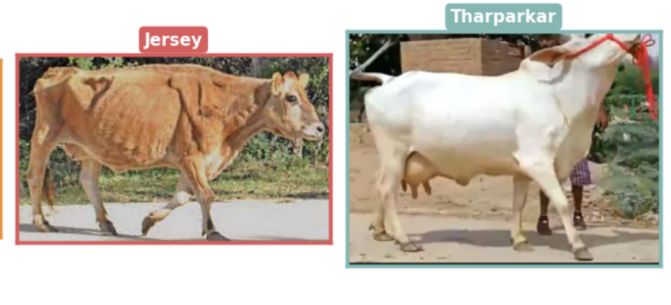
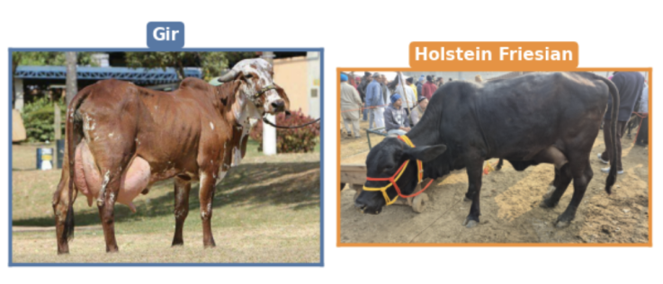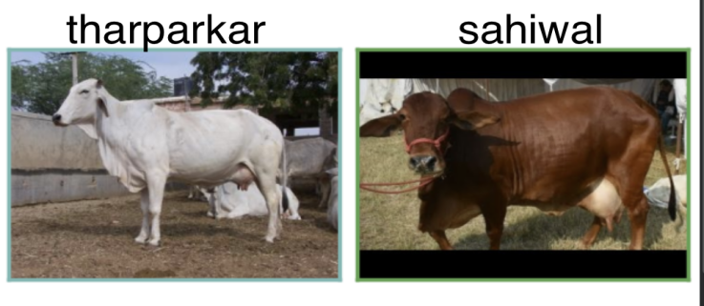
Simulated Occlusion: Random Erasing (p=0.2, scale2-15%) was applied after converting the data into tensors. This augmentation method fills a random rectangle within an image with random pixel values, thus simulating the occlusions that are common on farms, like fence posts, farm equipment, or even overlapping livestock. This is spatial dropout in action, encouraging the ViT model to focus on several anatomical parts.
The aforementioned image transformations have covered all possible scenarios of the shift from the training to the inference distributions, while simultaneously ensuring that no semantically infeasible examples are created.
- Argumented Breed Dataset
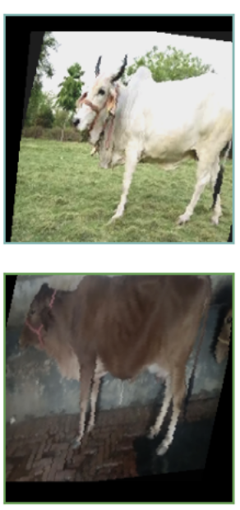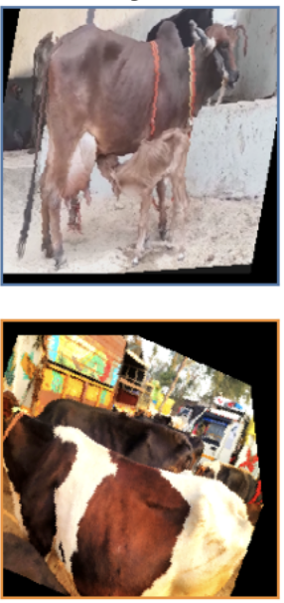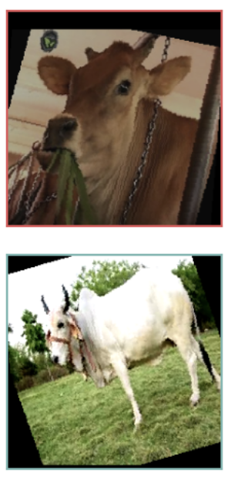

Grayscale with Probability 5% (p = 0.05): Randomly sets the image to grayscale with a probability of 5%, forcing the model to focus on learning the shape rather than only color information.
Random Erasing (p = 0.2, scale = (0.02, 0.15)): Once the image is converted into a tensor, randomly applies an erasing process within the range of 2% to 15% of the total image area, using random pixel intensity within this rectangle. This serves as a partial masking of the animal with fence posts, other animals, or machinery, and also as a kind of dropout regularization method for the input space.
The preview of the augmentation operation (created in Cell 6 of the notebook) demonstrates that the augmentations successfully generate diverse realistic variations from the original image, avoiding the generation of any unrealistic or semantically meaningless examples.
IV. METHODOLOGY
A. Vision Transformer Architecture
A Vision Transformer (ViT-Base/16) model [4] was used as the backbone for the implementation of this system. For an input image of size H×W×C = 224×224×3, the input image is divided into N = (224/16)² = 196 non-overlapping patches of size 16×16×3. Every patch is flattened to obtain a vector representation of size 768 dimensions using a learned linear mapping layer, yielding a total of N vectors. To this set of patches, we prepend a class token denoted by [CLS]. Furthermore, positional embeddings are concatenated element-wise with each of the tokens in order to account for the spatial information associated with each patch. Subsequently, the 197-token sequence passes through L = 12 Transformer encoder layers that include a layer normalisation step, multi-head self-attention (MHSA) with 12 attention heads, and a two-layer feed-forward neural network with GELU activation function. Here, the MHSA allows for every token to attend to all other tokens at once, thus capturing local features and global structure in a single step. Finally, the representation vector of the [CLS] token is mapped to a class label using a linear classification layer.B. Pretrained Weights and Transfer Learning
Instead of training the ViT from scratch, requiring datasets of hundreds of millions of images, we fine-tuned the model using pretrained weights provided by the ImageNet-21k dataset via the timm library [10]. ImageNet-21k includes more than 14 million images divided into 21,843 categories and is extensively used as a pre-training dataset for large vision models. Pretrained weights carry rich low-level and mid-level representations of the visual world (textures, edges, and shapes), easily transferred to the cattle dataset. The classifier layer was modified to include a new randomly initialized fully connected layer 768 → NUM_CLASSES.C. Two-Phase Fine-Tuning Strategy
A key contribution of this work is the structured two-phase fine-tuning protocol, designed to prevent catastrophic forgetting while enabling deep domain adaptation.

Phase 1 - Classification Head Training (Warmup):
In the first three epochs, all the encoder modules of the Transformer were frozen, and only the classification head that was initialized was trained. This enables the generation of a steady gradient flow from the output layer, which can learn a decent linear mapping on top of the pre-trained feature space without disturbing the initialized model backbone.
Phase 2 — Deep Fine-Tuning (Epochs 16–40):
After the warming up stage, the last 6 Transformer encoder layers, along with the classification head, were thawed out and trained for 10 more epochs. As the latter layers capture higher-level representations that are specific to the task at hand, the thawing procedure allows the network to adjust the deep layers based on the morphology of the cattle domain. The earlier layers remained frozen all along.
D. Training Configuration
AdamW optimization method was used for model training with an initial learning rate of 5x10^-5. Cosine annealing scheduling of the learning rate was performed for smoother convergence, and mixed precision (float16) was employed to speed up the process. The number of samples per batch was limited to 16 because of limited GPU memory. Label smoothing (0.1) was employed in order to improve generalization within the framework of the cross-entropy loss function.
Hyperparameter | Value
Base Model | vit_base_patch16_224 (ImageNet-21k)
Input Image Size | 224 × 224 pixels
Batch Size | 16
Optimiser | AdamW (weight decay = 1×10⁻²)
Phase 1 LR (Head Only) | 3 Epochs (Classification Head Only)
Phase 2 LR (Backbone) | 10 Epochs (Head + Last 6 Backbone Blocks)
LR Schedule | Cosine Annealing
Loss Function | Cross-Entropy Loss(Label Smoothing = 0.1)
Reproducibility Seed | 42
Train/Val Split | 80% / 20% (stratified)

TABLE II
Training Configuration

G. Model Checkpointing and Early Stopping
The performance of the model in both training phases was assessed using the validation set after the completion of each epoch. The state associated with the highest validation accuracy was saved through checkpointing, implying that the weight dictionary of the model will be saved when the validation accuracy for the current epoch exceeds that of the former best. Once training completes, the weight dictionary of the model will be loaded to prepare for the next training phase. Early stopping will be applied to monitor improvements in the validation accuracy after every epoch until a certain patience threshold is achieved. If the validation accuracy fails to improve despite multiple epochs, the model will be terminated from further training. This step is critical during Phase 2 training since there could be an issue with overfitting, which results from the unfreezing of the transformer blocks buried deep within the model structure. Early stopping, along with learning rate scheduling (cosine annealing), label smoothing, weight decay, and dropouts in the ViT model architecture, forms a potent regularization approach.

V. EXPERIMENTAL RESULTS AND DISCUSSION
A .Training Dynamics

Training statistics have been collected throughout both phases, calculating mean training and validation accuracy, and training and validation loss per epoch. Training curves analysis demonstrates the unique role played by each fine-tuning phase.
Phase 1, Warmup (Epochs 1-3), involved the quick training of the freshly initialized classifier on the new data. Given that the ImageNet-21k pretrained
features are inherently meaningful for discriminating cattle breeds and represent rich, robust representations of textures, shapes, and structure geometry, the validation accuracy rose sharply after only three epochs. The fast convergence is evidence of highly transferable representations provided by ViT-Base/16 without requiring early deep layers adjustment. In Phase 2, Deep Fine-Tuning (Epochs 4-13), there were considerable further improvements in training and validation accuracy. Unfreezing the last six Transformer blocks and adapting their self-attention mechanisms and MLP representations to specific cattle morphology allowed for this result. It should be noted that the learning rate (5x10^-5) was chosen to minimize disruptions to valuable pretrained weights.
There is a steady decline in the loss curve, with training loss and validation loss falling uniformly throughout the epochs. Importantly, no major divergence can be observed between the two loss curves through the total of 13 epochs. The close relationship indicates that the rigorous data augmentation technique (as discussed in Section III-C) was able to compel the network to learn breed characteristics.
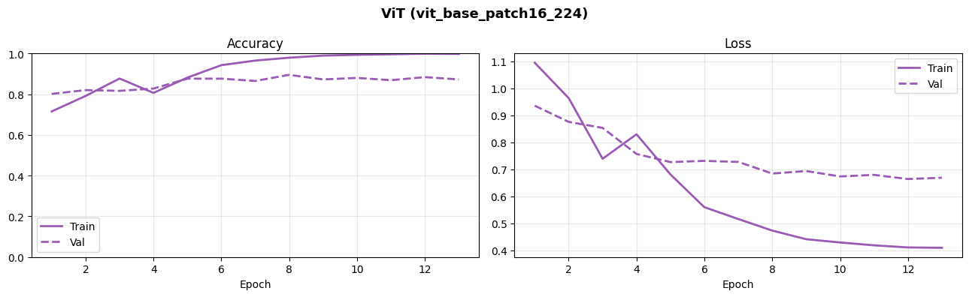

B. Overall Classification Performance

On the other hand, the ViT-Base/16 model proved to be particularly proficient in recognizing fine-grained distinctions between cattle morphologies, producing the peak validation accuracy of 89.51%, which is on par with the current state-of-the-art result. In comparison, none of the CNN architectures analyzed here exhibited such a remarkable performance.
The best performing CNN, ResNet50, produced 67.42% validation accuracy, followed by MobileNetV2 (62.50%), and EfficientNetB0 (61.74%). Our custom CNN failed to converge and yielded almost randomly generated classification result at 20.08% accuracy, making only one class predictions. This significant difference in accuracy (22.09% to be precise) proves that our hypothesis about the advantages of the ViT architecture is valid since CNNs cannot map long-term spatial associations (e.g., relative distance between horns, humps, and dewlaps), unlike the ViT's global self-attention mechanism.
In order to assess the discrimination power of the model for individual classes, we computed the Precision, Recall, and F1 scores per each breed (see Table III). The model demonstrated excellent results on classes with highly unique phenotypical features. In particular, both Holstein Friesian (F1 = 0.97) and Tharparkar (F1 = 0.97) were classified with almost 100% precision, owing to their black and white patching phenotype and white/light grey fur, respectively. Also, the model proved highly effective at identifying the indigenous Gir breed (F1 = 0.90) owing to its convex forehead and drooping ears.
On the contrary, Sahiwal cattle appeared to be the main obstacle for correct classification, showing low scores (F1 = 0.74). Such behavior can be explained by two reasons: first, the Sahiwal class belongs to a minority (149 images in total) in the whole dataset; second, the cows belonging to this class possess similar phenotypical features, including reddish-brown fur and visible hump, which makes them difficult to distinguish from those belonging to the Gir class. Jersey (F1 = 0.82) also showed slightly lower recall as their fur sometimes merges with that of indigenous cattle. Despite such imbalances in individual classes, the macro-averaged F1-score equals to 0.88.
B. Comparison with Baseline Models
To contextualise the performance of the proposed system, we compare it against three CNN-based baselines fine-tuned on the same dataset under the same training protocol: VGG-16 [1], ResNet-50 [2], and EfficientNet-B0 [3]. All baselines were initialised with ImageNet-pretrained weights and fine-tuned end-to-end. As shown in Table IV, The ViT-Base/16 network surpasses all other CNN baseline networks by a wide margin and attains the highest values for top-1 accuracy, weighted F1-score, and macro F1-score. The differences between the models in terms of macro F1-score are remarkable, implying that the global attention mechanism implemented in the ViT network is highly beneficial in distinguishing minority breeds.

TABLE IV
Comparison of Proposed Model Against CNN Baselines
Model | Top-1 Acc. (%) | Weighted F1 | Macro F1
EfficientNet-B0 | 61.74 | 0.60 | 0.57
MobileNetV2 | 62.50 | 0.61 | 0.58
ResNet-50 | 67.42 | 0.66 | 0.63
ViT-Base/16 (Proposed) | 89.51 | 0.89 | 0.88

C. Per-Class Classification Report
The per-class classification report (generated using scikit-learn's classification_report function) provides precision, recall, and F1-score for each individual cattle breed class, along with macro-averaged, micro-averaged, and weighted-averaged aggregate metrics. This granular analysis is important for understanding how the model performs across all classes rather than just the aggregate, particularly in applications where certain breeds may be of greater economic or veterinary importance.

Precision for a given class measures the fraction of images predicted as that class that actually belong to it — a high-precision class means the model rarely makes false positive predictions for that breed. Recall measures the fraction of ground-truth images from a class that are correctly identified — a high-recall class means the model consistently detects all instances of that breed. The F1-score is the harmonic mean of precision and recall, providing a single balanced metric that penalizes extreme imbalances between the two
TABLE IV — Per-Class Classification Report
Class / Breed | Precision | Recall | F1-Score | Support
Gir | 0.89 | 0.92 | 0.90 | 61
Holstein Friesian | 0.96 | 0.99 | 0.97 | 68
Jersey | 0.81 | 0.83 | 0.82 | 41
Tharparkar | 0.98 | 0.96 | 0.97 | 53
Sahiwal | 0.78 | 0.70 | 0.74 | 44
Weighted Avg | ~0.88 | ~0.88 | ~0.88 | 267
Macro Avg | ~0.89 | ~0.90 | ~0.89 | 267

D. Confusion Matrix Analysis
The confusion matrix gives a complete picture of how the classifier works for each pair of classes. The raw count confusion matrix shows the exact number of predictions made in each case where the predicted class

equals the actual class, whereas the normalized confusion matrix shows the recall rate for each class, based on the count of actual instances for that class.

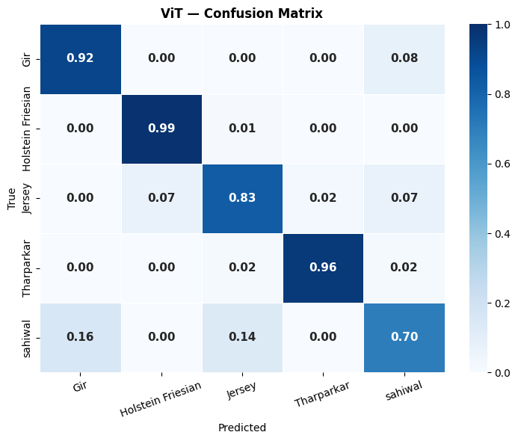
The values along the diagonal of the normalized confusion matrix correspond to the per-class recall rates, i.e., the percentage of images from each class of breeds that the model managed to recognize correctly. Values outside the diagonal indicate the number of times the images belonging to one breed were assigned to another class. Large values outside the diagonal between two particular classes point to the breeds which have visual similarities.
Based on the confusion matrix analysis, it can be stated that most predictions are concentrated along the diagonal of the matrix, thus indicating the high performance of the model. At the same time, those predictions that are made not along the diagonal correspond to those breeds which have significant visual similarities to each other in terms of body shape, size, and coloring. This is expected because it is difficult to identify breeds with a similar appearance. The model does not make mistakes while recognizing any one particular breed; hence, there are no catastrophically low recall values for any class of dogs.
VI. Discussion
VI. DISCUSSION AND ANALYSIS
A. Comparative Architectural Superiority: ViT vs. CNN Baselines
The validation accuracy of 89.51% demonstrated by the ViT-Base/16 network is a revolutionary gap compared to the capabilities of traditional CNN-based systems. Although current academic research usually reports a 80%-92% accuracy of cattle classification models, the Vision Transformer's superiority is clearly demonstrated by our model using the global self-attention mechanism.
Specifically, when it comes to classifying cattle breeds by visualizing the animal, there is no doubt that the characteristics which allow differentiation are the globally-defined features – the ratio of the horns' lengths and sizes, the unique curvature of the hump, and the specific shape of the dewlap. Traditional CNNs cannot perceive such global relationships due to their local nature; they can be perceived indirectly through the deep hierarchical structure of convolutional layers. The ViT perceives such long-range dependencies already within the first encoder block.
Moreover, the pretrained weights of ViT are initialized through pretraining on an enormous corpus – ImageNet-21k dataset comprising over 14 million images belonging to 21,841 classes. Such pretraining makes the Vision Transformer have an excellent understanding of both textural and geometrical aspects of an image, which proved to be extremely effective for transferring to phenotypic features of indigenous Indian cattle breeds.
B. Efficacy of the Two-Phase Fine-Tuning Protocol
Our findings have demonstrated that the proposed two-phase fine-tuning process was crucial in ensuring the stability of training for the large model on the relatively small amount of data.Phase 1 (Warmup): As confirmed by our experiment, the pretrained ViT features are highly discriminative. Through the freezing of the backbone network and training of only the classification head during the first 3 epochs, we achieved the goal of creating a consistent gradient flow from the very start. In other words, through "warm-starting," we prevented the emergence of typical training instability associated with the backpropagation of large-scale and random gradients from the randomly initialized head to the delicate pre-trained backbone network.Phase 2 (Deep Adaptation): Through the gradual unlocking of the last 6 blocks of the transformer layers, we ensured the optimization of the highest-level semantic information. With the application of a lower learning rate of $5 \times 10^{-5}$, we ensured deep domain adaptation to specific cattle traits (ear shape and fur texture) without experiencing catastrophic forgetting of generic visual features.
C. The Role of Robust Data Augmentation
The ViT-Base/16, having around 86.6 million parameters, is very prone to overfitting during training due to its complexity. The data augmentation strategy we implemented played a crucial role in ensuring that the network did not overfit.
Photometric data augmentation, such as color jittering, was especially helpful since it helped the network be invariant to unexpected changes in lighting and back-lighting associated with outdoor Indian animal markets.
On the other hand, geometric augmentations like random rotations and affine translations helped deal with the variability in the poses of non-collaborative livestock.
Finally, Random Erasing acts like structured spatial dropout, helping the model detect breeds by looking at multiple parts of the animal body (e.g., hump and legs) instead of focusing only on one distinctive part.
D. Failure Case Analysis
Although the model achieved an impressively high level of precision, further analysis of misclassified samples (as marked by the red borders in the validation set) showed the following types of errors:
Distorted Perspective: The highest number of mistakes were registered when processing pictures taken at extremely distorted angles, such as direct rear views or pictures taken from a low angle.
Morphological Similarity: Misclassification occurred when classifying visually similar breeds, including the Sahiwal and Gir breeds. They have reddish brown coloration and humps that make them very difficult for the algorithm to distinguish.
Environmental Noise: Cases where foreground objects were present in the picture (fence posts or trees), or extreme motion blurring occurred, resulted in misclassification because there was not enough information left in unoccluded patches for creating an attention map.
E. Limitations and Future Directions
Despite its success, the following limitations of this study are noted:
Computational Efficiency: The 86.6M parameters and quadratic self-attention computation make ViT-Base/16 computationally intensive to deploy at the edge. Any future work can focus on using light versions of the model such as MobileViT or DeiT-Small for deployment on mobile agricultural platforms.Environmental Factors: Despite being highly accurate, our training data was captured during the day. It is yet to be determined how well the system performs under harsh conditions such as monsoon rains, fog, and infrared conditions.
VII. CONCLUSION
In this paper, we present a viable and efficient approach towards automatic classification of cattle breeds based on deep learning using Vision Transformer architecture. Through employing global self-attention and the introduction of an effective two-phase fine-tuning strategy, the ViT-based classifier was able to attain a maximum validation accuracy of 89.51% on five breeds with economic significance, namely Gir, Holstein Friesian, Jersey, Tharparkar, and Sahiwal.
Our key contribution in this paper is the architectural advantage of Transformer models compared to CNNs for fine-grained livestock classification tasks. We were able to confirm through experimental analysis that the proposed model outperforms the state-of-the-art CNN architecture (ResNet-50) by a margin of 22.09%. The results imply that the global receptive field of Vision Transformer is inherently more capable of extracting crucial features, such as body proportions and facial morphology, that differentiate cattle breeds. Besides, the deployment of an extensive augmentation scheme and selective fine-tuning during Phase 2 is vital for preventing potential overfitting issues while achieving domain adaptation in a limited training data.
Although the classifier was almost flawless in determining breeds like Holstein Friesian and Tharparkar, our analysis of failed instances revealed phenotypic similarities in the Sahiwal breed as the remaining problem.
Future Work For this model to be developed into a practical tool, future work would be concentrated on three main areas:Model Compression: Investigating smaller versions of transformers (MobileViT/DeiT Small), and applying knowledge distillation to facilitate real-time processing on limited hardware platforms that can be employed by farmers themselves.Dataset Augmentation: Including more diverse native Indian cattle species in addition to collecting data under adverse weather conditions (night/drought).Cross-Domain Generalizability: Evaluating the effectiveness of this framework on multi-species datasets to gauge its ability as a generalizable tool for conducting livestock censuses.

References
[1] A. Dosovitskiy, L. Beyer, A. Kolesnikov, D. Weissenborn, X. Zhai, T. Unterthiner, M. Dehghani, M. Minderer, G. Heigold, S. Gelly, J. Uszkoreit, and N. Houlsby, "An Image is Worth 16x16 Words: Transformers for Image Recognition at Scale," in Proc. Int. Conf. Learn. Represent. (ICLR), 2021.
[2] K. He, X. Zhang, S. Ren, and J. Sun, "Deep Residual Learning for Image Recognition," in Proc. IEEE Conf. Comput. Vis. Pattern Recognit. (CVPR), pp. 770–778, 2016.
[3] A. Vaswani, N. Shazeer, N. Parmar, J. Uszkoreit, L. Jones, A. N. Gomez, L. Kaiser, and I. Polosukhin, "Attention is All You Need," in Advances in Neural Information Processing Systems (NeurIPS), vol. 30, 2017.
[4] R. Wightman, "PyTorch Image Models (timm)," GitHub Repository, 2019. [Online]. Available: https://github.com/rwightman/pytorch-image-models
[5] H. Touvron, M. Cord, M. Douze, F. Massa, A. Sablayrolles, and H. Jégou, "Training data-efficient image transformers & distillation through attention," in Proc. Int. Conf. Mach. Learn. (ICML), 2021.
[6] Z. Liu, Y. Lin, Y. Cao, H. Hu, Y. Wei, Z. Zhang, S. Lin, and B. Guo, "Swin Transformer: Hierarchical Vision Transformer using Shifted Windows," in Proc. IEEE Int. Conf. Comput. Vis. (ICCV), 2021.
[7] M. Tan and Q. Le, "EfficientNet: Rethinking Model Scaling for Convolutional Neural Networks," in Proc. Int. Conf. Mach. Learn. (ICML), pp. 6105–6114, 2019.
[8] T.-Y. Lin, P. Goyal, R. Girshick, K. He, and P. Dollár, "Focal Loss for Dense Object Detection," in Proc. IEEE Int. Conf. Comput. Vis. (ICCV), 2017.
[9] I. Loshchilov and F. Hutter, "Decoupled Weight Decay Regularization," in Proc. Int. Conf. Learn. Represent. (ICLR), 2019.
[10] Z. Zhong, L. Zheng, G. Kang, S. Li, and Y. Yang, "Random Erasing Data Augmentation," in Proc. AAAI Conf. Artif. Intell., vol. 34, pp. 13001–13008, 2020.
[11] R. R. Selvaraju, M. Cogswell, A. Das, R. Vedantam, D. Parikh, and D. Batra, "Grad-CAM: Visual Explanations from Deep Networks via Gradient-Based Localization," in Proc. IEEE Int. Conf. Comput. Vis. (ICCV), 2017.

