Free electron absorption models in TFOC and SIM
(Rev. 3/20/2007)

Both TFOC and SIM use the same models to estimate the absorption coefficient (imaginary part of the index) for silicon under the CO₂ irradiation. While the basic elements of the model are well developed, there remains some uncertainty with regard to the parameters – particularly as a function of temperature. This document details the model itself and the behavior of the various parameters.
Real part of the index: Over the range from 4 to 12 μm, the real part of the index is taken as constant with n = 3.412.
Carrier concentrations: The electron and hole concentrations as a function of temperature are determined by both the extrinsic doping and the intrinsic thermal generation. Given N_{D} donor and N_{A} acceptor concentrations (assumed to be fully activated at all temperatures of interest), the electron concentration n_{e} and hole n_{h} are set by:
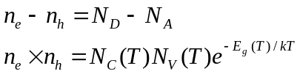
where N_{C}(T) and N_{V}(T) are the effective densities of states in the conduction and valance band, E_{G}(T) is the bandgap energy as a function of temperature, and k_{B} = 8.62x10⁻⁵ eV/K is Boltzmann’s constant. The density of states increases as approximately T^{3/2} and are estimated from the room (300 K) temperature values (cm⁻³).
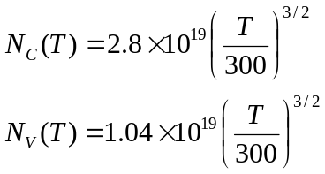
The bandgap for Si decreases significantly with temperature according to
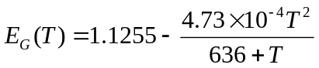
Combined, these give the intrinsic carrier concentration as a function of temperature.
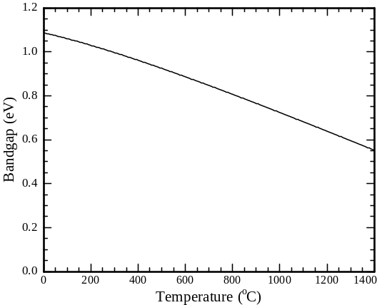
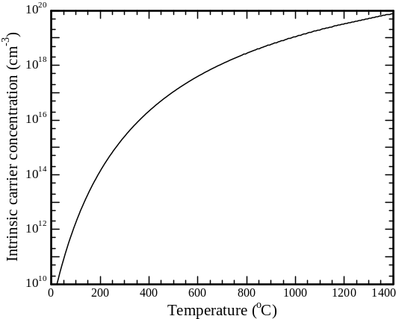
Mobility: The mobility of electrons and holes is a complex function of thermal and impurity scattering. Arsenic and Boron are assumed with parameters and data taken from:
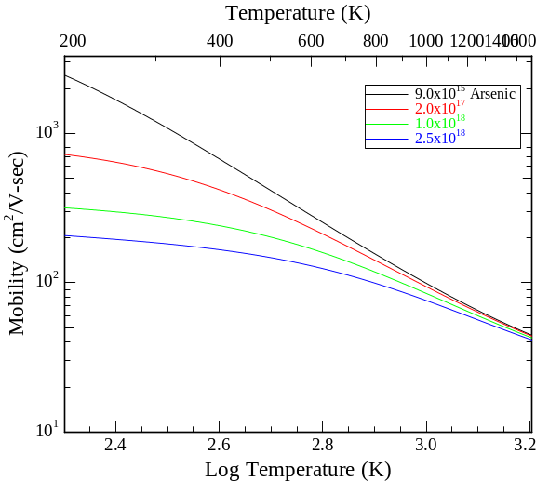
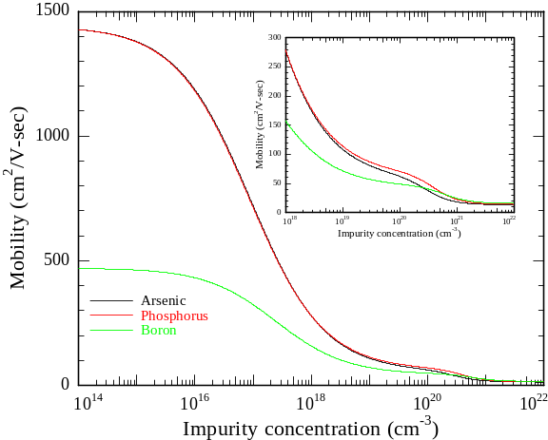
Electron and Hole Mobility in Silicon at Large Operating Temperatures - Part I: Bulk Mobility, Susanna Reggiani, Marina Valdinoci, Luigi Colalongo, Massimo Rudan, Giorgio Baccarani, Andreas D. Stricker, Fridolin Illien, Norbert Felber, Wolfgang Fichtner and Lucia Zullino, IEEE Transactions on Electron Devices, 49(3), March 2002.

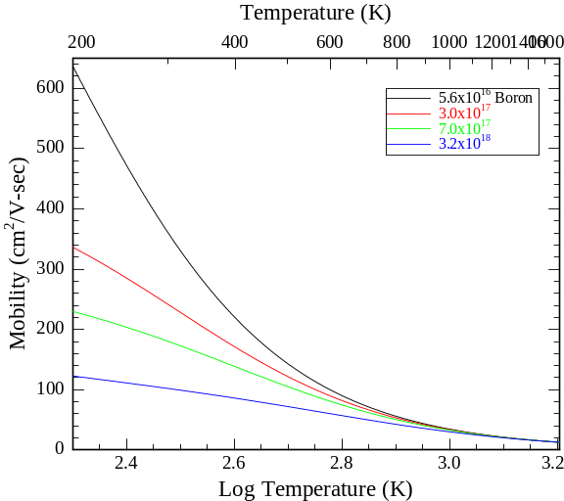

While impurity scattering has a strong effect, the substrates are mostly lightly doped and the dominate contribution is just the temperature dependent mobility of an intrinsic substrate. These are essentially the minority carrier mobilities given as:
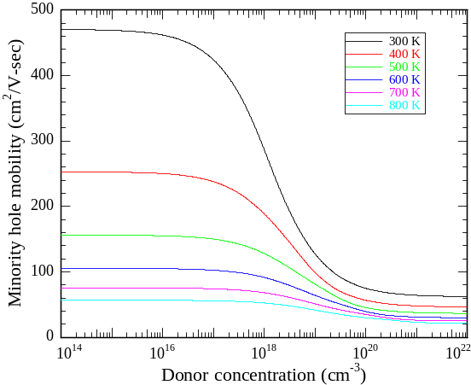
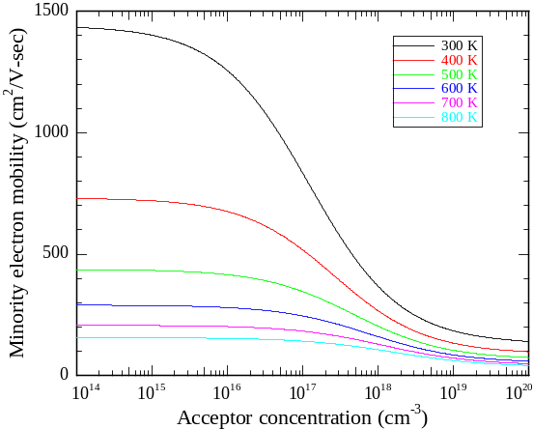

For intrinsically doped substrates, the mobility above 800 K (550ºC) is essentially stable at values of ~20 for holes and ~40 for electrons. Extrinsic doping impacts the absorption and mobility at low temperatures, but minimally impacts at high temperature.
Free carrier absorption: The electrons and holes independently contribute to the absorption. The model for absorption is taken from
Semiconductor Material and Device Characterization, Dieter K. Schroder, Wiley and Sons, 1990, p. 83.
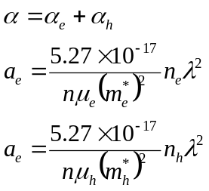
Where m_{e}* and m_{h}* are the effective mass, μ_{e}* and μ_{h}* are the electron and hole mobilities, λ is the wavelength in microns, n is the real part of the index, and the absorption coefficient is given in inverse centimeters. The real problem is the effective mass number.
Effective mass: The silicon valence band is degenerate, split into a heavy holes (m* = 0.50) band and a light hole (m* = 0.16) band, both located at the Γ point with a degeneracy of 4 for the heavy holes and 2 for the light holes. In contrast, the electrons are ellipsoidal bands with a longitudinal effective mass of 0.19 (degeneracy of 4) and a transverse effective mass of 0.98 (degeneracy of 2). For electrical conductivity calculations, the weighted average effective masses are 0.50 for holes and 0.26 for electrons.
For electrons, the effective mass is obtained as an inverse weighted average of the transverse and longitudinal masses. This is appropriate since the carrier acceleration is a = F/m from the simple scattering model.
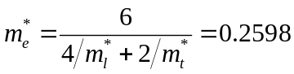
As the free carrier absorption scales as (1/m*)², the equivalent scaling would be with inverse weighted average of the square mass.
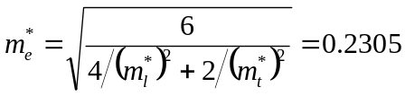
For the holes, it is more complex. Initially, a similar average was used for the holes, giving an effective mass for holes in absorption of approximately 0.2524. After reconsideration, theoretical feeling is that the holes should use an effective mass of 0.50 – just the heavy holes. Unlike the electrons, the holes have two distinct, but degenerate, bands. In occupying states, the shallow heavy hole band with its higher degeneracy will contain almost all of the holes in the system. This is consistent with the use of 0.50 as the effective mass in conventional conductivity models.
Unfortunately, the experimental data from LSA annealing suggests that the average value is closer to reality. The heavier value of 0.50 causes p-doped substrates to have essentially no predicted process window with 400ºC substrate heating, whereas in reality it is very doable. The code hence now has a switch fc_set_mstar_mode(int mode) to select the model. Default is to use averaged mass for both electrons and holes.
Optical reflectivity: For a uniformly doped substrate, the reflectance can be calculated from the absorption coefficient and the (assumed constant) real part of the index. The carrier concentrations are given by the extrinsic doping and intrinsic thermally generated carriers, using the mobility from the Klaasen model.
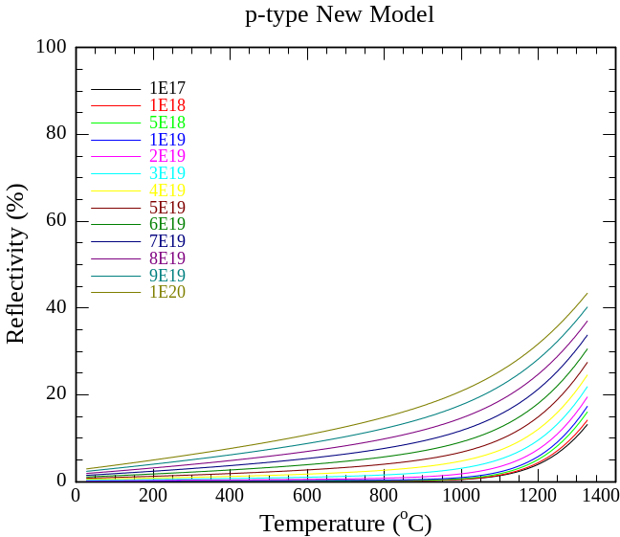
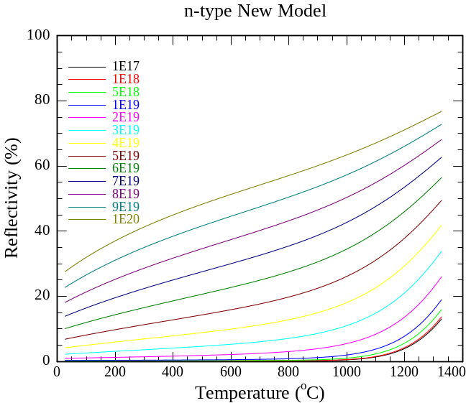
Because of the light effective mass of electrons, the absorption length is much shorter and the complex component of the index of reflective is large. This translates into substantial reflectance from a heavily doped n-type sample. Similarly, the high effective mass of the holes gives a much smaller effect. These simulations are at a 75 degree angle of incidence, near Brewster’s angle.
Because the effects scale also as λ², the behavior is really limited to the incident CO₂ laser beam and does not impact any of the optical characterization methods working primarily in the visible band.
A more realistic sample would be 60 nm of heavily doped S/D over a lightly doped substrate. The reflectivity still shows significant deviation, especially the n-type at high temperatures.
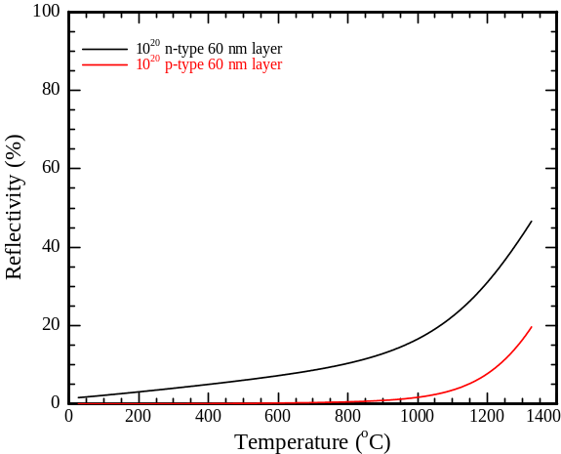
Still not included: There is an additional narrowing of the bandgap from doping. At 1E20 doping, this may be as much as 0.2 eV – but the data at high concentrations is poor and extrapolation even further would be difficult.

