

**Continuous Alternate Assessment –I**

**Advanced Data Structures and Algorithm Analysis**

**(23CSE301)**

**Submitted by**

**Name : P. Mounika**

**Roll no : 234G1A05A2**

**II B-Tech I Semester**

**Regulation: SRIT-R23**

**Department of Computer Science & Engineering**

**Details of CAA-I:**

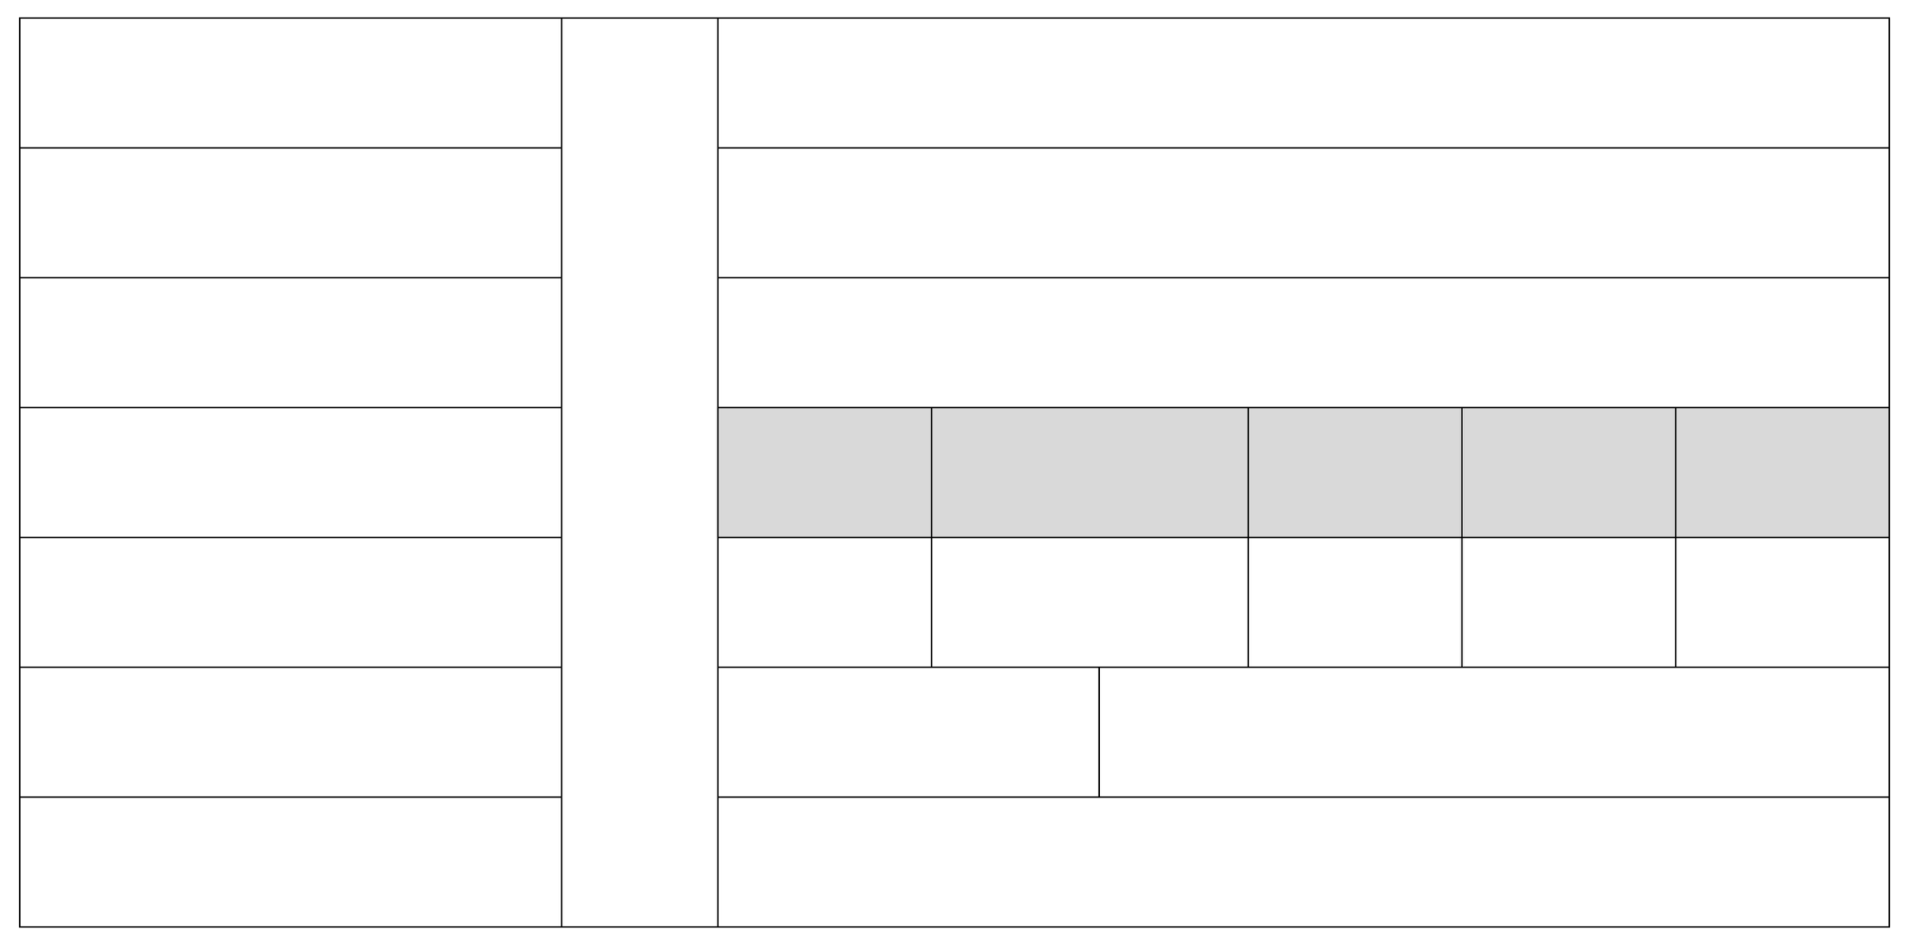

**Total Marks**

**Date of Issue**

**Marks Obtained**

**Question Numbers**

**Date of Submission**

**Last Date to Submit**

**Signature of the Faculty**

**:**

**:**

**:**

**:**

**:**

**:**

**:**

**Q1**

**Q2**

**Q3**

**Maximum Marks: 10**

**Q4**

**Q5**

**(2024-2025)**