Syrian Private University
Faculty of Engineering
Department of Artificial Intelligence Engineering and Data Science

Graduation Project 1

A Personal Assistant for Arabic Text Summarization Using Artificial Intelligence Techniques
مساعد شخصي لتلخيص النصوص العربية باستخدام تقنيات الذكاء الاصطناعي

This thesis was prepared to complete the Graduation Project 1 course in Artificial Intelligence Engineering and Data Science.

Prepared by
Mousaab Abdul-Latif Yousef - Mohammed Aqeed Amin - Muhand Adel Al-Salehani
مصعب عبد اللطيف يوسف - محمد عكيد أمين - مهند عادل الصالحاني

Supervised by
Dr. Kadan Jomaa - Eng. Anas Abdul-Aziz
د. كادان جمعة - م. أنس عبد العزيز

Damascus - Syrian Private University
2026

SUPERVISOR CERTIFICATION
I certify that the preparation of this project, entitled “A Personal Assistant for Arabic Text Summarization Using Artificial Intelligence Techniques,” prepared by Mosaab Abdul Latif Yousef, Mohammed Aqeed Amin, and Muhand Adel Al-Salehani, was carried out under my supervision at the Faculty of Engineering, Department of Artificial Intelligence Engineering and Data Science, in partial fulfillment of the requirements of Graduation Project 1.
Supervisor Name: ................................................
Date: .... / .... / 2026
Signature: ................................................

Declaration
We declare that the work and results presented in this thesis are the outcome of our personal effort and were completed under the guidance of our supervisors. Any information, result, paragraph, figure, diagram, or external material taken from other sources has been clearly attributed to its original source in the text and in the references section.
We also declare that the data and information used in this thesis were obtained through legitimate and proper methods, and that the work presented here has not been used previously, nor is it currently being used, to obtain any other academic degree.
Signatures:
Mohammed Aqeed Amin: __________________
Mosaab Abdul Latif Yousef: __________________
Muhand Adel Al-Salehani: __________________

Date: 20 / 4 / 2026

Acknowledgment
We would like to express our sincere gratitude to our supervisors, Dr. Kadan Jomaa and Eng. Anas Abdul Aziz, for their continuous guidance, valuable feedback, and academic support throughout the stages of this project. Their observations helped improve the scientific quality, organization, and practical direction of this work.
We also extend our appreciation to the teaching staff of the Faculty of Engineering at the Syrian Private University, and to everyone who provided academic or moral support during the preparation of this thesis.
نتقدم بجزيل الشكر والتقدير إلى مشرفينا د. كادان جمعة وم. أنس عبد العزيز على توجيههم المستمر وملاحظاتهم العلمية القيمة ودعمهم الأكاديمي خلال مراحل هذا المشروع. كما نشكر الكادر التدريسي في كلية الهندسة في الجامعة السورية الخاصة، وكل من قدم لنا الدعم العلمي أو المعنوي أثناء إعداد هذه الأطروحة.

Dedication
We dedicate this work to our families, who have always been our first source of support, to our teachers who guided us with knowledge, and to our colleagues and everyone who supported us throughout this academic journey.
نهدي هذا العمل إلى أهلنا الذين كانوا الداعم الأول في مسيرتنا العلمية، وإلى أساتذتنا الذين منحونا المعرفة والتوجيه، وإلى زملائنا وكل من ساندنا خلال هذه الرحلة الأكاديمية.

Abstract
This thesis aims to design and develop an intelligent assistant for summarizing long Arabic texts using the UBC-NLP/AraT5v2-base-1024 model, which is based on the Transformer encoder-decoder architecture. The project addresses the increasing need to reduce the time and effort required to read long Arabic texts, especially in educational and research contexts, while preserving the core meaning and reducing redundancy.
The methodology relies on the Arabic Summarization Dataset (ASDs), which provides official train, validation, and test splits of 2075, 259, and 260 samples, respectively. Preprocessing includes whitespace normalization, removal of hidden bidirectional characters, and tokenization using the model-specific tokenizer. The model was fine-tuned for 15 epochs with a learning rate of 3e-5, a batch size of 2, gradient accumulation steps of 4, and a weight decay of 0.01.
Long texts were handled through chunking with a chunk token size of 850 and an overlap of 80 tokens, with up to 3 hierarchical summarization rounds. Summaries were generated using beam search with 4 beams, a minimum summary length of 15, a maximum summary length of 128, a length penalty of 1.0, and a no-repeat n-gram size of 3. Final test results were as follows: ROUGE-1 = 7.4982, ROUGE-2 = 0.3846, ROUGE-L = 7.5458, BERTScore = 77.7619, METEOR = 26.8728, chrF = 39.6919, and Semantic Similarity = 83.5240. A Gradio interface was also developed to summarize Arabic text and text-based PDF files only; scanned PDFs are not supported because OCR was not implemented.
Keywords: Arabic text summarization, natural language processing, Transformers, AraT5v2, abstractive summarization, chunking, Gradio.
يهدف هذا المشروع إلى تصميم وتطوير مساعد ذكي لتلخيص النصوص العربية الطويلة باستخدام نموذج
UBC-NLP/AraT5v2-base-1024
المعتمد على بنية المحولات من نوع
Encoder-Decoder
. تنبع أهمية المشروع من الحاجة إلى تقليل الوقت والجهد اللازمين لقراءة النصوص العربية
الطويلة، وخاصة في المجالات التعليمية والبحثية، مع الحفاظ على المعنى الأساسي وتقليل التكرار
اعتمدت المنهجية على مجموعة بيانات Arabic Summarization Dataset (ASDs)، وهي مجموعة بيانات توفر تقسيمًا جاهزًا إلى بيانات تدريب وتحقق واختبار بأحجام 2075 و259 و260 على التوالي. شملت المعالجة المسبقة تنظيف الفراغات الزائدة وإزالة المحارف غير المرئية الخاصة باتجاه النص، ثم تقطيع النصوص باستخدام المحلل اللغوي الخاص بالنموذج. تم تدريب النموذج لمدة 15 حقبة باستخدام معدل تعلم 3e-5، وحجم دفعة 2، وخطوات تراكم تدرج 4، وقيمة Weight Decay تساوي 0.01.
عولجت النصوص الطويلة باستخدام تقنية Chunking بحجم 850 رمزًا وتداخل 80 رمزًا، مع عدد أقصى من جولات التلخيص الهرمي يساوي 3. كما تم توليد الملخصات باستخدام Beam Search بعدد حزم 4، وطول أدنى 15، وطول أقصى 128، وقيمة length penalty تساوي 1.0، ومنع تكرار n-grams بحجم 3. أظهرت نتائج الاختبار النهائي القيم التالية: ROUGE-1 = 7.4982، ROUGE-2 = 0.3846، ROUGE-L = 7.5458، BERTScore = 77.7619، METEOR = 26.8728، chrF = 39.6919، وSemantic Similarity = 83.5240. كما تم بناء واجهة Gradio لتلخيص النصوص العربية وملفات PDF النصية فقط، مع عدم دعم ملفات PDF المصورة لعدم وجود OCR في الكود.
الكلمات المفتاحية: التلخيص العربي، معالجة اللغات الطبيعية، المحولات، AraT5v2، التلخيص التجريدي، Chunking، Gradio.

Table of Contents
SUPERVISOR CERTIFICATION 2
Declaration 3
Acknowledgment 4
Dedication 5
Arabic Abstract 6
Abstract 7
List of Tables 9
List of Figures 10
List of Equations 11
List of Terms and Symbols 12
Chapter 1: Introduction - تمهيد 14
Chapter 2: Theoretical Background - الدراسة النظرية 16
Chapter 3: Literature Review - الدراسة المرجعية 19
Chapter 4: Research Methodology - منهج البحث 22
Chapter 5: Results and Evaluation - نتائج البحث 26
Chapter 6: Conclusion - الخاتمة 31
Appendix A: Notebook Implementation Summary 32
Appendix B: Reproducibility and Deployment Notes 33
Appendix C: Consistency Notes Between Thesis and Implementation 34
References 35

List of Tables
Table 0.1: Key technical terms and symbols used in the thesis. 12
Table 3.1: Summary of selected previous studies in Arabic text summarization. 19
Table 3.2: Comparative analysis of major summarization approaches. 20
Table 4.1: Official splits of the Arabic Summarization Dataset (ASDs). 22
Table 4.2: Actual training configuration used in the notebook implementation. 23
Table 4.3: Generation parameters used for summary decoding. 23
Table 4.4: Long-text chunking configuration. 24
Table 5.1: Evaluation metrics used in the project. 26
Table 5.2: Final test results obtained on the official ASDs test split. 26
Table 5.3: Qualitative demonstration of long-text summarization. 28
Table 5.4: Analytical comparison between the proposed system and selected previous work. 30

List of Figures
Figure 2.1: AraT5v2 encoder-decoder architecture used in the proposed system. 17
Figure 4.1: End-to-end pipeline of the Arabic text summarization system. 24
Figure 4.2: Representative Gradio interface for Arabic text and text-based PDF summarization. 25
Figure 5.1: Bar chart of the final evaluation metrics. 27
Figure 5.2: Training and validation loss curve during fine-tuning. 28

List of Equations
No standalone numbered equations were used in this thesis.

List of Terms and Symbols
Table 0.1: Key technical terms and symbols used in the thesis.
English Term | Arabic Translation | Abbreviation | Meaning / Context
Natural Language Processing | معالجة اللغات الطبيعية | NLP | Field that enables computers to understand and generate human language.
Automatic Text Summarization | التلخيص التلقائي للنصوص | ATS | Producing a shorter version of a source text while preserving important information.
Abstractive Summarization | التلخيص التجريدي | - | Generating a new summary rather than extracting sentences directly.
Transformers | المحولات | - | Deep learning architecture based on attention mechanisms.
Encoder-Decoder | المشفر وفك التشفير | - | The encoder reads the input text and the decoder generates the output summary.
Self-Attention | الانتباه الذاتي | - | A mechanism that relates each token to other tokens in the same sequence.
AraT5v2 | نموذج AraT5v2 | - | Arabic pretrained sequence-to-sequence model used in the implementation.
AraBART | نموذج AraBART | - | Important related Arabic model discussed only in the literature review.
Fine-Tuning | الضبط الدقيق | - | Adapting a pretrained model to a specific downstream task.
Tokenizer | المحلل اللغوي | - | Converts text into token IDs that the model can process.
Chunking | تقسيم النص إلى أجزاء | - | Processing long texts by splitting them into overlapping token segments.
Beam Search | البحث الشعاعي | - | A decoding strategy that explores multiple candidate sequences.
ROUGE | مقياس روج | ROUGE | Measures lexical overlap between generated and reference summaries.
BERTScore | مقياس بيرت سكور | - | Measures semantic similarity using contextual embeddings.
METEOR | مقياس ميتيور | METEOR | Evaluates flexible word matching and similarity beyond exact overlap.
chrF | مقياس chrF | - | Character-level F-score useful for morphologically rich languages.
Semantic Similarity | التشابه الدلالي | - | Measures meaning-level closeness between two summaries.
Text-Based PDF | ملف PDF نصي | - | A PDF from which text can be extracted directly; scanned PDF requires OCR.

Chapter 1: Introduction — الفصل الأول: تمهيد
This chapter introduces the general context of Arabic text summarization, the scientific problem, the research objectives, the contribution of the project, the beneficiaries, and the organization of the thesis.

1.1 Introduction
The rapid growth of Arabic digital content has created a major challenge for students, researchers, and readers who need to extract essential information quickly and accurately. Educational, academic, and news documents are becoming longer and more numerous, which increases the need for intelligent tools capable of producing concise and meaningful summaries.
Traditional human summarization requires considerable time and effort and may be affected by subjectivity, inconsistency, and the reader’s background knowledge. This makes manual summarization impractical when dealing with large amounts of Arabic documents or long educational materials.
Automatic Text Summarization provides a practical solution by producing a shorter version of the input while preserving the main ideas. With the development of deep learning and Transformer-based models, abstractive summarization has become more capable of understanding context and generating summaries that are linguistically coherent rather than simply extracting sentences from the source.
This project focuses on building a personal assistant for Arabic text summarization using UBC-NLP/AraT5v2-base-1024. The system supports Arabic text input and text-based PDF files, applies preprocessing and long-text chunking, generates summaries using beam search, and provides a Gradio interface for practical use.

1.2 Scientific Problem
Educational and research institutions in the Arab region face a growing challenge in managing and understanding large volumes of Arabic digital content. The lack of practical and reliable Arabic summarization tools increases the time needed to read and analyze long documents.
Arabic also presents linguistic challenges due to its rich morphology, derivational patterns, prefixes, suffixes, and contextual ambiguity. These characteristics make it difficult for a summarization system to preserve the intended meaning while producing a concise output.
Another technical challenge is the limited input length of Transformer models. Long documents may exceed the model’s maximum token length, which requires an additional strategy such as chunking. Generative models may also produce hallucinated information if they are not properly trained and evaluated.
Therefore, the main research problem is the need for a reliable Arabic summarization system that can summarize long Arabic texts while preserving meaning, reducing redundancy, handling long inputs, and supporting practical use through a simple interface.

1.3 Research Objectives
The main objective of this project is to build an intelligent assistant for summarizing long Arabic texts and text-based PDF files using AraT5v2-base-1024 and modern NLP techniques.
- Develop an abstractive Arabic summarization model using UBC-NLP/AraT5v2-base-1024.
- Apply the actual preprocessing steps implemented in the notebook: whitespace normalization, removal of hidden directional characters, and tokenization.
- Use the official ASDs dataset split: 2075 training samples, 259 validation samples, and 260 test samples.
- Fine-tune the model for 15 epochs using a learning rate of 3e-5 and the training configuration implemented in the code.
- Handle long texts using chunking with 850 tokens per chunk and 80 tokens of overlap.
- Evaluate the model using ROUGE-1, ROUGE-2, ROUGE-L, BERTScore, METEOR, chrF, and Semantic Similarity.
- Build a Gradio interface for Arabic text and text-based PDF summarization.

1.4 Research Contribution
The contribution of this project is the development of an applied Arabic summarization assistant that combines a pretrained Arabic sequence-to-sequence model, task-specific fine-tuning, long-text chunking, beam-search generation, multi-metric evaluation, and a user-facing interface.
The project also clarifies the practical limitations of Arabic abstractive summarization, including input length constraints, limited Arabic summarization datasets, possible hallucination, and the need for semantic evaluation beyond surface-level lexical overlap.

1.5 Beneficiaries
- Students who need to summarize lectures, textbooks, and long educational materials.
- Researchers who need quick access to the main ideas of papers, reports, and academic documents.
- Teachers and educational institutions that manage Arabic learning content.
- Content editors and journalists who work with long Arabic texts.
- Developers and researchers interested in Arabic NLP applications.

1.6 Thesis Organization
This thesis is organized into six chapters. Chapter 1 introduces the problem, objectives, contribution, and beneficiaries. Chapter 2 presents the theoretical background of Arabic NLP, summarization, Transformers, and AraT5v2. Chapter 3 reviews related studies and identifies the research gap. Chapter 4 explains the research methodology, dataset, preprocessing, model training, long-text handling, and interface. Chapter 5 presents the evaluation results and analysis. Chapter 6 concludes the work and discusses challenges and future directions.

Chapter 2: Theoretical Background — الفصل الثاني: الدراسة النظرية

2.1 Natural Language Processing
Natural Language Processing (NLP) is a field that combines artificial intelligence, linguistics, and computer science to enable computers to analyze, understand, and generate human language. In this project, the focus is Arabic, a morphologically rich language that introduces additional challenges for text processing and summarization.

2.2 Automatic Text Summarization
Automatic Text Summarization aims to produce a shorter version of a source text while preserving its most important information. It is commonly divided into extractive and abstractive summarization. Extractive summarization selects existing sentences from the source, while abstractive summarization generates new wording that may not appear directly in the original text.
This project adopts the abstractive approach because it is closer to human summarization. However, abstractive summarization is more difficult because it requires the model to understand context, preserve meaning, and avoid generating unsupported information.

2.3 Transformer Architecture
Transformer models rely on attention mechanisms that allow the model to represent relationships between tokens regardless of their distance in the sequence. This architecture has become the foundation of many modern NLP models, including AraT5, AraBART, mBART, and mT5.
The encoder-decoder structure is particularly suitable for summarization. The encoder reads and represents the input text, while the decoder generates the summary token by token. Cross-attention allows the decoder to focus on relevant parts of the source text during generation.

2.4 AraT5v2-base-1024
The practical model used in this project is UBC-NLP/AraT5v2-base-1024. It is an Arabic pretrained sequence-to-sequence model suitable for generation tasks such as summarization. The model can handle inputs up to 1024 tokens, which is useful for medium-length texts, but long documents still require chunking.
Fine-tuning allows the model to adapt its general Arabic language knowledge to the specific task of summarization by learning from pairs of articles and reference summaries.
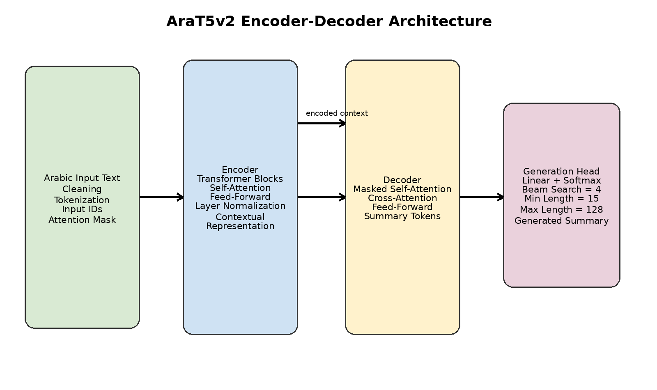
Figure 2.1: AraT5v2 encoder-decoder architecture used in the proposed system.

2.5 AraBART in the Literature Review
AraBART is discussed as an important Arabic abstractive summarization model in the literature review. However, it should not be described as the model used in the practical implementation unless a separate AraBART experiment is actually performed. In this thesis, AraBART remains a reference model for comparison, while AraT5v2 is the implemented model.

2.6 Arabic Text Preprocessing
The preprocessing used in the notebook is intentionally limited and should be described accurately. The implemented cleaning function normalizes repeated whitespace, removes hidden left-to-right and right-to-left direction marks, and trims the text. It does not implement advanced normalization such as full diacritic removal, hamza normalization, or link removal unless these operations are added later to the code.
After cleaning, the texts and summaries are tokenized using the AraT5 tokenizer. The maximum input length is 1024 tokens and the maximum target length is 128 tokens. Dynamic padding is handled during batching by DataCollatorForSeq2Seq.

2.7 Long-Text Handling Using Chunking
Because the model has an input limit, long texts are processed using chunking. The implementation uses a chunk token size of 850 and an overlap of 80 tokens. Each chunk is summarized separately, then the partial summaries are merged and summarized again when needed. The maximum number of hierarchical summarization rounds is 3.

2.8 Loss Function and Optimization
Sequence-to-sequence summarization models are trained using Cross-Entropy Loss, which measures the difference between the predicted token distribution and the correct reference token. The loss value is not a percentage; it is a mathematical training objective used to update the model weights. A lower loss generally indicates that the model is learning to predict the reference summary tokens more accurately, but it does not directly represent an accuracy percentage.
The optimizer used through the Hugging Face Trainer is AdamW, which is well suited for Transformer models. The implementation also uses weight decay, gradient accumulation, evaluation per epoch, checkpoint saving per epoch, and early stopping based on validation performance.

Chapter 3: Literature Review — الفصل الثالث: الدراسة المرجعية

3.1 Previous Studies in Related Fields
Several studies have contributed to Arabic text summarization using both traditional and deep learning approaches. The selected studies below represent the main directions in Arabic abstractive summarization, long-text summarization, graph-based summarization, and educational applications.
Table 3.1: Summary of selected previous studies in Arabic text summarization.
Study | Year | Model / Method | Metrics | Key Findings
Kamal Eddine et al. | 2022 | AraBART | ROUGE-1/2/L | Introduced AraBART as a strong Arabic abstractive summarization model.
Elsaid et al. | 2023 | AraBART vs mT5 | ROUGE, BERTScore | Arabic-specialized models showed stronger Arabic understanding.
Abdul Salam et al. | 2024 | MSG-ATS | Centrality, Cosine Similarity | Semantic graph representation reduced redundancy and improved structure.
Merniz et al. | 2024 | Thematic Annotation + PageRank | ROUGE-SU4 | Improved thematic coverage in multi-document summarization.
Magdy et al. | 2024 | Survey on long-text summarization | Comparative analysis | Highlighted the importance of chunking and hybrid methods.
Masri et al. | 2024 | AraT5 / AraBART / mBART | ROUGE | AraT5 showed promising generalization on Arabic scientific textbooks.
Zhang et al. | 2025 | LLM-based summarization | Faithfulness metrics | LLMs offer fluency but still suffer from hallucination risks.

Although these studies achieved important progress, most of them still face limitations related to long-document handling, dataset size, hallucination, and the absence of practical end-user interfaces.

3.2 Modern Techniques and Frameworks
Modern Arabic summarization research increasingly relies on pretrained Transformer models, including AraT5, AraBART, mBART, and mT5. Other directions include graph-based summarization, thematic segmentation, prompt engineering with large language models, and hybrid extractive-abstractive pipelines.
From an implementation perspective, Hugging Face Transformers, Datasets, Evaluate, PyTorch, and Gradio are important tools for building, training, evaluating, and deploying summarization systems.

3.3 Comparative Analysis
Traditional extractive methods such as TF-IDF, TextRank, and PageRank are fast and interpretable, but they do not generate new wording and may produce disconnected summaries. Arabic abstractive models such as AraT5 and AraBART can generate more fluent summaries, but they require training data, computational resources, and careful evaluation. Hybrid approaches may improve long-text handling, while large language models offer strong fluency but may introduce higher cost, privacy concerns, and hallucination risks.
Table 3.2: Comparative analysis of major summarization approaches.
Approach | Techniques | Strengths | Weaknesses
Traditional Extractive Methods | TF-IDF, TextRank, PageRank | Fast, simple, interpretable | Do not generate new phrasing and may be less coherent.
Arabic Abstractive Models | AraT5, AraBART, Encoder-Decoder | Good fluency and contextual understanding | Require data and computational resources.
Hybrid Methods | Extractive + Abstractive, thematic segmentation | Useful for long documents and coverage | More complex to design and evaluate.
Large Language Models | LLMs, prompt engineering | High fluency and flexible instructions | Costly and may hallucinate.
Proposed System | AraT5v2 + Chunking + Gradio | Practical Arabic assistant with long-text support | Still needs stronger ROUGE and broader evaluation.

3.4 Research Gap and Proposed Innovation
The research gap can be summarized in three points:
Existing Arabic summarization models often focus on model evaluation without providing a practical assistant interface.
Long Arabic documents remain difficult because of the input token limit of Transformer models.
Many systems do not clearly support text-based PDF summarization with an explicit limitation regarding scanned PDFs.
The proposed project addresses these gaps by combining AraT5v2 fine-tuning, chunking, multi-metric evaluation, and a Gradio interface.
The literature shows that Arabic summarization still faces challenges related to long documents, limited specialized datasets, hallucination, and insufficient practical interfaces for end users. Many studies focus on model performance but do not always provide a complete usable tool for text and document summarization.
This project addresses the gap by developing an Arabic summarization assistant based on AraT5v2, official ASDs dataset splits, long-text chunking, beam-search generation, multi-metric evaluation, and a Gradio interface for text and text-based PDF summarization.

Chapter 4: Research Methodology — الفصل الرابع: منهج البحث

4.1 Introduction
This chapter explains the practical methodology used to build the Arabic summarization assistant. It covers the dataset, preprocessing, model architecture, training configuration, generation settings, long-text summarization, and the user interface.

4.2 Traditional Methods for the Problem
Earlier summarization systems often relied on extractive approaches such as TF-IDF, TextRank, and PageRank. These methods identify important words or sentences and select the most relevant ones. Although they are computationally efficient and interpretable, they cannot rewrite content or synthesize information from different parts of the text.
The proposed system uses a Transformer-based abstractive model instead because it can generate a new summary that is more coherent and closer to human writing.

4.3 Dataset
The dataset used in the implementation is Arabic Summarization Dataset (ASDs), loaded from Hugging Face using the name karimraouf/Arabic-Summarization-Dataset-AsDs. The dataset contains four fields: title, article, summary, and topic.
The dataset already provides official splits; therefore, the final thesis must not state that an 80/20 split was used. The correct split is: 2075 samples for training, 259 samples for validation, and 260 samples for testing.
Table 4.1: Official splits of the Arabic Summarization Dataset (ASDs).
Split | Number of Samples | Fields
Train | 2075 | title, article, summary, topic
Validation | 259 | title, article, summary, topic
Test | 260 | title, article, summary, topic

4.4 Preprocessing
The implemented preprocessing includes converting input values to strings, normalizing repeated whitespace, removing hidden bidirectional marks, and trimming leading and trailing spaces. The articles and summaries are then tokenized using the AraT5 tokenizer.
The maximum input length is 1024 tokens and the maximum target length is 128 tokens. Padding is not applied inside the preprocessing function; instead, dynamic padding is applied later by DataCollatorForSeq2Seq during batching.

4.5 Model Architecture
The proposed model is based on the Transformer encoder-decoder architecture. The encoder reads the Arabic input text and produces contextual representations, while the decoder uses these representations to generate the summary token by token. Self-attention captures relationships inside the input sequence, and cross-attention connects the generated tokens with relevant information from the source text.
The practical model is UBC-NLP/AraT5v2-base-1024. This model was selected because it is pretrained for Arabic sequence-to-sequence tasks and can be fine-tuned for abstractive summarization.

4.6 Training Configuration
The correct training configuration from the notebook is as follows. The model was fine-tuned for 15 epochs using a learning rate of 3e-5. The train batch size was 2, the evaluation batch size was 2, gradient accumulation steps were set to 4, weight decay was 0.01, and early stopping patience was 2. Evaluation and saving were performed at the end of each epoch. The best model was selected based on validation ROUGE-L.
The previous values that stated 3 epochs and a learning rate of 5e-5 must be removed from the thesis because they do not match the final notebook implementation.
Table 4.2: Actual training configuration used in the notebook implementation.
Parameter | Value
Model | UBC-NLP/AraT5v2-base-1024
Epochs | 15
Learning Rate | 3e-5
Train Batch Size | 2
Evaluation Batch Size | 2
Gradient Accumulation Steps | 4
Weight Decay | 0.01
Early Stopping Patience | 2
Max Input Length | 1024
Max Target Length | 128
Best Model Metric | Validation ROUGE-L

4.7 Summary Generation
After fine-tuning, summaries are generated using beam search. The correct generation settings are: num_beams = 4, min_summary_length = 15, max_summary_length = 128, length_penalty = 1.0, and no_repeat_ngram_size = 3. The previous value length_penalty = 2.0 should be replaced with 1.0.
Table 4.3: Generation parameters used for summary decoding.
Generation Parameter | Value
num_beams | 4
min_length | 15
max_length | 128
length_penalty | 1.0
no_repeat_ngram_size | 3

4.8 Project Pipeline
The system pipeline begins with either Arabic text input or a text-based PDF file. If a PDF is provided, the system extracts text from it. The text is then cleaned, tokenized, divided into chunks if it exceeds the model length limit, summarized chunk by chunk, merged, and summarized again if needed. Finally, the output summary is displayed through the Gradio interface.
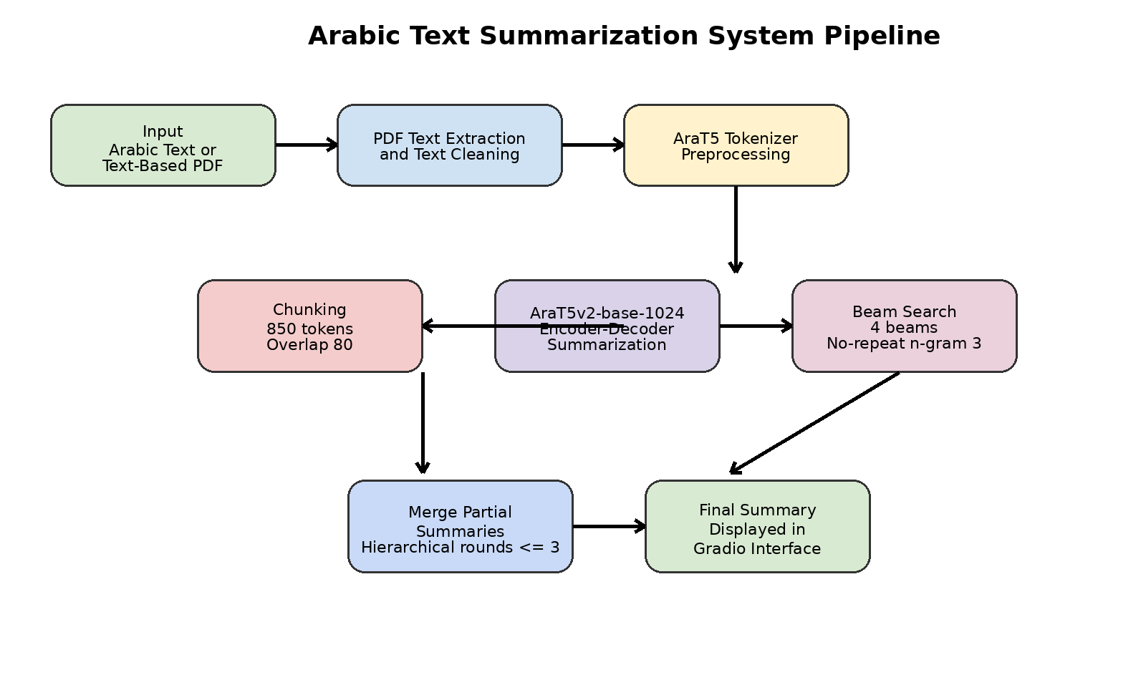
Figure 4.1: End-to-end pipeline of the Arabic text summarization system.

4.9 Long-Text Summarization
The long-text component is a necessary part of the system because AraT5v2 has a maximum input length. The implemented algorithm splits the input into overlapping token chunks, summarizes each chunk, merges the partial summaries, and repeats the process when the merged result is still too long.
Table 4.4: Long-text chunking configuration.
Parameter | Value
Chunk token size | 850
Chunk overlap | 80
Maximum hierarchical rounds | 3
Supported PDF type | Text-based PDF only
Unsupported PDF type | Scanned PDF without OCR

4.10 Practical Interface
A Gradio interface was built to make the model usable by non-specialist users. The interface provides two tabs: one for Arabic text summarization and one for text-based PDF summarization. It is important to state that scanned PDFs are not supported because OCR was not implemented in the project code.
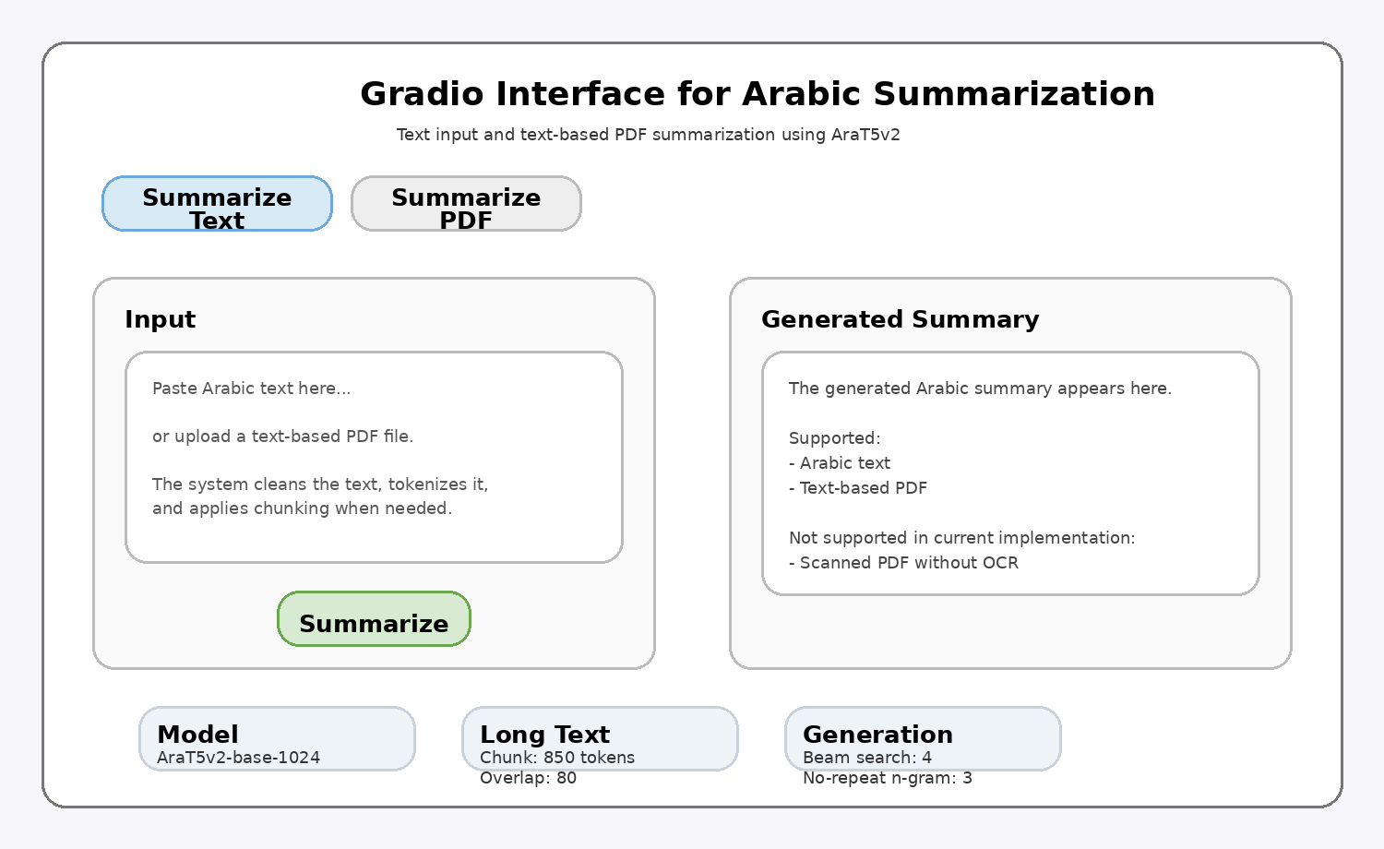
Figure 4.2: Representative Gradio interface for Arabic text and text-based PDF summarization.

4.11 Implementation Challenges and Solutions
- Long input texts were handled using chunking with 850 tokens per chunk and 80 tokens of overlap.
- Repeated phrases were reduced using no_repeat_ngram_size = 3 during generation.
- Limited training data was addressed by using transfer learning from AraT5v2.
- Computational cost was reduced by using Google Colab GPU when available and small batch sizes with gradient accumulation.
- Text-based PDF summarization was supported, but scanned PDFs remain a future improvement because OCR is not implemented.

Chapter 5: Results and Evaluation — الفصل الخامس: نتائج البحث

5.1 Tools and Evaluation Methods
The experiments were implemented using Python, PyTorch, Hugging Face Transformers, Hugging Face Datasets, Evaluate, SentenceTransformers, pypdf, and Gradio in Google Colab. GPU acceleration was used when available.
The evaluation focuses on metrics that were actually calculated in the notebook: ROUGE-1, ROUGE-2, ROUGE-L, BERTScore, METEOR, chrF, and Semantic Similarity. Precision, Recall, and F1 Score were removed from the thesis because they were not computed directly in the final notebook for the generative summarization task.
Table 5.1: Evaluation metrics used in the project.
Metric | Meaning | Why it is suitable
ROUGE-1 | Unigram overlap | Measures core content coverage.
ROUGE-2 | Bigram overlap | Reflects phrase-level overlap and local fluency.
ROUGE-L | Longest common subsequence | Captures structural overlap and ordering.
BERTScore | Embedding-based semantic similarity | Evaluates meaning beyond exact wording.
METEOR | Flexible overlap metric | Handles variation better than exact lexical matching.
chrF | Character n-gram F-score | Useful for morphologically rich languages like Arabic.
Semantic Similarity | Meaning-level closeness | Evaluates semantic faithfulness of the summary.

5.2 Results of the Proposed Model
The final evaluation was conducted on the full official test split containing 260 samples. The final metrics obtained from the notebook are presented in Table 5.2.
Table 5.2: Final test results obtained on the official ASDs test split.
Metric | Value
ROUGE-1 | 7.4982
ROUGE-2 | 0.3846
ROUGE-L | 7.5458
BERTScore | 77.7619
METEOR | 26.8728
chrF | 39.6919
Semantic Similarity | 83.5240

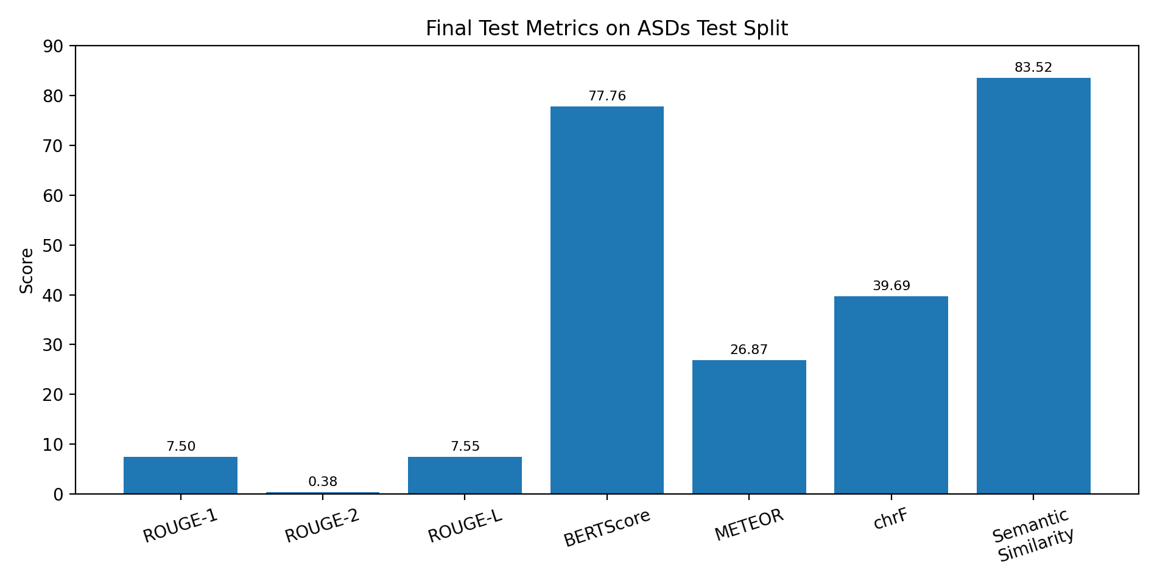
Figure 5.1: Bar chart of the final evaluation metrics.
These results show that the generated summaries preserve a meaningful semantic relationship with the references, especially according to BERTScore and Semantic Similarity. The lower ROUGE values indicate that the generated summaries do not always share the same surface wording as the references, which is common in abstractive summarization and suggests room for additional fine-tuning, data improvement, and domain adaptation. The low ROUGE values indicate limited lexical overlap with the reference summaries, while the higher BERTScore and Semantic Similarity values indicate that the generated summaries preserve part of the intended meaning despite using different wording.

5.3 Result Analysis
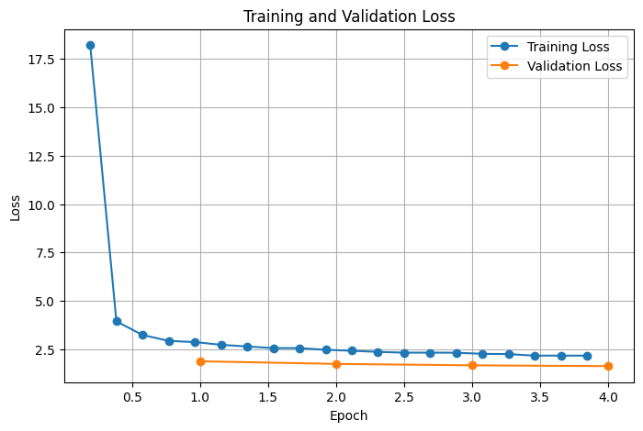
Figure 5.2: Training and validation loss curve during fine-tuning.
Qualitative testing showed that the model can produce understandable Arabic summaries and reduce redundancy. The use of beam search improved generation stability, while no_repeat_ngram_size = 3 helped reduce repeated phrases. The chunking mechanism also allowed the system to summarize input longer than the model’s maximum context size.
However, the model may still face difficulties with rare technical terms, uncommon proper names, and texts containing many dense ideas in a small number of sentences. The chunking approach may also lose some cross-chunk context if the document structure is highly interconnected.

5.4 Practical Demonstration
The notebook includes a long-text test in which the input exceeded the model’s maximum sequence length and was therefore split into two chunks. The resulting summary demonstrates that the hierarchical chunking mechanism can process long Arabic input without directly exceeding the model input limit.
Table 5.3: Qualitative demonstration of long-text summarization.
Input Type | System Behavior | Generated Output Summary
Long Arabic text | The input was split into 2 chunks, summarized separately, then merged. | The generated summary explained that technology has become an essential part of modern life, affecting education, healthcare, communication, and work. It also mentioned benefits such as access to information, distance learning, smart diagnosis, and electronic health records, while noting privacy, data security, and reduced direct communication as challenges.

5.5 Comparison of Proposed Experiments
The current implementation focuses on one practical model: AraT5v2-base-1024. Therefore, the thesis should not claim that several models were experimentally compared unless those experiments are actually added. A future comparison can include AraBART, mT5, or a non-fine-tuned baseline.
For the current version, comparison is limited to analytical discussion of the implemented configuration and the effect of chunking and controlled generation settings.

5.6 Comparison with Previous Work
A direct numerical comparison is not fully fair because previous studies used different datasets, preprocessing strategies, and evaluation protocols. Therefore, this thesis provides an analytical comparison rather than claiming direct superiority.
A direct numerical comparison with previous studies is difficult because datasets, preprocessing, and evaluation settings differ. Therefore, the comparison is analytical unless the same dataset and evaluation protocol are reproduced. The project aligns with previous research that emphasizes pretrained Arabic sequence-to-sequence models and long-text handling strategies, while adding a practical Gradio-based assistant for text and text-based PDF summarization.

Table 5.4: Analytical comparison between the proposed system and selected previous work.
Work | Model / Method | Strength | Difference from this thesis
Kamal Eddine et al. (2022) | AraBART | Strong Arabic abstractive baseline | Focuses on a pretrained model rather than a practical assistant.
Merniz et al. (2024) | Thematic annotation + graph models | Good thematic coverage | More oriented to multi-document summarization.
Masri et al. (2024) | AraT5 / AraBART / mBART | Educational-domain summarization | Closest to the educational motivation of this thesis.
This thesis | AraT5v2 + Chunking + Gradio | Practical Arabic assistant with long-text support | Includes interface and text-based PDF summarization.

Chapter 6: Conclusion — الفصل السادس: الخاتمة

6.1 Conclusions
This project demonstrates that AraT5v2-base-1024 can be used to build a practical Arabic abstractive summarization assistant. The system combines fine-tuning, long-text chunking, controlled beam-search generation, multi-metric evaluation, and a Gradio interface.
The results indicate that the model can generate semantically coherent summaries, although surface-level overlap metrics such as ROUGE still require improvement. The project also shows that chunking is necessary for processing long Arabic texts and text-based PDF files that exceed the model input limit.
The final implementation corrected the earlier methodological inconsistencies: training was performed for 15 epochs, the learning rate was 3e-5, the official dataset splits were used, Precision/Recall/F1 were removed from the final results, and PDF support was limited to text-based PDF files only.

6.2 Challenges and Future Work
- Expand the dataset with more educational, scientific, and technical Arabic content.
- Add OCR support to process scanned PDF files.
- Experiment with longer-context models such as Longformer-style architectures or newer Arabic LLMs.
- Compare AraT5v2 with AraBART, mT5, and non-fine-tuned baselines using the same dataset.
- Add structured human evaluation for fluency, faithfulness, coverage, and coherence.
- Improve faithfulness and reduce hallucination using verification-based techniques.
- Deploy the system as a web application or Hugging Face Space for practical use.

6.3 Final Summary
The thesis confirms that combining Arabic pretrained Transformer models with appropriate preprocessing, chunking, and semantic evaluation can support the development of useful Arabic summarization tools. The proposed system represents a practical foundation for educational and research-oriented Arabic knowledge management.

Appendix A: Notebook Implementation Summary
The implementation notebook follows a clear workflow that starts with installing the required libraries, mounting Google Drive, defining the configuration class, loading the dataset and tokenizer, preparing tokenized splits, fine-tuning AraT5v2 using Seq2SeqTrainer, saving the best model, and finally evaluating the system using multiple metrics.
The most important configuration values were defined in a single class named CFG. This class specifies the model name, dataset name, maximum input and target lengths, training hyperparameters, generation parameters, chunking parameters, and output directories. Keeping these values in one place makes the notebook reproducible and easier to discuss during the defense.
- Model: UBC-NLP/AraT5v2-base-1024.
- Dataset: karimraouf/Arabic-Summarization-Dataset-AsDs.
- Input and target lengths: 1024 tokens and 128 tokens.
- Training: 15 epochs, learning rate 3e-5, batch size 2, gradient accumulation 4.
- Generation: beam search with 4 beams and no-repeat n-gram size 3.
- Long text handling: chunk size 850 tokens, overlap 80 tokens, and up to 3 hierarchical rounds.
The notebook also separates training and inference. After training, the model and tokenizer are saved to Google Drive, allowing the user to reload the model later without repeating the full training process. This design makes the system more practical for demonstration and future experimentation.

Appendix B: Reproducibility and Deployment Notes
To reproduce the project, the user should run the notebook in Google Colab with GPU enabled. The required Python libraries include transformers, datasets, evaluate, accelerate, sentencepiece, rouge_score, bert-score, nltk, pypdf, gradio, sentence-transformers, and PyTorch. The notebook saves the model, tokenizer, metrics, plots, and predictions under the project directory in Google Drive.
The interface was implemented with Gradio to support two practical use cases: summarizing direct Arabic text and summarizing text-based PDF files. The PDF component extracts text using pypdf and then passes the extracted text to the same summarization pipeline. Scanned PDFs are excluded because they require OCR, which was not implemented in the current version.
- Use a GPU runtime when fine-tuning the model to reduce training time.
- Keep the saved model directory unchanged when testing inference after training.
- Use the official dataset splits to keep the results consistent with the thesis.
- Do not report metrics that are not computed in the notebook.
- When demonstrating PDF summarization, use text-based PDFs rather than scanned images.
For future deployment, the Gradio interface can be hosted using a local server, Google Colab public sharing, or a Hugging Face Space. A permanent deployment should include input length warnings, file type validation, and a clear note that OCR is not yet supported.

Appendix C: Consistency Notes Between Thesis and Implementation
This appendix documents the consistency between the final thesis and the practical notebook implementation. It is included to make the methodological choices clear and reproducible.
The implemented model is AraT5v2-base-1024, while AraBART is discussed only as related work.
The final training configuration uses 15 epochs and a learning rate of 3e-5.
The official ASDs dataset splits are used: Train = 2075, Validation = 259, and Test = 260.
The reported evaluation metrics are ROUGE-1, ROUGE-2, ROUGE-L, BERTScore, METEOR, chrF, and Semantic Similarity.
The interface supports text-based PDF files only; scanned PDFs require OCR and remain future work.
The generation configuration uses beam search with 4 beams, length penalty 1.0, and no-repeat n-gram size 3.
These consistency notes ensure that the thesis content accurately reflects the implementation and avoids unsupported experimental claims.

References
[1] M. Kamal Eddine, A. J. P. Tixier, and M. Vazirgiannis, “AraBART: A Pretrained Arabic Sequence-to-Sequence Model for Abstractive Summarization,” 2022.
[2] S. Magdy, N. El-Fishawy, and A. El-Ghamry, “A Systematic Review of Arabic Text Summarization: Techniques, Datasets, and Challenges,” 2024.
[3] R. Masri et al., “Abstractive Summarization of Arabic Scientific Textbooks: A Case Study on Palestinian Biology Books,” 2024.
[4] S. Merniz and M. Boughanem, “Multi-document Arabic Text Summarization Based on Thematic Annotation and Graph-based Models,” 2024.
[5] M. Abdul Salam et al., “MSG-ATS: Multi-Level Semantic Graph for Arabic Text Summarization,” 2024.
[6] M. Magdy et al., “Exploring Advances in Arabic Long-Text Summarization Strategies: A Survey,” 2024.
[7] Y. Zhang et al., “A Comprehensive Survey on Automatic Text Summarization with Exploration of LLM-Based Methods,” 2025.
[8] B. Rodrigues et al., “A Systematic Literature Review of AI-Driven Intelligent Tutoring Systems in Engineering Education,” 2025.

