|  |  |
| --- | --- |
| **NOMBRE ESTUDIANTE:** | Ismael Toala |
| **FECHA:** | [08-12-2024] |
|  |  |
|  |  |
| **TEMA:** | Mockups Medication Reminder App |
|  |  |

**DESARROLLO**  
**Log in:**

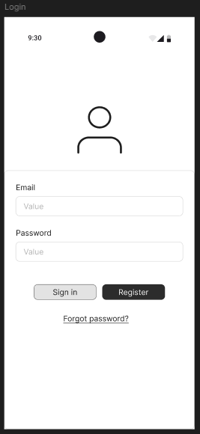

**Active Medications**

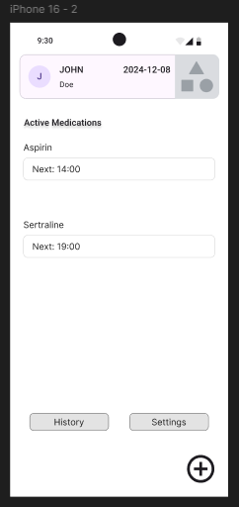

**Medications**

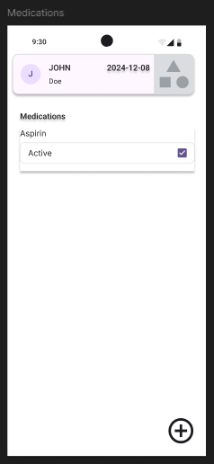

**Add Medications**

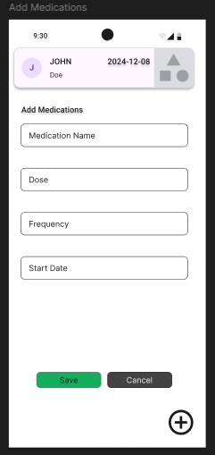

**Active Reminders**

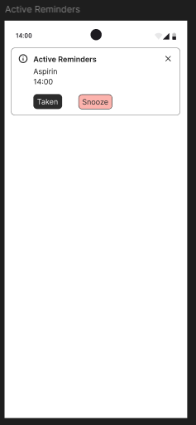

**History**

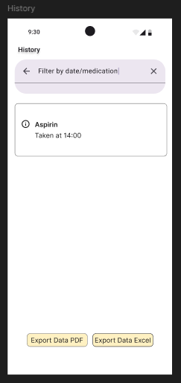

**Profile Settings**

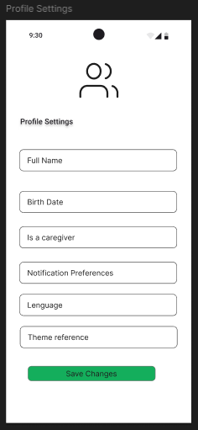

**Patient Managment**

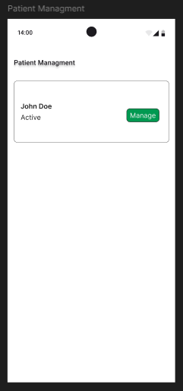

**Link Fingma**

<https://www.figma.com/design/qWmzVO1u7lB10ABCp4utsN/Medication-Reminder-App?node-id=0-1&t=hbtb1dRtnrHUPRYg-1>