SRI KRISHNA COLLEGE OF ENGINEERING AND TECHNOLOGY
An Autonomous Institution | Approved by AICTE | Affiliated to Anna University
Kuniamuthur, Coimbatore – 641008.

FITNESS COMMUNITY PLATFORM
A MINI PROJECT REPORT

Submitted by
MOWLISH D
ROLL NUMBER: 2403727710621121

In partial fulfilment for the award of the degree
BACHELOR OF ENGINEERING
IN
COMPUTER SCIENCE AND ENGINEERING (CYBER SECURITY)

October 2026

SUSTAINABLE DEVELOPMENT GOALS
The project supports the broader objective of encouraging healthier lifestyles and accessible digital fitness communities. Its primary alignment is with SDG 3 (Good Health and Well-Being). The platform promotes regular physical activity, access to structured workouts, and peer interaction.
Question | Answer
Which SDG does the project directly address? | SDG 3 (Good Health and Well-Being).
What strategies are implemented? | Workout sharing, fitness community interaction, trainer discovery, category-based content and progress-oriented participation.
How can progress be measured? | User adoption, workout participation, community activity, trainer interactions and engagement with fitness content.
Why is this goal relevant? | The system is designed to make fitness information and community support easier to access through a centralized web platform.

BONAFIDE CERTIFICATE
Certified that this mini project report titled “Fitness Community Platform” is the bonafide work of MOWLISH D (2403727710621121) carried out under the guidance and supervision of the project supervisor.
SIGNATURE
PROJECT GUIDE
Assistant Professor
Department of CSE (Cyber Security)
Sri Krishna College of Engineering and Technology
SIGNATURE
HEAD OF THE DEPARTMENT
Department of CSE (Cyber Security)
Sri Krishna College of Engineering and Technology

ACKNOWLEDGEMENT
I express my sincere gratitude to the management of Sri Krishna College of Engineering and Technology for providing the facilities and environment required to complete this mini project.
I thank the Principal and the Head of the Department, Department of CSE (Cyber Security), for their encouragement and support. I also extend my sincere thanks to my project guide for valuable guidance, technical suggestions and continuous support throughout the development of the Fitness Community Platform.
Finally, I thank my friends and family for their encouragement during the planning, implementation, testing and documentation of this project.

ABSTRACT
The Fitness Community Platform is a web-based MERN application designed to connect fitness members, trainers and administrators in a centralized digital community. The system addresses the difficulty of finding structured workout information, suitable trainers and relevant fitness discussions across disconnected platforms.
The platform provides secure registration and login, role-based access, member and trainer profiles, workout management, community posts, likes, comments, notifications and category-based feed filtering. Members can discover workouts and trainers, while trainers can contribute workout content and participate in the community. Administrators can be given elevated access for system-level management.
The frontend is implemented using React with JSX, reusable components, React Router, Axios and Bootstrap. The backend uses Node.js and Express to expose REST APIs. MongoDB with Mongoose provides document-based persistence. JWT is used for authentication and bcryptjs is used for password hashing. The project demonstrates the major concepts required for a MERN mini project, including CRUD operations, API integration, state management, routing, authentication and database relationships.

TABLE OF CONTENTS
1. 1 INTRODUCTION
2. 1.1 Overview
3. 1.2 Components of System
4. 1.3 Advanced Technologies
5. 1.4 Global Perspective
6. 2 SYSTEM ANALYSIS
7. 2.1 Existing System
8. 2.1.1 Drawbacks
9. 2.2 Problem Definition
10. 2.3 Proposed System
11. 2.3.1 Advantages
12. 3 SYSTEM REQUIREMENTS
13. 3.1 Hardware Requirements
14. 3.2 Software Requirements
15. 3.3 Software Description
16. 3.3.1 Frontend — ReactJS
17. 3.3.2 Backend — Node.js and Express
18. 3.3.3 Database — MongoDB
19. 4 SYSTEM DESIGN
20. 4.1 Module Description
21. 4.2 Use Case Diagram
22. 4.3 Sequence Diagram
23. 4.4 Class Diagram
24. 4.5 Database Design
25. 4.6 REST API Design
26. 5 TESTING
27. 5.1 Unit Testing
28. 5.2 Integration Testing
29. 5.3 Security and Authentication
30. 5.4 Test Cases
31. 6 CONCLUSION AND FUTURE WORK
32. 6.1 Conclusion
33. 6.2 Future Work
34. 7 APPENDICES
35. Appendix I — Source Code Structure
36. Appendix II — Installation and Execution
37. Appendix III — Viva Demonstration Flow
38. REFERENCES

CHAPTER 1

INTRODUCTION

1.1 OVERVIEW
Fitness participation increasingly depends on digital resources for workout discovery, trainer guidance and peer motivation. However, information is often fragmented across social networks, messaging applications and isolated fitness tools. This makes it difficult for a user to find relevant content, maintain a consistent fitness workflow and interact with trainers in one place.
The Fitness Community Platform provides a centralized web application where members can create profiles, discover workouts, publish fitness posts, interact with other users and find trainers. The category-based feed is the distinctive feature of the proposed system: users can filter community content and workout information according to fitness categories such as Strength, Cardio, Yoga and Weight Loss.

1.2 COMPONENTS OF SYSTEM

Landing Page
Introduces the platform and provides registration and login navigation.

Member Dashboard
Provides a personalized entry point to the category-based community feed and workout content.

Workout Management
Supports creating, viewing, updating and deleting workout records.

Trainer Management
Provides trainer profiles, specialization and availability information.

Member Management
Stores member fitness level, goals, preferred category and trainer association.

Community Feed
Allows users to publish posts and interact using likes and comments.

Notification Module
Creates in-app notification records for important community interactions.

Authentication and Access Control
Uses JWT-based authentication and role information to protect REST APIs.

1.3 ADVANCED TECHNOLOGIES
JWT authentication provides stateless authentication for protected REST endpoints. bcryptjs hashes passwords before database storage. Mongoose provides schema modeling and references between User, Member, Trainer, Workout, Post and Notification documents. React hooks such as useState and useEffect manage client-side state and data loading. Axios provides HTTP communication between the React frontend and Express backend.

1.4 GLOBAL PERSPECTIVE
Digital fitness ecosystems increasingly combine community participation, personalized content and professional guidance. A centralized platform can reduce fragmentation by bringing workouts, trainers and peer interaction into a single application. The proposed project is a small-scale academic implementation of this broader model.

CHAPTER 2

SYSTEM ANALYSIS

2.1 EXISTING SYSTEM
In the existing approach, users commonly depend on multiple applications for workout plans, trainer discovery, fitness discussions and progress sharing. Social platforms provide community interaction but may not organize fitness information into structured categories. Dedicated workout applications may provide routines but do not always provide community workflows and trainer discovery.

2.1.1 DRAWBACKS
• Fragmented information across different platforms.
• Difficulty filtering community content according to fitness category.
• Limited connection between workout resources and trainer profiles.
• No single role-aware workflow for members, trainers and administrators.
• Repeated manual effort to discover, share and discuss fitness content.
• Limited integration between social interaction and structured workout management.

2.2 PROBLEM DEFINITION
There is a need for a centralized fitness community platform that combines member profiles, trainer profiles, workout management and social interaction. The system should support secure authentication, role-based behavior, category-based filtering and RESTful CRUD operations while remaining simple enough for a mini-project implementation.

2.3 PROPOSED SYSTEM
• Secure member and trainer registration with JWT authentication.
• Role-aware access for members, trainers and administrators.
• Category-based feed filtering as the unique feature.
• Workout CRUD operations with difficulty, duration and category.
• Trainer and member management APIs.
• Community posts, likes, comments and notification records.
• Responsive React interface using Bootstrap.
• MongoDB persistence through Mongoose.

2.3.1 ADVANTAGES
• Centralized fitness community workflow.
• Improved discoverability of relevant content.
• Reusable React components and REST APIs.
• Secure password hashing and token-based authentication.
• Scalable document database structure.
• Clear separation between frontend, backend and database.

CHAPTER 3

SYSTEM REQUIREMENTS

3.1 HARDWARE REQUIREMENTS
S.No | Component | Recommended Specification
1 | Processor | Intel Core i5 / Ryzen 5 or equivalent
2 | RAM | 8 GB or above
3 | Storage | 10 GB free space for tools and project

3.2 SOFTWARE REQUIREMENTS
Component | Technology
Operating System | Windows 10/11, Linux or macOS
IDE | Visual Studio Code
Frontend | ReactJS + Vite + Bootstrap
Backend | Node.js + Express
Database | MongoDB
API Client | Browser / Postman
Authentication | JWT + bcryptjs

3.3 SOFTWARE DESCRIPTION

3.3.1 FRONTEND — REACTJS
React is used to build the component-based user interface. JSX combines UI markup with JavaScript logic. React Router provides client-side navigation and hooks such as useState and useEffect manage local state and asynchronous API loading. Axios communicates with the Express backend.

3.3.2 BACKEND — NODE.JS AND EXPRESS
Node.js provides the server runtime and Express provides routing and middleware for REST APIs. Authentication middleware reads bearer tokens, verifies JWT signatures and loads the authenticated user. The API is organized into route modules for authentication, workouts, members, trainers, posts and notifications.

3.3.3 DATABASE — MONGODB
MongoDB stores application data as documents. Mongoose provides schemas, validation, references and convenient query methods. The main collections are User, Workout, Member, Trainer, Post and Notification.

CHAPTER 4

SYSTEM DESIGN

4.1 MODULE DESCRIPTION

User Management
Registration, login, password hashing, JWT generation and role information.

Member Management
Member fitness level, goals, preferred category and trainer association.

Trainer Management
Trainer specialization, experience, certifications and availability.

Workout Management
Create, read, update and delete structured workouts.

Community Feed
Create posts, category filtering, likes and comments.

Notification Management
Stores interaction notifications for recipients.

Admin Management
The data model supports an admin role for system-level management; admin-only operations can be protected using role middleware.

4.2 USE CASE DIAGRAM
The use case model identifies Member, Trainer and Admin as primary actors. Members register, manage their profile, view/filter the feed, interact with posts and use workouts. Trainers contribute workout content and maintain trainer information. Admins can perform elevated management operations.
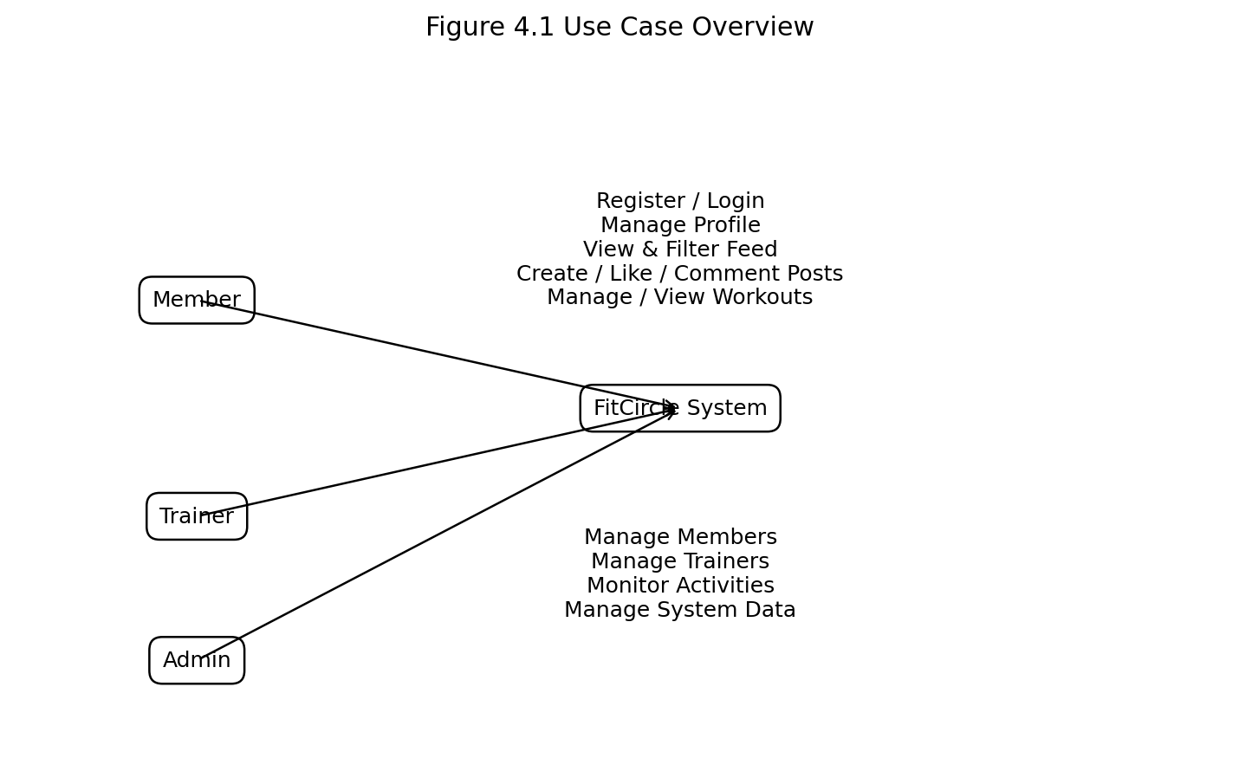
Fig. 4.1 Use Case Overview

4.3 SEQUENCE DIAGRAM
The sequence below shows the login and authenticated request flow. The React client sends credentials to Express, the server verifies the password, signs a JWT and returns it. Subsequent requests include the bearer token, which the authentication middleware validates before MongoDB operations are performed.
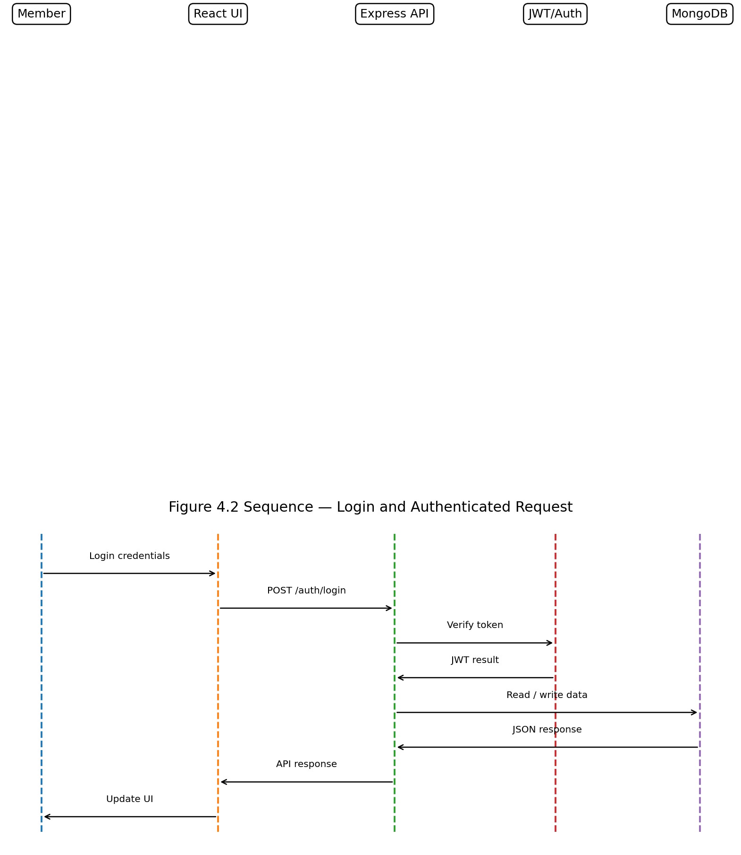
Fig. 4.2 Sequence — Login and Authenticated Request

4.4 CLASS DIAGRAM
The class/model diagram represents the core MongoDB collections and their references. User is the central identity model. Member and Trainer extend the identity information with role-specific profile data. Posts and workouts reference their creator, while notifications reference their recipient.
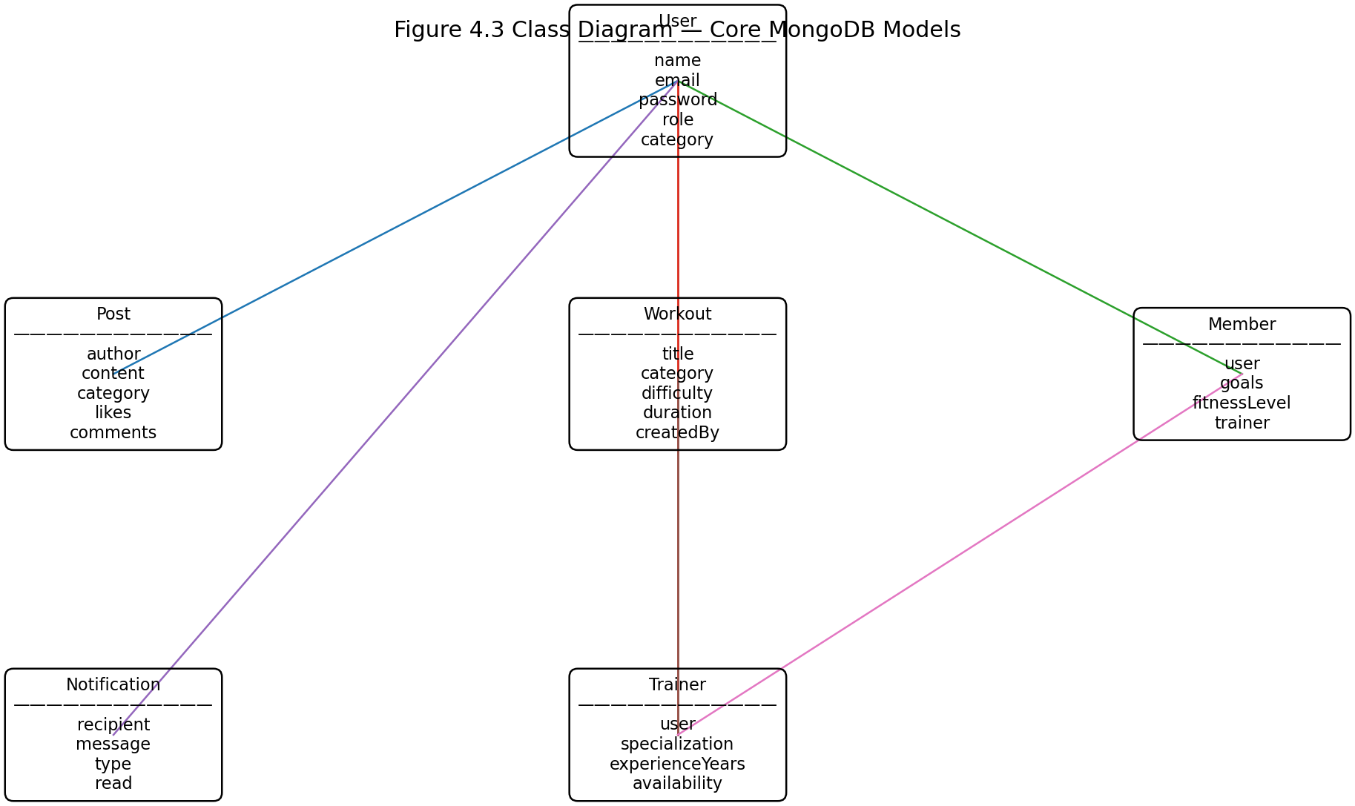
Fig. 4.3 Class Diagram — Core MongoDB Models

4.5 DATABASE DESIGN
Collection | Important Fields | Relationship
User | name, email, password, role, category | Parent identity for application users
Member | user, goals, fitnessLevel, preferredCategory, trainer | References User and optional Trainer/User
Trainer | user, specialization, experienceYears, certifications | References User
Workout | title, category, difficulty, duration, createdBy | References User
Post | author, content, category, likes, comments | References User and commenting users
Notification | recipient, message, type, read | References User

4.6 REST API DESIGN
Method | Endpoint | Purpose
POST | /api/auth/register | Register member/trainer
POST | /api/auth/login | Authenticate and return JWT
GET | /api/workout | List workouts; optional category filter
POST | /api/workout | Create workout
PUT | /api/workout/:id | Update owned workout
DELETE | /api/workout/:id | Delete owned workout
GET | /api/member | List members
GET | /api/trainer | List trainers
GET | /api/posts | List community posts; optional category filter
POST | /api/posts | Create post
POST | /api/posts/:id/like | Like/unlike a post
POST | /api/posts/:id/comments | Add a comment
GET | /api/notifications | List current user's notifications

CHAPTER 5

TESTING

5.1 UNIT TESTING
Unit testing should validate individual backend routes, authentication middleware, model validation and frontend components. During the mini-project demonstration, each CRUD operation should be tested independently before testing the complete workflow.

5.2 INTEGRATION TESTING
Integration testing verifies communication between React, Express and MongoDB. Typical tests include registering a user in React, receiving the JWT, sending the token through Axios and displaying the protected workout or feed data returned by the API.

5.3 SECURITY AND AUTHENTICATION
Passwords are hashed with bcryptjs rather than stored as plaintext. JWTs are signed on the server and sent by the login API. Protected requests use the Authorization: Bearer <token> header. The authentication middleware verifies the token and loads the corresponding user. The project should keep JWT_SECRET and MongoDB credentials in .env and never commit them to source control.

5.4 TEST CASES
Test ID | Scenario | Expected Output | Result
TC01 | Register with valid details | Account is created and JWT is returned | Pass when implemented
TC02 | Register with an existing email | 409 error and registration rejected | Pass when implemented
TC03 | Login with incorrect password | 401 error with invalid credential message | Pass when implemented
TC04 | Access protected API without token | 401 authentication error | Pass when implemented
TC05 | Create workout with valid data | Workout document is stored | Pass when implemented
TC06 | Delete another user's workout | Operation is rejected | Pass when implemented
TC07 | Filter posts by category | Only selected category is returned | Pass when implemented
TC08 | Like a post | Like count changes and notification is created when applicable | Pass when implemented
TC09 | Add incomplete workout | Validation prevents invalid record | Pass when implemented
TC10 | Open dashboard after login | Protected dashboard loads user and community data | Pass when implemented

CHAPTER 6

CONCLUSION AND FUTURE WORK

6.1 CONCLUSION
The Fitness Community Platform provides a practical MERN-based solution for connecting fitness members and trainers. The system combines structured workout management with social interaction, role-based access and category-based filtering. The project demonstrates the complete flow from React user interface to Express REST APIs and MongoDB persistence.
The implementation also demonstrates essential software engineering concepts including modular design, CRUD operations, authentication, password hashing, API communication, database modeling and testing. The project can be presented as a working academic mini project after configuring MongoDB, installing dependencies and completing the demonstration workflow.

6.2 FUTURE WORK
• Trainer-member appointment scheduling and chat.
• Workout progress tracking and personal statistics.
• Image/video upload for exercise demonstrations.
• Advanced recommendation engine for workouts and trainers.
• Mobile application using React Native.
• Admin analytics dashboard and audit logs.
• Email/push notifications and reminders.
• Deployment using a cloud database and hosting service.

CHAPTER 7

APPENDICES

APPENDIX I — SOURCE CODE STRUCTURE
fitness_community_platform/
├── client/
│ ├── src/
│ │ ├── pages/
│ │ ├── App.jsx
│ │ ├── api.js
│ │ ├── main.jsx
│ │ └── styles.css
│ ├── package.json
│ └── vite.config.js
├── server/
│ ├── middleware/
│ ├── models/
│ ├── routes/
│ ├── .env.example
│ ├── package.json
│ ├── seed.js
│ └── server.js
├── diagrams/
└── README.md

APPENDIX II — INSTALLATION AND EXECUTION
Install Node.js 18 or newer and MongoDB Community Server, or create a MongoDB Atlas database.
Open the project folder in Visual Studio Code.
Open a terminal in the server folder and run: npm install.
Copy .env.example to .env and set MONGO_URI and JWT_SECRET.
Run npm run dev in the server folder. Confirm that the API is running on port 5000.
Open a second VS Code terminal, move to client, run npm install and then npm run dev.
Open the Vite URL, normally http://localhost:5173.
Register a member and trainer account and demonstrate the dashboard, category filtering, workout CRUD and community interactions.
Use the seed script if demo data is required: node seed.js.

APPENDIX III — VIVA DEMONSTRATION FLOW
• Explain the problem and unique category-based feed feature.
• Show registration and login.
• Explain JWT and bcryptjs.
• Create and display a workout.
• Create a community post and filter by category.
• Like the post and show the notification endpoint.
• Explain MongoDB collections and Mongoose references.
• Show REST endpoints using browser/Postman.
• Demonstrate invalid login and protected API behavior.

REFERENCES
React Documentation — https://react.dev/
Node.js Documentation — https://nodejs.org/docs/
Express Documentation — https://expressjs.com/
MongoDB Documentation — https://www.mongodb.com/docs/
Mongoose Documentation — https://mongoosejs.com/docs/
JSON Web Token Introduction — https://jwt.io/introduction/
Bootstrap Documentation — https://getbootstrap.com/docs/

