**MongoDB Task**

Design database for Zen class programme

* **Users**

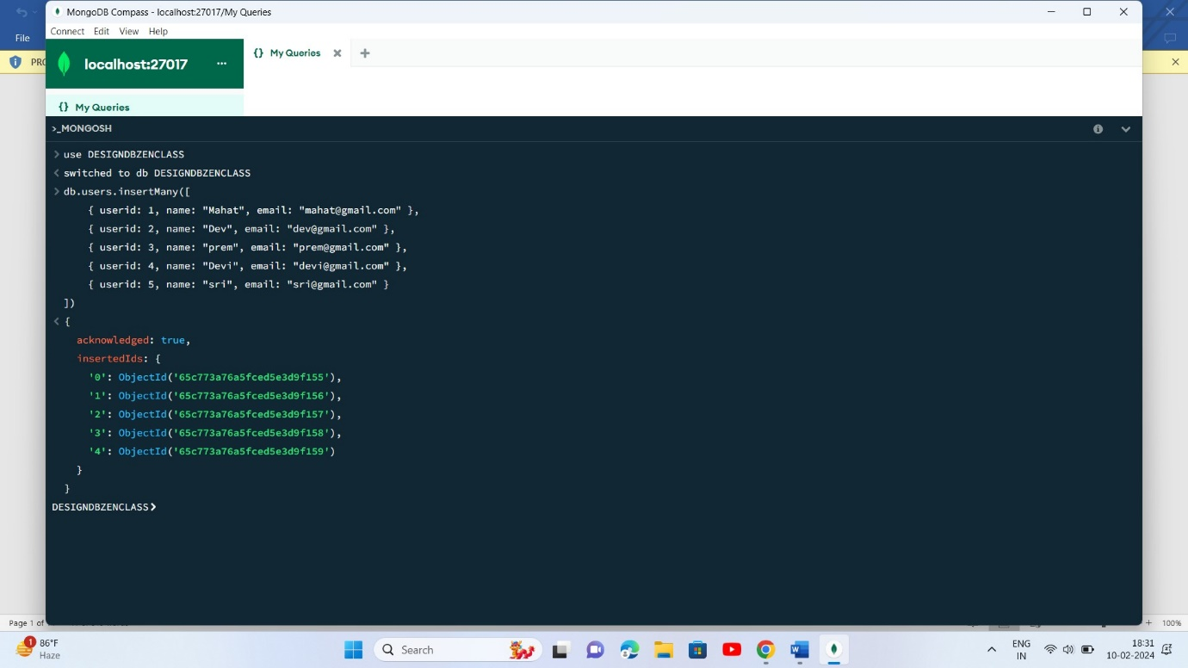

* **Codekata**

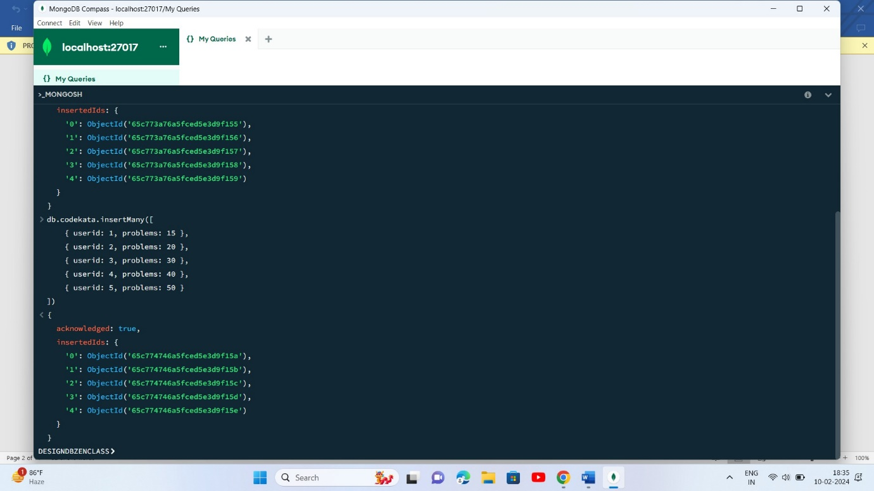

* **Attendance**

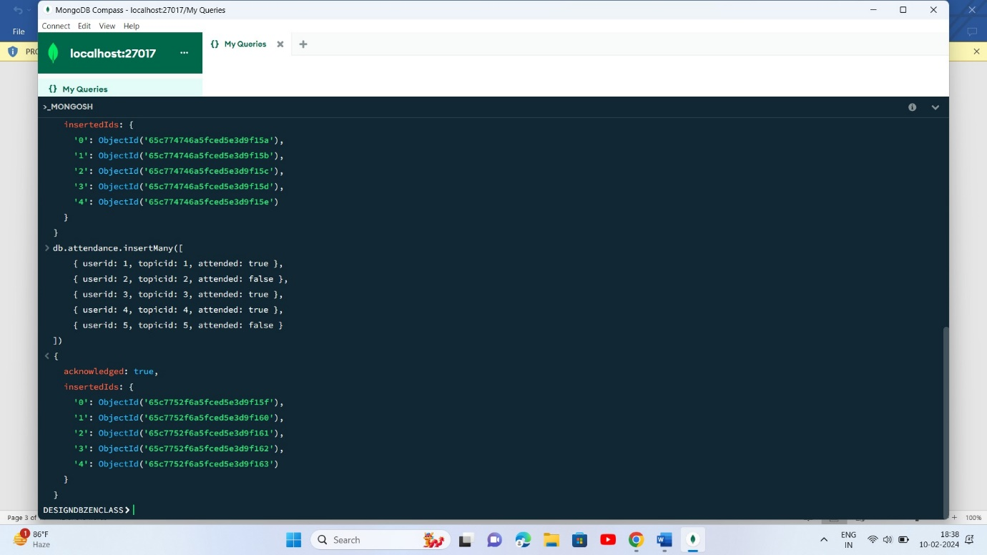

* **Topics**

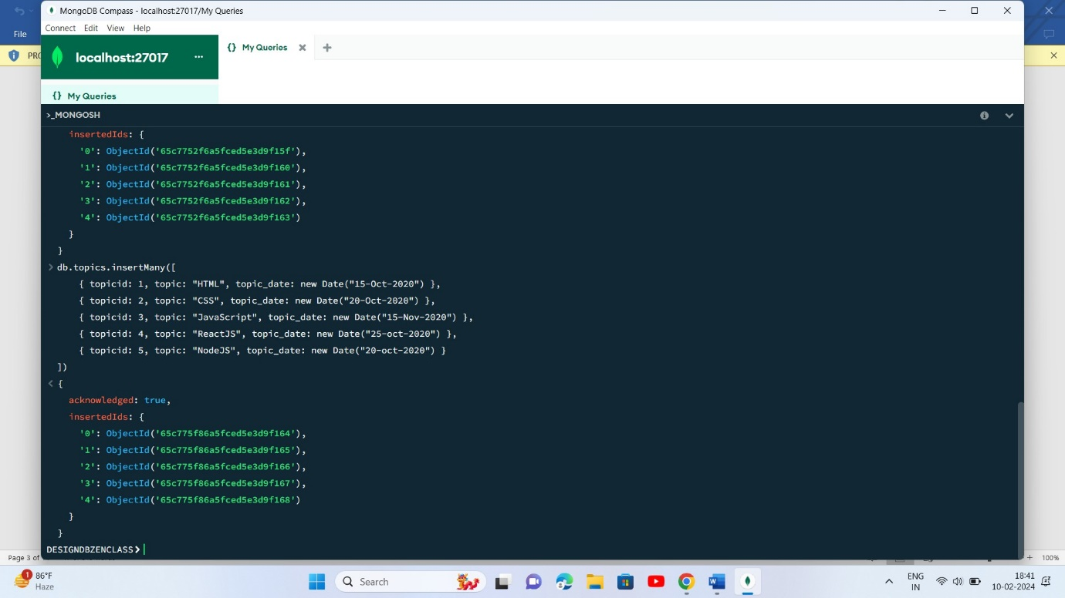

* **Tasks**

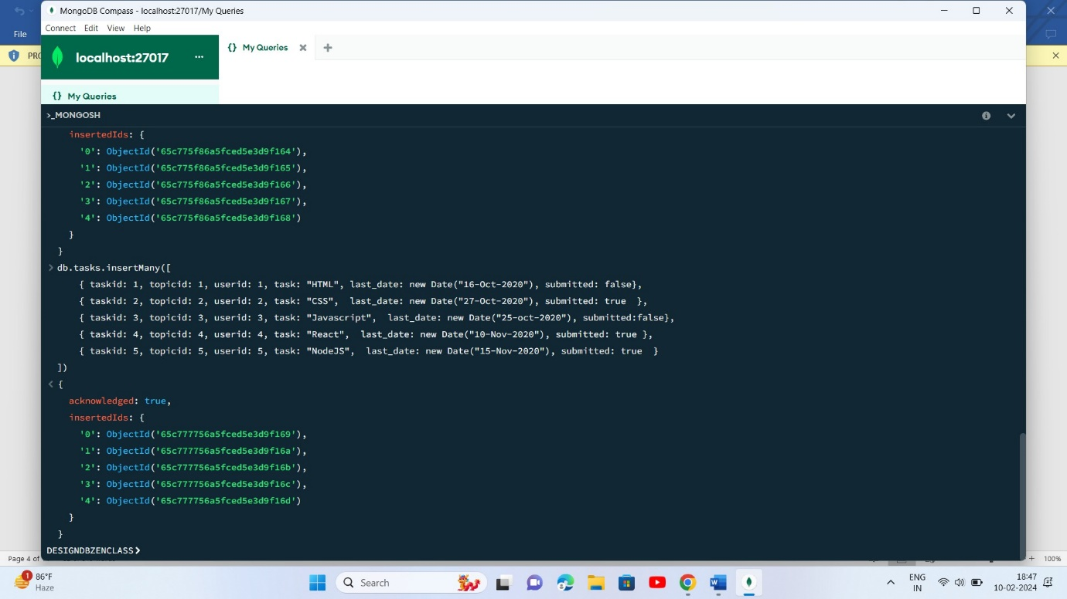

* **company_drives**

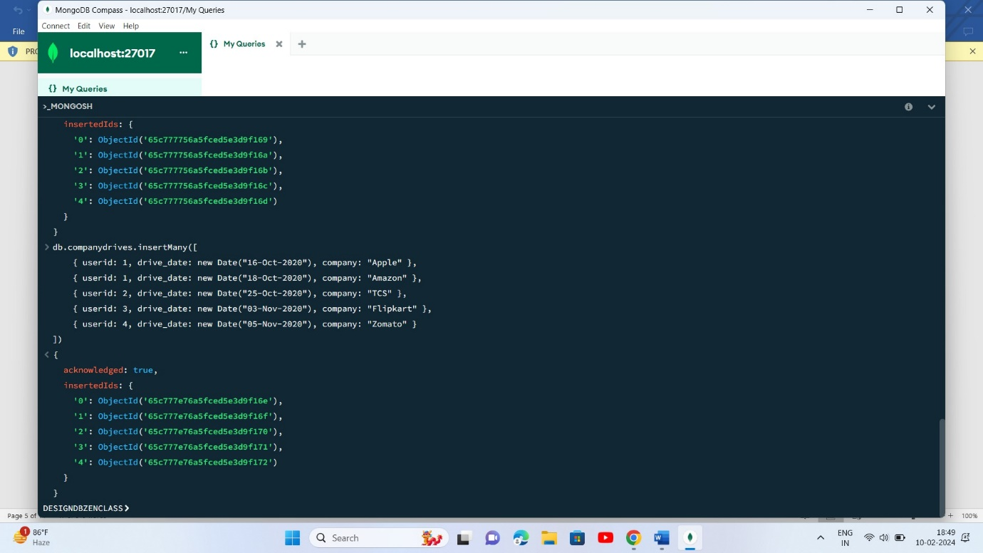

* **mentors**

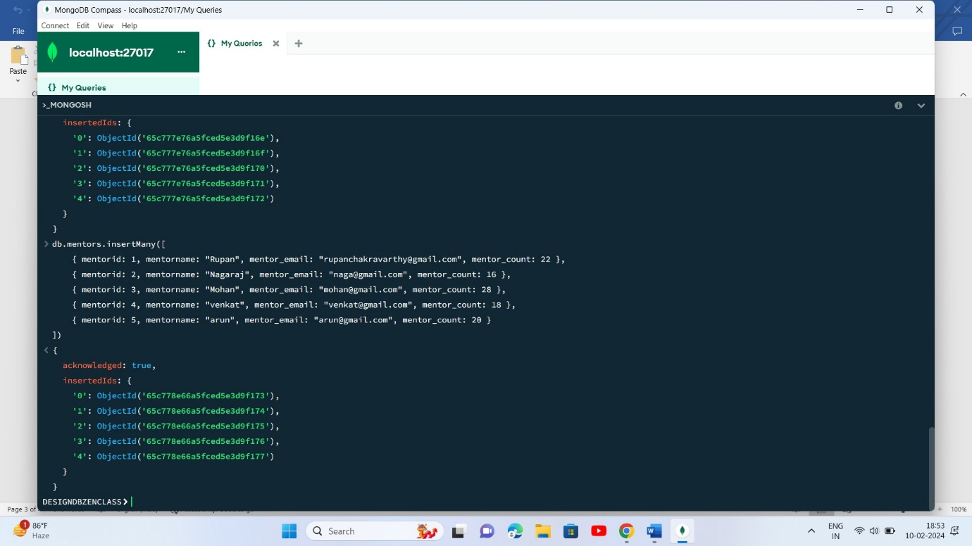

**Database-DESIGNDBZENCLASS**

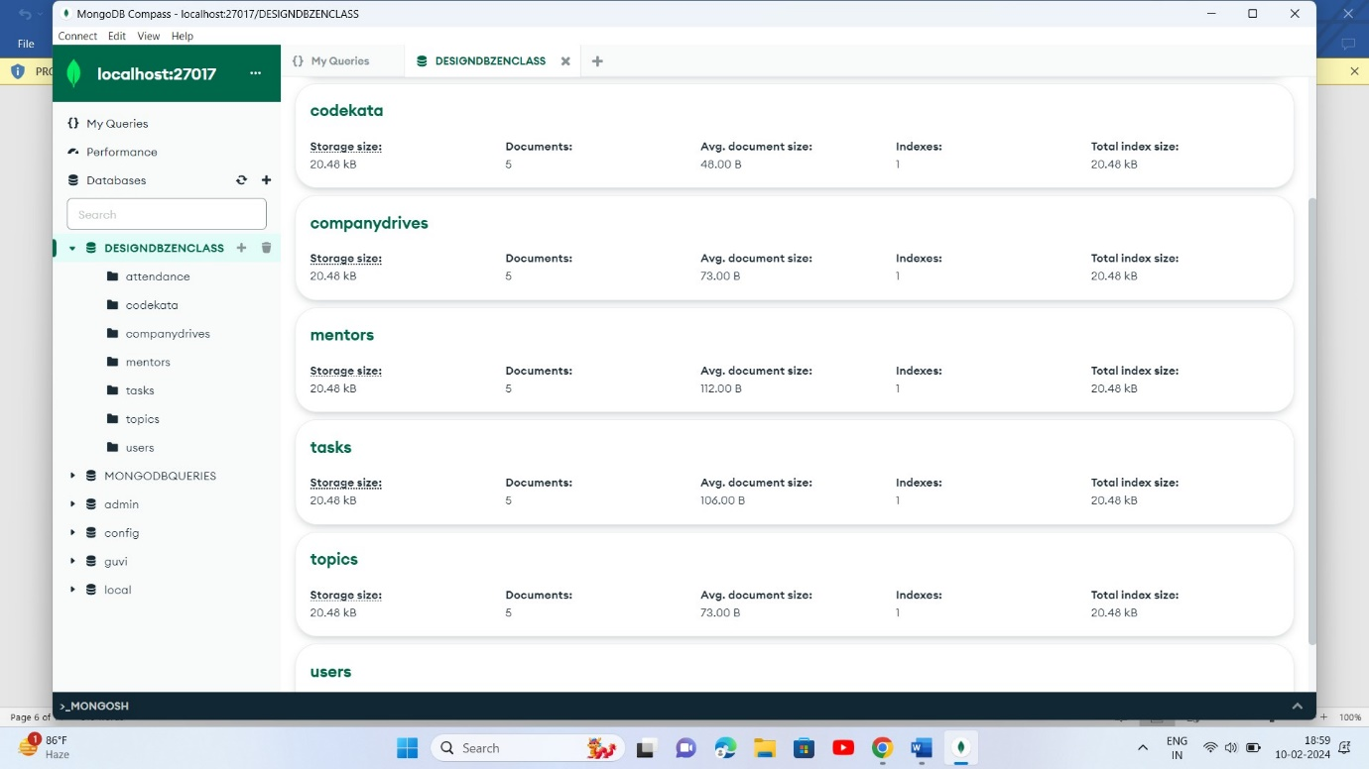

**Queries:**

1. **Find all the topics and tasks which are thought in the month of October**

db.topics.aggregate([

{ $lookup: {

from: "tasks",

localField: "topicid",

foreignField: "topicid",

as: "taskinfo" }

},

{$match: { $and: [

{ topic_date: { $gte: new Date("2020-10-01"), $lt: new Date("2020-11-01") } },

{ $or: [

{ "taskinfo.due_date": { $gte: new Date("2020-10-01"), $lt: new Date("2020-11-01") } },

{ "taskinfo.due_date": { $exists: false } }

]

}

]

}

},

{

$project: {

_id: 0,

topicid: 1,

topic: 1,

topic_date: 1,

tasks: "$taskinfo.task",

due_dates: "$taskinfo.due_date"

}

}

])

1. **Find all the company drives which appeared between 15 oct-2020 and 31-oct-2020**

db.companydrives.find({

$or: [

{ drive_date: { $gte: new Date("15-oct-2020") } },

{ drive_date: { $lte: new Date("31-oct-2020") } }

]

})

1. **Find all the company drives and students who are appeared for the placement.**

db.companydrives.aggregate([

{

$lookup: {

from: "users",

localField: "userid",

foreignField: "userid",

as: "userinfo"

}

},

{

$project: {

_id: 0,

company: 1,

drive_date: 1,

users: "$userinfo"

}

} ])

1. **Find the number of problems solved by the user in codekata**

db.codekata.aggregate([

{

$lookup: {

from: "users",

localField: "userid",

foreignField: "userid",

as: "userinfo"

}

},

{

$group: {

_id: {

userid: "$userid",

username: "$userinfo.name"

},

total_problems_solved: { $sum: "$problems" }

}

},

{

$project: {

_id: 0,

userid: "$_id.userid",

username: "$_id.username",

total_problems_solved: 1

}

}

])

1. **Find all the mentors with who has the mentee's count more than 15**

db.mentors.find({mentor_count:{$gt:15}},{mentor_count:1})

1. **Find the number of users who are absent and task is not submitted  between 15 oct-2020 and 31-oct-2020**

db.attendance.aggregate([

{

$lookup: {

from: "topics",

localField: "topicid",

foreignField: "topicid",

as: "topics"

}

},

{

$lookup: {

from: "tasks",

localField: "topicid",

foreignField: "topicid",

as: "tasks"

}

},

{

$match: {

attended: false,

"tasks.submitted": false,

$and: [

{ "topics.topic_date": { $gte: new Date("15-oct-2020") } },

{ "topics.topic_date": { $lte: new Date("31-oct-2020") } },

{ "tasks.last_date": { $gte: new Date("15-oct-2020") } },

{ "tasks.last_date": { $lte: new Date("31-oct-2020") } }

]

}

},

{$count: "No_of_users_absent"}])