**Distribution of Depression Scores Across Cases**

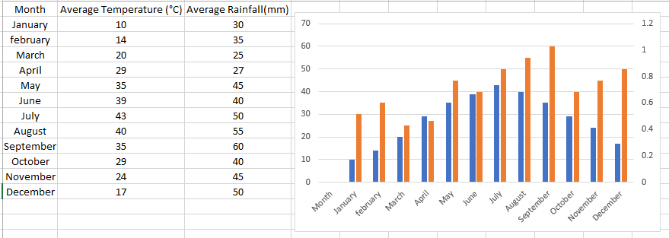

**Figure 1:** Monthly Temperature and Rainfall Trends: A Dual-Axis Analysis of Seasonal Variations.

**Temperature and Rainfall Trends Analysis**

**1. Temperature Trends**

* **Range**: The average monthly temperature varies from **10°C** in **January** (coldest) to **43°C** in **July** (hottest).
* **Pattern**: Temperatures rise consistently from January to July, peaking in the summer months, and then gradually decline from August to December.

**2. Rainfall Trends**

* **Range**: Rainfall fluctuates throughout the year, with the lowest at **25 mm** in **March** and the highest at **60 mm** in **September**.
* **Pattern**: Rainfall increases from January to September, reflecting the monsoon season, before tapering off towards the end of the year.

**3. Combined Patterns**

* **Temperature and Rainfall**: The hottest months (**June, July, August**) coincide with moderate to high rainfall levels, which aligns with the typical tropical climate pattern.
* **Post-Monsoon**: From **October to December**, temperatures and rainfall both decrease.

**Chart Details**

* **Dual-Axis Format**:
  + **Blue Bars**: Represent average monthly temperatures.
  + **Orange Bars**: Represent average monthly rainfall.
* **Seasonal Influence**: The chart shows how temperature and rainfall vary across months, illustrating the seasonal effects on both patterns.

**Conclusion**

This analysis provides insights into the relationship between temperature and rainfall throughout the year. Understanding these patterns is critical for applications in agriculture, water resource management, and climate studies.

**Correlation matrix of CGPA, Department, and Gender**

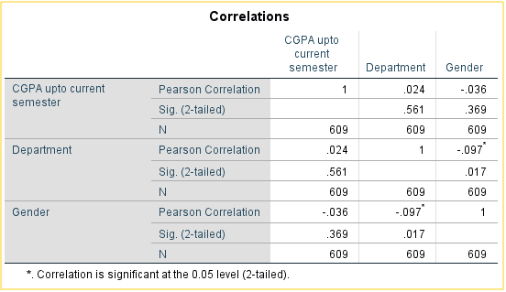

**Figure 2:** Correlation Analysis of CGPA, Department, and Gender: Pearson's Coefficients and Significance Levels.

**Correlation Analysis Summary**

**1. CGPA up to Current Semester and Department**

* **Pearson Correlation Coefficient**: 0.024 (Very weak positive correlation)
* **Significance (p-value)**: 0.561 (> 0.05, not statistically significant)

**2. CGPA up to Current Semester and Gender**

* **Pearson Correlation Coefficient**: -0.036 (Very weak negative correlation)
* **Significance (p-value)**: 0.369 (> 0.05, not statistically significant)

**3. Department and Gender**

* **Pearson Correlation Coefficient**: -0.097 (Weak negative correlation)
* **Significance (p-value)**: 0.017 (< 0.05, statistically significant)

**Additional Details**

* **Sample Size (N)**: 609
* **Significance Level**: 0.05 (2-tailed)

**Key Observations**

* **Non-significant Correlations**: The relationships between CGPA and Department, and CGPA and Gender, are both very weak and not statistically significant.
* **Significant Correlation**: The relationship between Department and Gender is statistically significant (p = 0.017), but the correlation is weak, indicating a potential but limited association.
* **Insight**: The significant relationship between Department and Gender might reflect variations in gender distribution across departments, though the strength of the correlation is not substantial.

This analysis offers an understanding of the interactions among CGPA, department affiliation, and gender.

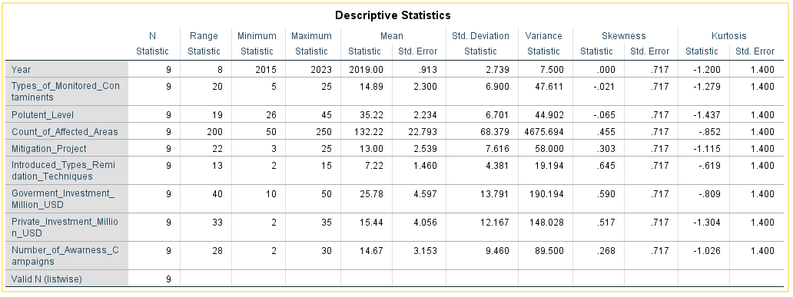

**Figure 3:** Descriptive Statistics of Environmental Monitoring and Remediation Variables

This table presents descriptive statistics for variables relevant to the research. The key statistics include the range, minimum, maximum, mean, standard deviation, variance, skewness, and kurtosis for each variable, calculated from nine observations (N = 9). Below is a summary of the included variables and their statistical properties:

1. **Year**: The data spans a range of 8 years, from 2015 to 2023, with an average year value of 2019.
2. **Types of Monitored Contaminants**: The number of contaminants monitored varies between 5 and 25, with an average of 14.89. The standard deviation is 6.9, indicating moderate variation.
3. **Pollutant Level**: Pollution levels range from 26 to 45, with a mean of 35.22 and a standard deviation of 6.701, reflecting relatively low variability.
4. **Count of Affected Areas**: The number of areas impacted ranges from 20 to 250, with a high mean of 132.22 and a variance of 4675.69, indicating considerable variability.
5. **Mitigation Projects**: The number of mitigation projects implemented ranges from 3 to 25, with an average of 13 and a standard deviation of 7.616.
6. **Introduced Types of Remediation Techniques**: The range of introduced techniques varies between 2 and 15, with a mean of 7.22 and low variability (SD = 4.381).
7. **Government Investment (Million USD)**: Government spending ranges from 10 to 50 million USD, with a mean of 25.78 and a standard deviation of 13.791.
8. **Private Investment (Million USD)**: Private investments range from 2 to 35 million USD, with an average of 15.44 and a standard deviation of 12.167.
9. **Number of Awareness Campaigns**: Campaigns range from 3 to 28, with an average of 14.67 and a standard deviation of 9.46.

The skewness and kurtosis values suggest that most variables are moderately symmetric and do not exhibit extreme outliers, as their values are close to zero. These statistics provide an overview of the data distribution and variability, supporting the analysis of trends and impacts in environmental monitoring and remediation efforts.